**Stage 3 – Term 3**

**Week 2**

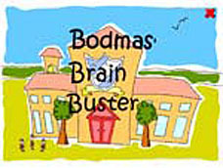

**Johnny’s Maths (Whole Number)**

Johnny’s teacher challenged him to use the numbers 3, 6 and 9 in any order and apply the order of operations in the spaces below.

1. (9 + \_\_) × \_\_ = \_\_\_\_
2. \_\_ × (\_\_ ─ \_\_) = \_\_\_\_
3. \_\_ + \_\_ ─ \_\_ = \_\_\_\_
4. \_\_ × \_\_ ÷ \_\_ = \_\_\_\_
5. \_\_ × \_\_ + \_\_ = \_\_\_\_
6. \_\_ + \_\_ × \_\_ = \_\_\_\_
7. \_\_ + \_\_ ÷ \_\_ = \_\_\_\_

Now, list as many factors for each number as you can.

**Week 3**

**Sophie and Chad’s Journey (Time)**

Sophie and Chad went on a 10 hour car trip on Sunday, to be back home, ready for work on Monday morning.

****

They travelled at an average speed of 80 km/h and stopped twice for 1 hour each time. Show their journey on a timeline including possible start and end times (don’t forget to include a scale).

If Sophie and Chad took the freeway instead of the country road their average speed would have been 100 km/h but it would have taken them an extra 2 hours. Make another timeline to discover which route would have been faster.

**Week 4**

**Guess the Number (Patterns and Algebra)**



Nicole’s teacher was letting the class play a game of ‘Guess the Number’. When it was Nicole’s turn she thought she would challenge the class and make them find 8 of her secret numbers.

Nicole told her class mates that they must find the eight numbers and gave them the formula “when the numbers are divided by 3 then multiplied by 8 the answers fall between 156 and 220”.

What are Nicole’s 8 secret numbers?

Now make your own formula for your set of secret numbers. How many secret numbers will you have?

**Week 5**

**Eliza’s Boutique (Percentages)**

Eliza is starting up a new boutique fashion store. One of her suppliers is selling her singlet tops, denim skirts and denim handbags and is giving her a special price of 40% off each item to help her get started.

|  |  |
| --- | --- |
| Singlet tops- original price $36.40 | C:\Users\nmcneill\Pictures\colorful_giftboxes_tank_top-rf8c74f7bbf4140deacf36925734fd6ae_6vj2q_324.jpg |
| Handbags- original price$18.20 | C:\Users\nmcneill\Pictures\large-Purse-0-7969.gif |
| Denim skirts- original price $54.60 | C:\Users\nmcneill\Pictures\k19964522.jpg |

How much will Eliza pay for each item?

How much of each item do you think Eliza ordered from her supplier if the total order came to $1040.00?

If Eliza made 20% clear profit on the items, how much would she make if she sold all the singlets, skirts and handbags?

**Week 6**

**Happy Numbers (Addition)**



Take any two digit number, square the digits and add the resulting numbers together. Do this again to your new number. If you keep doing this do you get back to the number you started with?

When you return to the start we call this a happy number (happy to be home again)!

Find out which two digit numbers are happy numbers and which ones are sad.

Hint: Make a table.

**Week 7**



**What’s the Difference? (Subtraction)**

Two numbers differ by 54 and they are composed of the same two digits reversed.

Find the numbers.

Can you find a different answer? How many answers are possible?

How many answers can you find if the two differ by 36?

**Week 8**

**Fruit Picking (Multiplication)**



Billy, Tommy and Sam spent the weekend fruit picking in Farmer James’ orchards. They picked a total of 320 fruits over both days.

a) If three times the amount of fruit picked on Saturday was picked on Sunday, how many fruits did the boys pick on each of the days?

Saturday ……………………………………..Sunday………………………………………

b) A mixture of pears, nectarines and oranges were picked. The number of pears picked was twice the number of nectarines and ten times the number of oranges.

How many of each type of fruit were picked?

pears …………………… nectarines …….……………… oranges ………..……………

**Week 9**

**Kenny’s Questions (Division)**

Kenny wrote a problem to challenge himself, and answered it.

|  |  |
| --- | --- |
| Jason had a bag of 158 coloured pencils that he shared among himself and four friends. How many pencils did each child receive?C:\Users\nmcneill\Pictures\coloured-pencils-2.jpg |  |

How many problems can you write and solve that have an answer ending in remainder 3?

|  |  |  |
| --- | --- | --- |
| a. |  |  |
| b. |  |  |
| c. |  |  |
| d. |  |  |
| e. |  |  |

**Week 10**

**What can I carry? (Mass)**

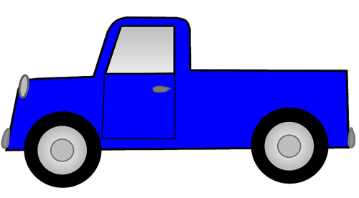

1.How many bags of cement can I carry on my one tonne ute, if one bag of cement has a mass of 20 kilograms?

2.How many bricks can I carry on my one tonne ute, if one brick weighs 40 kilograms?

3.How many newspapers can I carry on my one tonne ute, if one newspaper weighs 500 grams?

4.How many sheep can I carry on mu ne tonne ute, if one sheep weighs 125kilograms?