**Stage 3 – Term 2**

**Week 2**

**Buffalo (Whole Number)**

1. Charlie lives in Buffalo, New York. The table below shows the temperature changes in Buffalo over a three-hour period.

|  |  |
| --- | --- |
| Time | Change in Temperature |
| 6 am to 7 am | -2.5∘C |
| 7 am to 8 am | -3.5∘C |
| 8 am to 9 am | +2.0∘C |

Charlie noticed that the temperature at 6 am was -3.5∘C

What is the temperature in Buffalo at 9 am?

How far is this temperature from 0?

1. James lives in Frederickton, Mississippi. The table below shows the temperature changes in Buffalo over a three-hour period.

|  |  |
| --- | --- |
| Time | Change in Temperature |
| 6 am to 7 am | +4.5∘F |
| 7 am to 8 am | +7.5∘F |
| 8 am to 9 am | +9.5∘F |

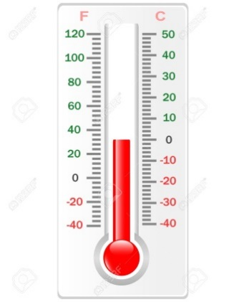

James noticed that the temperature at 6 am was -7.5∘F

What is the temperature in Buffalo at 9 am?

How far is this temperature from 0?

Is Buffalo or Frederickton colder at 9 am?

**Week 3**

**Time Zones (Time)**

The time now in Sydney, NSW is 20 minutes after 3 o’clock. Show this time in as many ways as you can.

What is the time in the other states of Australia?

|  |  |
| --- | --- |
| Australian Capital Territory |  |
| Northern Australia |  |
| Queensland |  |
| South Australia |  |
| Tasmania |  |
| Victoria |  |
| Western Australia |  |

Write these times in as many ways as you can.

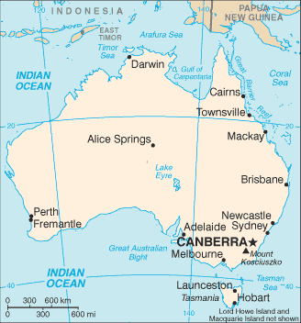

**Week 4**

**Matches (Fractions)**

Move three matches so that the area of the new figure is of the area of the original triangle.

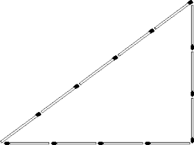

**Week 5**

**Uncle Fred’s Paddock (Decimals)**

Uncle Fred knows that the area of his rectangular paddock is 0.9 square units. What might the perimeter be? Write as many possibilities as you can, including the smallest and the largest possible perimeters. Show your working.

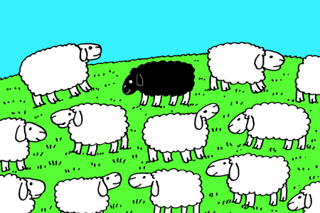

Now round each of your answers.

**Week 6**

**Round Rock Island (Addition)**

Mr Jones has bought himself a new car to travel around Round Rock Island. It costs quite a lot to run and does 16 kilometres to every litre of petrol. Petrol is also expensive on the island. It costs $2.20 per litre.

****Calculate some journeys Mr Jones could do, noting the number of kilometres, the amount of petrol needed and how much it would cost. One trip is done for you.

|  |  |  |  |
| --- | --- | --- | --- |
| Journey | Distance | Litres of petrol | Fuel cost |
| Turtle Bay to Lighthouse via Green Lake and Round Rock | 464 km | 29 | $63.80 |
|  |  |  |  |
|  |  |  |  |
|  |  |  |  |
|  |  |  |  |

**Week 7**

**Ellen’s Calculator (Subtraction)**

Ellen’s teacher was asking her to make numbers on her calculator. Unfortunately, Ellen accidentally dropped hers. When she picked it up she noticed that the 3, 6, 9 and + keys were not working.

To make matters worse, the next number the teacher wanted made was 693.

Show as many ways as you can that Ellen could make 693 on her calculator. Show that your answers are correct using the inverse operation.



**Week 8**

**Building a Wall (Multiplication)**

Gordon the bricklayer builds many brick walls. Before he builds each wall, he usually gives a quote to the person ordering them.

He works out the price of the wall by working out how many bricks he needs then calculating the cost of the bricks plus what he charges for laying them.

Here is some information that Jack uses to quote for his brick walls.

* He uses about fifty bricks per square metre of wall.
* Each brick costs about 95c.
* He charges $1.80 to lay each brick.

2 m × 3 m = 6 m²

6 m² × 50 bricks = 300 bricks.

So …

300 bricks × 95c = $285

300 bricks laid at $1.80 ea. = $540

Total $825

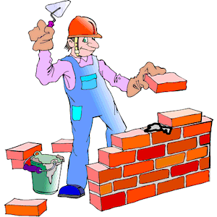

**2 m**

3 m

Draw 2 single-thickness brick walls and calculate how much Gordon would quote to build each one.

Now draw 2 double-thickness brick walls and calculate how much Gordon would quote to build them.

**Week 9**

**Bike Racing (Division)**

The local bike racing club noticed that there was a growing membership of girls because bike racing was becoming more popular with girls.



The last registration figures showed that of the members were girls and of the members were boys.

The president of the bike racing association couldn’t remember exactly how many children were registered but he knew that it was between 850 and 950 and that the number was divisible by 9.

*Hint: Any number with digits that add to 9 is divisible by 9. For example, 855 is divisible by 9 because 8 + 5 + 5 = 18, and 18 is a multiple of 9.*

Make a list of all possible combinations of boys and girls racing bikes from the information above. One example has been provided for you.

|  |  |  |
| --- | --- | --- |
| Total number of riders | Boys | Girls |
| 855 | 570 | 285 |
|  |  |  |
|  |  |  |
|  |  |  |
|  |  |  |
|  |  |  |
|  |  |  |
|  |  |  |
|  |  |  |
|  |  |  |
|  |  |  |

**Week 10**

**Calendars (Patterns and Algebra)**

What months this year start on the same day as each other? Without looking at a calendar for next year, what months next year start on the same day as each other?

Also, without looking, at a calendar, what months the year after that start on the same day as each other?

Describe the pattern.

