Learning and Support Team
Policy and Procedures

Adopted May 2017

Contents:
- Policy
- Referrals
  - Procedures
  - Learning Support Team Reflection Sheet
  - Referral Forms
- Individual Student Learning Support Action Plan
- Assessment Package

This document has been heavily informed by the Oakville Public School Learning and Support team Policy and Procedures.

Learning and Support

Snow Gums Learning Alliance

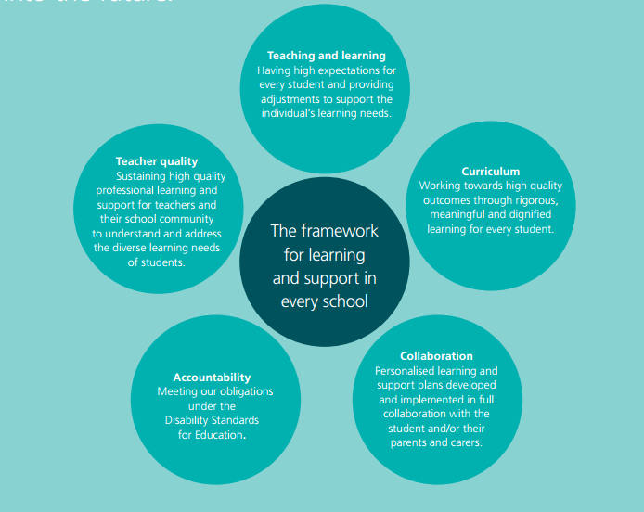
The achievement of successful educational outcomes for every student is supported through high quality teaching and learning. Some students need additional support to access the full range of education opportunities and to achieve success.
The Snow Gums learning alliance learning support team brings together the school communities from Bald Blair Public School, Ben Lomond Public School, Black Mountain Public School, Ebor Public School and Chandler Public School. The collective power of or alliance offers our learning support team increased access to support, resources and specialist professional learning.
Every student, every school offers students, teachers, parents and school communities the chance to engage in high quality learning. This document frames how the Snow Gums learning alliance will implement Every Student, Every School into our schools.
The Snow Gums learning and support team will:
- Develop a collective policy for students experiencing difficulties in learning or those requiring extension
- Develop referral systems for classroom teachers to access support services;
- Work with classroom teachers to support assessment for learning of their students with additional educational needs, and identify specific learning and support needs;
- Plan, implement, monitor and evaluate teaching programs for students with additional learning and support needs in conjunction with regular classroom teachers;
- Plan, implement, monitor and evaluate personalised adjustments for learning where required, with the classroom teacher, student and/or parent or carer;
- Devise a professional learning plan which supports the needs of our schools and the alliance;
- Work collectively to access specialist services.

Professional learning for skilled and knowledgeable teachers
Research demonstrates that one of the most significant contributors to educational outcomes in the school environment in the teacher. Effective teachers are our most important resource for supporting high quality educational outcomes for every student, including those with a disability.
The Snow Gums Learning and support team will plan for and implement high quality professional learning throughout our schools. Our team will build and share expertise across the alliance, ensuring continuity of professional expertise across each of our schools. Teachers from across the alliance will engage in collaborative, ongoing professional learning.

Support for students with disability in regular classrooms
Through working collectively and collaboratively, our teachers will have more immediate access to additional support within the school to meet the educational needs of students with disability or in need of extension.

Understanding and assessing the learning and support needs of students
Our alliance will accelerate the development of a functional assessment tool for teachers to profile the learning and support needs of individual students in collaboration with student and their parents.
Teachers will be supported in development of personalised learning plans.
The role of the learning support team is to ensure that all students requiring support are having their needs met. The Learning support team will address:
- Teaching and learning
- Assessment
- Attendance
- Training and Development
- Parent participation
- Student Support and Development
The learning support team will meet twice per term, with all referrals and updates being discussed. Schools will still make referrals to the Senior School Psychologist outside of meeting times, in line with individual school needs. Updates to referrals will be given at learning support meetings.
Core Members of the Learning and Support Team
- Chair, from within the Snow Gums Learning Alliance
- Senior School Psychologist or school counsellor
- Principals of Snow Gums Learning Alliance schools
- Learning and Support Teacher (LaST)
- Class teacher
- Other specialist personnel e.g. Assistant Principal Learning Assistance, outside agencies, parents and care givers can be invited to attend as necessary.

Snow Gums Learning Alliance Learning and Support Team Referral Flowchart

General Adjustments
Things to think about:
1. Adjusting content
2. Adjusting teacher language
3. Adjust work output
4. Adjust the environment
5. Organisation of routines and behaviour

Learning Support Team Referral

Student Name: _______________________________ Class:____________
Teacher making referral:________________________ Date:____________

Concern Reason for Referral
- Attendance
- Behaviour
- Disability
- Learning
- Wellbeing
- Out of Home Care
- Other______________

Previous Programs and Assistance Additional Information

- English Second Lang.
- LaST
- Outside Agencies
- Parent Contact
- Previous Teacher
- Reading Recovery
- School Counsellor
- SLSO
- Supervisor Consultation
- Wellbeing Programs
- Other_____________
Supervisors Comments and Recommendations

Learning Support Team Recommendations Date:________

Learning Support Team LAST Assessment

Student Name: _______________________________ Class:____________
Teacher:____________________________________ Date:____________
Assessments
- Literacy
- Numeracy
- Receptive and Expressive Language
- Behaviour
- Student Observations
Assessments Administered and Results

Recommendations

Senior School Psychologist Parent Referral Form
Student Background |  | PRIVACY NOTICE
Student name |  | This information is being obtained to assist the Senior School Psychologist in providing support for your child. It may, as appropriate, be provided to other members of the school staff involved in supporting your child. Provision of this information is voluntary. It will be stored securely. You may correct any personal information provided at any time by contacting the Senior School Psychologist.
Date of birth
Date of referral
Parent/caregiver
Please speak with your child’s class teacher or the Senior School Psycologist if you would like help to complete this
form.
Reasons for Referral/ What concerns do you have?
Briefly describe concerns:

Developmental History (e.g. has your child ever been seriously ill or had an accident?)
Briefly describe illness or accident:

Previous Assessments (e.g. Doctor, Psychologist, Paediatrician, Speech Therapist)
Please describe any previous assessments and the outcomes of the assessment/s:

Is there anything else you would like the Senior School Psychologist to know?
What you hope will happen as a result of the Senior School Psychologist seeing your child.

I have read the privacy notice and give permission for the Senior School Psychologist to:
Carry out assessment and counselling as required | Yes / No
Contact the authors/ agencies of any reports I have provided | Yes / No
Exchange information with these authors/agencies | Yes / No
Parent/Caregivers Signature Date

Senior School Psychologist Teacher Referral Form
From Learning Support Team
Student name
Class / Teacher
Date of birth
Date of referral

Reasons for Referral
Specific details:

Classroom Achievement
Comments on Reading. Spelling, Numeracy etc

Language Skills
Comments on expressive and receptive language, fluency

Physical Skills
Gross motor and fine motor

Behaviour /Social Skills/ Attendance patterns
What strategies have been tried and with what success?
What outcomes would you like from this referral?
Information/Permission Form requested from Parent/Caregiver Yes/No

Assessment package
Curriculum
Reading
- K-2 Screening test for Reading Failure
- Edwards and Summers Word Recognition
- BURT Word test
- NEAL Educheck
- Sutherland phonological awareness test
- Waddington Reading Test 1 and 2
- Reading recovery assessments
Writing
- Writing assessment rubric
- Hearing and Recording Sounds
Spelling
- South Australia Spelling Test
- Waddington Spelling Assessment one and two
Speaking and Listening
- Hearing and Recording sounds
- Kindergarten Speech and Language Checklist
- Language Assessment
Behaviour
- Checklist

