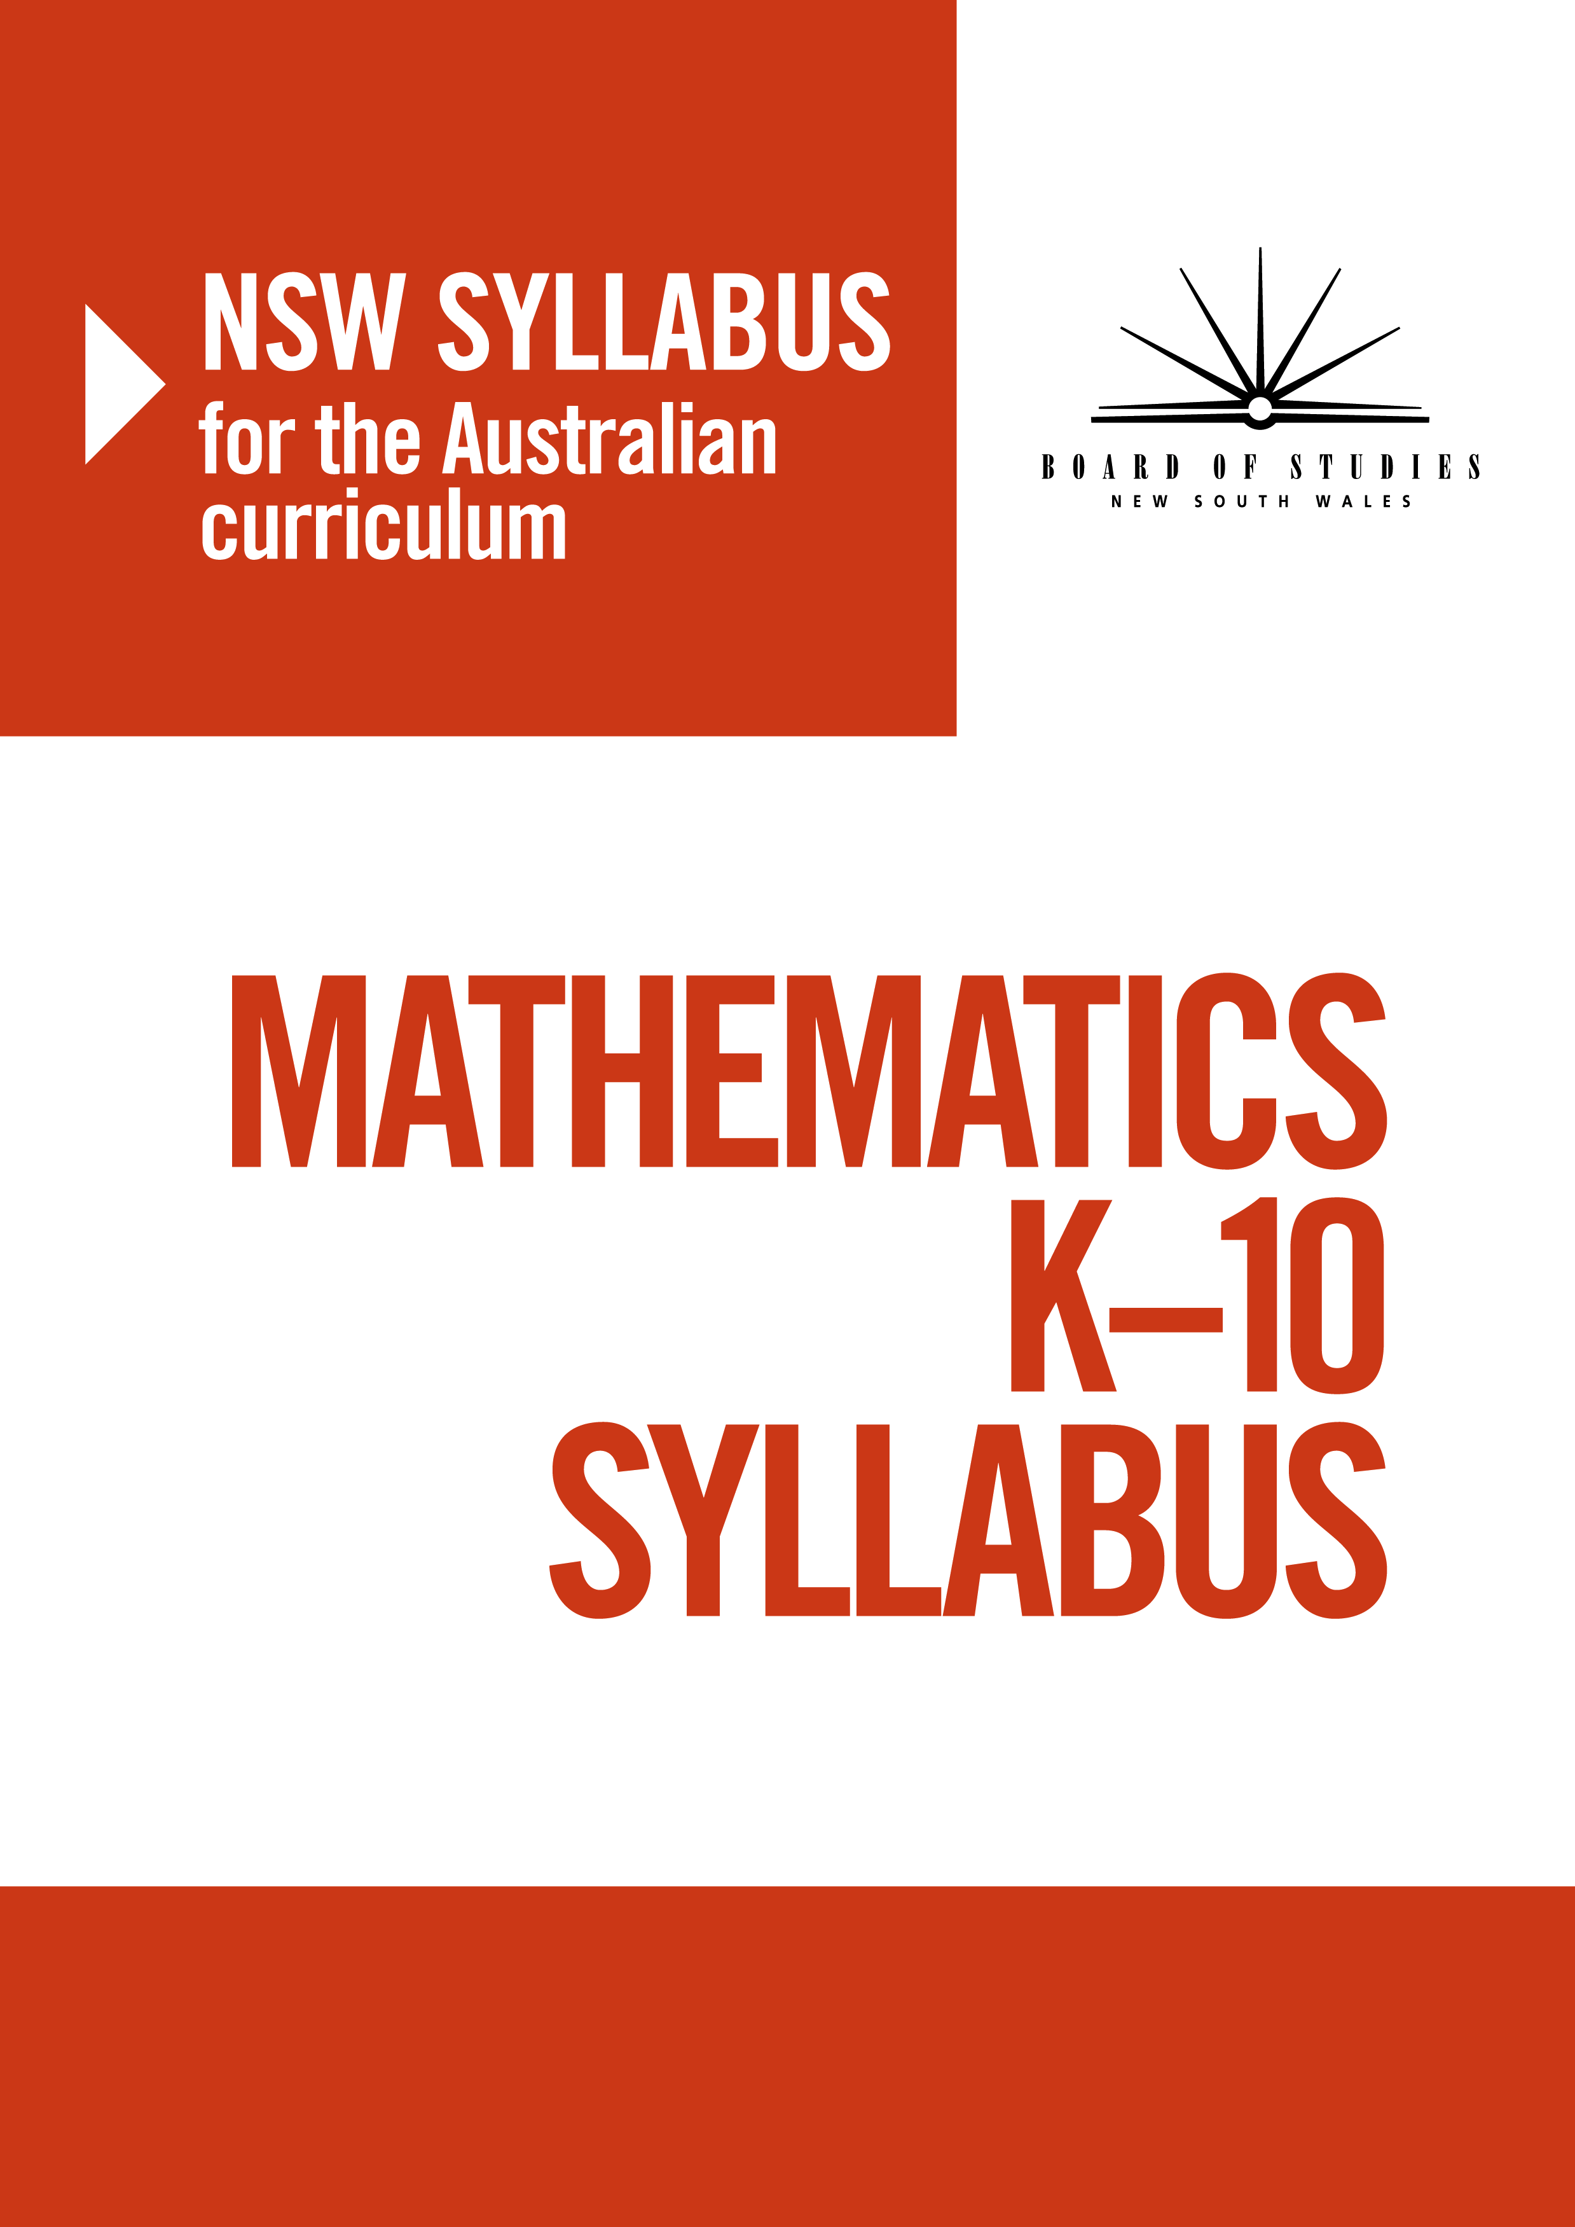
© 2012 Copyright Board of Studies NSW for and on behalf of the Crown in right of the State of New South Wales.
This document contains Material prepared by the Board of Studies NSW for and on behalf of the State of New South Wales. The Material is protected by Crown copyright.
All rights reserved. No part of the Material may be reproduced in Australia or in any other country by any process, electronic or otherwise, in any material form or transmitted to any other person or stored electronically in any form without the prior written permission of the Board of Studies NSW, except as permitted by the Copyright Act 1968. School students in NSW and teachers in schools in NSW may copy reasonable portions of the Material for the purposes of bona fide research or study.
When you access the Material you agree:
- to use the Material for information purposes only
- to reproduce a single copy for personal bona fide study use only and not to reproduce any major extract or the entire Material without the prior permission of the Board of Studies NSW
- to acknowledge that the Material is provided by the Board of Studies NSW
- not to make any charge for providing the Material or any part of the Material to another person or in any way make commercial use of the Material without the prior written consent of the Board of Studies NSW and payment of the appropriate copyright fee
- to include this copyright notice in any copy made
- not to modify the Material or any part of the Material without the express prior written permission of the Board of Studies NSW.
The Material may contain third-party copyright materials such as photos, diagrams, quotations, cartoons and artworks. These materials are protected by Australian and international copyright laws and may not be reproduced or transmitted in any format without the copyright owner’s specific permission. Unauthorised reproduction, transmission or commercial use of such copyright materials may result in prosecution.
The Board of Studies NSW has made all reasonable attempts to locate owners of third-party copyright material and invites anyone from whom permission has not been sought to contact the Copyright Officer, phone (02) 9367 8289, fax (02) 9279 1482.

Published by
Board of Studies NSW
GPO Box 5300
Sydney NSW 2001
Australia

Phone: (02) 9367 8111
Fax: (02) 9367 8484
Internet: www.boardofstudies.nsw.edu.au

Contents

Introduction 4
Mathematics key 8
Rationale 10
The place of the Mathematics K–10 Syllabus in the K–12 curriculum 11
Aim 13
Objectives 14
Outcomes 15
Stage statements 29
Organisation of content 34
Content 44
Early Stage 1 44
Stage 1 71
Stage 2 128
Stage 3 193
Stage 4 260
Stage 5.1 317
Stage 5.2 337
Stage 5.3 362
Years 7–10 Life Skills outcomes and content 399
Assessment 452
Glossary 455

Introduction

K–10 curriculum
Board of Studies syllabuses have been developed with respect to some overarching views about education. These include the Board of Studies K–10 Curriculum Framework and Statement of Equity Principles and the Melbourne Declaration on Educational Goals for
Young Australians (December 2008).
Board of Studies syllabuses include the agreed Australian curriculum content and content
that clarifies the breadth and depth of learning and scope for Mathematics. The Australian curriculum achievement standards underpin the syllabus outcomes and the stage statements for Early Stage 1 to Stage 5.
In accordance with the K–10 Curriculum Framework and the Statement of Equity Principles, the Mathematics syllabus takes into account the diverse needs of all students. It identifies essential knowledge, skills, understanding, values and attitudes. It outlines clear standards of what students are expected to know and be able to do in K–10. It provides structures and processes by which teachers can provide continuity of study for all students.
The framework also provides a set of broad learning outcomes that summarise the knowledge, skills, understanding, values and attitudes essential for all students in all learning areas to succeed in and beyond their schooling.
The continued relevance of the K–10 Curriculum Framework is consistent with the intent of the Melbourne Declaration on Educational Goals for Young Australians (December 2008), which sets the direction for Australian schooling for the next 10 years. There are two broad goals:
Goal 1: Australian schooling promotes equity and excellence
Goal 2: All young Australians become successful learners, confident and creative individuals, and active and informed citizens.
The way in which learning in the Mathematics K–10 Syllabus will contribute to the
curriculum and to students’ achievement of the broad learning outcomes is outlined
in the syllabus rationale.

DIVERSITY OF LEARNERS
The Mathematics K–10 Syllabus is inclusive of the learning needs of all students. Particular advice about supporting students with special education needs, gifted and talented students, students learning English as an additional language, and students learning Standard English
as an additional dialect follows.

Students with special education needs
The rationale, aim, objectives, outcomes and content of the Mathematics K–10 Syllabus have been designed to accommodate teaching approaches that support the learning needs of all students. The stage statements and the continuum of learning can help teachers identify the starting point for instruction for every student, including those with special education needs.
Collaborative curriculum planning will determine the most appropriate curriculum options for students with special education needs in keeping with their learning needs, strengths, goals
and interests.
Most students with special education needs will participate fully in learning experiences based on the regular syllabus outcomes and content. Students may require additional support or adjustments to teaching, learning and assessment activities.
Adjustments are measures or actions taken in relation to teaching, learning and assessment that enable a student to access syllabus outcomes and content. These adjustments
may involve:
- classroom organisation
- appropriate materials and resources to support teaching and learning activities
- the amount of content to be covered in a particular lesson or unit of work or the time allocated to complete work
- consideration of students’ individual communication strategies, including verbal and
non-verbal communication systems
- additional demonstration of key concepts and skills by the teacher, the teacher’s aide
or a peer
- a range of appropriate learning activities with structured opportunities for guided and independent practice and effective feedback
- group work, peer or volunteer tutoring, and other individual assistance.

Kindergarten – Year 6
In Kindergarten to Year 6, it is important for all students to have the opportunity to participate fully in and progress through the curriculum. As they move through the developmental stages
of learning, students demonstrate individual strengths and establish preferred ways of learning.
There are several curriculum options for students with special education needs in K–6.
Students may:
- engage with selected outcomes and content appropriate to their learning needs
- engage with syllabus outcomes and content with adjustments
- engage with outcomes from an earlier stage, using age-appropriate content.
All decisions regarding curriculum options for students with special education needs should be made through the collaborative curriculum planning process to ensure that syllabus outcomes and content reflect the learning needs and priorities of individual students.
In addition, the NSW K–6 curriculum provides for students with special education needs through:
- inclusive syllabus outcomes and content accessible by the full range of students
- additional advice and programming support for teachers on how to assist students to access the outcomes of the syllabus
- specific support documents for students with special education needs as part of the overall syllabus package.

Years 7–10
Students build on their achievement in Kindergarten to Year 6 as they undertake courses to meet requirements of the Years 7–10 curriculum. Students with special education needs can access the Years 7–10 syllabus outcomes and content in a range of ways, including:
- under regular course arrangements
- with adjustments to teaching, learning and/or assessment experiences
- through Years 7–10 Life Skills outcomes and content.
For some students with special education needs, particularly those students with an intellectual disability, it may be determined that adjustments to teaching, learning and assessment are not sufficient to access some or all of the Stage 4 and Stage 5 outcomes. For these students, the Years 7–10 Life Skills outcomes and content can provide the basis for developing a rigorous, relevant, accessible and meaningful age-appropriate program. A range of adjustments should be explored before a decision is made to access Years 7–10 Life Skills outcomes and content.
The Years 7–10 Life Skills outcomes and content are developed from the objectives of
the Mathematics K–10 Syllabus. Further information about accessing and implementing Mathematics Years 7–10 Life Skills outcomes and content can be found in the Mathematics support document and Life Skills Years 7–10: Advice on Planning, Programming
and Assessment.
School principals have the authority to approve student access to courses based on Years 7–10 Life Skills outcomes and content, and to determine the appropriateness of making adjustments to curriculum and assessment for individual students. Life Skills Years 7–10: Advice on Planning, Programming and Assessment provides further advice in relation to determining students for whom Life Skills outcomes and content are appropriate.
The Years 7–10 Life Skills outcomes and content are in the Life Skills section of the syllabus. Assessment and reporting information for students with special education needs is in the Assessment section of the syllabus.

Gifted and talented students
Gifted students have specific learning needs that may require adjustments to the pace, level and content of the curriculum. Differentiated educational opportunities will assist in meeting the needs of gifted students.
Generally, gifted students demonstrate the following characteristics:
- the capacity to learn at faster rates
- the capacity to find and solve problems
- the capacity to make connections and manipulate abstract ideas.
There are different kinds and levels of giftedness. Gifted and talented students may also possess learning disabilities that should be addressed when planning appropriate teaching, learning and assessment activities.
Curriculum strategies for gifted and talented students may include:
- differentiation: modifying the pace, level and content of teaching, learning and assessment activities
- acceleration: promoting a student to a level of study beyond their age group
- curriculum compacting: assessing a student’s current level of learning and addressing aspects of the curriculum that have not yet been mastered.
School decisions about appropriate strategies are generally collaborative and involve teachers, parents and students with reference to documents and advice available from the Board of Studies and education sectors.
Gifted and talented students may also benefit from individual planning to determine the curriculum options, as well as teaching, learning and assessment strategies, most suited
to their needs and abilities.

STUDENTS LEARNING ENGLISH AS AN ADDITIONAL LANGUAGE OR DIALECT
(EAL/D)*
Many students in Australian schools are learning English as an additional language or dialect (EAL/D). EAL/D learners are students whose first language is a language other than Standard Australian English and who require additional support to assist them in developing English language proficiency.

* EAL/D is the term adopted by all Australian schools as part of the national education reform agenda
of developing a K–12 Australian curriculum. The term English as an additional language or dialect (EAL/D) may be used interchangeably with the following terms: English as a second language (ESL), English language learners (ELL), English as an additional language (EAL) and English as an additional dialect (EAD).
EAL/D students come from diverse backgrounds and may include:
- overseas- and Australian-born children whose first language is a language other
than English
- Aboriginal and Torres Strait Islander students whose first language is an Indigenous language, including traditional languages
- Aboriginal and Torres Strait Islander students whose first language is Aboriginal English, including creoles and related varieties.
EAL/D learners enter Australian schools at different ages and stages of schooling and at different stages of English language learning. They have diverse talents and capabilities and
a range of prior learning experiences and levels of literacy in their first language and in English. EAL/D students represent a significant and growing percentage of learners in NSW schools.
For some, school is the only place they use English.
EAL/D learners are simultaneously learning a new language and the knowledge, skills and understanding of the Mathematics syllabus through that new language. They require additional time and support, along with informed teaching that explicitly addresses their language needs, and assessments that take into account their developing language proficiency.

Mathematics Key
The following codes and icons are used in the Mathematics K–10 Syllabus.

Outcome coding
Syllabus outcomes have been coded in a consistent way. The code identifies the subject, the stage, the outcome number and the way content is organised.
The stages are represented by the following codes:
Stage | Code
Early Stage 1 | e
Stage 1 | 1
Stage 2 | 2
Stage 3 | 3
Stage 4 | 4
Stage 5.1 | 5.1
Stage 5.2 | 5.2
Stage 5.3 | 5.3
In the Mathematics syllabus, Working Mathematically and the strands are represented by the following codes:
Working Mathematically | WM
Number and Algebra | NA
Measurement and Geometry | MG
Statistics and Probability | SP

For example:
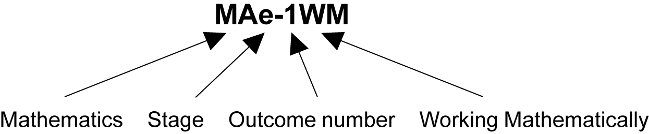

Outcome code | Interpretation
MAe-1WM | Mathematics, Early Stage 1 - Outcome 1, Working Mathematically
MA4-5NA | Mathematics, Stage 4 - Outcome 5, Number and Algebra
MA5.2-16SP | Mathematics, Stage 5.2 - Outcome 16, Statistics and Probability
MALS-27MG | Mathematics, Life Skills - Outcome 27, Measurement and Geometry

Coding of the Australian curriculum content
The syllabus includes all the Australian curriculum content descriptions for Mathematics. The content descriptions are identified by an Australian curriculum code, which appears in brackets at the end of each content description, for example:
Count collections to 100 by partitioning numbers using place value (ACMNA014).
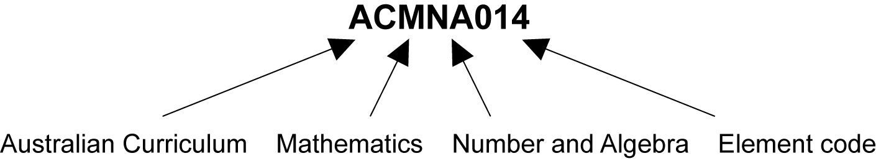
- The Australian curriculum Mathematics codes are:
Code | Interpretation
ACMNA | Australian Curriculum, Mathematics, Number and Algebra
ACMMG | Australian Curriculum, Mathematics, Measurement and Geometry
ACMSP | Australian Curriculum, Mathematics, Statistics and Probability

Learning across the curriculum Icons
Learning across the curriculum content, including cross-curriculum priorities, general capabilities and other areas identified as important learning for all students, is incorporated
and identified by icons in the Mathematics K–10 Syllabus.
Cross-curriculum priorities
 | Aboriginal and Torres Strait Islander histories and cultures
 | Asia and Australia’s engagement with Asia
 | Sustainability
General capabilities
 | Critical and creative thinking
 | Ethical understanding
 | Information and communication technology capability
 | Intercultural understanding
 | Literacy
 | Numeracy*
 | Personal and social capability
Other learning across the curriculum areas
 | Work and enterprise

* Numeracy is embedded throughout the Mathematics K–10 Syllabus. It relates to a high proportion of content across K–10. Consequently, this particular general capability is not tagged in the syllabus.

Rationale
Mathematics is a reasoning and creative activity employing abstraction and generalisation to identify, describe and apply patterns and relationships. The symbolic nature of mathematics provides a powerful, precise and concise means of communication.
Mathematical ideas have evolved across all cultures over thousands of years and are constantly developing. Digital technologies facilitate this expansion of ideas, providing access to new tools for continuing mathematical exploration and invention. Mathematics is integral to scientific and technological advances in many fields of endeavour. In addition to its practical applications, the study of mathematics is a valuable pursuit in its own right, providing opportunities for originality, challenge and leisure.
Mathematics in K–10 provides students with knowledge, skills and understanding in Number and Algebra, Measurement and Geometry, and Statistics and Probability. It focuses on developing increasingly sophisticated and refined mathematical understanding, fluency, communication, logical reasoning, analytical thought and problem-solving skills. These capabilities enable students to respond to familiar and unfamiliar situations by employing strategies to make informed decisions and solve problems relevant to their further education and everyday lives.
The ability to make informed decisions and to interpret and apply mathematics in a variety
of contexts is an essential component of students’ preparation for life in the 21st century.
To participate fully in society, students need to develop the capacity to critically evaluate ideas and arguments that involve mathematical concepts or that are presented in mathematical form.
The Mathematics curriculum makes clear the links between the various components of mathematics, as well as the relationship between mathematics and other disciplines. Students learn to apply their mathematical knowledge, skills and understanding in a broad range of contexts beyond the mathematics classroom, including in such core learning areas as science, geography, history and English.
The study of mathematics provides opportunities for students to appreciate the elegance
and power of mathematical reasoning and to apply mathematical understanding creatively
and efficiently. The study of the subject enables students to develop a positive self-concept
as learners of mathematics, obtain enjoyment from mathematics, and become self-motivated learners through inquiry and active participation in challenging and engaging experiences.

The place of the Mathematics K–10 Syllabus in the K–12 curriculum
The Mathematics K–10 Syllabus describes a continuum of mathematics learning from Kindergarten to Year 10. The Stage 6 syllabuses describe the Preliminary and HSC courses
in Years 11 and 12 and therefore represent the mathematics learning for all students who study Mathematics in those years.
The diagram on the following page represents available pathways of learning in Mathematics from Early Stage 1 to Stage 6.
Students exhibit a wide range of mathematical skills, levels of competence, and aspirations. Some students may be aiming to develop the mathematical skills necessary to function in
daily life and various work contexts. Other students may seek to address more challenging mathematics to prepare them for the highest-level courses in Year 11 and Year 12.
For this reason, Stage 5 of the K–10 Mathematics curriculum has been expressed in terms of the three substages, Stage 5.1, Stage 5.2 and Stage 5.3. These substages are not designed
as prescribed courses, and many different ‘endpoints’ are possible. As well as studying the
Stage 5.1 content, the majority of students will study some or all of the Stage 5.2 content. Similarly, as well as studying the Stage 5.2 content, many students will study some or all
of the Stage 5.3 content.
The Mathematics Life Skills outcomes and content are designed to provide a relevant and meaningful program of study for a small percentage of students with special education needs, for whom the Stage 4 and/or Stage 5 outcomes and content of the Mathematics K–10 Syllabus are not appropriate.
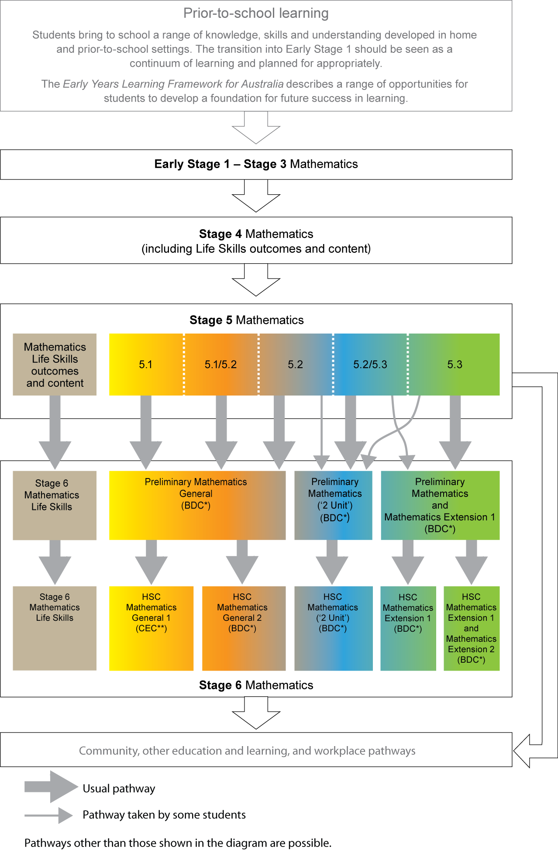
* BDC – Board Developed Course (HSC BDCs are examined at the HSC).
** CEC – Content Endorsed Course (HSC CECs are not examined at the HSC).
The HSC Mathematics General 1 course (two units of study in the HSC year) is a Content Endorsed Course and cannot be used to meet the requirement that, to be eligible for the HSC award, students must study at least six units of Board Developed Courses. Also, the two units of study for the HSC Mathematics General 1 course cannot be counted in the 10 units required for the calculation of an ATAR. For further information, please refer to the Board’s Assessment Certification Examination (ACE) website.

Aim
The aim of Mathematics in K–10 is for students to:
- be confident, creative users and communicators of mathematics, able to investigate, represent and interpret situations in their personal and work lives and as active citizens
- develop an increasingly sophisticated understanding of mathematical concepts and fluency with mathematical processes, and be able to pose and solve problems and reason in Number and Algebra, Measurement and Geometry, and Statistics and Probability
- recognise connections between the areas of mathematics and other disciplines and appreciate mathematics as an accessible, enjoyable discipline to study, and an important aspect of lifelong learning.

Objectives

Knowledge, skills and understanding
Students:
Working Mathematically
- develop understanding and fluency in mathematics through inquiry, exploring and connecting mathematical concepts, choosing and applying problem-solving skills and mathematical techniques, communication and reasoning
Number and Algebra
- develop efficient strategies for numerical calculation, recognise patterns, describe relationships and apply algebraic techniques and generalisation
Measurement and Geometry
- identify, visualise and quantify measures and the attributes of shapes and objects, and explore measurement concepts and geometric relationships, applying formulas, strategies and geometric reasoning in the solution of problems
Statistics and Probability
- collect, represent, analyse, interpret and evaluate data, assign and use probabilities, and make sound judgements.

Values and attitudes
Students:
- appreciate mathematics as an essential and relevant part of life, recognising that its
cross-cultural development has been largely in response to human needs
- demonstrate interest, enjoyment and confidence in the pursuit and application of mathematical knowledge, skills and understanding to solve everyday problems
- develop and demonstrate perseverance in undertaking mathematical challenges.

Outcomes
The continuum of learning table for Mathematics K–10 is an overview of the substrands and outcomes in each of the content strands.
The concepts in each of these strands are developed across the stages to show how understanding in the early years needs to precede understanding in later years. In this way,
the continuum of learning table provides an overview of the sequence of learning for particular concepts in mathematics and links content that is typically taught in primary mathematics classrooms with content that is typically taught in secondary mathematics classrooms. It illustrates assumptions about prior learning and indicates pathways for further learning.
In this syllabus, it is generally the case that content is not repeated. This is intentional and is not meant to suggest that review and consolidation are not necessary. When programming, it will be necessary for teachers to determine the level of achievement of outcomes in previous stages before planning new teaching and learning experiences. Students may be operating at different stages for different strands of the continuum of learning. For example, a student may be working on Stage 4 content in the Number and Algebra strand but be working on Stage 3 content in the Measurement and Geometry strand.
It is not intended that the continuum of learning table be used as a checklist of teaching ideas. Rather, a variety of learning experiences need to be planned and presented to students to maximise opportunities for achievement of outcomes. Students need appropriate time to explore, experiment and engage with the underpinning concepts and principles of what they
are to learn.

TABLE OF OBJECTIVES AND OUTCOMES – CONTINUUM OF LEARNING

Working Mathematically
Students:
- develop understanding and fluency in mathematics through inquiry, exploring and connecting mathematical concepts, choosing and applying problem-solving skills and mathematical techniques, communication and reasoning
EARLY  STAGE 1 | STAGE 1 | STAGE 2 | STAGE 3
Communicating  MAe-1WM describes mathematical situations using everyday language, actions, materials and informal recordings | Communicating  MA1-1WM describes mathematical situations and methods using everyday and some mathematical language, actions, materials, diagrams and symbols | Communicating  MA2-1WM uses appropriate terminology to describe, and symbols to represent, mathematical ideas | Communicating  MA3-1WM describes and represents mathematical situations in a variety of ways using mathematical terminology and some conventions
Problem Solving  MAe-2WM uses objects, actions, technology and/or trial and error to explore mathematical problems | Problem Solving  MA1-2WM uses objects, diagrams and technology to explore mathematical problems | Problem Solving  MA2-2WM selects and uses appropriate mental or written strategies, or technology, to solve problems | Problem Solving  MA3-2WM selects and applies appropriate problem-solving strategies, including the use of digital technologies, in undertaking investigations
Reasoning  MAe-3WM uses concrete materials and/or pictorial representations to support conclusions | Reasoning  MA1-3WM supports conclusions by explaining or demonstrating how answers were obtained | Reasoning  MA2-3WM checks the accuracy of a statement and explains the reasoning used | Reasoning  MA3-3WM gives a valid reason for supporting one possible solution over another

STAGE 4 | STAGE 5.1 | STAGE 5.2 | STAGE 5.3
Communicating  MA4-1WM communicates and connects mathematical ideas using appropriate terminology, diagrams and symbols | Communicating  MA5.1-1WM uses appropriate terminology, diagrams and symbols in mathematical contexts | Communicating  MA5.2-1WM selects appropriate notations and conventions to communicate mathematical ideas and solutions | Communicating  MA5.3-1WM uses and interprets formal definitions and generalisations when explaining solutions and/or conjectures
Problem Solving  MA4-2WM applies appropriate mathematical techniques to solve problems | Problem Solving  MA5.1-2WM selects and uses appropriate strategies to solve problems | Problem Solving  MA5.2-2WM interprets mathematical or real-life situations, systematically applying appropriate strategies to solve problems | Problem Solving  MA5.3-2WM generalises mathematical ideas and techniques to analyse and solve problems efficiently
Reasoning  MA4-3WM recognises and explains mathematical relationships using reasoning | Reasoning  MA5.1-3WM provides reasoning to support conclusions that are appropriate to the context | Reasoning  MA5.2-3WM constructs arguments to prove and justify results | Reasoning  MA5.3-3WM uses deductive reasoning in presenting arguments and formal proofs

Number and Algebra
Students:
- develop efficient strategies for numerical calculation, recognise patterns, describe relationships and apply algebraic techniques and generalisation
EARLY  STAGE 1 | STAGE 1 | STAGE 2 | STAGE 3
Whole Numbers  MAe-4NA counts to 30, and orders, reads and represents numbers in the range 0 to 20 | Whole Numbers  MA1-4NA applies place value, informally, to count, order, read and represent two- and three-digit numbers | Whole Numbers  MA2-4NA applies place value to order, read and represent numbers of up to five digits | Whole Numbers  MA3-4NA orders, reads and represents integers of any size and describes properties of whole numbers
Addition and Subtraction  MAe-5NA combines, separates and compares collections of objects, describes using everyday language, and records using informal methods | Addition and Subtraction  MA1-5NA uses a range of strategies and informal recording methods for addition and subtraction involving one- and two-digit numbers | Addition and Subtraction  MA2-5NA uses mental and written strategies for addition and subtraction involving two-, three-, four- and five-digit numbers | Addition and Subtraction  MA3-5NA selects and applies appropriate strategies for addition and subtraction with counting numbers of any size
Multiplication and Division  MAe-6NA groups, shares and counts collections of objects, describes using everyday language, and records using informal methods | Multiplication and Division  MA1-6NA uses a range of mental strategies and concrete materials for multiplication and division | Multiplication and Division  MA2-6NA uses mental and informal written strategies for multiplication and division | Multiplication and Division  MA3-6NA selects and applies appropriate strategies for multiplication and division, and applies the order of operations to calculations involving more than one operation
Fractions and Decimals  MAe-7NA describes two equal parts as halves | Fractions and Decimals  MA1-7NA represents and models halves, quarters and eighths | Fractions and Decimals  MA2-7NA represents, models and compares commonly used fractions and decimals | Fractions, Decimals and Percentages  MA3-7NA compares, orders and calculates with fractions, decimals and percentages

STAGE 4 | STAGE 5.1 |  | STAGE 5.2 |  | STAGE 5.3
Computation with Integers
MA4-4NA compares, orders and calculates with integers, applying a range of strategies to aid computation
Fractions, Decimals and Percentages
MA4-5NA operates with fractions, decimals and percentages
Financial Mathematics  MA4-6NA solves financial problems involving purchasing goods | Financial Mathematics  MA5.1-4NA solves financial problems involving earning, spending and investing money |  | Financial Mathematics ◊  MA5.2-4NA solves financial problems involving compound interest
Ratios and Rates  MA4-7NA operates with ratios and rates, and explores their graphical representation |  |  | Ratios and Rates  MA5.2-5NA recognises direct and indirect proportion, and solves problems involving direct proportion |  | Ratios and Rates  MA5.3-4NA draws, interprets and analyses graphs of physical phenomena
EARLY  STAGE 1 |  | STAGE 1 |  | STAGE 2 |  | STAGE 3
Patterns and Algebra  MAe-8NA recognises, describes and continues repeating patterns |  | Patterns and Algebra  MA1-8NA creates, represents and continues a variety of patterns with numbers and objects |  | Patterns and Algebra  MA2-8NA generalises properties of odd and even numbers, generates number patterns, and completes simple number sentences by calculating missing values |  | Patterns and Algebra  MA3-8NA analyses and creates geometric and number patterns, constructs and completes number sentences, and locates points on the Cartesian plane
STAGE 4 | STAGE 5.1 |  | STAGE 5.2 |  | STAGE 5.3
Algebraic Techniques  MA4-8NA generalises number properties to operate with algebraic expressions |  |  | Algebraic Techniques  MA5.2-6NA simplifies algebraic fractions, and expands and factorises quadratic expressions |  | Algebraic Techniques §  MA5.3-5NA selects and applies appropriate algebraic techniques to operate with algebraic expressions
Indices  MA4-9NA operates with positive-integer and zero indices of numerical bases | Indices  MA5.1-5NA operates with algebraic expressions involving positive-integer and zero indices, and establishes the meaning of negative indices for numerical bases |  | Indices  MA5.2-7NA applies index laws to operate with algebraic expressions involving integer indices |  | Surds and Indices §  MA5.3-6NA performs operations with surds and indices
Equations  MA4-10NA uses algebraic techniques to solve simple linear and quadratic equations |  |  | Equations  MA5.2-8NA solves linear and simple quadratic equations, linear inequalities and linear simultaneous equations, using analytical and graphical techniques |  | Equations §  MA5.3-7NA solves complex linear, quadratic, simple cubic and simultaneous equations, and rearranges literal equations
Linear Relationships  MA4-11NA creates and displays number patterns; graphs and analyses linear relationships; and performs transformations on the Cartesian plane | Linear Relationships  MA5.1-6NA determines the midpoint, gradient and length of an interval, and graphs linear relationships |  | Linear Relationships  MA5.2-9NA uses the gradient-intercept form to interpret and graph linear relationships |  | Linear Relationships §  MA5.3-8NA uses formulas to find midpoint, gradient and distance on the Cartesian plane, and applies standard forms of the equation of a straight line
 | Non-Linear Relationships  MA5.1-7NA graphs simple non-linear relationships |  | Non-Linear Relationships ◊  MA5.2-10NA connects algebraic and graphical representations of simple non-linear relationships |  | Non-Linear Relationships §  MA5.3-9NA sketches and interprets a variety of non-linear relationships
Polynomials #
MA5.3-10NA recognises, describes and sketches polynomials, and applies the factor and remainder theorems to solve problems
Logarithms #
MA5.3-11NA uses the definition of a logarithm to establish and apply the laws of logarithms
Functions and Other Graphs #
MA5.3-12NA uses function notation to describe and sketch functions

Measurement and Geometry
Students:
- identify, visualise and quantify measures and the attributes of shapes and objects, and explore measurement concepts and geometric relationships, applying formulas, strategies and geometric reasoning in the solution of problems
EARLY  STAGE 1 | STAGE 1 | STAGE 2 | STAGE 3
Length  MAe-9MG describes and compares lengths and distances using everyday language | Length  MA1-9MG measures, records, compares and estimates lengths and distances using uniform informal units, metres and centimetres | Length  MA2-9MG measures, records, compares and estimates lengths, distances and perimeters in metres, centimetres and millimetres, and measures, compares and records temperatures | Length  MA3-9MG selects and uses the appropriate unit and device to measure lengths and distances, calculates perimeters, and converts between units of length
Area  MAe-10MG describes and compares areas using everyday language | Area  MA1-10MG measures, records, compares and estimates areas using uniform informal units | Area  MA2-10MG measures, records, compares and estimates areas using square centimetres and square metres | Area  MA3-10MG selects and uses the appropriate unit to calculate areas, including areas of squares, rectangles and triangles
Volume and Capacity  MAe-11MG describes and compares the capacities of containers and the volumes of objects or substances using everyday language | Volume and Capacity  MA1-11MG measures, records, compares and estimates volumes and capacities using uniform informal units | Volume and Capacity  MA2-11MG measures, records, compares and estimates volumes and capacities using litres, millilitres and cubic centimetres | Volume and Capacity  MA3-11MG selects and uses the appropriate unit to estimate, measure and calculate volumes and capacities, and converts between units of capacity
Mass  MAe-12MG describes and compares the masses of objects using everyday language | Mass  MA1-12MG measures, records, compares and estimates the masses of objects using uniform informal units | Mass  MA2-12MG measures, records, compares and estimates the masses of objects using kilograms and grams | Mass  MA3-12MG selects and uses the appropriate unit and device to measure the masses of objects, and converts between units of mass
Time  MAe-13MG sequences events, uses everyday language to describe the durations of events, and reads hour time on clocks | Time  MA1-13MG describes, compares and orders durations of events, and reads half- and quarter-hour time | Time  MA2-13MG reads and records time in one-minute intervals and converts between hours, minutes and seconds | Time  MA3-13MG uses 24-hour time and am and pm notation in real-life situations, and constructs timelines

STAGE 4 | STAGE 5.1 | STAGE 5.2 | STAGE 5.3
Length
MA4-12MG calculates the perimeters of plane shapes and the circumferences of circles
Area  MA4-13MG uses formulas to calculate the areas of quadrilaterals and circles, and converts between units of area | Area and Surface Area  MA5.1-8MG calculates the areas of composite shapes, and the surface areas of rectangular and triangular prisms | Area and Surface Area  MA5.2-11MG calculates the surface areas of right prisms, cylinders and related composite solids | Area and Surface Area  MA5.3-13MG applies formulas to find the surface areas of right pyramids, right cones, spheres and related composite solids
Volume  MA4-14MG uses formulas to calculate the volumes of prisms and cylinders, and converts between units of volume |  | Volume  MA5.2-12MG applies formulas to calculate the volumes of composite solids composed of right prisms and cylinders | Volume  MA5.3-14MG applies formulas to find the volumes of right pyramids, right cones, spheres and related composite solids
Time  MA4-15MG performs calculations of time that involve mixed units, and interprets time zones | Numbers of Any Magnitude  MA5.1-9MG interprets very small and very large units of measurement, uses scientific notation, and rounds to significant figures
Right-Angled Triangles (Pythagoras)  MA4-16MG applies Pythagoras’ theorem to calculate side lengths in right-angled triangles, and solves related problems | Right-Angled Triangles (Trigonometry)  MA5.1-10MG applies trigonometry, given diagrams, to solve problems, including problems involving angles of elevation and depression | Right-Angled Triangles (Trigonometry) ◊  MA5.2-13MG applies trigonometry to solve problems, including problems involving bearings | Trigonometry and Pythagoras' Theorem §  MA5.3-15MG applies Pythagoras’ theorem, trigonometric relationships, the sine rule, the cosine rule and the area rule to solve problems, including problems involving three dimensions

EARLY  STAGE 1 | STAGE 1 | STAGE 2 | STAGE 3
Three-Dimensional  Space  MAe-14MG manipulates, sorts and represents three-dimensional objects and describes them using everyday language | Three-Dimensional  Space  MA1-14MG sorts, describes, represents and recognises familiar three-dimensional objects, including cones, cubes, cylinders, spheres and prisms | Three-Dimensional  Space  MA2-14MG makes, compares, sketches and names three-dimensional objects, including prisms, pyramids, cylinders, cones and spheres, and describes their features | Three-Dimensional  Space  MA3-14MG identifies three-dimensional objects, including prisms and pyramids, on the basis of their properties, and visualises, sketches and constructs them given drawings of different views
Two-Dimensional Space  MAe-15MG manipulates, sorts and describes representations of two-dimensional shapes, including circles, triangles, squares and rectangles, using everyday language | Two-Dimensional  Space  MA1-15MG manipulates, sorts, represents, describes and explores two-dimensional shapes, including quadrilaterals, pentagons, hexagons and octagons | Two-Dimensional  Space  MA2-15MG manipulates, identifies and sketches two-dimensional shapes, including special quadrilaterals, and describes their features | Two-Dimensional  Space  MA3-15MG manipulates, classifies and draws two-dimensional shapes, including equilateral, isosceles and scalene triangles, and describes their properties
 |  | Angles  MA2-16MG identifies, describes, compares and classifies angles | Angles  MA3-16MG measures and constructs angles, and applies angle relationships to find unknown angles
Position  MAe-16MG describes position and gives and follows simple directions using everyday language | Position  MA1-16MG represents and describes the positions of objects in everyday situations and on maps | Position  MA2-17MG uses simple maps and grids to represent position and follow routes, including using compass directions | Position  MA3-17MG locates and describes position on maps using a grid-reference system

STAGE 4 |  | STAGE 5.1 |  | STAGE 5.2 |  | STAGE 5.3
Properties of Geometrical Figures  MA4-17MG classifies, describes and uses the properties of triangles and quadrilaterals, and determines congruent triangles to find unknown side lengths and angles | Properties of Geometrical Figures  MA5.1-11MG describes and applies the properties of similar figures and scale drawings |  | Properties of Geometrical Figures  MA5.2-14MG calculates the angle sum of any polygon and uses minimum conditions to prove triangles are congruent or similar |  | Properties of Geometrical Figures §  MA5.3-16MG proves triangles are similar, and uses formal geometric reasoning to establish properties of triangles and quadrilaterals
Angle Relationships
MA4-18MG identifies and uses angle relationships, including those related to transversals on sets of parallel lines
Circle Geometry #
MA5.3-17MG applies deductive reasoning to prove circle theorems and to solve related problems

Statistics and Probability
Students:
- collect, represent, analyse, interpret and evaluate data, assign and use probabilities, and make sound judgements

EARLY  STAGE 1 | STAGE 1 | STAGE 2 | STAGE 3
Data  MAe-17SP represents data and interprets data displays made from objects | Data  MA1-17SP gathers and organises data, displays data in lists, tables and picture graphs, and interprets the results | Data  MA2-18SP selects appropriate methods to collect data, and constructs, compares, interprets and evaluates data displays, including tables, picture graphs and column graphs | Data  MA3-18SP uses appropriate methods to collect data and constructs, interprets and evaluates data displays, including dot plots, line graphs and two-way tables
 | Chance  MA1-18SP recognises and describes the element of chance in everyday events | Chance  MA2-19SP describes and compares chance events in social and experimental contexts | Chance  MA3-19SP conducts chance experiments and assigns probabilities as values between 0 and 1 to describe their outcomes

STAGE 4 | STAGE 5.1 | STAGE 5.2 | STAGE 5.3
Data Collection and Representation
MA4-19SP collects, represents and interprets single sets of data, using appropriate statistical displays
Single Variable Data Analysis  MA4-20SP analyses single sets of data using measures of location, and range | Single Variable Data Analysis  MA5.1-12SP uses statistical displays to compare sets of data, and evaluates statistical claims made in the media | Single Variable Data Analysis ◊  MA5.2-15SP uses quartiles and box plots to compare sets of data, and evaluates sources of data | Single Variable Data Analysis  MA5.3-18SP uses standard deviation to analyse data
 |  | Bivariate Data Analysis  MA5.2-16SP investigates relationships between two statistical variables, including their relationship over time | Bivariate Data Analysis  MA5.3-19SP investigates the relationship between numerical variables using lines of best fit, and explores how data is used to inform decision-making processes
Probability  MA4-21SP represents probabilities of simple and compound events | Probability  MA5.1-13SP calculates relative frequencies to estimate probabilities of simple and compound events | Probability  MA5.2-17SP describes and calculates probabilities in multi-step chance experiments

Years 7–10 Life Skills outcomes and content
For some students with special education needs, particularly those students with an intellectual disability, it may be determined that the Stage 4 and Stage 5 outcomes and content are not appropriate. For these students, Life Skills outcomes and content can provide a relevant and meaningful program. Refer to the Introduction for further information about curriculum options for students with special education needs. Years 7–10 Life Skills outcomes and content are in the Life Skills section of the syllabus.

Stage Statements
Stage statements are summaries of the knowledge, skills, understanding, values and attitudes that have been developed by students as a result of achieving the outcomes for each stage
of learning.

Prior-to-school learning
Students bring to school a range of knowledge, skills and understanding developed in home and prior-to-school settings. The movement into Early Stage 1 should be seen as a continuum of learning and planned for appropriately.
The Early Years Learning Framework for Australia describes a range of opportunities for students to learn and develop a foundation for future success in learning.
The Early Years Learning Framework for Australia has five learning outcomes that reflect contemporary theories and research evidence concerning children’s learning. The outcomes
are used to guide planning and to assist all children to make progress.
The outcomes are:
1. Children have a strong sense of identity
2. Children are connected with and contribute to their world
3. Children have a strong sense of wellbeing
4. Children are confident and involved learners
5. Children are effective communicators.
In addition, teachers need to acknowledge the learning that children bring to school, and plan appropriate learning experiences that make connections with existing language and literacy development, including language used at home.

Early Stage 1
By the end of Early Stage 1, students ask questions and use known facts to explore mathematical problems and develop fluency with mathematical ideas. They use everyday language, concrete materials and informal recordings to demonstrate understanding and link mathematical ideas.
Students count to 30 and represent numbers to 20 with objects, pictures, numerals and words. They read and use ordinal numbers to at least ‘tenth’. Students use concrete materials to
model addition, subtraction, multiplication and division. They use the language of money and recognise the coins and notes of the Australian monetary system. Students divide objects into two equal parts and describe them as halves. They recognise, describe and continue repeating patterns of objects and drawings.
Students identify length, area, volume, capacity and mass, and compare and arrange
objects according to these attributes. They manipulate, sort and represent three-dimensional objects and describe them using everyday language. Students manipulate, sort and describe representations of two-dimensional shapes, identifying circles, squares, triangles and rectangles. They connect events and the days of the week and explain the order and duration
of events, telling the time on the hour. Students give and follow simple directions and describe position using appropriate language.
Students answer simple questions to collect information. They use objects to create a data display and interpret data.

Stage 1
By the end of Stage 1, students ask questions and use known facts, objects, diagrams and technology to explore mathematical problems and develop mathematical fluency. They link mathematical ideas and use appropriate language and diagrams to explain strategies used.
Students count, order, read and write two- and three-digit numbers and use a range of strategies and recording methods. They use mental strategies and concrete materials to add, subtract, multiply and divide, and solve problems. Students model and describe objects and collections divided into halves, quarters and eighths. They associate collections of Australian coins with their value. They use place value to partition numbers. Students describe and continue a variety of number patterns and build number relationships. They relate addition
and subtraction facts for sums to at least 20.
Students estimate, measure, compare and record using informal units for length, area, volume, capacity and mass. They recognise the need for formal units of length and use the metre and centimetre to measure length and distance. They use a calendar to identify the date and name and order the months and the seasons of the year. Students use informal units to compare
and order the duration of events and tell the time on the half- and quarter-hour. They identify, describe, sort and model particular three-dimensional objects and two-dimensional shapes. Students represent and describe the positions of objects and interpret simple maps.
Students collect, organise, display and interpret data using lists, tables and picture graphs.
They recognise and describe the element of chance in everyday events.

Stage 2
By the end of Stage 2, students ask questions and use efficient mental and written strategies with increasing fluency to solve problems. They use technology to investigate mathematical concepts and check their solutions. Students use appropriate terminology to describe and link mathematical ideas, check statements for accuracy and explain their reasoning.
Students count, order, read and record numbers of up to five digits. They use informal and formal mental and written strategies to solve addition and subtraction problems. Students use mental strategies to recall multiplication facts up to 10 × 10 and related division facts. They
use informal written strategies for multiplication and division of two-digit numbers by one-digit numbers. Students represent, model and compare commonly used fractions, and model, compare and represent decimals of up to two decimal places. Students perform simple calculations with money and solve simple purchasing problems. They record, describe and complete number patterns and determine missing numbers in number sentences. Students recognise the properties of odd and even numbers.
Students estimate, measure, compare, convert and record length, area, volume, capacity and mass using formal units. They read and record time in hours and minutes, convert between units of time, and solve simple problems involving the duration of time. Students name, describe and sketch particular three-dimensional objects and two-dimensional shapes. They combine and split two-dimensional shapes to create other shapes. They compare angles using informal means and classify angles according to their size. Students use a grid-reference system to describe position, and compass points to give and follow directions. They make simple calculations using scales on maps and plans.
Students collect and organise data, and create and interpret tables and picture and column graphs. They list all possible outcomes of everyday events, and describe and compare chance events in social and experimental contexts.

Stage 3
By the end of Stage 3, students ask questions and undertake investigations, selecting appropriate technological applications and problem-solving strategies to demonstrate fluency in mathematical techniques. They use mathematical terminology and some conventions, and they give valid reasons when comparing and selecting from possible solutions, making connections with existing knowledge and understanding.
Students select and apply appropriate mental, written or calculator strategies for the four operations and check the reasonableness of answers using estimation. They solve word problems and apply the order of operations to number sentences where required. Students identify factors and multiples and recognise the properties of prime, composite, square
and triangular numbers. They connect fractions, decimals and percentages as different representations of the same value. Students compare, order and perform calculations with simple fractions, decimals and percentages and apply the four operations to money in real-life situations. Students record, describe and continue geometric and number patterns, and they find missing numbers in number sentences. They locate an ordered pair in any one of the four quadrants on the Cartesian plane.
Students select and use the appropriate unit to estimate, measure and calculate length, area, volume, capacity and mass. They make connections between capacity and volume, and solve problems involving length and area. Students use 24-hour time in real-life situations, construct and interpret timelines and use timetables. They convert between units of length, units of capacity and units of mass. They construct and classify three-dimensional objects and
two-dimensional shapes, and compare and describe their features, including line and rotational symmetries. Students measure and construct angles, and find unknown angles in diagrams using known angle results. They use a grid-reference system to locate landmarks and describe routes using landmarks and directional language.
Students use appropriate data collection methods to interpret and analyse sets of data
and construct a range of data displays. They assign probabilities as fractions, decimals
or percentages in simple chance experiments.

Stage 4
By the end of Stage 4, students use mathematical terminology, algebraic notation, diagrams, text and tables to communicate mathematical ideas, and link concepts and processes within and between mathematical contexts. They apply their mathematical knowledge, skills and understanding in analysing real-life situations and in systematically exploring and solving problems using technology where appropriate. Students develop fluency with a range of algebraic techniques and in the solution of familiar problems. In solving particular problems, they compare the strengths and weaknesses of different strategies and solutions.
Students develop a range of mental strategies to enhance their computational skills. They operate competently with integers, fractions, decimals and percentages, and apply these
in a range of practical contexts, including problems related to GST, discounts and profit and loss. Students are familiar with the concepts of ratios and rates, and apply these when solving problems. They investigate divisibility tests, use index notation for numbers with positive integral indices, and explore prime factorisation, squares and cubes, and related square and cube roots, and the concept of irrational numbers.
Extending and generalising number patterns leads students into an understanding of the use
of pronumerals and the language of algebra. They simplify algebraic expressions, substitute
into algebraic expressions and formulas, and expand and factorise algebraic expressions. Students solve simple linear and quadratic equations. They develop tables of values from linear relationships and illustrate these relationships on the Cartesian plane, with and without the use of digital technologies.
Students calculate the perimeters and areas of a variety of polygons, circles, sectors and simple composite figures, and solve related problems. They calculate the volumes and capacities of
right prisms and cylinders, and solve related problems. They convert between units of area
and units of volume, and connect units of volume and capacity. Pythagoras’ theorem is used
to calculate side lengths in right-angled triangles and solve problems in two dimensions. Students calculate time duration and apply their understanding of Australian and world time zones to solve problems.
Knowledge of the properties of two-dimensional geometrical figures, angles, parallel lines, perpendicular lines and congruent figures enables students to apply logical reasoning to solve numerical exercises involving unknown lengths and angles in figures.
Students construct, interpret and compare data displays, including dot plots, stem-and-leaf plots, sector graphs, divided bar graphs, and frequency tables and histograms. In analysing data, they consider both categorical and numerical (discrete and continuous) variables, sampling versus census, and possible misrepresentation of data, and calculate the mean, mode, median and range. Students represent events using Venn diagrams and two-way
tables, and calculate the probability of simple and complementary events in single-step
chance experiments.

Stage 5.1
By the end of Stage 5.1, students explain and verify mathematical relationships, select and use appropriate strategies to solve problems, and link mathematical ideas to existing knowledge and understanding. They use mathematical language and notation to explain mathematical ideas, and interpret tables, diagrams and text in mathematical situations.
Students apply their knowledge of percentages, fractions and decimals to financial problems related to earning and spending money, taxation, and simple and compound interest. They simplify and evaluate numerical expressions using index laws for positive and zero indices, round numbers to a specified number of significant figures, and express numbers in scientific notation. Students apply the index laws to simplify algebraic expressions. They determine the midpoint, gradient and length of intervals on the Cartesian plane and draw graphs of linear and simple non-linear relationships.
Skills in measurement are further developed to include finding the areas of composite shapes and the surface areas of rectangular and triangular prisms. Students describe the limit of accuracy of measurements. They apply right-angled triangle trigonometry to practical situations, including those involving angles of elevation and depression. They apply the properties of similar figures to find side lengths in problems related to similar figures.
Students’ statistical skills are extended to include considering shape and skewness of distributions, comparing data and data displays, and evaluating the reliability of statistical claims. They also determine the relative frequencies of events in chance experiments and calculate probabilities from information displayed in Venn diagrams and two-way tables.

Stage 5.2
By the end of Stage 5.2, students use mathematical arguments to reach and justify conclusions. When communicating mathematical ideas, they use appropriate mathematical language and algebraic, statistical and other notations and conventions in written, oral or graphical form. Students use suitable problem-solving strategies, which include selecting and organising key information, and they extend their inquiries by identifying and working on related problems.
Students apply their knowledge of percentages, fractions and decimals to problems involving conversion of rates, direct proportion, and financial contexts related to compound interest
and depreciation.
Students apply the index laws with integer indices to simplify expressions. They operate
with algebraic fractions, expand binomial products and factorise monic quadratic trinomial expressions. They solve linear equations and use them to solve word problems. They solve linear inequalities and linear simultaneous equations. Students solve simple quadratic equations and solve monic quadratic equations by factorisation. On the Cartesian plane they draw and interpret graphs of straight lines, and simple parabolas, circles and exponential graphs. Students determine the equations of straight lines and use the properties of parallel and perpendicular lines on the Cartesian plane.
Students extend their skills in measurement to solve problems involving the surface areas and volumes of right prisms, cylinders and related composite solids. They use trigonometric ratios
to solve problems in which angles may be measured to the nearest second, and problems involving bearings and angles of elevation and depression. In geometry, they use deductive reasoning in numerical and non-numerical problems, drawing on their knowledge of the properties of congruent triangles, the angle properties of polygons, and the properties
of quadrilaterals.
Statistical skills are extended to include the construction of box-and-whisker plots and the calculation of interquartile range to analyse and compare data sets in appropriate data displays. Students investigate bivariate data sets and use scatter plots to describe relationships between variables. They evaluate the sources of data in statistical reports. In their study of probability, students record and determine probabilities of events in multi-step chance experiments and examine conditional language.

Stage 5.3
By the end of Stage 5.3, students use deductive reasoning in problem solving and in presenting arguments and formal proofs. They interpret and apply formal definitions and generalisations and connect and apply mathematical ideas within and across substrands. They demonstrate fluency in selecting, combining and applying relevant knowledge, skills and understanding in
the solution of familiar and unfamiliar problems.
Students operate with irrational numbers and extend their knowledge of the number system to include all real numbers. They analyse and describe physical phenomena and rates of change. Algebraic skills are extended to expanding the special binomial products and factorising
non-monic quadratic expressions, using a variety of techniques. Students solve complex linear equations, non-monic quadratic equations, simple cubic equations, and simultaneous equations involving one linear and one non-linear equation. They solve practical problems using linear, quadratic and simultaneous equations. They change the subject of literal equations. Students generate, describe and graph straight lines, parabolas, cubics, hyperbolas and circles. They use formulas to calculate midpoint, gradient and distance on the Cartesian plane, and to determine the equations of straight lines.
Students solve problems involving the surface areas and volumes of pyramids, cones and spheres, and related composite solids. They explore similarity relationships for area and volume. They determine exact trigonometric ratios for 30°, 45° and 60°, extend trigonometric ratios to obtuse angles, and sketch sine and cosine curves for angular values from 0° to 360°. Students apply the sine and cosine rules for finding unknown angles and/or sides in non-right-angled triangles. They use Pythagoras’ theorem and trigonometry to solve problems in
three dimensions.
Their knowledge of a wide range of geometrical facts and relationships is used to prove
general properties in geometry, extending the concepts of similarity and congruence to
more generalised applications. Students prove known properties of triangles, quadrilaterals
and circles.
Students use standard deviation to analyse data, and interpolate and extrapolate from bivariate data using lines of best fit. They investigate statistical reports and explore how data is used to inform decision-making processes.

Organisation of content
For Kindergarten to Year 10, courses of study and educational programs are based on the outcomes of syllabuses. The content describes in more detail how the outcomes are to be interpreted and used, and the intended learning appropriate for the stage. In considering the intended learning, teachers will make decisions about the sequence, the emphasis to be given to particular areas of content, and any adjustments required based on the needs, interests and abilities of their students.
The knowledge, skills and understanding described in the outcomes and content provide
a sound basis for students to successfully move to the next stage of learning.
The following diagram shows the scope of the strands and substrands, and illustrates the central role of Working Mathematically in Mathematics K–10 teaching and learning.

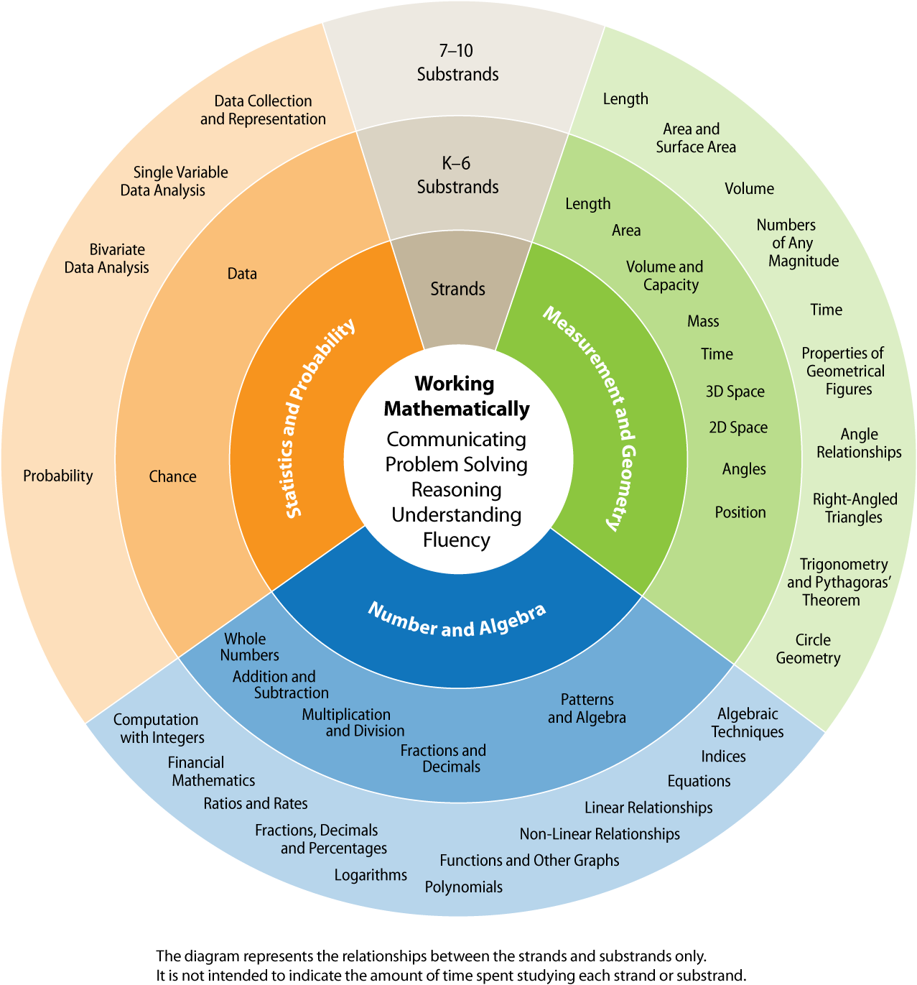
The content presented in a stage represents the knowledge, skills and understanding that are to be acquired by a typical student by the end of that stage. It is acknowledged that students learn at different rates and in different ways, so that there will be students who have not achieved the outcomes for the stage(s) prior to that identified with their stage of schooling. For example, some students will achieve Stage 3 outcomes during Year 5, while the majority will achieve them by the end of Year 6. Other students might not develop the same knowledge, skills and understanding until Year 7 or later.
The Mathematics K–10 Syllabus contains the syllabus content for Early Stage 1 to Stage 5. Within each stage, the syllabus is organised into the three content strands, Number and Algebra, Measurement and Geometry, and Statistics and Probability, with the components of Working Mathematically integrated into these strands. The syllabus is written with the flexibility to enable students to work at different stages in different strands. For example, students could be working on Stage 4 content in the Number and Algebra strand, while working on Stage 3 content in the Measurement and Geometry strand.
Outcomes, content, background information, and advice about language are organised into substrands within the three content strands. There are some substrands, mainly in Early
Stage 1 to Stage 3, that contain the development of several concepts. To assist programming, the content in these substrands has been separated into two parts, ‘1’ and ‘2’, such as in
‘Area 1’ and ‘Area 2’. The first part typically focuses on early concept development. Teachers and schools need to decide how to program the two parts of these substrands within a stage.
In Early Stage 1 to Stage 3, the language section of each substrand includes a word list. Words appearing for the first time in each substrand are listed in bold type. In Stage 4 and Stage 5, the background information includes the purpose/relevance of the substrands.

Working Mathematically
Working Mathematically relates to the syllabus objective:
Students develop understanding and fluency in mathematics through inquiry, exploring and connecting mathematical concepts, choosing and applying problem-solving skills and mathematical techniques, communication and reasoning
As an essential part of the learning process, Working Mathematically provides students with the opportunity to engage in genuine mathematical activity and develop the skills to become flexible and creative users of mathematics.
In this syllabus, Working Mathematically encompasses five interrelated components:
Communicating
Students develop the ability to use a variety of representations, in written, oral or graphical form, to formulate and express mathematical ideas. They are communicating mathematically when they describe, represent and explain mathematical situations, concepts, methods and solutions to problems, using appropriate language, terminology, tables, diagrams, graphs, symbols, notation and conventions.
Problem Solving
Students develop the ability to make choices, interpret, formulate, model and investigate problem situations, and communicate solutions effectively. They formulate and solve problems when they use mathematics to represent unfamiliar or meaningful situations, design investigations and plan their approaches, apply strategies to seek solutions, and verify that their answers are reasonable.
Reasoning
Students develop an increasingly sophisticated capacity for logical thought and actions, such as analysing, proving, evaluating, explaining, inferring, justifying and generalising. They are reasoning mathematically when they explain their thinking, deduce and justify strategies used and conclusions reached, adapt the known to the unknown, transfer learning from one context to another, prove that something is true or false, and compare and contrast related ideas and explain their choices.
Understanding
Students build a strong foundation that enables them to adapt and transfer mathematical concepts. They make connections between related concepts and progressively apply the familiar to develop new ideas. Students develop an understanding of the relationship between the ‘why’ and the ‘how’ of mathematics.
They build understanding when they connect related ideas, represent concepts in different ways, identify commonalities and differences between aspects of content, describe their thinking mathematically, and interpret mathematical information.
Fluency
Students develop skills in choosing appropriate procedures, carrying out procedures flexibly, accurately, efficiently and appropriately, and recalling factual knowledge and concepts readily. They are fluent when they calculate answers efficiently, recognise robust ways of answering questions, choose appropriate methods and approximations, recall definitions and regularly use facts, and manipulate expressions and equations to find solutions.
The five components of Working Mathematically describe how content is explored or developed − that is, the thinking and doing of mathematics. They provide the language to build in the developmental aspects of the learning of mathematics. The components come into play when students are developing new skills and concepts, and also when they are applying their existing knowledge to solve routine and non-routine problems both within and beyond mathematics. At times the focus may be on a particular component of Working Mathematically or a group of the components, but often the components overlap. While not all of the Working Mathematically components apply to all content, they indicate the breadth of mathematical actions that teachers need to emphasise.
In addition to its explicit link to one syllabus objective, Working Mathematically has a separate set of outcomes for the components Communicating, Problem Solving and Reasoning. This approach has been adopted to ensure students’ level of proficiency in relation to these components becomes increasingly sophisticated over the years of schooling.
Separate syllabus outcomes have not been developed for the Working Mathematically components Understanding and Fluency. These components are encompassed in the development of knowledge, skills and understanding across the range of syllabus strands, objectives and outcomes.
Teachers are able to extend students’ level of proficiency in relation to the components of Working Mathematically by creating opportunities for their development through the learning experiences that they design.

strand overview: Number and Algebra
The knowledge, skills and understanding developed in the Number and Algebra strand are fundamental to the other strands of this syllabus and are developed across the stages from Early Stage 1 to Stage 5.3.
Numbers, in their various forms, are used to quantify and describe the world. From Early Stage 1 there is an emphasis on the development of number sense, and confidence and competence in using concrete materials and mental, written and calculator techniques for solving appropriate problems. Algorithms are introduced after students have gained a firm understanding of basic concepts, including place value, and have developed mental strategies for computing with two- and three-digit numbers. Approximation is important and the systematic use of estimation is to be encouraged at all times. Students should always check that their answers ‘make sense’ in the contexts of the problems that they are solving.
In the early stages, students explore number and pre-algebra concepts by pattern making, and by discussing, generalising and recording their observations. This demonstrates the importance of early number learning in the development of algebraic thinking and the algebra concepts
that follow.
The use of mental-computation strategies should be developed in all stages. Information and communication technology (ICT) can be used to investigate number patterns and relationships, and facilitate the solution of real problems involving measurements and quantities not easy to handle with mental or written techniques.
In Stage 2 to Stage 5, students apply their number skills to a variety of situations, including financial situations and practical problems, developing a range of life skills important for numeracy. Ratios and rates underpin proportional reasoning needed for problem solving and the development of concepts and skills in other aspects of mathematics, such as trigonometry, similarity and gradient.
Following the development of foundational number skills and pre-algebra concepts through patterning, a concrete approach to algebra is continued when students generalise their understanding of the number system to the algebraic symbol system. They develop an understanding of the notion of a variable, establish the equivalence of expressions, apply algebraic conventions, and graph relationships on the number plane.
Students recognise that graphing is a powerful tool that enables algebraic relationships to be visualised. The use of ICT for graphing provides an opportunity for students to compare and investigate these relationships dynamically. By the end of Stage 5.3, students have the opportunity to develop knowledge and understanding of the shapes of graphs of different relationships and the effects of performing transformations on these graphs.
Algebra has strong links with the other strands in the syllabus, particularly when situations are to be generalised symbolically.

Strand overview: measurement and Geometry
Measurement enables the identification and quantification of attributes of objects so that
they can be compared and ordered, while geometry is the study of spatial forms and involves representation of the shape, size, pattern, position and movement of objects in the three-dimensional world or in the mind of the learner. The study of geometry enables the investigation of three-dimensional objects and two-dimensional shapes, as well as the concepts of position, location and movement.
The presentation of Measurement and Geometry as a single strand recognises and emphasises their interrelationship.
The term ‘geometry’, derived from the Greek geo, meaning ‘earth’, and metria, meaning ‘measure’, traditionally has included relationships between the magnitude of the sides and angles of geometrical figures. While the units used to measure the magnitude of the sides may change, the relationships between the sides remain constant. A focus on the development of units of measure is pivotal in distinguishing the key ideas studied in measurement from the key ideas studied in geometry.
Important and critical skills for students to acquire are those of recognising, visualising and drawing shapes and describing the features and properties of three-dimensional objects and two-dimensional shapes in static and dynamic situations. Manipulation of a variety of real objects and shapes is crucial to the development of appropriate levels of imagery, language
and representation. ICT, and dynamic geometry software in particular, can be used to facilitate the exploration and manipulation of shapes, geometric relationships and two-dimensional representations of three-dimensional objects.
Geometry uses systematic classification of angles, triangles, regular polygons and polyhedra. The ability to classify is a trait of human cultural development and an important aspect of education. Class inclusivity is a powerful tool in reasoning and determining properties. Justification and reasoning in both an informal and, later, a formal way are fundamental
to geometry in Stage 4 and Stage 5.
When classifying quadrilaterals, for example, students need to begin to develop an understanding of inclusivity within the classification system. Quadrilaterals are inclusive
of the parallelograms, trapeziums and kites, while parallelograms are inclusive of the rectangles and rhombuses, which are inclusive of the squares.
Measurement involves the application of number and geometry knowledge, skills and understanding when quantifying and solving problems in practical situations. Students need to make reasonable estimates for quantities, be familiar with commonly used units for length, area, volume and capacity, and be able to convert between these units. They should develop an idea of the levels of accuracy that are appropriate to particular situations. Competence in applying Pythagoras’ theorem to solve practical problems is developed in Stage 4 and applied throughout the topics involving measurement.

Strand overview: Statistics and Probability
In the Statistics and Probability strand, statistics and probability are developed initially
in parallel, with the links between them then built progressively across the stages.
The study of statistics within the strand includes the collection, organisation, display and analysis of data. Early experiences are based on real-life contexts using concrete materials. This leads to data collection methods and the display of data in a variety of ways. Students are encouraged to ask questions relevant to their experiences and interests, and to design ways of investigating their questions. They should be aware of the extensive use of statistics in society and be encouraged to critically evaluate claims based on statistical evidence. Data from
a variety of sources, including print-based materials and the internet, can be analysed and evaluated. Electronic tools, such as spreadsheets and other software packages, may be used where appropriate to organise, display and analyse data.
The study of chance is introduced from Stage 1 to enable the development of understanding
of chance concepts from an early age. Early emphasis is on understanding the notion of
chance and the use of informal language associated with chance. The understanding of chance situations is further developed through the use of simple experiments that produce data, so that students can make comparisons of the likelihood of events occurring, and begin to order chance expressions on a scale from zero to one. In later stages, students link chance concepts to numerical probabilities, and explore increasingly sophisticated methods of determining the likelihoods of events, using experimental and theoretical approaches. Emphasis should be placed on developing skills in representing outcomes of events in ways that facilitate the calculation of probabilities.
Students need to develop the ability to use the language of statistics and probability, distinguishing between such concepts as simple and compound events, mutually exclusive and non-mutually exclusive events, discrete and categorical data, and independent and dependent variables. Appropriate analysis of data and the solution of associated problems depend on sound knowledge and understanding of such terms.
Skills in evaluation, and the ability to produce reasoned judgements, lead to students building further skills in critical evaluation of statistical information. In our contemporary society, there
is a constant need to understand, interpret and analyse information displayed in tabular or graphical forms. Students need to recognise ways in which information can be displayed in
a misleading manner, resulting in false conclusions.

Mathematics Learning In Stage 5
The arrangement of content in Stage 5 acknowledges the wide range of achievement of students in Mathematics by the time they reach the end of Year 8. Three substages of Stage 5 (Stages 5.1, 5.2 and 5.3) have been identified and made explicit in the syllabus:
- Stage 5.1 is designed to assist in meeting the needs of students who are continuing to work towards the achievement of Stage 4 outcomes when they enter Year 9
- Stage 5.2 builds on the content of Stage 5.1 and is designed to assist in meeting the needs of students who have achieved Stage 4 outcomes, generally by the end of Year 8
- Stage 5.3 builds on the content of Stage 5.2 and is designed to assist in meeting the needs of students who have achieved Stage 4 outcomes before the end of Year 8.
Students studying some or all of the content of Stage 5.2 also study all of the content of
Stage 5.1. Similarly, students studying some or all of the content of Stage 5.3 also study
all of the content of Stage 5.1 and Stage 5.2. Content written in different substages within
Stage 5 may be studied continuously. For example, students may study the content of the Linear Relationships substrand in Stage 5.1, followed immediately by the content of the Linear Relationships substrand in Stage 5.2, or by the content of the Linear Relationships substrand
in Stage 5.2 and the Linear Relationships substrand in Stage 5.3. The following diagram illustrates the relationship between the substages in Stage 5.

A large variety of ‘endpoints’ is possible in Stage 5. For example, some students may achieve all of the Stage 5.2 outcomes and
a selection of the Stage 5.3 outcomes by
the end of Year 10.
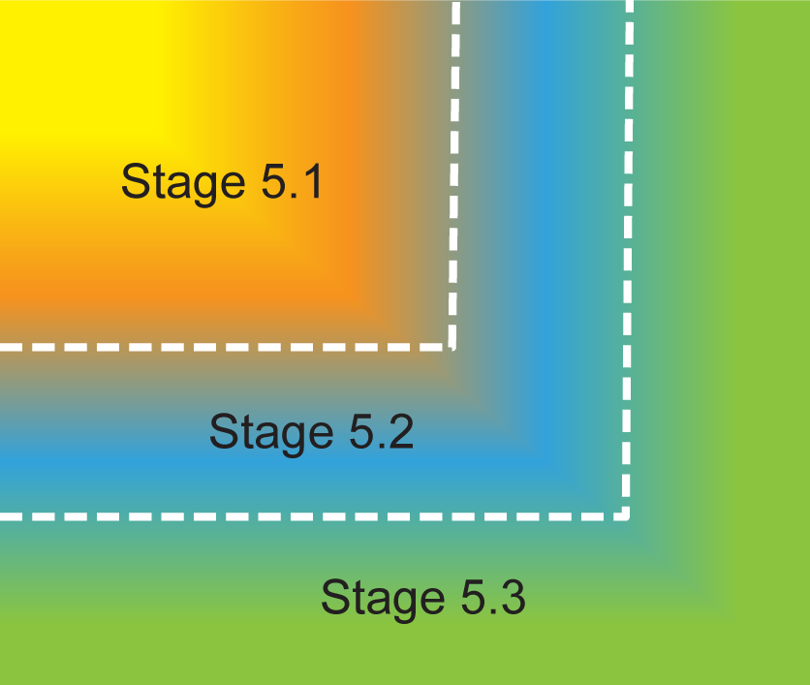
When planning learning experiences for students in Years 9 and 10, teachers need
to consider the courses of study that their students plan to follow beyond Stage 5.
The table below outlines Stage 5 content recommendations in relation to current
Stage 6 Mathematics Board Developed Courses. Other students may study Mathematics in Stage 6 through Board Endorsed Courses or Life Skills. The diagram contained in the section titled ‘The place of the Mathematics K–10 Syllabus in the K–12 curriculum’ shows the relationship between Stage 5 Mathematics and the various courses offered in Stage 6.
Intended Stage 6  Board Developed Course | Recommended Stage 5 content (minimum)
Preliminary Mathematics General/  HSC Mathematics General 2  ◊  (substrands identified by ◊) | All substrands of Stage 5.1 and the following Stage 5.2 substrands:  - Financial Mathematics  - Non-Linear Relationships  - Right-Angled Triangles (Trigonometry)  - Single Variable Data Analysis
Mathematics (‘2 Unit’)  §  (substrands identified by §) | All substrands of Stage 5.1 and Stage 5.2 and the following Stage 5.3 substrands:  - Algebraic Techniques  - Surds and Indices  - Equations  - Linear Relationships  and at least some of the content of the following Stage 5.3 substrands:  - Non-Linear Relationships  - Trigonometry and Pythagoras’ Theorem  - Properties of Geometrical Figures
Mathematics Extension 1  #  (optional substrands identified by #) | All substrands of Stage 5.1, Stage 5.2 and Stage 5.3, including the optional Stage 5.3 substrands:  - Polynomials  - Logarithms  - Functions and Other Graphs  - Circle Geometry

Life Skills
For some students with special education needs, particularly those students with an intellectual disability, it may be determined that the Stage 4 and Stage 5 outcomes and content are not appropriate. For these students, Life Skills outcomes and content can provide a relevant and meaningful program. Refer to the Introduction for further information about curriculum options for students with special education needs. Years 7–10 Life Skills outcomes and content are in the Life Skills section of the syllabus.

Learning across the curriculum
Learning across the curriculum content, including the cross-curriculum priorities and general capabilities, assists students to achieve the broad learning outcomes defined in the Board of Studies K–10 Curriculum Framework and Statement of Equity Principles, and in the Melbourne Declaration on Educational Goals for Young Australians (December 2008).
Cross-curriculum priorities enable students to develop understanding about and address the contemporary issues they face.
The cross-curriculum priorities are:
- Aboriginal and Torres Strait Islander histories and cultures
- Asia and Australia’s engagement with Asia
- Sustainability
General capabilities encompass the knowledge, skills, attitudes and behaviours to assist students to live and work successfully in the 21st century.
The general capabilities are:
- Critical and creative thinking
- Ethical understanding
- Information and communication technology capability
- Intercultural understanding
- Literacy
- Numeracy
- Personal and social capability
The Board’s syllabuses include other areas identified as important learning for all students:
- Civics and citizenship 
- Difference and diversity
- Work and enterprise

Learning across the curriculum content is incorporated, and identified by icons, in the content of the Mathematics K–10 Syllabus in the following ways:

Aboriginal and Torres Strait Islander histories and cultures
Aboriginal and Torres Strait Islander peoples have a unique sense of identity, which can be demonstrated through the interconnected aspects of Country and Place, People, and Culture.
Mathematics is a representation of the world that has developed over thousands of years through many diverse cultural contexts. Aboriginal and Torres Strait Islander cultures
have a rich understanding of mathematics that includes a broad range of applications
of mathematical concepts.
The NSW K–10 Mathematics curriculum values Aboriginal and Torres Strait Islander perspectives of mathematics and provides opportunities for students to investigate various aspects of number, measurement and geometry, including time and location and relevant interrelationships, in Aboriginal and Torres Strait Islander contexts. Students can deepen and extend their understanding of the lives of Aboriginal and Torres Strait Islander peoples through the application and evaluation of statistical data.

Asia and Australia’s engagement with Asia
The Asia and Australia’s engagement with Asia priority provides a regional context for learning in all areas of the curriculum. An understanding of Asia underpins the capacity of Australian students to be active and informed citizens working together to build harmonious local, regional and global communities, and build Australia’s social, intellectual and creative capital. This priority is concerned with Asia literacy for all Australian students. Asia literacy develops knowledge, skills and understanding about the histories, geographies, cultures, arts, literatures and languages of the diverse countries of our region. It fosters social inclusion in the Australian community and enables students to communicate and engage with the peoples of Asia so that the students can live, work and learn effectively in the region.
In their study of the NSW K–10 Mathematics curriculum, students investigate the concept of chance using Asian games and can explore the way Asian societies apply other mathematical concepts, such as patterns and symmetry in art and architecture. Investigations involving data collection and representation can be used to examine issues pertinent to the Asia region.

Sustainability
Sustainability is concerned with the ongoing capacity of Earth to maintain all life. Sustainable patterns of living meet the needs of the present without compromising the ability of future generations to meet their needs. Education for sustainability develops the knowledge, skills, understanding, values and attitudes necessary for people to act in ways that contribute to more sustainable patterns of living.
Mathematics provides a foundation for the exploration of issues of sustainability. It equips students with, for example, the skills to investigate data, to evaluate and communicate findings, and to make predictions based on those findings. They can measure and evaluate sustainability changes over time and develop a deeper appreciation of the world around them through such aspects of mathematics as patterning, three-dimensional space, symmetry and tessellations. Mathematical knowledge, skills and understanding are necessary to monitor and quantify both the impact of human activity on ecosystems and changes to conditions in the biosphere.
The NSW K–10 Mathematics curriculum provides students with knowledge, skills and understanding to observe, record, organise and analyse data, and to engage in investigations regarding sustainability. The curriculum supports students in early stages to build connections with the natural world and their local community. In later stages, students can use probability concepts, mathematical and computer modelling, chance and probability, multiple data sets and statistical analysis to understand more complex concepts relevant to sustainability.

Critical and creative thinking
Critical and creative thinking are key to the development of mathematical understanding. Students use critical and creative thinking as they learn to generate and evaluate knowledge, ideas and possibilities, and when seeking new pathways or solutions. Mathematical reasoning and logical thought are fundamental elements of critical and creative thinking. They are
integral to mathematical problem solving as students identify similarities and differences in mathematical situations and engage in reasoning and thinking about solutions to problems,
and the strategies needed to find those solutions.
In their study of mathematics in K–10, students use critical and creative thinking in such activities as exploring properties of shapes, setting up statistical investigations, comparing actual to expected results, approximating and estimating, interpreting data displays, examining misleading data, and interpolating and extrapolating. Critical and creative thinking are also of fundamental importance in such aspects of the Mathematics curriculum as posing problems, modelling situations, justifying choices and strategies used, and giving reasons to explain mathematical ideas.

Ethical understanding
Students develop ethical understanding as they learn about, and learn to act in accordance with, ethical principles, values, integrity and regard for others. There are various opportunities in the NSW K–10 Mathematics curriculum for students to develop and apply ethical understanding when, for example, collecting and displaying data, interpreting misleading graphs and displays, examining selective use of data by individuals and organisations, and detecting and eliminating bias in the reporting of information.

Information and communication technology capability
Information and communication technology (ICT) includes digital technologies such as calculators, spreadsheets, dynamic geometry software, and computer algebra and graphing software. Students use ICT effectively and appropriately when investigating, creating and communicating ideas and information, including in representing mathematics in a variety of ways to aid understanding. ICT can be used by students to solve problems and to perform previously onerous tasks more readily.
In the Number and Algebra strand in the NSW K–10 Mathematics curriculum, students can
use ICT in such topic areas as creating patterns, creating and interpreting graphs, investigating compound interest, and solving equations graphically. In the Measurement and Geometry strand of the curriculum, students can utilise ICT in such areas as exploring properties of angles and shapes, including symmetry; creating designs that involve shapes and transformations; representing, visualising and manipulating three-dimensional objects; investigating congruency and similarity; representing position and paths; making informal measures of length and area; and developing formulas for perimeter and area. In the Statistics and Probability strand, students can use ICT in such areas as recording and displaying data in various forms, comparing data sets, calculating measures of location and spread, modelling probability experiments, and using the internet to gather and analyse data presented by the media.

Intercultural understanding
Students develop intercultural understanding as they learn to understand themselves in relation to others. This involves students valuing their own cultures and beliefs and those of others, and engaging with people of diverse cultures in ways that recognise commonalities and differences, create connections, and cultivate respect.
Intercultural understanding can be enhanced if students are exposed to a range of cultural traditions in mathematics. It may be demonstrated, for example, through examining Aboriginal and Torres Strait Islander peoples’ perceptions of time and weather patterns, and the networks embedded in family relationships, as well as in such activities as examining patterns in art and design, learning about culturally specific calendar days, comparing currencies, and showing awareness of cultural sensitivities when collecting data.

Literacy
Students become literate as they develop the skills to learn and communicate confidently. These skills include listening, reading and viewing, writing, speaking and creating print, visual and digital materials accurately and purposefully within and across all learning areas.
Literacy is an important aspect of mathematics. Students need to understand written problems and instructions, including the use of common words with a specific meaning in a mathematical context and metaphorical language used to express mathematics concepts and processes.
In their K–10 mathematics learning, students are provided with opportunities to learn mathematical vocabulary and the conventions for communicating mathematics in written
form, including through its symbols and structures, as well as verbally through description and explanation. Mathematical literacy also extends to interpreting information from mathematical texts such as tables, graphs and other representations.

Numeracy
Numeracy is embedded throughout the Mathematics K–10 Syllabus. It relates to a high proportion of the content across K–10. Consequently, this particular general capability is
not tagged in the syllabus.
Numeracy involves drawing on knowledge of particular contexts and circumstances in deciding when to use mathematics, choosing the mathematics to use, and critically evaluating its use.
To be numerate is to use mathematics effectively to meet the general demands of life at home, in work, and for participation in community and civic life. Students become numerate as they develop the capacity to recognise and understand the role of mathematics in the world around them and the confidence, willingness and ability to apply mathematics to their lives in constructive and meaningful ways. Highly numerate students interpret, apply and critically evaluate mathematical strategies, and communicate mathematical reasoning in a range of practical situations.
Numeracy is relevant and important across the range of learning areas in K–10, in further education, and in everyday life. Mathematics makes a special contribution to the development of numeracy in a manner that is more explicit and foregrounded than is the case in other learning areas. It is important that the Mathematics curriculum provides the opportunity to apply mathematical skills and understanding in context, both in other learning areas and in real-world contexts. The NSW K–10 Mathematics curriculum provides students with opportunities to use numerical, spatial, graphical, statistical and algebraic concepts and skills in a variety of contexts and involves the critical evaluation, interpretation, application and communication of mathematical information in a range of practical situations.
The key role that teachers of mathematics play in the development of numeracy includes teaching students specific skills and providing them with opportunities to select, use, evaluate and communicate mathematical ideas in a range of situations. Students’ numeracy and underlying mathematical understanding will be enhanced through engagement with a variety
of applications of mathematics to real-world situations and problems in other learning areas.

Personal and social capability
Students develop personal and social competence as they learn to understand and manage themselves, their relationships and their lives more effectively. This includes establishing positive relationships, making responsible decisions, working effectively in teams, and handling challenging situations constructively.
The elements of personal and social competence relevant to mathematics include the application of mathematical skills for personal purposes, such as giving and following directions, visualisation and mapping skills, interpreting timetables and calendars, calculating with money and the Goods and Services Tax (GST), budgeting, using price comparison websites, evaluating discount offers, investigating payment on terms, and conducting statistical investigations in teams.

Work and enterprise
Students develop work-related knowledge, skills and understanding through a variety of experiences. These experiences may include constructing budgets, calculating wage and salary earnings, investigating and determining leave loadings, using deductions and ‘pay-as-you-go’ (PAYG) instalments to calculate a tax liability or refund, and investigating tax rebates and levies. Students perform calculations involving discounts, and profit and loss, and use statistics to predict future earnings, monitor inventories, and analyse and interpret information gained
from surveys.
Early Stage 1
Number and Algebra
Whole Numbers
Outcomes
A student:
- describes mathematical situations using everyday language, actions, materials and informal recordings MAe-1WM
- uses objects, actions, technology and/or trial and error to explore mathematical problems MAe-2WM
- uses concrete materials and/or pictorial representations to support conclusions MAe-3WM
- counts to 30, and orders, reads and represents numbers in the range 0 to 20 MAe-4NA
Content
Students:
Establish understanding of the language and processes of counting by naming numbers in sequences, initially to and from 20, moving from any starting point (ACMNA001)
- count forwards to 30 from a given number
- count backwards from a given number in the range 0 to 20
- identify the number before and after a given number
- describe the number before as 'one less than' and the number after as 'one more than' a given number (Communicating)
- read and use the ordinal names to at least 'tenth'
Connect number names, numerals and quantities, including zero, initially up to 10 and then beyond (ACMNA002)
- read numbers to at least 20, including zero, and represent these using objects (such as fingers), pictures, words and numerals
- recognise numbers in a variety of contexts, eg classroom charts, cash register, computer keyboard, telephone (Communicating)
- communicate the use of numbers through everyday language, actions, materials and informal recordings (Communicating)
- estimate the number of objects in a group of up to 20 objects, and count to check
- use 5 as a reference in forming numbers from 6 to 10, eg 'Six is one more than five'
- use 10 as a reference in forming numbers from 11 to 20, eg 'Thirteen is 1 group of ten and 3 ones'
Subitise small collections of objects (ACMNA003)
- recognise the number of objects or dots in a pattern of objects or dots instantly, eg
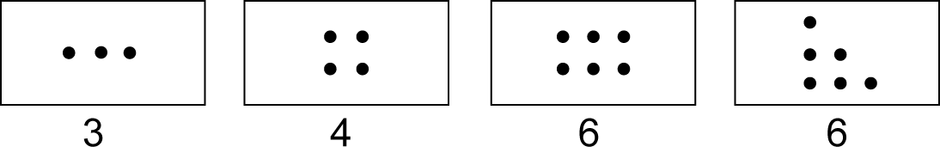
- recognise dice and domino dot patterns, eg
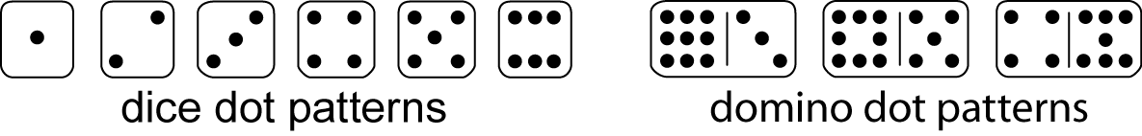
- (Communicating)
- instantly recognise (subitise) different arrangements for the same number, eg different representations of five
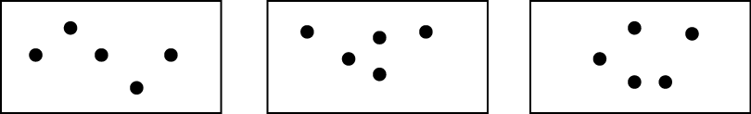
- recognise that the way objects are arranged affects how easy it is to subitise (Reasoning)
Compare, order and make correspondences between collections, initially to 20, and explain reasoning (ACMNA289)
- count with one-to-one correspondence
- recognise that the last number name represents the total number in the collection when counting (Communicating)
- make correspondences between collections, eg 'I have four counters, you have seven counters. So you have more counters than me'
- compare and order numbers and groups of objects
- apply counting strategies to solve simple everyday problems and justify answers (Problem Solving, Reasoning)
- use the term 'is the same as' to express equality of groups
- determine whether two groups have the same number of objects and describe the equality, eg 'The number of objects here is the same as the number there' (Communicating, Reasoning)
Use the language of money
- use the language of money in everyday contexts, eg coins, notes, cents, dollars
- recognise that there are different coins and notes in our monetary system
- exchange money for goods in a play situation (Problem Solving)
Background Information
In Early Stage 1, students are expected to be able to count to 30. Many classes have between 20 and 30 students, and counting the number of students is a common activity. Students will also encounter numbers up to 31 in calendars.
Counting is an important component of number and the early learning of operations. There is a distinction between counting by rote and counting with understanding. Regularly counting forwards and backwards from a given number will familiarise students with the sequence. Counting with understanding involves counting with one-to-one correspondence, recognising that the last number name represents the total number in the collection, and developing a sense of the size of numbers, their order and their relationships. Representing numbers in a variety of ways is essential for developing number sense.
Subitising involves immediately recognising the number of objects in a small collection without having to count the objects. The word 'subitise' is derived from Latin and means 'to arrive suddenly'.
In Early Stage 1, forming groups of objects that have the same number of elements helps to develop the concept of equality.
Language
Students should be able to communicate using the following language: count forwards, count backwards, number before, number after, more than, less than, zero, ones, groups of ten, tens, is the same as, coins, notes, cents, dollars.
The teen numbers are often the most difficult for students. The oral language pattern of teen numbers is the reverse of the usual pattern of 'tens first and then ones'.
Students may use incorrect terms since these are frequently heard in everyday language, eg 'How much did you get?' rather than 'How many did you get?' when referring to a score in a game.
To represent the equality of groups, the terms 'is the same as' and 'is equal to' should be used. In Early Stage 1, the term 'is the same as' is emphasised as it is more appropriate for students' level of conceptual understanding.

Early Stage 1
Number and Algebra
Addition and Subtraction
Outcomes
A student:
- describes mathematical situations using everyday language, actions, materials and informal recordings MAe-1WM
- uses objects, actions, technology and/or trial and error to explore mathematical problems MAe-2WM
- uses concrete materials and/or pictorial representations to support conclusions MAe-3WM
- combines, separates and compares collections of objects, describes using everyday language, and records using informal methods MAe-5NA
Content
Students:
Represent practical situations to model addition and sharing (ACMNA004)
- combine two or more groups of objects to model addition
- model subtraction by separating and taking away part of a group of objects
- use concrete materials or fingers to model and solve simple addition and subtraction problems
- compare two groups of objects to determine 'how many more'
- use visual representations of numbers to assist with addition and subtraction, eg ten frames
- create and recognise combinations for numbers to at least 10, eg 'How many more make 10?'
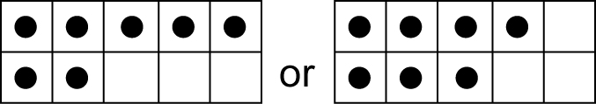
- describe the action of combining, separating and comparing using everyday language,
eg makes, joins, combines with, and, get, take away, how many more, all together
- explain or demonstrate how an answer was obtained (Communicating, Reasoning)
- apply strategies that have been demonstrated by other students (Problem Solving)
- investigate different methods of adding and subtracting used in various cultures, eg Aboriginal and Torres Strait Islander methods involving spatial patterns and reasoning, Asian counting tools such as the abacus (Communicating, Problem Solving)
- count forwards by ones to add and backwards by ones to subtract
- record addition and subtraction informally using drawings, words and numerals
Background Information
Addition and subtraction should move from counting and combining perceptual objects, to using numbers as replacements for completed counts with mental strategies, to recordings that support mental strategies (such as jump, split, partitioning and compensation).
Subtraction typically covers two different situations: 'taking away' from a group, and 'comparing' two groups (ie finding 'how many more'). Students should be confident with taking away from a group before being introduced to comparing two groups. They should be able to compare groups of objects by using one-to-one correspondence before being asked to find out how many more or how many less there are in a group.
In Early Stage 1, addition and subtraction problems should be related to real-life experiences that involve the manipulation of objects.
Modelling, drawing and writing mathematical problems should be encouraged in Early Stage 1. However, formal writing of number sentences, including the use of the symbols +, − and =, is introduced in Stage 1.
Addition and subtraction should be taught in conjunction with each other as the foundation for conceptual understanding of their inverse relationship.
Language
Students should be able to communicate using the following language: count forwards, combines with, joins, count backwards, take away, how many more, all together, makes.
Some students may need assistance when two tenses are used in the one problem, eg 'I had six beans and took away four. How many do I have?'
The word 'difference' has a specific meaning in this context, referring to the numeric value of the group. In everyday language, it can refer to any attribute.
Early Stage 1
Number and Algebra
Multiplication and Division
Outcomes
A student:
- describes mathematical situations using everyday language, actions, materials and informal recordings MAe-1WM
- uses objects, actions, technology and/or trial and error to explore mathematical problems MAe-2WM
- groups, shares and counts collections of objects, describes using everyday language, and records using informal methods MAe-6NA
Content
Students:
Investigate and model equal groups
- use the term 'group' to describe a collection of objects
- use the term 'sharing' to describe the distribution of a collection of objects
- model equal groups
- recognise groups that are not equal in size
- group and share concrete materials to solve problems
- explain or demonstrate how an answer was obtained (Communicating, Reasoning)
Record grouping and sharing using informal methods
- label the number of objects in a group
- record grouping and sharing informally using pictures, words and numerals
Background Information
All activities should involve students manipulating concrete materials. The emphasis is on modelling groups of the same size and describing them. Students need to acquire the concept that fair sharing means all shares are equal. After students have shared objects equally, the process can be reversed to begin to develop the link between multiplication and division. This can be done by students first sharing a group of objects and then putting back together all of the shared objects to form one collection.
There are two forms of division:
Sharing (partitive) – How many in each group?
eg 'If 12 marbles are shared between three students, how many does each get?'
Grouping (quotitive) – How many groups are there?
eg 'If I have 12 marbles and each child is to get four, how many children will get marbles?'
While the total number of objects that have been shared or grouped can be found incidentally, strategies for doing this are addressed in Stage 1.
Multiplication and division should be taught in conjunction with each other as the foundation for conceptual understanding of their inverse relationship.
Language
Students should be able to communicate using the following language: group, share, equal.
Sharing – relates to distributing items one at a time into a set number of groups, eg the student has a number of pop sticks and three cups and shares out the pop sticks into the cups one at a time.
Grouping – relates to distributing the same number of items into an unknown number of groups, eg the student has 12 pop sticks and wants to make groups of four, so places four pop sticks down, then another four, and so on.
Early Stage 1
Number and Algebra
Fractions and Decimals
Outcomes
A student:
- describes mathematical situations using everyday language, actions, materials and informal recordings MAe-1WM
- uses concrete materials and/or pictorial representations to support conclusions MAe-3WM
- describes two equal parts as halves MAe-7NA
Content
Students:
Establish the concept of one-half
- share an object by dividing it into two equal parts, eg cutting a piece of ribbon into halves
- describe how to make equal parts (Communicating)
- recognise that halves are two equal parts
- explain the reason for dividing an object in a particular way (Communicating, Reasoning)
- recognise when two parts are not halves of one whole
- explain why two parts of one whole are or are not halves, eg 'The two parts are not halves because they are not the same' (Communicating, Reasoning)
- use the term 'half' accurately in everyday situations
- record halves of objects using drawings
Background Information
The focus on halves in Early Stage 1 is only a guide. Some students will be able to describe other fractions from everyday contexts. The emphasis is on dividing one whole object into two equal parts. Fairness in making equal parts is the focus.
Halves can be different shapes. 
Halves of different objects can be different sizes, eg half of a sheet of art paper is larger than half of a serviette. Fractions refer to the relationship of the equal parts to the whole unit.
Language
Students should be able to communicate using the following language: whole, part, equal parts, half, halves.
In everyday usage, the term 'half' is sometimes used to mean one of two parts and not necessarily two equal parts, eg 'I'll have the biggest half'. It is important to model and reinforce the language of 'two equal parts' when describing half.
Early Stage 1
Number and Algebra
Patterns and Algebra
Outcomes
A student:
- describes mathematical situations using everyday language, actions, materials and informal recordings MAe-1WM
- uses objects, actions, technology and/or trial and error to explore mathematical problems MAe-2WM
- uses concrete materials and/or pictorial representations to support conclusions MAe-3WM
- recognises, describes and continues repeating patterns MAe-8NA
Content
Students:
Sort and classify familiar objects and explain the basis for these classifications (ACMNA005)
- sort and classify a group of familiar objects into smaller groups
- recognise that a group of objects can be sorted and classified in different ways
- explain the basis for their classification of objects (Communicating, Reasoning)
Copy, continue and create patterns with objects and drawings
- recognise, copy and continue repeating patterns using sounds and/or actions
- recognise, copy, continue and create repeating patterns using shapes, objects or pictures, eg
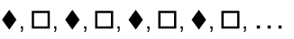
- create or continue a repeating pattern using simple computer graphics (Problem Solving)
- recognise when an error occurs in a pattern and explain what is wrong (Communicating, Reasoning)
- describe a repeating pattern made from shapes by referring to its distinguishing features, eg 'I have made my pattern from squares. The colours repeat. They go red, blue, red, blue, …'
Background Information
Early number learning (including additive and multiplicative thinking) is important to the development of algebraic thinking in later stages.
In Early Stage 1, repeating patterns can be created using sounds, actions, shapes, objects, stamps, pictures and other materials.
Language
Students should be able to communicate using the following language: group, pattern, repeat.
Early Stage 1
Measurement and Geometry
Length
Outcomes
A student:
- describes mathematical situations using everyday language, actions, materials and informal recordings MAe-1WM
- uses concrete materials and/or pictorial representations to support conclusions MAe-3WM
- describes and compares lengths and distances using everyday language MAe-9MG
Content
Students:
Use direct and indirect comparisons to decide which is longer, and explain their reasoning using everyday language (ACMMG006)
- identify the attribute of 'length' as the measure of an object from end to end
- make and sort long and short constructions from concrete materials
- use everyday language to describe length, eg long, short, high, tall, low
- use everyday language to describe distance, eg near, far, nearer, further, closer
- use comparative language to describe length, eg longer, higher, taller than, shortest, lower than, longest, the same as
- identify an object that is longer or shorter than another, eg 'Find an object longer than this pencil' (Communicating)
- compare lengths directly by placing objects side-by-side and aligning the ends
- explain why the length of a piece of string remains unchanged whether placed in a straight line or a curve (Communicating, Reasoning)
- predict whether an object will be longer or shorter than another object and explain the reasons for this prediction (Communicating, Reasoning)
- compare lengths indirectly by copying a length, eg using the same strip of paper to compare lengths
- record length comparisons informally by drawing, tracing, or cutting and pasting, and by using words and numerals
Background Information
In Early Stage 1, students develop an awareness of the attribute of length and some of the language used to describe length.
Students develop an awareness of the attribute of length as comparisons of lengths are made.
Early Stage 1 focuses on one-to-one comparisons and the importance of accurately aligning one end of each of the objects to be compared.
When students are asked to compare the lengths of two objects of equal length and can consistently say that the objects are equal in length though their relative positions have been altered, they are conserving length.
This is an important concept and develops over time.
Once students can compare two lengths, they should then be given the opportunity to order three or more lengths. This process requires students to understand that if A is longer than B, and B is longer than C, then A is longer than C.
Length and distance are distinct concepts. The term 'length' is generally used to describe a measure from end to end of a drawn interval, a two-dimensional shape or a three-dimensional object. The term 'distance' is generally used to describe the lineal space between two things, places or points. Activities should focus on both concepts.
Language
Students should be able to communicate using the following language: length, end, end-to-end, side-by-side, long, longer than, longest, short, shorter than, shortest, high, higher than, highest, tall, taller than, tallest, low, lower than, lowest, the same as, near, nearer, far, further, close, closer.
Students may need practice with the language of length in a variety of contexts. They may know the word 'fat', but not the word 'thick'. Students may be using the general terms 'big' and 'long' for attributes such as height, width, depth, length and thickness.
Young students often confuse concepts such as big, tall, long and high. It is important to engage students in activities that help them differentiate between these concepts.
Early Stage 1
Measurement and Geometry
Area
Outcomes
A student:
- describes mathematical situations using everyday language, actions, materials and informal recordings MAe-1WM
- uses concrete materials and/or pictorial representations to support conclusions MAe-3WM
- describes and compares areas using everyday language MAe-10MG
Content
Students:
Use direct comparison to decide which shape has a larger area and explain their reasoning using everyday language
- identify the attribute of 'area' as the measure of the amount of surface
- cover surfaces completely with smaller shapes
- make closed shapes and describe the area of each shape
- use computer software to draw a closed shape, colouring in the area (Communicating)
- use everyday language to describe area, eg surface, inside, outside
- use comparative language to describe area, eg bigger than, smaller than, the same as
- ask questions about area in everyday situations, eg 'Which book cover is bigger?' (Communicating)
- compare two areas directly, eg superimposing or superpositioning two surfaces
- demonstrate how one surface is bigger than another by comparing directly (Reasoning)
- predict whether a surface will be larger or smaller than another surface and explain the reasons for this prediction (Communicating, Reasoning)
- record area comparisons informally by drawing, tracing, or cutting and pasting, and by using numerals and words
Background Information
Area relates to the measurement of two-dimensional space in the same way that volume and capacity relate to the measurement of three-dimensional space.
The attribute of area is the amount of surface (either flat or curved) and can be measured in square units, eg square centimetres (cm²), square metres (m²).
In Early Stage 1, students develop an awareness of the attribute of area and some of the language used to describe area. They develop an awareness of the attribute of area through covering activities, through colouring in, and as comparisons of area are made.
Students should be given opportunities to compare:
- two similar shapes of different areas where one fits inside the boundary of the other
- two different-shaped areas where one can be placed on top of the other
- two shapes where one shape can be cut up and pasted onto the other.
Once students can compare two areas, they should then be given the opportunity to order three or more areas. This process requires students to understand that if A is larger than B, and B is larger than C, then A is larger than C.
Language
Students should be able to communicate using the following language: area, surface, closed shape, inside, outside, bigger than, smaller than, the same as.
Superimposing – the comparison of areas by placing one area on top of another.

Superpositioning – the comparison of areas by aligning the edges (or corners) of two areas when one is placed on top of the other.

Early Stage 1
Measurement and Geometry
Volume and Capacity
Outcomes
A student:
- describes mathematical situations using everyday language, actions, materials and informal recordings MAe-1WM
- describes and compares the capacities of containers and the volumes of objects or substances using everyday language MAe-11MG
Content
Students:
Use direct and indirect comparisons to decide which holds more, and explain their reasoning using everyday language (ACMMG006)
- identify the attribute of 'capacity' as the amount of liquid a container can hold
- fill and empty containers using materials such as water and sand
- use the terms 'full', 'empty' and 'about half-full'
- recognise when a container, such as a watering can, is nearly full, about half-full or empty (Reasoning)
- compare the capacities of two containers directly by filling one and pouring into the other
- predict which container has the greater capacity and explain the reasons for this prediction, eg plant pots of different sizes (Communicating, Reasoning)
- compare the capacities of two containers indirectly by pouring their contents into two other identical containers and observing the level reached by each
- establish that containers of different shapes may have the same capacity, eg a tall narrow container may hold the same amount as a short wide container
- identify the attribute of 'volume' as the amount of space an object or substance occupies
- stack and pack blocks into defined spaces, eg boxes
- identify which three-dimensional objects stack and pack easily (Reasoning)
- compare the volumes of two objects made from blocks or connecting cubes directly by deconstructing one object and using its parts to construct a copy of the other object
- compare the volumes of two piles of material directly by filling two identical containers, eg 'This pile of rice has a larger volume as it takes up more space in the container'
- compare the volumes of two objects by observing the amount of space each occupies, eg a garbage truck takes up more space than a car
- use comparative language to describe volume and capacity, eg has more, has less, will hold more, will hold less, takes up more space
- record volume and capacity comparisons informally using drawings, numerals and words
Background Information
The order in which volume and capacity appear in the content is not necessarily indicative of the order in which they should be taught.
Volume and capacity relate to the measurement of three-dimensional space, in the same way that area relates to the measurement of two-dimensional space.
The attribute of volume is the amount of space occupied by an object or substance. Capacity is only used in relation to containers and generally refers to liquid measurement. It is not necessary to refer to these definitions with students.
In Early Stage 1, comparisons are made directly, using methods such as pouring or packing the contents of one container into another. Early experiences often lead students to the conclusion that taller containers 'hold more'. To develop beyond this, students need to directly compare containers that are short and hold more, tall and hold less, short and hold less, tall and hold more, and short and hold the same as a tall container, etc.
Many opportunities to emphasise volume (stacking, packing and making models) and capacity (pouring and filling) concepts occur when students pack toys or objects into cupboards, or in play situations, eg sand pit play, water play.
Language
Students should be able to communicate using the following language: capacity, container, liquid, full, empty, about half-full, volume, space, has more, has less, will hold more, will hold less, takes up more space.
Students need meaningful practice in using the general word 'container' to include bottles, jars, tubs and other everyday containers.
The term 'big' is often used by students to describe a variety of attributes. Depending on the context, it could mean long, tall, heavy, etc. It is important to model with students more precise language to describe volume and capacity.
Early Stage 1
Measurement and Geometry
Mass
Outcomes
A student:
- describes mathematical situations using everyday language, actions, materials and informal recordings MAe-1WM
- uses concrete materials and/or pictorial representations to support conclusions MAe-3WM
- describes and compares the masses of objects using everyday language MAe-12MG
Content
Students:
Use direct and indirect comparisons to decide which is heavier, and explain their reasoning using everyday language (ACMMG006)
- identify the attribute of 'mass' as the amount of matter in an object
- use everyday language to describe objects in terms of their mass, eg heavy, light, hard to push, hard to pull
- use comparative language to describe mass, eg heavier, lighter, heaviest, lightest
- identify an object that is heavier or lighter than another (Communicating)
- compare and describe two masses, such as by pushing or pulling
- compare two masses directly by hefting, eg 'This toy feels heavier than that one'
- predict which object would be heavier than, lighter than, or have about the same mass as another object and explain reasons for this prediction (Communicating, Reasoning)
- investigate the use of hefting in practical situations, eg the practice used by Aboriginal people of hefting duck eggs to determine whether ducklings will be male or female (Problem Solving)
- record comparisons of mass informally using drawings, numerals and words
Background Information
In Early Stage 1, students develop an awareness of the attribute of mass and some of the language used to describe mass. Opportunities to explore mass concepts and understand the action of a two-pan balance occur in play situations, such as a seesaw in a children's playground.
Students in Early Stage 1 should only be comparing two objects that are quite different in mass. Early experiences often lead students to the conclusion that large things are heavier than small things and that if two things are the same size and shape, then they will have the same mass. To develop beyond this, students need to have experiences with objects that are light and large, heavy and large, light and small, heavy and small, and large but lighter than a smaller object.
When students are asked to compare the masses of two objects of equal mass and can consistently say that the objects are equal in mass though their shapes are different, they are conserving mass.
Aboriginal communities were traditionally able to determine whether ducklings would be male or female by hefting duck eggs (female eggs are heavier), as well as by considering other factors such as size, shape and temperature.
Language
Students should be able to communicate using the following language: mass, matter, heavy, heavier, heaviest, light, lighter, lightest, about the same as, hard to push, hard to pull.
As the terms 'weigh' and 'weight' are common in everyday usage, they can be accepted in student language should they arise. Weight is a force that changes with gravity, while mass remains constant.
'Hefting' is testing the weight of an object by lifting and balancing it. Where possible, students can compare the weights of two objects by using their bodies to balance each object, eg holding one object in each hand.
Early Stage 1
Measurement and Geometry
Time
Outcomes
A student:
- describes mathematical situations using everyday language, actions, materials and informal recordings MAe-1WM
- sequences events, uses everyday language to describe the durations of events, and reads hour time on clocks MAe-13MG
Content
Students:
Compare and order the duration of events using the everyday language of time (ACMMG007)
- use terms such as 'daytime', 'night-time', 'yesterday', 'today', 'tomorrow', 'before', 'after', 'next', 'morning' and 'afternoon'
- sequence events in time
- compare the duration of two events using everyday language, eg 'It takes me longer to eat my lunch than it does to clean my teeth'
- describe events that take 'a long time' and events that take 'a short time' (Communicating)
Connect days of the week to familiar events and actions (ACMMG008)
- recall that there are seven days in a week
- name and order the days of the week
- classify weekdays and weekend days
- relate events to a particular day or time of day, eg 'Assembly is on Tuesday', 'We come to school in the morning'
- identify events that occur every day, eg 'We have news every day' (Communicating)
Tell time on the hour on analog and digital clocks
- read analog and digital clocks to the hour using the term 'o'clock'
- describe the position of the hands on an analog clock when reading hour time
Background Information
Duration
In Early Stage 1, students begin to develop an understanding of the duration of time and learn to identify moments in time. An understanding of duration is introduced through ideas such as 'before', 'after', 'how long' and 'how soon'. It should be noted that time spans in Early Stage 1 are personal judgements. Moments in time include ideas such as daytime, today, days of the week and seasons. Sunday is commonly the first day of the calendar week. A week, however, may also mean a period of seven days beginning on any day, eg 'One week starting from Thursday'.
Teachers should be aware of the multicultural nature of our society and of significant times in the year for different cultural groups. These could include religious festival days, national days and anniversaries.
Telling Time
In Early Stage 1, 'telling time' focuses on reading hour time on analog and digital clocks. The focus on hour time in Early Stage 1 is only a guide. Some students will be able to read other times.
Language
Students should be able to communicate using the following language: daytime, night-time, yesterday, today, tomorrow, before, after, next, a long time, a short time, week, days, weekdays, weekend days, time, morning, afternoon, clock, analog, digital, hands (of a clock), o'clock.
The words 'long' and 'short' can be confusing to students who have only experienced these words in terms of length measurement. Students will need experience with these words in both length and time contexts.
References to time are often used inaccurately in everyday language, eg 'I'll be a second', 'back in a minute'.
Early Stage 1
Measurement and Geometry
Three-Dimensional Space
Outcomes
A student:
- describes mathematical situations using everyday language, actions, materials and informal recordings MAe-1WM
- uses concrete materials and/or pictorial representations to support conclusions MAe-3WM
- manipulates, sorts and represents three-dimensional objects and describes them using everyday language MAe-14MG
Content
Students:
Sort, describe and name familiar three-dimensional objects in the environment (ACMMG009)
- describe the features of familiar three-dimensional objects, such as local landmarks including Aboriginal landmarks, using everyday language, eg flat, round, curved
- describe the difference between three-dimensional objects and two-dimensional shapes using everyday language (Communicating)
- sort three-dimensional objects and explain the attributes used to sort them, eg colour, size, shape, function
- recognise how a group of objects has been sorted, eg 'These objects are all pointy' (Communicating, Reasoning)
- recognise and use informal names for three-dimensional objects, eg box, ball
- manipulate and describe a variety of objects found in the environment
- manipulate and describe an object hidden from view using everyday language, eg describe an object hidden in a 'mystery bag' (Communicating)
- predict and describe the movement of objects, eg 'This will roll because it is round'
- use a plank or board to determine which objects roll and which objects slide (Problem Solving)
- make models using a variety of three-dimensional objects and describe the models, eg 'I made a model of a person using a ball and some blocks'
- predict the building and stacking capabilities of various three-dimensional objects (Reasoning)
Background Information
In Early Stage 1, the emphasis is on students handling, describing, sorting and representing the many objects around them. It is important that students are encouraged to use their own language to describe objects.
Manipulation of a variety of real objects and shapes is crucial to the development of appropriate levels of imagery, language and representation.
Local landmarks include buildings, rivers, rock formations and bridges, as well as Aboriginal landmarks. Aboriginal landmarks may include contemporary landmarks and local points of interest. Local Aboriginal communities and education consultants can provide examples.
Language
Students should be able to communicate using the following language: object, shape, size, curved, flat, pointy, round, roll, slide, stack.
Teachers can model mathematical language while still accepting and encouraging students' informal terms.
The term 'shape' refers to a two-dimensional figure. The term 'object' refers to a three-dimensional figure.
Early Stage 1
Measurement and Geometry
Two-Dimensional Space
Outcomes
A student:
- describes mathematical situations using everyday language, actions, materials and informal recordings MAe-1WM
- uses objects, actions, technology and/or trial and error to explore mathematical problems MAe-2WM
- manipulates, sorts and describes representations of two-dimensional shapes, including circles, triangles, squares and rectangles, using everyday language MAe-15MG
Content
Students:
Sort, describe and name familiar two-dimensional shapes in the environment (ACMMG009)
- identify, represent and name circles, triangles, squares and rectangles presented in different orientations, eg
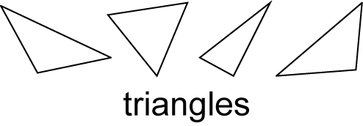
- identify circles, triangles, squares and rectangles in pictures and the environment, including in Aboriginal art (Problem Solving)
- ask and respond to questions that help identify a particular shape (Communicating, Problem Solving)
- sort two-dimensional shapes according to features such as size and shape
- recognise and explain how a group of two-dimensional shapes has been sorted (Communicating, Reasoning)
- manipulate circles, triangles, squares and rectangles, and describe their features using everyday language, eg 'A square has four sides'
- turn two-dimensional shapes to fit into or match a given space (Problem Solving)
- make representations of two-dimensional shapes using a variety of materials, including paint, paper, body movements and computer drawing tools
- make pictures and designs using a selection of shapes, eg make a house from a square and a triangle (Communicating)
- draw a two-dimensional shape by tracing around one face of a three-dimensional object
- identify and draw straight and curved lines
- compare and describe closed shapes and open lines
- draw closed two-dimensional shapes without tracing
- recognise and explain the importance of closing the shape when drawing a shape (Communicating, Reasoning)
Background Information
Experiences with shapes, even in Early Stage 1, should not be limited. It is important that students experience shapes that are represented in a variety of ways, eg 'tall skinny' triangles, 'short fat' triangles, right-angled triangles presented in different orientations and of different sizes, and shapes that are represented using a variety of materials, eg paint, images on the computer, string. Manipulation of a variety of real objects and shapes is crucial to the development of appropriate levels of language and representation.
In Early Stage 1, it is important that teachers present students with both regular and irregular shapes (regular shapes have all sides and all angles equal). However, students are not expected to use the terms 'regular' and 'irregular' themselves.
Students should be given time to explore materials in order to represent shapes by tearing, painting, drawing, writing, or cutting and pasting.
Language
Students should be able to communicate using the following language: shape, circle, triangle, square, rectangle, features, side, straight line, curved line, open line, closed shape.
The term 'shape' refers to a two-dimensional figure. The term 'object' refers to a three-dimensional figure.
Early Stage 1
Measurement and Geometry
Position
Outcomes
A student:
- describes mathematical situations using everyday language, actions, materials and informal recordings MAe-1WM
- describes position and gives and follows simple directions using everyday language MAe-16MG
Content
Students:
Describe position and movement (ACMMG010)
- give and follow simple directions to position an object or themselves, eg 'Put the blue teddy in the circle'
- follow directions to a point or place, including in mazes and games (Reasoning)
- direct simple computer-controlled toys and equipment to follow a path (Communicating)
- describe the position of an object in relation to themselves using everyday language, such as 'between', 'next to', 'behind' or 'inside', eg 'The table is behind me'
- describe the position of an object in relation to another object using everyday language, such as 'between', 'next to', 'behind' or 'inside', eg 'The book is inside the box'
- describe the positions of objects in relation to themselves using the terms 'left' and 'right', eg 'The tree is on my right'
- use the terms 'left' and 'right' when referring to familiar tasks, eg 'I hold my pencil in my right hand' (Communicating)
- participate in movement games involving turning and direction (Reasoning)
Background Information
There are two main ideas for students in Early Stage 1: following an instruction to position an object or themselves, and describing the relative position of an object or themselves. Some students may be able to describe the position of an object in relation to themselves, but not in relation to another object.
In Early Stage 1, students use the terms 'left' and 'right' to describe position in relation to themselves. They are not expected to use the terms 'left' and 'right' to describe the position of an object from the perspective of a person facing in the opposite direction until Stage 1.
Language
Students should be able to communicate using the following language: position, between, next to, behind, inside, outside, left, right, directions.
Early Stage 1
Statistics and Probability
Data
Outcomes
A student:
- describes mathematical situations using everyday language, actions, materials and informal recordings MAe-1WM
- uses concrete materials and/or pictorial representations to support conclusions MAe-3WM
- represents data and interprets data displays made from objects MAe-17SP
Content
Students:
Answer yes/no questions to collect information (ACMSP011)
- collect information about themselves and their environment, including by asking and answering yes/no questions
- pose and answer questions about situations using everyday language, eg 'Do you have any brothers or sisters?', 'What is the favourite colour of most people in our class?' (Communicating)
Organise objects into simple data displays and interpret the displays
- group objects according to characteristics to form a simple data display, eg sort blocks or counters according to colour
- compare the sizes of groups of objects by counting (Reasoning)
- arrange objects in rows or columns according to characteristics to form a data display, eg arrange lunchboxes in columns according to colour
- give reasons why a row of three objects may look bigger than a row of five objects, eg 'The three green lunchboxes are spaced out more than the five blue lunchboxes' (Communicating, Reasoning)
- interpret information presented in a display of objects to answer questions, eg 'How many children in our class have red pencil cases?'
Background Information
In Early Stage 1, students collect information about themselves and their environment with teacher assistance. They use actual objects as data and group these objects into a data display.
Language
Students should be able to communicate using the following language: information, collect, group, display, objects.
Stage 1
Number and Algebra
Whole Numbers 1
Outcomes
A student:
- describes mathematical situations and methods using everyday and some mathematical language, actions, materials, diagrams and symbols MA1-1WM
- uses objects, diagrams and technology to explore mathematical problems MA1-2WM
- supports conclusions by explaining or demonstrating how answers were obtained MA1-3WM
- applies place value, informally, to count, order, read and represent two- and three-digit numbers MA1-4NA
Content
Students:
Develop confidence with number sequences to 100 by ones from any starting point (ACMNA012)
- count forwards and backwards by ones from a given two-digit number
- identify the number before and after a given two-digit number
- describe the number before as 'one less than' and the number after as 'one more than' a given number (Communicating)
- read and use the ordinal names to at least 'thirty-first', eg when reading calendar dates
Count collections to 100 by partitioning numbers using place value (ACMNA014)
- count and represent large sets of objects by systematically grouping in tens
- use and explain mental grouping to count and to assist with estimating the number of items in large groups
- use place value to partition two-digit numbers, eg 32 as 3 groups of ten and 2 ones
- state the place value of digits in two-digit numbers, eg 'In the number 32, the "3" represents 30 or 3 tens'
- partition two-digit numbers in non-standard forms, eg 32 as 32 ones or 2 tens and 12 ones
Recognise, model, read, write and order numbers to at least 100; locate these numbers on a number line (ACMNA013)
- represent two-digit numbers using objects, pictures, words and numerals
- locate and place two-digit numbers on a number line
- apply an understanding of place value and the role of zero to read, write and order two-digit numbers
- use number lines and number charts to assist with counting and ordering
- give reasons for placing a set of numbers in a particular order (Communicating, Reasoning)
- round numbers to the nearest ten
- estimate, to the nearest ten, the number of objects in a collection and check by counting, eg estimate the number of children in a room to the nearest ten
- solve simple everyday problems with two-digit numbers
- choose an appropriate strategy to solve problems, including trial-and-error and drawing a diagram (Communicating, Problem Solving)
- ask questions involving two-digit numbers, eg 'Why are the houses on either side of my house numbered 32 and 36?' (Communicating)
Recognise, describe and order Australian coins according to their value (ACMNA017)
- identify, sort, order and count money using the appropriate language in everyday contexts, eg coins, notes, cents, dollars
- recognise that total amounts can be made using different denominations, eg 20 cents can be made using a single coin or two 10-cent coins
- recognise the symbols for dollars ($) and cents (c)
Background Information
By developing a variety of counting strategies and ways to combine quantities, students recognise that there are more efficient ways to count collections than counting by ones.
Language
Students should be able to communicate using the following language: count forwards, count backwards, number before, number after, more than, less than, number line, number chart, digit, zero, ones, groups of ten, tens, round to, coins, notes, cents, dollars.
Students should be made aware that bus, postcode and telephone numbers are said differently from cardinal numbers, ie they are not said using place value language. Ordinal names may be confused with fraction names, eg 'the third' relates to order but 'a third' is a fraction.
The word 'round' has different meanings in different contexts and some students may confuse it with the word 'around'.
Stage 1
Number and Algebra
Whole Numbers 2
Outcomes
A student:
- describes mathematical situations and methods using everyday and some mathematical language, actions, materials, diagrams and symbols MA1-1WM
- uses objects, diagrams and technology to explore mathematical problems MA1-2WM
- supports conclusions by explaining or demonstrating how answers were obtained MA1-3WM
- applies place value, informally, to count, order, read and represent two- and three-digit numbers MA1-4NA
Content
Students:
Develop confidence with number sequences from 100 by ones from any starting point (ACMNA012)
- count forwards or backwards by ones, from a given three-digit number
- identify the numbers before and after a given three-digit number
- describe the number before as 'one less than' and the number after as 'one more than' a given number (Communicating)
Recognise, model, represent and order numbers to at least 1000 (ACMNA027)
- represent three-digit numbers using objects, pictures, words and numerals
- use the terms 'more than' and 'less than' to compare numbers
- arrange numbers of up to three digits in ascending order
- use number lines and number charts beyond 100 to assist with counting and ordering (Communicating, Problem Solving)
- give reasons for placing a set of numbers in a particular order (Communicating, Reasoning)
Investigate number sequences, initially those increasing and decreasing by twos, threes, fives and tens from any starting point, then moving to other sequences (ACMNA026)
- count forwards and backwards by twos, threes and fives from any starting point
- count forwards and backwards by tens, on and off the decade, with two- and three-digit numbers, eg 40, 30, 20, … (on the decade); 427, 437, 447, … (off the decade)
- identify number sequences on number charts
Group, partition and rearrange collections of up to 1000 in hundreds, tens and ones to facilitate more efficient counting (ACMNA028)
- apply an understanding of place value and the role of zero to read, write and order three-digit numbers
- form the largest and smallest number from three given digits (Communicating, Reasoning)
- count and represent large sets of objects by systematically grouping in tens and hundreds
- use models such as base 10 material, interlocking cubes and bundles of sticks to explain grouping (Communicating, Reasoning)
- use and explain mental grouping to count and to assist with estimating the number of items in large groups
- use place value to partition three-digit numbers, eg 326 as 3 groups of one hundred, 2 groups of ten and 6 ones
- state the place value of digits in numbers of up to three digits, eg 'In the number 583, the "5" represents 500 or 5 hundreds'
- partition three-digit numbers in non-standard forms, eg 326 can be 32 groups of ten and 6 ones
- round numbers to the nearest hundred
- estimate, to the nearest hundred, the number of objects in a collection and check by counting, eg show 120 pop sticks and ask students to estimate to the nearest hundred
Count and order small collections of Australian coins and notes according to their value (ACMNA034)
- use the face value of coins and notes to sort, order and count money
- compare Australian coins and notes with those from other countries, eg from students' cultural backgrounds (Communicating)
- determine whether there is enough money to buy a particular item (Problem Solving, Reasoning)
- recognise that there are 100 cents in $1, 200 cents in $2, …
- identify equivalent values in collections of coins and in collections of notes, eg four $5 notes have the same value as one $20 note
Background Information
The learning needs of students are to be considered when determining the appropriate range of two- and three-digit numbers.
Students should be encouraged to develop different counting strategies, eg if they are counting a large number of items, they can count out groups of ten and then count the groups.
They need to learn correct rounding of numbers based on the convention of rounding up if the last digit is 5 or more and rounding down if the last digit is 4 or less.
Language
Students should be able to communicate using the following language: count forwards, count backwards, number before, number after, more than, less than, number line, number chart, digit, zero, ones, groups of ten, tens, groups of one hundred, hundreds, round to.
The word 'and' is used when reading a number or writing it in words, eg five hundred and sixty-three.
Stage 1
Number and Algebra
Addition and Subtraction 1
Outcomes
A student:
- describes mathematical situations and methods using everyday and some mathematical language, actions, materials, diagrams and symbols MA1-1WM
- uses objects, diagrams and technology to explore mathematical problems MA1-2WM
- supports conclusions by explaining or demonstrating how answers were obtained MA1-3WM
- uses a range of strategies and informal recording methods for addition and subtraction involving one- and two-digit numbers MA1-5NA
Content
Students:
Represent and solve simple addition and subtraction problems using a range of strategies, including counting on, partitioning and rearranging parts (ACMNA015)
- use the terms 'add', 'plus', 'equals', 'is equal to', 'take away', 'minus' and the 'difference between'
- use concrete materials to model addition and subtraction problems involving one- and two-digit numbers
- use concrete materials and a number line to model and determine the difference between two numbers, eg
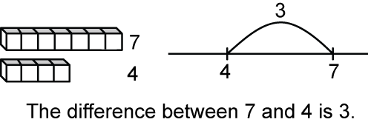
- recognise and use the symbols for plus (+), minus (–) and equals (=)
- record number sentences in a variety of ways using drawings, words, numerals and mathematical symbols
- recognise, recall and record combinations of two numbers that add to 10
- create, record and recognise combinations of two numbers that add to numbers up to and including 9
- model and record patterns for individual numbers by making all possible whole-number combinations, eg
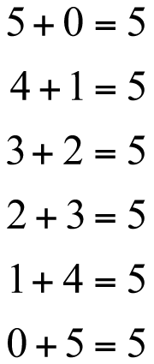 (Communicating, Problem Solving)
- describe combinations for numbers using words such as 'more', 'less' and 'double', eg describe 5 as 'one more than four', 'three combined with two', 'double two and one more' and 'one less than six' (Communicating, Problem Solving)
- create, record and recognise combinations of two numbers that add to numbers from 11 up to and including 20
- use combinations for numbers up to 10 to assist with combinations for numbers beyond 10 (Problem Solving)
- investigate and generalise the effect of adding zero to a number, eg 'Adding zero to a number does not change the number'
- use concrete materials to model the commutative property for addition and apply it to aid the recall of addition facts, eg 4 + 5 = 5 + 4
- relate addition and subtraction facts for numbers to at least 20, eg 5 + 3 = 8, so 8 – 3 = 5 and 8 – 5 = 3
- use and record a range of mental strategies to solve addition and subtraction problems involving one- and two-digit numbers, including:
- counting on from the larger number to find the total of two numbers
- counting back from a number to find the number remaining
- counting on or back to find the difference between two numbers
- using doubles and near doubles, eg 5 + 7: double 5 and add 2
- combining numbers that add to 10, eg 4 + 7 + 8 + 6 + 3: first combine 4 and 6, and 7 and 3, then add 8
- bridging to 10, eg 17 + 5: 17 and 3 is 20, then add 2 more
- using place value to partition numbers, eg 25 + 8: 25 is 20 + 5, so 25 + 8 is 20 + 5 + 8, which is 20 + 13
- choose and apply efficient strategies for addition and subtraction (Problem Solving)
- use the equals sign to record equivalent number sentences involving addition, and to mean 'is the same as', rather than as an indication to perform an operation, eg 5 + 2 = 3 + 4
- check given number sentences to determine if they are true or false and explain why,
eg 'Is 7 + 5 = 8 + 4 true? Why or why not?' (Communicating, Reasoning)
Language
Students should be able to communicate using the following language: counting on, counting back, combine, plus, add, take away, minus, the difference between, total, more than, less than, double, equals, is equal to, is the same as, number sentence, strategy.
The word 'difference' has a specific meaning in this context, referring to the numeric value of the group. In everyday language, it can refer to any attribute. Students need to understand that the requirement to carry out subtraction can be indicated by a variety of language structures. The language used in the 'comparison' type of subtraction is quite different from that used in the 'take away' type.
Students need to understand the different uses for the = sign, eg 4 + 1 = 5, where the = sign indicates that the right side of the number sentence contains 'the answer' and should be read to mean 'equals', compared to a statement of equality such as 4 + 1 = 3 + 2, where the = sign should be read to mean 'is the same as'.
Stage 1
Number and Algebra
Addition and Subtraction 2
Outcomes
A student:
- describes mathematical situations and methods using everyday and some mathematical language, actions, materials, diagrams and symbols MA1-1WM
- uses objects, diagrams and technology to explore mathematical problems MA1-2WM
- supports conclusions by explaining or demonstrating how answers were obtained MA1-3WM
- uses a range of strategies and informal recording methods for addition and subtraction involving one- and two-digit numbers MA1-5NA
Content
Students:
Explore the connection between addition and subtraction (ACMNA029)
- use concrete materials to model how addition and subtraction are inverse operations
- use related addition and subtraction number facts to at least 20,
eg 15 + 3 = 18, so 18 – 3 = 15 and 18 – 15 = 3
Solve simple addition and subtraction problems using a range of efficient mental and written strategies (ACMNA030)
- use and record a range of mental strategies to solve addition and subtraction problems involving two-digit numbers, including:
- the jump strategy on an empty number line
- the split strategy, eg record how the answer to 37 + 45 was obtained using the split strategy
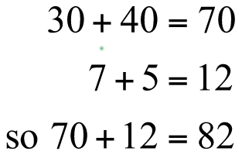
- an inverse strategy to change a subtraction into an addition, eg 54 – 38: start at 38, adding 2 makes 40, then adding 10 makes 50, then adding 4 makes 54, and so the answer is 2 + 10 + 4 = 16
- select and use a variety of strategies to solve addition and subtraction problems involving one- and two-digit numbers
- perform simple calculations with money, eg buying items from a class shop and giving change (Problem Solving)
- check solutions using a different strategy (Problem Solving)
- recognise which strategies are more efficient and explain why (Communicating, Reasoning)
- explain or demonstrate how an answer was obtained for addition and subtraction problems,
eg show how the answer to 15 + 8 was obtained using a jump strategy on an empty number line
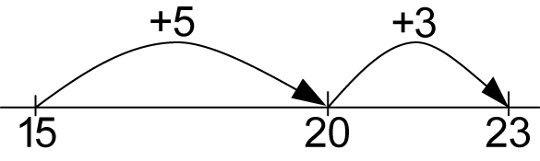 (Communicating, Reasoning)
Background Information
It is appropriate for students in Stage 1 to use concrete materials to model and solve problems, for exploration and for concept building. Concrete materials may also help in explanations of how solutions were obtained.
Addition and subtraction should move from counting and combining perceptual objects, to using numbers as replacements for completed counts with mental strategies, to recordings that support mental strategies (such as jump, split, partitioning and compensation).
Subtraction typically covers two different situations: 'taking away' from a group, and 'comparison' (ie determining how many more or less when comparing two groups). In performing a subtraction, students could use 'counting on or back' from one number to find the difference. The 'counting on or back' type of subtraction is more difficult for students to grasp than the 'taking away' type. Nevertheless, it is important to encourage students to use 'counting on or back' as a method of solving comparison problems once they are confident with the 'taking away' type.
In Stage 1, students develop a range of strategies to aid quick recall of number facts and to solve addition and subtraction problems. They should be encouraged to explain their strategies and to invent ways of recording their actions. It is also important to discuss the merits of various strategies in terms of practicality and efficiency.
Jump strategy on a number line – an addition or subtraction strategy in which the student places the first number on an empty number line and then counts forward or backwards, first by tens and then by ones, to perform a calculation. (The number of jumps will reduce with increased understanding.)
Jump strategy method: eg 46 + 33
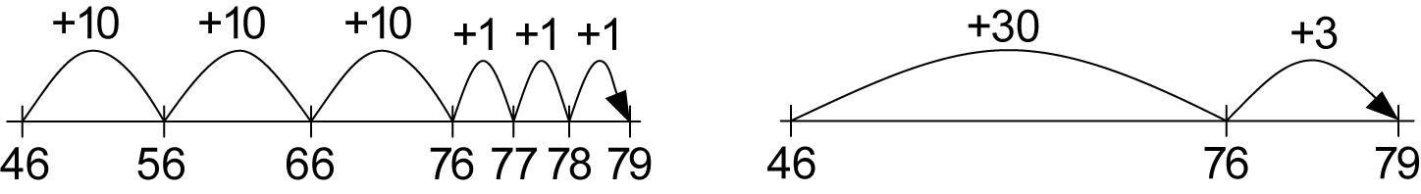

Jump strategy method: eg 79 – 33
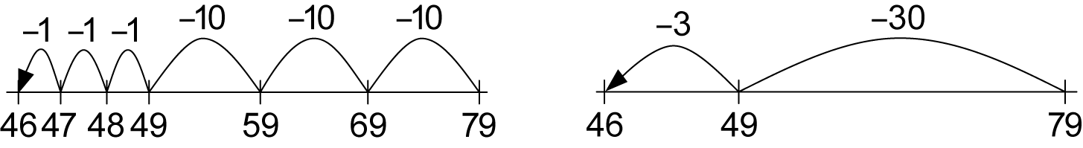
Split strategy – an addition or subtraction strategy in which the student separates the tens from the units and adds or subtracts each separately before combining to obtain the final answer.
Split strategy method: eg 46 + 33
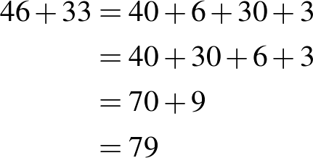
Inverse strategy – a subtraction strategy in which the student adds forward from the smaller number to obtain the larger number, and so obtains the answer to the subtraction calculation.
Inverse strategy method: eg 65 – 37
start at 37
add 3 to make 40
then add 20 to make 60
then add 5 to make 65
and so the answer is 3 + 20 + 5 = 28
An inverse operation is an operation that reverses the effect of the original operation. Addition and subtraction are inverse operations; multiplication and division are inverse operations.
Language
Students should be able to communicate using the following language: plus, add, take away, minus, the difference between, equals, is equal to, empty number line, strategy.
Some students may need assistance when two tenses are used within the one problem, eg 'I had six beans and took away four. So, how many do I have now?'
The word 'left' can be confusing for students, eg 'There were five children in the room. Three went to lunch. How many are left?' Is the question asking how many children are remaining in the room, or how many children went to lunch?
Stage 1
Number and Algebra
Multiplication and Division 1
Outcomes
A student:
- describes mathematical situations and methods using everyday and some mathematical language, actions, materials, diagrams and symbols MA1-1WM
- uses a range of mental strategies and concrete materials for multiplication and division MA1-6NA
Content
Students:
Skip count by twos, fives and tens starting from zero (ACMNA012)
- count by twos, fives and tens using rhythmic counting and skip counting from zero
- use patterns on a number chart to assist in counting by twos, fives or tens (Communicating)
Model and use equal groups of objects as a strategy for multiplication
- model and describe collections of objects as 'groups of', eg
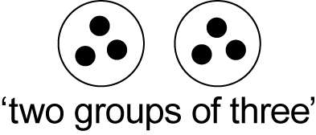
- recognise the importance of having groups of equal size (Reasoning)
- determine and distinguish between the 'number of groups' and the 'number in each group' when describing collections of objects (Communicating)
- find the total number of objects using skip counting
Recognise and represent division as grouping into equal sets (ACMNA032)
- recognise when there are equal numbers of items in groups, eg 'There are three pencils in each group'
- model division by sharing a collection of objects equally into a given number of groups to determine how many in each group, eg determine the number in each group when 10 objects are shared between two people

- describe the part left over when a collection cannot be shared equally into a given number of groups (Communicating, Problem Solving, Reasoning)
- model division by sharing a collection of objects into groups of a given size to determine the number of groups, eg determine the number of groups when 20 objects are shared into groups of four
- describe the part left over when a collection cannot be distributed equally using the given group size, eg when 22 objects are shared into groups of four, there are five groups of four and two objects left over (Communicating, Problem Solving, Reasoning)
Background Information
There are two forms of division:
Sharing (partitive) – How many in each group?
eg 'If 12 marbles are shared between three students, how many does each get?'
Grouping (quotitive) – How many groups are there?
eg 'If I have 12 marbles and each child is to get four, how many children will get marbles?'
After students have divided a quantity into equal groups (eg they have divided 12 into groups of four), the process can be reversed by combining the groups, thus linking multiplication and division.
When sharing a collection of objects into two groups, students may describe the number of objects in each group as being one-half of the whole collection.
Language
Students should be able to communicate using the following language: group, number of groups, number in each group, sharing, shared between, left over, total, equal.
Sharing – relates to distributing items one at a time into a set number of groups, eg the student has a number of pop sticks and three cups and shares out the pop sticks into the cups one at a time.
Grouping – relates to distributing the same number of items into an unknown number of groups, eg the student has 12 pop sticks and wants to make groups of four, so places four pop sticks down, then another four, and so on.
It is preferable that students use 'groups of', before progressing to 'rows of' and 'columns of'. The term 'lots of' can be confusing to students because of its everyday use and should be avoided, eg 'lots of fish in the sea'.
Stage 1
Number and Algebra
Multiplication and Division 2
Outcomes
A student:
- describes mathematical situations and methods using everyday and some mathematical language, actions, materials, diagrams and symbols MA1-1WM
- uses objects, diagrams and technology to explore mathematical problems MA1-2WM
- supports conclusions by explaining or demonstrating how answers were obtained MA1-3WM
- uses a range of mental strategies and concrete materials for multiplication and division MA1-6NA
Content
Students:
Recognise and represent multiplication as repeated addition, groups and arrays (ACMNA031)
- model multiplication as repeated addition, eg 3 groups of 4 is the same as 4 + 4 + 4
- find the total number of objects by placing them into equal-sized groups and using repeated addition (Problem Solving)
- use empty number lines and number charts to record repeated addition, eg
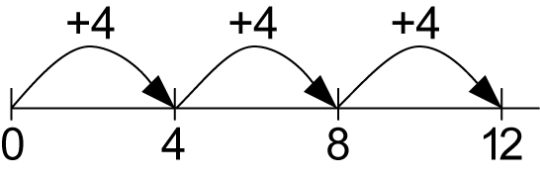(Communicating)
- explore the use of repeated addition to count in practical situations, eg counting stock on a farm (Problem Solving)
- recognise when items have been arranged into groups, eg 'I can see two groups of three pencils'
- use concrete materials to model multiplication as equal 'groups' and by forming an array of equal 'rows' or equal 'columns', eg
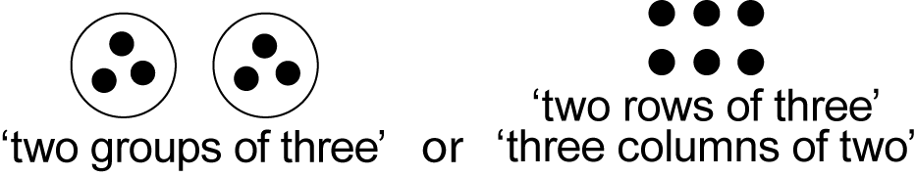
- describe collections of objects as 'groups of', 'rows of' and 'columns of' (Communicating)
- determine and distinguish between the 'number of rows/columns' and the 'number in each row/column' when describing collections of objects (Communicating)
- recognise practical examples of arrays, such as seedling trays or vegetable gardens (Reasoning)
- model the commutative property of multiplication, eg '3 groups of 2 is the same as 2 groups of 3'
Represent division as grouping into equal sets and solve simple problems using these representations (ACMNA032)
- model division by sharing a collection of objects equally into a given number of groups, and by sharing equally into a given number of rows or columns in an array, eg determine the number each person receives when 10 objects are shared between two people

- describe the part left over when a collection cannot be shared equally into a given number of groups/rows/columns (Communicating, Problem Solving, Reasoning)
- model division by sharing a collection of objects into groups of a given size, and by arranging it into rows or columns of a given size in an array, eg determine the number of columns in an array when 20 objects are arranged into rows of four
- describe the part left over when a collection cannot be distributed equally using the given group/row/column size, eg when 14 objects are arranged into rows of five, there are two rows of five and four objects left over (Communicating, Problem Solving, Reasoning)
- model division as repeated subtraction
- use an empty number line to record repeated subtraction (Communicating)
- explore the use of repeated subtraction to share in practical situations, eg share 20 stickers between five people (Problem Solving)
- solve multiplication and division problems using objects, diagrams, imagery and actions
- support answers by demonstrating how an answer was obtained (Communicating)
- recognise which strategy worked and which did not work and explain why (Communicating, Reasoning)
- record answers to multiplication and division problems using drawings, words and numerals, eg 'two rows of five make ten', '2 rows of 5 is 10'
Background Information
There are two forms of division:
Sharing (partitive) – How many in each group?
eg 'If 12 marbles are shared between three students, how many does each get?'
Grouping (quotitive) – How many groups are there?
eg 'If I have 12 marbles and each child is to get four, how many children will get marbles?' This form of division relates to repeated subtraction, 12 – 4 – 4 – 4 = 0, so three children will get four marbles each.
After students have divided a quantity into equal groups (eg they have divided 12 into groups of four), the process can be reversed by combining the groups, thus linking multiplication and division.
When sharing a collection of objects into two, four or eight groups, students may describe the number of objects in each group as being one-half, one-quarter or one-eighth, respectively, of the whole collection.
An array is one of several different arrangements that can be used to model multiplicative situations involving whole numbers. It is made by arranging a set of objects, such as counters, into columns and rows. Each column must contain the same number of objects as the other columns, and each row must contain the same number of objects as the other rows.
Formal writing of number sentences for multiplication and division, including the use of the symbols × and ÷, is not introduced until Stage 2.
Language
Students should be able to communicate using the following language: add, take away, group, row, column, array, number of rows, number of columns, number in each row, number in each column, total, equal, is the same as, shared between, shared equally, part left over, empty number line, number chart.
The term 'row' refers to a horizontal grouping, and the term 'column' refers to a vertical grouping.
Refer also to language in Stage 1 Multiplication and Division 1.
Stage 1
Number and Algebra
Fractions and Decimals 1
Outcomes
A student:
- describes mathematical situations and methods using everyday and some mathematical language, actions, materials, diagrams and symbols MA1-1WM
- represents and models halves, quarters and eighths MA1-7NA
Content
Students:
Recognise and describe one-half as one of two equal parts of a whole (ACMNA016)
- use concrete materials to model half of a whole object, eg
- describe two equal parts of a whole object, eg 'I folded my paper into two equal parts and now I have halves' (Communicating)
- recognise that halves refer to two equal parts of a whole
- describe parts of a whole object as 'about a half', 'more than a half' or 'less than a half'
- record two equal parts of whole objects and shapes, and the relationship of the parts to the whole, using pictures and the fraction notation for half 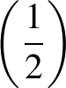, eg
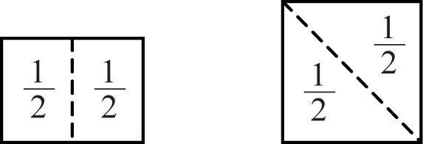
- use concrete materials to model half of a collection, eg
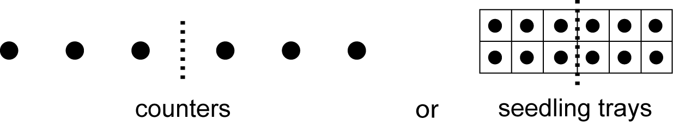
- describe two equal parts of a collection, eg 'I have halves because the two parts have the same number of seedlings' (Communicating)
- record two equal parts of a collection, and the relationship of the parts to the whole, using pictures and fraction notation for half , eg
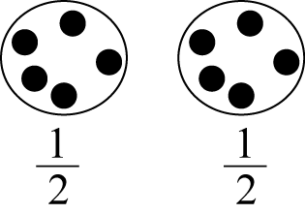
Background Information
In Stage 1, fractions are used in two different ways: to describe equal parts of a whole, and to describe equal parts of a collection of objects. Fractions refer to the relationship of the equal parts to the whole unit. When using collections to model fractions, it is important that students appreciate the collection as being a 'whole' and the resulting groups as being 'parts of a whole'. It should be noted that the size of the resulting fraction will depend on the size of the original whole or collection of objects.
It is not necessary for students to distinguish between the roles of the numerator and the denominator in Stage 1. They may use the symbol as an entity to mean 'one-half' or 'a half', and similarly use to mean 'one-quarter' or 'a quarter'.
Three models of fractions
Continuous model, linear – uses one-directional cuts or folds that compare fractional parts based on length; this model should be introduced first. Cuts or folds may be either vertical or horizontal.
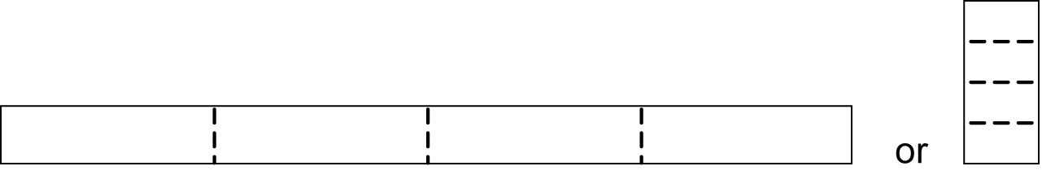
Continuous model, area – uses multi-directional cuts or folds to compare fractional parts to the whole. This model should be introduced once students have an understanding of the concept of area in Stage 2.
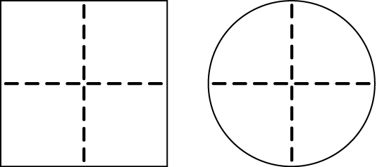
Discrete model – uses separate items in collections to represent parts of the whole group.

Language
Students should be able to communicate using the following language: whole, part, equal parts, half, halves, about a half, more than a half, less than a half.
Some students may hear 'whole' in the phrase 'part of a whole' and confuse it with the term 'hole'.
Stage 1
Number and Algebra
Fractions and Decimals 2
Outcomes
A student:
- describes mathematical situations and methods using everyday and some mathematical language, actions, materials, diagrams and symbols MA1-1WM
- supports conclusions by explaining or demonstrating how answers were obtained MA1-3WM
- represents and models halves, quarters and eighths MA1-7NA
Content

Students:
Recognise and interpret common uses of halves, quarters and eighths of shapes and collections (ACMNA033)
- use concrete materials to model a half, a quarter or an eighth of a whole object, eg divide a piece of ribbon into quarters
- create quarters by halving one-half, eg 'I halved my paper then halved it again and now I have quarters' (Communicating, Problem Solving)
- describe the equal parts of a whole object, eg 'I folded my paper into eight equal parts and now I have eighths' (Communicating)
- discuss why is less than , eg if a cake is shared among eight people, the slices are smaller than if the cake is shared among four people (Communicating, Reasoning)
- recognise that fractions refer to equal parts of a whole, eg all four quarters of an object are the same size
- visualise fractions that are equal parts of a whole, eg 'Imagine where you would cut the rectangle before cutting it' (Problem Solving)
- recognise when objects and shapes have been shared into halves, quarters or eighths
- record equal parts of whole objects and shapes, and the relationship of the parts to the whole, using pictures and the fraction notation for half , quarter 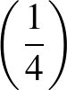 and eighth 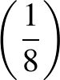, eg
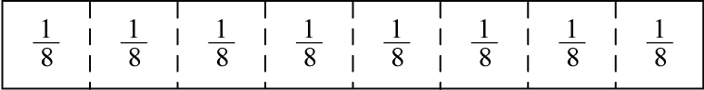
- use concrete materials to model a half, a quarter or an eighth of a collection, eg

- describe equal parts of a collection of objects, eg 'I have quarters because the four parts have the same number of counters' (Communicating)
- recognise when a collection has been shared into halves, quarters or eighths
- record equal parts of a collection, and the relationship of the parts to the whole, using pictures and the fraction notation for half , quarter and eighth
- use fraction language in a variety of everyday contexts, eg the half-hour, one-quarter of the class
Background Information
Refer to background information in Fractions and Decimals 1.
Language
Students should be able to communicate using the following language: whole, part, equal parts, half, quarter, eighth, one-half, one-quarter, one-eighth, halve (verb).
In Stage 1, the term 'three-quarters' may be used to name the remaining parts after one-quarter has been identified.
Stage 1
Number and Algebra
Patterns and Algebra 1
Outcomes
A student:
- describes mathematical situations and methods using everyday and some mathematical language, actions, materials, diagrams and symbols MA1-1WM
- uses objects, diagrams and technology to explore mathematical problems MA1-2WM
- creates, represents and continues a variety of patterns with numbers and objects MA1-8NA
Content
Students:
Investigate and describe number patterns formed by skip counting and patterns with objects (ACMNA018)
- identify and describe patterns when skip counting forwards or backwards by ones, twos, fives and tens from any starting point
- use objects to represent counting patterns (Communicating)
- investigate and solve problems based on number patterns (Problem Solving)
- represent number patterns on number lines and number charts
- recognise, copy and continue given number patterns that increase or decrease, eg
1, 2, 3, 4, …
20, 18, 16, 14, …
- describe how number patterns are made and how they can be continued (Communicating, Problem Solving)
- create, record and describe number patterns that increase or decrease
- recognise, copy and continue patterns with objects or symbols
- recognise when an error occurs in a pattern and explain what is wrong (Communicating, Problem Solving)
- create, record and describe patterns with objects or symbols
- describe a repeating pattern of objects or symbols in terms of a 'number' pattern, eg
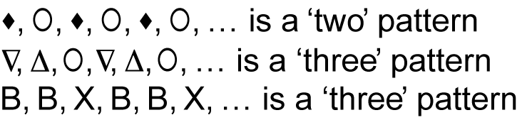
- make connections between repeating patterns and counting, eg a 'three' pattern and skip counting by threes (Communicating, Reasoning)
- model and describe 'odd' and 'even' numbers using counters paired in two rows
- describe the pattern created by modelling odd and even numbers (Communicating)
Background Information
Repeating patterns of objects or symbols are described using numbers that indicate the number of elements that repeat, eg A, B, C, A, B, C, … has three elements that repeat and is referred to as a 'three' pattern.
In Stage 1, students further explore additive number patterns that increase or decrease. Patterns could now include any patterns observed on a number chart and these might go beyond patterns created by counting in ones, twos, fives or tens. This links closely with the development of Whole Numbers and Multiplication and Division.
Language
Students should be able to communicate using the following language: pattern, number line, number chart, odd, even.
Stage 1
Number and Algebra
Patterns and Algebra 2
Outcomes
A student:
- describes mathematical situations and methods using everyday and some mathematical language, actions, materials, diagrams and symbols MA1-1WM
- uses objects, diagrams and technology to explore mathematical problems MA1-2WM
- supports conclusions by explaining or demonstrating how answers were obtained MA1-3WM
- creates, represents and continues a variety of patterns with numbers and objects MA1-8NA
Content
Students:
Describe patterns with numbers and identify missing elements (ACMNA035)
- describe a number pattern in words, eg 'It goes up by threes'
- determine a missing number in a number pattern, eg 3, 7, 11, __, 19, 23, 27
- describe how the missing number in a number pattern was determined (Communicating, Reasoning)
- check solutions when determining missing numbers in number patterns by repeating the process (Reasoning)
Solve problems by using number sentences for addition or subtraction (ACMNA036)
- complete number sentences involving one operation of addition or subtraction by calculating the missing number, eg find so that 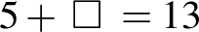 or
- make connections between addition and related subtraction facts to at least 20 (Reasoning)
- describe how a missing number in a number sentence was calculated (Communicating, Reasoning)
- solve problems involving addition or subtraction by using number sentences
- represent a word problem as a number sentence (Communicating, Problem Solving)
- pose a word problem to represent a number sentence (Communicating, Problem Solving)
Background Information
In Stage 1, describing number relationships and making generalisations should be encouraged when appropriate.
Language
Students should be able to communicate using the following language: pattern, missing number, number sentence.
Stage 1
Measurement and Geometry
Length 1
Outcomes
A student:
- describes mathematical situations and methods using everyday and some mathematical language, actions, materials, diagrams and symbols MA1-1WM
- supports conclusions by explaining or demonstrating how answers were obtained MA1-3WM
- measures, records, compares and estimates lengths and distances using uniform informal units, metres and centimetres MA1-9MG
Content
Students:
Measure and compare the lengths of pairs of objects using uniform informal units (ACMMG019)
- use uniform informal units to measure lengths and distances by placing the units end-to-end without gaps or overlaps
- select appropriate uniform informal units to measure lengths and distances, eg paper clips instead of pop sticks to measure a pencil, paces instead of pop sticks to measure the length of the playground (Problem Solving)
- measure the lengths of a variety of everyday objects, eg use handspans to measure the length of a table (Problem Solving)
- explain the relationship between the size of a unit and the number of units needed, eg more paper clips than pop sticks will be needed to measure the length of the desk (Communicating, Reasoning)
- record lengths and distances by referring to the number and type of uniform informal unit used
- investigate different informal units of length used in various cultures, including those used in Aboriginal communities (Communicating)
- compare the lengths of two or more objects using appropriate uniform informal units and check by placing the objects side-by-side and aligning the ends
- explain why the length of an object remains constant when units are rearranged, eg 'The book was seven paper clips long. When I moved the paper clips around and measured again, the book was still seven paper clips long' (Communicating, Reasoning)
- estimate linear dimensions and the lengths of curves by referring to the number and type of uniform informal unit used and check by measuring
- discuss strategies used to estimate lengths, eg visualising the repeated unit, using the process 'make, mark and move' (Communicating, Problem Solving)
Background Information
In Stage 1, measuring the lengths of objects using uniform informal units enables students to develop some key understandings of measurement. These include that:
- units should be repeatedly placed end-to-end without gaps or overlaps
- units must be equal in size
- identical units should be used to compare lengths
- some units are more appropriate for measuring particular objects
- there is a relationship between the size of the chosen unit and the number of units needed.
Using the terms 'make', 'mark' and 'move' assists students in understanding the concept of repeated units. By placing a unit on a flat surface, marking where it ends, moving it along and continuing the process, students see that the unit of measurement is the space between the marks on a measuring device and not the marks themselves.
Recognising that a length may be divided and recombined to form the same length is an important component of conserving length.
It is important that students have had some measurement experiences before being asked to estimate lengths and distances, and that a variety of estimation strategies is taught.
Students will have an informal understanding of measurement prior to school, although this may not align to Western concepts of measurement. In particular, Aboriginal students often have developed a sense of measurement based on their self and their environment.
Language
Students should be able to communicate using the following language: length, distance, end, end-to-end, side-by-side, gap, overlap, measure, estimate, handspan.
Stage 1
Measurement and Geometry
Length 2
Outcomes
A student:
- describes mathematical situations and methods using everyday and some mathematical language, actions, materials, diagrams and symbols MA1-1WM
- supports conclusions by explaining or demonstrating how answers were obtained MA1-3WM
- measures, records, compares and estimates lengths and distances using uniform informal units, metres and centimetres MA1-9MG
Content
Students:
Compare and order several shapes and objects based on length, using appropriate uniform informal units (ACMMG037)
- relate the term 'length' to the longest dimension when referring to an object
- make and use a tape measure calibrated in uniform informal units, eg calibrate a paper strip using footprints as a repeated unit
- use computer software to draw a line and use a simple graphic as a uniform informal unit to measure its length (Communicating)
- compare and order two or more shapes or objects according to their lengths using an appropriate uniform informal unit
- compare the lengths of two or more objects that cannot be moved or aligned (Reasoning)
- record length comparisons informally using drawings, numerals and words, and by referring to the uniform informal unit used
Recognise and use formal units to measure the lengths of objects
- recognise the need for formal units to measure lengths and distances
- use the metre as a unit to measure lengths and distances to the nearest metre or half-metre
- explain and model, using concrete materials, that a metre-length can be a straight line or a curved line (Communicating, Reasoning)
- record lengths and distances using the abbreviation for metres (m)
- estimate lengths and distances to the nearest metre and check by measuring
- recognise the need for a formal unit smaller than the metre
- recognise that there are 100 centimetres in one metre, ie 100 centimetres = 1 metre
- use the centimetre as a unit to measure lengths to the nearest centimetre, using a device with 1 cm markings, eg use a paper strip of length 10 cm
- record lengths and distances using the abbreviation for centimetres (cm)
- estimate lengths and distances to the nearest centimetre and check by measuring
Background Information
Students should be given opportunities to apply their understanding of measurement, gained through experiences with the use of uniform informal units, to experiences with the use of the centimetre and metre. They could make a measuring device using uniform informal units before using a ruler, eg using a length of 10 connecting cubes. This would assist students in understanding that the distances between marks on a ruler represent unit lengths and that the marks indicate the endpoints of each unit.
When recording measurements, a space should be left between the number and the abbreviated unit, eg 3 cm, not 3cm.
Refer also to background information in Length 1.
Language
Students should be able to communicate using the following language: length, distance, straight line, curved line, metre, centimetre, measure, estimate.
Stage 1
Measurement and Geometry
Area 1
Outcomes
A student:
- describes mathematical situations and methods using everyday and some mathematical language, actions, materials, diagrams and symbols MA1-1WM
- measures, records, compares and estimates areas using uniform informal units MA1-10MG
Content
Students:
Measure and compare areas using uniform informal units
- compare, indirectly, the areas of two surfaces that cannot be moved or superimposed, eg by cutting paper to cover one surface and superimposing the paper over the second surface
- predict the larger of the areas of two surfaces of the same general shape and compare these areas by cutting and covering
- use uniform informal units to measure area by covering the surface in rows or columns without gaps or overlaps
- select and use appropriate uniform informal units to measure area (Reasoning)
- explain the relationship between the size of a unit and the number of units needed to measure an area, eg 'I need more tiles than workbooks to measure the area of my desktop' (Communicating, Reasoning)
- describe why the area remains constant when units are rearranged (Communicating, Reasoning)
- describe any parts of units left over when counting uniform informal units to measure area (Communicating)
- use computer software to create a shape and use a simple graphic as a uniform informal unit to measure its area (Communicating)
- record areas by referring to the number and type of uniform informal unit used, eg 'The area of this surface is 20 tiles'
- estimate areas by referring to the number and type of uniform informal unit used and check by measuring
- discuss strategies used to estimate area, eg visualising the repeated unit (Communicating, Problem Solving)
Background Information
Area relates to the measurement of two-dimensional space in the same way that volume and capacity relate to the measurement of three-dimensional space.
The attribute of area is the amount of surface (either flat or curved) and can be measured in square units, eg square centimetres (cm²), square metres (m²).
In Stage 1, measuring the areas of objects using informal units enables students to develop some key understandings of measurement. These include repeatedly placing units so that there are no gaps or overlaps and understanding that the units must be equal in size. Covering surfaces with a range of informal units should assist students in understanding that some units tessellate and are therefore more suitable for measuring area.
When students understand why tessellating units are important, they should be encouraged to make, draw and describe the spatial structure (grid). Students should develop procedures for counting tile or grid units so that no units are missed or counted twice.
Students should also be encouraged to identify and use efficient strategies for counting, eg using repeated addition, rhythmic counting or skip counting.
It is important that students have had some measurement experiences before being asked to estimate areas, and that a variety of estimation strategies is taught.
Students may have a prior understanding of area based upon the concept of boundaries and/or landmarks, such as those used by Aboriginal communities.
Language
Students should be able to communicate using the following language: area, surface, measure, row, column, gap, overlap, parts of (units), estimate.
Stage 1
Measurement and Geometry
Area 2
Outcomes
A student:
- describes mathematical situations and methods using everyday and some mathematical language, actions, materials, diagrams and symbols MA1-1WM
- supports conclusions by explaining or demonstrating how answers were obtained MA1-3WM
- measures, records, compares and estimates areas using uniform informal units MA1-10MG
Content
Students:
Compare and order several shapes and objects based on area using appropriate uniform informal units (ACMMG037)
- draw the spatial structure (grid) of repeated units covering a surface
- explain the structure of the unit tessellation in terms of rows and columns (Communicating)
- compare and order the areas of two or more surfaces that cannot be moved, or superimposed, by measuring in uniform informal units
- predict the larger of two or more areas and check by measuring (Reasoning)
- record comparisons of area informally using drawings, numerals and words, and by referring to the uniform informal unit used
Background Information
Refer to background information in Area 1.
Language
Students should be able to communicate using the following language: area, surface, measure, grid, row, column.

Stage 1
Measurement and Geometry
Volume and Capacity 1
Outcomes
A student:
- describes mathematical situations and methods using everyday and some mathematical language, actions, materials, diagrams and symbols MA1-1WM
- supports conclusions by explaining or demonstrating how answers were obtained MA1-3WM
- measures, records, compares and estimates volumes and capacities using uniform informal units MA1-11MG
Content
Students:
Measure and compare the capacities of pairs of objects using uniform informal units (ACMMG019)
- use uniform informal units to measure the capacities of containers by counting the number of times a smaller container can be filled and emptied into the container being measured
- select appropriate uniform informal units to measure the capacities of containers, eg using cups rather than teaspoons to fill a bucket (Problem Solving)
- explain the relationship between the size of a unit and the number of units needed, eg more cups than ice cream containers will be needed to fill a bucket (Communicating, Reasoning)
- record capacities by referring to the number and type of uniform informal unit used
- compare the capacities of two or more containers using appropriate uniform informal units
- recognise that containers of different shapes may have the same capacity (Reasoning)
- estimate capacities by referring to the number and type of uniform informal unit used and check by measuring
- pack cubic units (eg blocks) into rectangular containers so that there are no gaps
- recognise that cubes pack better than other objects in rectangular containers (Reasoning)
- measure the volume of a container by filling the container with uniform informal units and counting the number of units used, eg the number of blocks a box can hold
- devise and explain strategies for packing and counting units to fill a box, eg packing in layers and ensuring that there are no gaps between units (Communicating, Problem Solving)
- explain that if there are gaps when packing and stacking, this will affect the accuracy of measuring the volume (Communicating, Reasoning)
- record volumes by referring to the number and type of uniform informal unit used
- estimate volumes of containers by referring to the number and type of uniform informal unit used and check by measuring
- explain a strategy used for estimating a volume (Communicating, Problem Solving)
- predict the larger volume of two or more containers and check by measuring using uniform informal units (Reasoning)
- estimate the volume of a pile of material and check by measuring, eg estimate how many buckets would be used to form a pile of sand
Background Information
The order in which volume and capacity appear in the content is not necessarily indicative of the order in which they should be taught.
Volume and capacity relate to the measurement of three-dimensional space, in the same way that area relates to the measurement of two-dimensional space.
The attribute of volume is the amount of space occupied by an object or substance and can be measured in cubic units, eg cubic centimetres (cm³) and cubic metres (m³).
Capacity refers to the amount a container can hold, and can be measured in millilitres (mL) and/or litres (L). Capacity is only used in relation to containers and generally refers to liquid measurement. The capacity of a closed container will be slightly less than its volume – capacity is based on the inside dimensions, while volume is determined by the outside dimensions of the container. It is not necessary to refer to these definitions with students (capacity is not taught as a concept separate from volume until Stage 4).
Students need experience in filling containers both with continuous material (eg water) and with discrete objects (eg marbles). The use of continuous material leads to measurement using the units litre and millilitre in later stages. The use of blocks leads to measurement using the units cubic metre and cubic centimetre.
Language
Students should be able to communicate using the following language: capacity, container, liquid, full, empty, volume, gap, measure, estimate.
Stage 1
Measurement and Geometry
Volume and Capacity 2
Outcomes
A student:
- describes mathematical situations and methods using everyday and some mathematical language, actions, materials, diagrams and symbols MA1-1WM
- uses objects, diagrams and technology to explore mathematical problems MA1-2WM
- supports conclusions by explaining or demonstrating how answers were obtained MA1-3WM
- measures, records, compares and estimates volumes and capacities using uniform informal units MA1-11MG
Content
Students:
Compare and order several objects based on volume and capacity using appropriate uniform informal units (ACMMG037)
- make and use a measuring device for capacity calibrated in uniform informal units, eg calibrate a bottle by adding cups of water and marking the new level as each cup is added
- compare and order the capacities of two or more containers by measuring each container in uniform informal units
- compare and order the volumes of two or more models by counting the number of blocks used in each model
- recognise that models with different appearances may have the same volume (Reasoning)
- compare and order the volumes of two or more objects by marking the change in water level when each is submerged
- recognise that changing the shape of an object does not change the amount of water it displaces (Reasoning)
- record volume and capacity comparisons informally using drawings, numerals and words, and by referring to the uniform informal unit used
Background Information
The order in which volume and capacity appear in the content is not necessarily indicative of the order in which they should be taught.
Calibrating a container using uniform informal units is a precursor to students using measuring cylinders calibrated in formal units (litres and millilitres) at a later stage.
An object displaces its own volume when totally submerged.
Refer also to background information in Volume and Capacity 1.
Language
Students should be able to communicate using the following language: capacity, container, volume, measure.
Stage 1
Measurement and Geometry
Mass 1
Outcomes
A student:
- describes mathematical situations and methods using everyday and some mathematical language, actions, materials, diagrams and symbols MA1-1WM
- measures, records, compares and estimates the masses of objects using uniform informal units MA1-12MG
Content
Students:
Investigate mass using a pan balance
- identify materials that are light or heavy
- place objects on either side of a pan balance to obtain a level balance
- use a pan balance to compare the masses of two objects
- discuss the action of a pan balance when a heavy object is placed in one pan and a lighter object in the other pan (Communicating)
- predict the action of a pan balance before placing particular objects in each pan (Reasoning)
- sort objects on the basis of their mass
- use a pan balance to find two collections of objects that have the same mass, eg a collection of blocks and a collection of counters
- use drawings to record findings from using a pan balance
Background Information
Mass is an intrinsic property of an object, but its most common measure is in terms of weight. Weight is a force that changes with gravity, while mass remains constant.
Language
Students should be able to communicate using the following language: mass, heavy, heavier, light, lighter, about the same as, pan balance, (level) balance.
As the terms 'weigh' and 'weight' are common in everyday usage, they can be accepted in student language should they arise.
Stage 1
Measurement and Geometry
Mass 2
Outcomes
A student:
- describes mathematical situations and methods using everyday and some mathematical language, actions, materials, diagrams and symbols MA1-1WM
- uses objects, diagrams and technology to explore mathematical problems MA1-2WM
- supports conclusions by explaining or demonstrating how answers were obtained MA1-3WM
- measures, records, compares and estimates the masses of objects using uniform informal units MA1-12MG
Content
Students:
Compare the masses of objects using balance scales (ACMMG038)
- compare and order the masses of two or more objects by hefting and check using a pan balance
- recognise that mass is conserved, eg the mass of a lump of plasticine remains constant regardless of the shape it is moulded into or whether it is divided up into smaller pieces
- use uniform informal units to measure the mass of an object by counting the number of units needed to obtain a level balance on a pan balance
- select an appropriate uniform informal unit to measure the mass of an object and justify the choice (Problem Solving)
- explain the relationship between the mass of a unit and the number of units needed, eg more toothpicks than pop sticks will be needed to balance the object (Communicating, Reasoning)
- record masses by referring to the number and type of uniform informal unit used
- compare two or more objects according to their masses using appropriate uniform informal units
- record comparisons of mass informally using drawings, numerals and words, and by referring to the uniform informal units used
- find differences in mass by measuring and comparing, eg 'The pencil has a mass equal to three blocks and a pair of plastic scissors has a mass of six blocks, so the scissors are three blocks heavier than the pencil'
- predict whether the number of units will be more or less when a different unit is used, eg 'I will need more pop sticks than blocks as the pop sticks are lighter than the blocks' (Reasoning)
- solve problems involving mass (Problem Solving)
- estimate mass by referring to the number and type of uniform informal unit used and check by measuring
Background Information
In Stage 1, measuring mass using informal units enables students to develop some key understandings of measurement. These include:
- repeatedly using a unit as a measuring device
- selecting an appropriate unit for a specific task
- appreciating that a common informal unit is necessary for comparing the masses of objects
- understanding that some units are unsatisfactory because they are not uniform, eg pebbles.
Students should appreciate that the pan balance has two functions: comparing the masses of two objects and measuring the mass of an object by using a unit repeatedly as a measuring device.
When students realise that changing the shape of an object does not alter its mass, they are said to conserve the property of mass.
Language
Students should be able to communicate using the following language: mass, heavier, lighter, about the same as, pan balance, (level) balance, measure, estimate.
'Hefting' is testing the weight of an object by lifting and balancing it. Where possible, students can compare the weights of two objects by using their bodies to balance each object, eg holding one object in each hand.
Refer also to language in Mass 1.
Stage 1
Measurement and Geometry
Time 1
Outcomes
A student:
- describes mathematical situations and methods using everyday and some mathematical language, actions, materials, diagrams and symbols MA1-1WM
- uses objects, diagrams and technology to explore mathematical problems MA1-2WM
- describes, compares and orders durations of events, and reads half- and quarter-hour time MA1-13MG
Content
Students:
Name and order months and seasons (ACMMG040)
- name and order the months of the year
- recall the number of days that there are in each month
- name and order the seasons, and name the months for each season
- describe the environmental characteristics of each season, eg 'Winter is cool and some trees lose their leaves' (Communicating)
- recognise that in some cultures seasonal changes mark the passing of time, eg the flowering of plants and the migration patterns of animals are used by many peoples, including Aboriginal people (Reasoning)
- recognise that in countries in the northern hemisphere, the season is the opposite to that being experienced in Australia at that time (Reasoning)
Use a calendar to identify the date and determine the number of days in each month (ACMMG041)
- identify a day and date using a conventional calendar
- identify personally or culturally significant days (Communicating)
- identify the different uses of calendars in various communities (Communicating)
Tell time to the half-hour (ACMMG020)
- read analog and digital clocks to the half-hour using the terms 'o'clock' and 'half past'
- describe the position of the hands on a clock for the half-hour
- explain why the hour hand on a clock is halfway between the two hour-markers when the minute hand shows the half-hour (Communicating, Reasoning)
- describe everyday events with particular hour and half-hour times, eg 'We start school at 9 o'clock' (Communicating)
- record hour and half-hour time on analog and digital clocks
Background Information
'Timing' and 'telling time' are two different notions. The first relates to the duration of time and the second is 'dial reading'. Both, however, assist students in understanding the passage of time and its measurement.
Duration
It is important in Stage 1 that students develop a sense of one hour, one minute and one second through practical experiences, rather than simply recalling that there are 60 minutes in an hour.
Telling Time
In Stage 1, 'telling time' focuses on reading the half-hour on both analog and digital clocks. An important understanding is that when the minute hand shows the half-hour, the hour hand is always halfway between two hour-markers. Students need to be aware that there is always more than one way of expressing a particular time, eg
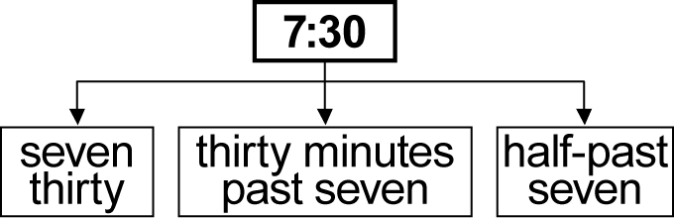
Note: When writing digital time, two dots should separate hours and minutes, eg 9:30.
In Aboriginal communities, calendars may vary in accordance with local seasonal and environmental changes, such as the flowering of plants and the migration patterns of animals, or according to significant events in the local community. Consult with local communities regarding specific local perspectives.
Language
Students should be able to communicate using the following language: calendar, days, date, month, year, seasons, time, clock, analog, digital, hour hand, minute hand, o'clock, half past.
The terms 'hour hand' and 'minute hand', rather than 'big hand' and 'little hand', should be used to promote understanding of their respective functions.
Stage 1
Measurement and Geometry
Time 2
Outcomes
A student:
- describes mathematical situations and methods using everyday and some mathematical language, actions, materials, diagrams and symbols MA1-1WM
- uses objects, diagrams and technology to explore mathematical problems MA1-2WM
- supports conclusions by explaining or demonstrating how answers were obtained MA1-3WM
- describes, compares and orders durations of events, and reads half- and quarter-hour time MA1-13MG
Content
Students:
Describe duration using months, weeks, days and hours (ACMMG021)
- use a calendar to calculate the number of months, weeks or days until an upcoming event
- estimate and measure the duration of an event using a repeated informal unit, eg the number of times you can clap your hands while the teacher writes your name
- solve simple everyday problems about time and duration (Problem Solving)
- recognise that some cultures use informal units of time, eg the use of tidal change in Aboriginal communities (Reasoning)
- compare and order the duration of events measured using a repeated informal unit, eg 'It takes me ten claps to write my name but only two claps to say my name'
- use the terms 'hour', 'minute' and 'second'
- experience and recognise activities that have a duration of one hour, half an hour or a quarter of an hour, one minute, and a few seconds
- indicate when it is thought that an activity has continued for one hour, one minute or one second (Reasoning)
- compare and discuss the relationship between time units, eg an hour is a longer time than a minute (Communicating, Reasoning)
- make predictions about the duration of time remaining until a particular school activity starts or finishes, eg the length of time until lunch begins (Reasoning)
Tell time to the quarter-hour using the language of 'past' and 'to' (ACMMG039)
- read analog and digital clocks to the quarter-hour using the terms 'past' and 'to', eg 'It is a quarter past three', 'It is a quarter to four'
- describe the position of the hands on a clock for quarter past and quarter to
- describe the hands on a clock as turning in a 'clockwise' direction (Communicating)
- associate the numerals 3, 6 and 9 with 15, 30 and 45 minutes and with the terms 'quarter past', 'half past' and 'quarter to', respectively (Communicating)
- identify which hour has just passed when the hour hand is not pointing to a numeral
- record quarter-past and quarter-to time on analog and digital clocks
Background Information
Refer to background information in Time 1.
Language
Students should be able to communicate using the following language: calendar, week, days, date, month, time, clock, analog, digital, hour hand, minute hand, clockwise, numeral, hour, minute, second, o'clock, half past, quarter past, quarter to.
Refer also to language in Time 1.
Stage 1
Measurement and Geometry
Three-Dimensional Space 1
Outcomes
A student:
- describes mathematical situations and methods using everyday and some mathematical language, actions, materials, diagrams and symbols MA1-1WM
- sorts, describes, represents and recognises familiar three-dimensional objects, including cones, cubes, cylinders, spheres and prisms MA1-14MG
Content
Students:
Recognise and classify familiar three-dimensional objects using obvious features (ACMMG022)
- manipulate and describe familiar three-dimensional objects, including cones, cubes, cylinders, spheres and prisms
- identify and name familiar three-dimensional objects, including cones, cubes, cylinders, spheres and prisms, from a collection of everyday objects
- select an object from a description of its features, eg find an object with six square faces (Reasoning)
- use the terms 'surface', 'flat surface' and 'curved surface' in describing familiar three-dimensional objects
- identify the type and number of flat and curved surfaces of three-dimensional objects, eg 'This prism has eight flat surfaces', 'A cone has two surfaces: one is a flat surface and the other is a curved surface' (Reasoning)
- use the term 'face' to describe the flat surfaces of three-dimensional objects with straight edges, including squares, rectangles and triangles
- distinguish between 'flat surfaces' and 'curved surfaces' and between 'flat surfaces' and 'faces' when describing three-dimensional objects (Communicating)
- sort familiar three-dimensional objects according to obvious features, eg 'All these objects have curved surfaces'
- select and name a familiar three-dimensional object from a description of its features, eg find an object with six square faces
- recognise that three-dimensional objects look different from different vantage points
- identify cones, cubes, cylinders and prisms when drawn in different orientations, eg
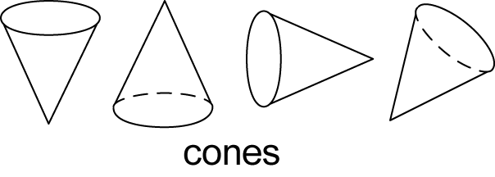
- recognise familiar three-dimensional objects from pictures and photographs, and in the environment
Background Information
In Stage 1, students begin to explore three-dimensional objects in greater detail. They continue to describe the objects using their own language and are introduced to some formal language. Developing and retaining mental images of objects is an important skill for these students. Manipulation of a variety of real three-dimensional objects and two-dimensional shapes in the classroom, the playground and outside the school is crucial to the development of appropriate levels of language and representation.
A cube is a special prism in which all faces are squares. In Stage 1, students do not need to be made aware of this classification.
Language
Students should be able to communicate using the following language: object, cone, cube, cylinder, sphere, prism, surface, flat surface, curved surface, face.
In geometry, the term 'face' refers to a flat surface with only straight edges, as in prisms and pyramids, eg a cube has six faces. Curved surfaces, such as those found in cones, cylinders and spheres, are not classified as faces. Similarly, flat surfaces with curved boundaries, such as the circular surfaces of cones and cylinders, are not faces.
Stage 1
Measurement and Geometry
Three-Dimensional Space 2
Outcomes
A student:
- describes mathematical situations and methods using everyday and some mathematical language, actions, materials, diagrams and symbols MA1-1WM
- sorts, describes, represents and recognises familiar three-dimensional objects, including cones, cubes, cylinders, spheres and prisms MA1-14MG
Content
Students:
Describe the features of three-dimensional objects (ACMMG043)
- use the terms 'flat surface', 'curved surface', 'face', 'edge' and 'vertex' appropriately when describing three-dimensional objects
- describe the number of flat surfaces, curved surfaces, faces, edges and vertices of three-dimensional objects using materials, pictures and actions, eg 'A cylinder has two flat surfaces, one curved surface, no faces, no edges and no vertices', 'This prism has 5 faces, 9 edges and 6 vertices' (Communicating)
- distinguish between objects, which are 'three-dimensional' (3D), and shapes, which are 'two-dimensional' (2D), and describe the differences informally, eg 'This is a two-dimensional shape because it is flat'
- relate the terms 'two-dimensional' and 'three-dimensional' to their use in everyday situations, eg a photograph is two-dimensional and a sculpture is three-dimensional (Communicating, Reasoning)
- recognise that flat surfaces of three-dimensional objects are two-dimensional shapes and name the shapes of these surfaces
- sort three-dimensional objects according to particular attributes, eg the shape of the surfaces
- explain the attribute or multiple attributes used when sorting three-dimensional objects (Communicating, Reasoning)
- represent three-dimensional objects, including landmarks, by making simple models or by drawing or painting
- choose a variety of materials to represent three-dimensional objects, including digital technologies (Communicating)
- explain or demonstrate how a simple model was made (Communicating, Reasoning)
Background Information
Refer to background information in Three-Dimensional Space 1.
Language
Students should be able to communicate using the following language: object, shape, two-dimensional shape (2D shape), three-dimensional object (3D object), cone, cube, cylinder, sphere, prism, surface, flat surface, curved surface, face, edge, vertex (vertices).
The term 'vertex' (plural: vertices) refers to the point where three or more faces of a three-dimensional object meet (or where two straight sides of a two-dimensional shape meet).
In geometry, the term 'edge' refers to the interval (straight line) formed where two faces of a three-dimensional object meet.
Refer also to language in Three-Dimensional Space 1.
Stage 1
Measurement and Geometry
Two-Dimensional Space 1
Outcomes
A student:
- describes mathematical situations and methods using everyday and some mathematical language, actions, materials, diagrams and symbols MA1-1WM
- supports conclusions by explaining or demonstrating how answers were obtained MA1-3WM
- manipulates, sorts, represents, describes and explores two-dimensional shapes, including quadrilaterals, pentagons, hexagons and octagons MA1-15MG
Content
Students:
Recognise and classify familiar two-dimensional shapes using obvious features (ACMMG022)
- identify vertical and horizontal lines in pictures and the environment and use the terms 'vertical' and 'horizontal' to describe such lines
- relate the terms 'vertical' and 'horizontal' to 'portrait' and 'landscape' page orientation, respectively, when using digital technologies (Communicating)
- identify parallel lines in pictures and the environment and use the term 'parallel' to describe such lines
- recognise that parallel lines can occur in orientations other than vertical and horizontal (Reasoning)
- give everyday examples of parallel lines, eg railway tracks (Reasoning)
- manipulate, compare and describe features of two-dimensional shapes, including triangles, quadrilaterals, pentagons, hexagons and octagons
- describe features of two-dimensional shapes using the terms 'side' and 'vertex' (Communicating)
- sort two-dimensional shapes by a given attribute, eg by the number of sides or vertices
- explain the attribute used when sorting two-dimensional shapes (Communicating, Reasoning)
- identify and name two-dimensional shapes presented in different orientations according to their number of sides, including using the terms 'triangle', 'quadrilateral', 'pentagon', 'hexagon' and 'octagon', eg
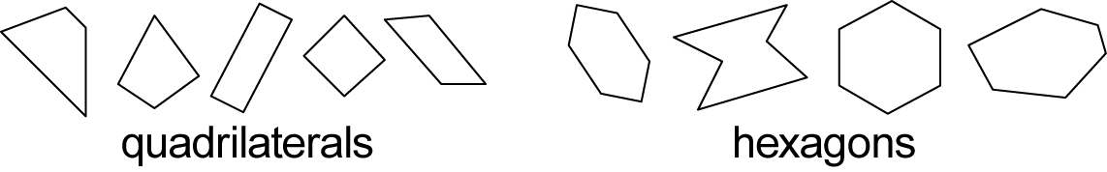
- recognise that the name of a shape does not change when the shape changes its orientation in space, eg a square turned on its vertex is still a square
 (Communicating, Reasoning)
- select a shape from a description of its features (Reasoning)
- recognise that shapes with the same name may have sides of equal or different lengths (Reasoning)
- recognise that rectangles and squares are quadrilaterals
- identify and name shapes embedded in pictures, designs and the environment, eg in Aboriginal art
- use computer drawing tools to outline shapes embedded in a digital picture or design (Communicating)
Background Information
Manipulation of a variety of real objects and shapes is crucial to the development of appropriate levels of visualisation, language and representation.
The skills of discussing, representing and visualising three-dimensional objects and two-dimensional shapes are developing in Stage 1 and must be fostered through practical activities and communication. It is important that students have experience involving a broad range and variety of objects and shapes in order to develop flexible mental images and language.
Students need to be able to recognise shapes presented in different orientations. They need to develop an understanding that changing the orientation of a shape does not change its features or its name. In addition, students should have experiences identifying both regular and irregular shapes, although it is not expected that students understand or distinguish between regular and irregular shapes in Stage 1. Regular shapes have all sides and all angles equal.
Many shapes used in Aboriginal art are used with specific meanings. Local Aboriginal communities and many education consultants can provide examples. Further exploration of such meanings could be incorporated in students' studies within the Creative Arts Key Learning Area.
Language
Students should be able to communicate using the following language: shape, circle, triangle, quadrilateral, square, rectangle, pentagon, hexagon, octagon, orientation, features, side, vertex (vertices), vertical, horizontal, portrait (orientation), landscape (orientation), parallel.
The term 'vertex' (plural: vertices) refers to the point where two straight sides of a two-dimensional shape meet (or where three or more faces of a three-dimensional object meet).
The term 'shape' refers to a two-dimensional figure. The term 'object' refers to a three-dimensional figure.
Stage 1
Measurement and Geometry
Two-Dimensional Space 2
Outcomes
A student:
- describes mathematical situations and methods using everyday and some mathematical language, actions, materials, diagrams and symbols MA1-1WM
- manipulates, sorts, represents, describes and explores two-dimensional shapes, including quadrilaterals, pentagons, hexagons and octagons MA1-15MG
Content
Students:
Describe and draw two-dimensional shapes, with and without the use of digital technologies (ACMMG042)
- use the term 'two-dimensional' to describe plane (flat) shapes
- make representations of two-dimensional shapes in different orientations using concrete materials
- combine and split single shapes and arrangements of shapes to form new shapes, eg create a hexagon from six triangles (Communicating)
- draw and name two-dimensional shapes in different orientations, with and without the use of digital technologies
- recognise that the name of a shape does not change if its size or orientation in space is changed (Reasoning)
Investigate the effect of one-step slides and flips, with and without the use of digital technologies (ACMMG045)
- identify a one-step slide or flip of a single shape and use the terms 'slide' and 'flip' to describe the movement of the shape
- perform a one-step slide or flip with a single shape
- recognise that sliding or flipping a shape does not change its size or features (Reasoning)
- describe the result of a one-step slide or flip of a shape, eg 'When I flip the shape, it is the same but backwards' (Communicating)
- record the result of performing one-step slides and flips, with and without the use of digital technologies
- copy and manipulate a shape using the computer functions for slide and flip (Communicating)
- make designs with line symmetry using paper-folding, pattern blocks, drawings and paintings
- recognise the connection between line symmetry and performing a flip (Reasoning)
Identify and describe half-turns and quarter-turns (ACMMG046)
- identify full-, half- and quarter-turns of a single shape and use the terms 'turn', 'full-turn', 'half-turn' and 'quarter-turn' to describe the movement of the shape
- identify and describe amounts of turn using the terms 'clockwise' and 'anti-clockwise'
- perform full-, half- and quarter-turns with a single shape
- recognise that turning a shape does not change its size or features (Reasoning)
- describe the result of a turn of a shape, eg 'When the shape does a half-turn, it is the same but upside-down' (Communicating)
- record the result of performing full-, half- and quarter-turns of a shape, with and without the use of digital technologies
- copy and manipulate a shape using the computer function for turn (Communicating)
- determine the number of half-turns required for a full-turn and the number of quarter-turns required for a full-turn
- connect the use of quarter- and half-turns to the turn of the minute hand on a clock for the passing of quarter- and half-hours (Communicating, Reasoning)
Background Information
In Stage 1, students need to have experiences involving directions and turning. Discussions about what represents a 'full-turn', a 'half-turn' and a 'quarter-turn' will be necessary. Relating this information to students physically may be helpful, eg by playing games such as 'Simon Says' with Simon saying to make turns.
Digital technologies such as computer drawing tools may use the terms 'move', 'rotate' and 'flip horizontal', or various other terms, to describe transformations. The icons for these functions may assist students in locating the required transformations.
Language
Students should be able to communicate using the following language: shape, two-dimensional shape (2D shape), circle, triangle, quadrilateral, square, rectangle, pentagon, hexagon, octagon, orientation, features, symmetry, slide, flip, turn, full-turn, half-turn, quarter-turn, clockwise, anti-clockwise.
In Stage 1, students refer to the transformations of shapes using the terms 'slide', 'flip' and 'turn'. While in Stage 2, students are expected to use the terms 'translate', 'reflect' and 'rotate', respectively.
Linking the vocabulary of half-turns and quarter-turns to students' experiences with clocks may be of benefit.
A shape is said to have line symmetry if matching parts are produced when it is folded along a line of symmetry. Each part represents the 'mirror image' of the other.
Stage 1
Measurement and Geometry
Position 1
Outcomes
A student:
- describes mathematical situations and methods using everyday and some mathematical language, actions, materials, diagrams and symbols MA1-1WM
- represents and describes the positions of objects in everyday situations and on maps MA1-16MG
Content
Students:
Give and follow directions to familiar locations (ACMMG023)
- use the terms 'left' and 'right' to describe the positions of objects in relation to themselves and from the perspective of a person facing in the opposite direction, eg 'The ball is on her left'
- give and follow directions, including directions involving turns to the left and right, to move between familiar locations, eg within the classroom or school
- use amounts of turn (full and half) to describe direction (Communicating)
- give and follow instructions to position objects in models and drawings, eg 'Draw the bird between the two trees'
- give and follow simple directions using a diagram or description (Communicating)
- describe the path from one location to another on drawings
- use a diagram to give simple directions (Communicating)
- create a path from one location to another using computer software (Communicating)
Background Information
Being able to describe the relative positions of objects in a picture or diagram requires interpretation of a two-dimensional representation.
Locations that are familiar to Aboriginal students may not be limited to their home environments and may also include other locations within the community, eg local landmarks and organisations.
Language
Students should be able to communicate using the following language: position, left, right, directions, turn.
In Early Stage 1, students used the terms 'left' and 'right' to describe position in relation to themselves. In Stage 1, students use the terms 'left' and 'right' to describe position from the perspective of a person facing in the opposite direction.
Stage 1
Measurement and Geometry
Position 2
Outcomes
A student:
- describes mathematical situations and methods using everyday and some mathematical language, actions, materials, diagrams and symbols MA1-1WM
- represents and describes the positions of objects in everyday situations and on maps MA1-16MG
Content
Students:
Interpret simple maps of familiar locations and identify the relative positions of key features (ACMMG044)
- interpret simple maps by identifying objects in different locations, eg find a classroom on a school plan map
- describe the positions of objects in models, photographs and drawings
- give reasons when answering questions about the positions of objects (Communicating, Reasoning)
- make simple models from memory, photographs, drawings or descriptions, eg students make a model of their classroom
- use knowledge of positions in real-world contexts to re-create models (Communicating)
- draw a sketch of a simple model
- use drawings to represent the positions of objects along a path
Background Information
Making models and drawing simple sketches of their models is the focus for students in Stage 1. Students usually concentrate on the relative positions of objects in their sketches. Representing the relative size of objects is difficult and will be refined over time, leading to the development of scale drawings in later stages. Accepting students' representations in models and sketches is important.
Language
Students should be able to communicate using the following language: position, location, map, path.
Stage 1
Statistics and Probability
Data 1
Outcomes
A student:
- describes mathematical situations and methods using everyday and some mathematical language, actions, materials, diagrams and symbols MA1-1WM
- supports conclusions by explaining or demonstrating how answers were obtained MA1-3WM
- gathers and organises data, displays data in lists, tables and picture graphs, and interprets the results MA1-17SP
Content
Students:
Choose simple questions and gather responses (ACMSP262)
- investigate a matter of interest by choosing suitable questions to obtain appropriate data
- gather data and track what has been counted by using concrete materials, tally marks, words or symbols
Represent data with objects and drawings where one object or drawing represents one data value and describe the displays (ACMSP263)
- use concrete materials or pictures of objects as symbols to create data displays where one object or picture represents one data value (one-to-one correspondence), eg use different-coloured blocks to represent different-coloured cars
- record a data display created from concrete materials or pictures of objects (Communicating)
- interpret information presented in data displays where one object, picture or drawing represents one data value, eg weather charts
- describe information presented in simple data displays using comparative language such as 'more than' and 'less than', eg 'There were more black cars than red cars' (Communicating, Reasoning)
- explain interpretations of information presented in data displays, eg 'More children like dogs because there are more dog pictures than cat pictures' (Communicating, Reasoning)
- write a simple sentence to describe data in a display, eg 'The most popular fruit snack is an apple' (Communicating)
Background Information
In Stage 1, students are introduced to the abstract notion of representing an object with a different object, picture or drawing.
It is important that each object in a three-dimensional graph represents one object, except in the case where items are used in pairs, eg shoes. One object can also represent an idea, such as a person's preference.
When collecting information to investigate a question, students can develop simple ways of recording. Some methods include placing blocks or counters in a line, colouring squares on grid paper, and using tally marks.
A single mark in a tally represents one observation. Tally marks are usually drawn in groups of five. The first four marks are vertical, with the fifth mark drawn diagonally through the first four to make counting more efficient, eg  represents 3, represents 5, represents 9.
Language
Students should be able to communicate using the following language: information, data, collect, gather, display, objects, symbol, tally mark, picture, row.
Stage 1
Statistics and Probability
Data 2
Outcomes
A student:
- describes mathematical situations and methods using everyday and some mathematical language, actions, materials, diagrams and symbols MA1-1WM
- uses objects, diagrams and technology to explore mathematical problems MA1-2WM
- supports conclusions by explaining or demonstrating how answers were obtained MA1-3WM
- gathers and organises data, displays data in lists, tables and picture graphs, and interprets the results MA1-17SP
Content
Students:
Identify a question of interest based on one categorical variable and gather data relevant to the question (ACMSP048)
- pose suitable questions that will elicit categorical answers and gather the data, eg 'Which school sport is the most popular with our class members?', 'How did each student in our class get to school today?'
- predict the likely responses within data to be collected (Reasoning)
- determine what data to gather in order to investigate a question of interest, eg colour, mode of transport, gender, type of animal, sport (Problem Solving)
Collect, check and classify data (ACMSP049)
- collect data on familiar topics through questioning, eg 'How many students are in our class each day this week?'
- use tally marks to assist with data collection (Communicating)
- identify categories of data and use them to sort data, eg sort data collected on attendance by day of the week and into boys and girls present
Create displays of data using lists, tables and picture graphs and interpret them (ACMSP050)
- represent data in a picture graph using a baseline, equal spacing, same-sized symbols and a key indicating one-to-one correspondence
- identify misleading representations of data in a picture graph, eg where the symbol used to represent one item is shown in different sizes or where symbols are not equally spaced (Reasoning)
- use digital technologies to create picture graphs (Communicating)
- display data using lists and tables
- use displays to communicate information gathered in other learning areas, eg data gathered in a unit on families or local places (Communicating)
- interpret information presented in lists, tables and picture graphs
- describe data displayed in simple tables and picture graphs found in books and created by other students (Communicating)
- record observations based on tables and picture graphs developed from collected data
Background Information
Categorical variables can be separated into distinct groups or categories, eg the different colours of smarties in a box, the types of favourite fruit of class members.
A key indicating one-to-one correspondence in a picture graph uses one symbol to represent one response/item, eg  = 1 flower.
Language
Students should be able to communicate using the following language: information, data, collect, gather, category, display, symbol, tally mark, picture graph, list, table, equal spacing, key, baseline.
Stage 1
Statistics and Probability
Chance 1
Outcomes
A student:
- describes mathematical situations and methods using everyday and some mathematical language, actions, materials, diagrams and symbols MA1-1WM
- supports conclusions by explaining or demonstrating how answers were obtained MA1-3WM
- recognises and describes the element of chance in everyday events MA1-18SP
Content
Students:
Identify outcomes of familiar events involving chance and describe them using everyday language, such as 'will happen', 'won't happen' or 'might happen' (ACMSP024)
- identify possible outcomes of familiar activities and events, eg the activities that might happen if the class is asked to sit on the floor in a circle
- use everyday language to describe the possible outcomes of familiar activities and events, eg 'will happen', 'might happen', 'won't happen', 'probably'
Background Information
Students should be encouraged to recognise that, because of the element of chance, their predictions will not always be proven true.
When discussing certainty, there are two extremes: events that are certain to happen and those that are certain not to happen. Words such as 'might', 'may' and 'possible' are used to describe events between these two extremes.
Language
Students should be able to communicate using the following language: will happen, might happen, won't happen, probably.
Stage 1
Statistics and Probability
Chance 2
Outcomes
A student:
- describes mathematical situations and methods using everyday and some mathematical language, actions, materials, diagrams and symbols MA1-1WM
- recognises and describes the element of chance in everyday events MA1-18SP
Content
Students:
Identify practical activities and everyday events that involve chance (ACMSP047)
- recognise and describe the element of chance in familiar activities and events, eg 'I might play with my friend after school'
- predict what might occur during the next lesson or in the near future, eg 'How many people might come to your party?', 'How likely is it to rain if there are no clouds in the sky?' (Communicating, Reasoning)
Describe outcomes as 'likely' or 'unlikely' and identify some events as 'certain' or 'impossible' (ACMSP047)
- describe possible outcomes in everyday activities and events as being 'likely' or 'unlikely' to happen
- compare familiar activities and events and describe them as being 'likely' or 'unlikely' to happen
- identify and distinguish between 'possible' and 'impossible' events
- describe familiar events as being 'possible' or 'impossible', eg 'It is possible that it will rain today', 'It is impossible to roll a standard six-sided die and get a 7' (Communicating)
- identify and distinguish between 'certain' and 'uncertain' events
- describe familiar situations as being certain or uncertain, eg 'It is uncertain what the weather will be like tomorrow', 'It is certain that tomorrow is Saturday' (Communicating)
Background Information
Refer to background information in Chance 1.
Language
Students should be able to communicate using the following language: chance, certain, uncertain, possible, impossible, likely, unlikely.
The meaning of 'uncertain' is 'not certain' – it does not mean 'impossible'.

Stage 2
Number and Algebra
Whole Numbers 1
Outcomes
A student:
- uses appropriate terminology to describe, and symbols to represent, mathematical ideas MA2-1WM
- selects and uses appropriate mental or written strategies, or technology, to solve problems MA2-2WM
- checks the accuracy of a statement and explains the reasoning used MA2-3WM
- applies place value to order, read and represent numbers of up to five digits MA2-4NA
Content
Students:
Recognise, model, represent and order numbers to at least 10 000 (ACMNA052)
- represent numbers of up to four digits using objects, words, numerals and digital displays
- make the largest and smallest number from four given digits (Communicating)
- identify the number before and after a given two-, three- or four-digit number
- describe the number before as 'one less than' and the number after as 'one more than' a given number (Communicating)
- count forwards and backwards by tens and hundreds on and off the decade, eg 1220, 1230, 1240, … (on the decade); 423, 323, 223, … (off the decade)
- arrange numbers of up to four digits in ascending and descending order
- use place value to compare and explain the relative size of four-digit numbers (Communicating, Reasoning)
- use the terms and symbols for 'is less than'  and 'is greater than'  to show the relationship between two numbers
Apply place value to partition, rearrange and regroup numbers to at least 10 000 to assist calculations and solve problems (ACMNA053)
- apply an understanding of place value and the role of zero to read, write and order numbers of up to four digits
- interpret four-digit numbers used in everyday contexts (Problem Solving)
- use place value to partition numbers of up to four digits, eg 3265 as 3 groups of one thousand, 2 groups of one hundred, 6 groups of ten and 5 ones
- state the 'place value' of digits in numbers of up to four digits, eg 'In the number 3426, the place value of the "4" is 400 or 4 hundreds'
- record numbers of up to four digits using place value, eg 5429 = 5000 + 400 + 20 + 9
- partition numbers of up to four digits in non-standard forms, eg 3265 as 32 hundreds and 65 ones
- round numbers to the nearest ten, hundred or thousand
Background Information
The place value of digits in various numerals should be investigated. Students should understand, for example, that the '5' in 35 represents 5 ones, but the '5' in 53 represents 50 or 5 tens.
Language
Students should be able to communicate using the following language: number before, number after, more than, greater than, less than, largest number, smallest number, ascending order, descending order, digit, zero, ones, groups of ten, tens, groups of one hundred, hundreds, groups of one thousand, thousands, place value, round to.
The word 'and' is used between the hundreds and the tens when reading and writing a number in words, but not in other places, eg 3568 is read as 'three thousand, five hundred and sixty-eight'.
The word 'round' has different meanings in different contexts, eg 'The plate is round', 'Round 23 to the nearest ten'.
Stage 2
Number and Algebra
Whole Numbers 2
Outcomes
A student:
- uses appropriate terminology to describe, and symbols to represent, mathematical ideas MA2-1WM
- checks the accuracy of a statement and explains the reasoning used MA2-3WM
- applies place value to order, read and represent numbers of up to five digits MA2-4NA
Content
Students:
Recognise, represent and order numbers to at least tens of thousands (ACMNA072)
- apply an understanding of place value to read and write numbers of up to five digits
- arrange numbers of up to five digits in ascending and descending order
- state the place value of digits in numbers of up to five digits
- pose and answer questions that extend understanding of numbers, eg 'What happens if I rearrange the digits in the number 12 345?', 'How can I rearrange the digits to make the largest number?' (Communicating, Reasoning)
- use place value to partition numbers of up to five digits and recognise this as 'expanded notation', eg 67 012 is 60 000 + 7000 + 10 + 2
- partition numbers of up to five digits in non-standard forms, eg 67 000 as 50 000 + 17 000
- round numbers to the nearest ten, hundred, thousand or ten thousand
Background Information
The convention for writing numbers of more than four digits requires that numerals have a space (and not a comma) to the left of each group of three digits when counting from the units column, eg 16 234. No space is used in a four-digit number, eg 6234.
Language
Students should be able to communicate using the following language: largest number, smallest number, ascending order, descending order, digit, ones, tens, hundreds, thousands, tens of thousands, place value, expanded notation, round to.
Refer also to language in Whole Numbers 1.
Stage 2
Number and Algebra
Addition and Subtraction 1
Outcomes
A student:
- uses appropriate terminology to describe, and symbols to represent, mathematical ideas MA2-1WM
- selects and uses appropriate mental or written strategies, or technology, to solve problems MA2-2WM
- checks the accuracy of a statement and explains the reasoning used MA2-3WM
- uses mental and written strategies for addition and subtraction involving two-, three-, four- and five-digit numbers MA2-5NA
Content
Students:
Recall addition facts for single-digit numbers and related subtraction facts to develop increasingly efficient mental strategies for computation (ACMNA055)
- add three or more single-digit numbers
- model and apply the associative property of addition to aid mental computation, eg 2 + 3 + 8 = 2 + 8 + 3 = 10 + 3 = 13
- apply known single-digit addition and subtraction facts to mental strategies for addition and subtraction of two-, three- and four-digit numbers, including:
- the jump strategy on an empty number line, eg 823 + 56: 823 + 50 = 873, 873 + 6 = 879
- the split strategy, eg 23 + 35: 20 + 30 + 3 + 5 = 58
- the compensation strategy, eg 63 + 29: 63 + 30 = 93, subtract 1 to obtain 92
- using patterns to extend number facts, eg 500 – 200: 5 – 2 = 3, so 500 – 200 = 300
- bridging the decades, eg 34 + 26: 34 + 6 = 40, 40 + 20 = 60
- changing the order of addends to form multiples of 10, eg 16 + 8 + 4: add 16 to 4 first
- using place value to partition numbers, eg 2500 + 670: 2500 + 600 + 70 = 3170
- partitioning numbers in non-standard forms, eg 500 + 670: 670 = 500 + 170, so 500 + 670 = 500 + 500 + 170, which is 1000 + 170 = 1170
- choose and apply efficient strategies for addition and subtraction (Problem Solving)
- discuss and compare different methods of addition and subtraction (Communicating)
- use concrete materials to model the addition and subtraction of two or more numbers, with and without trading, and record the method used
- select, use and record a variety of mental strategies to solve addition and subtraction problems, including word problems, with numbers of up to four digits
- give a reasonable estimate for a problem, explain how the estimate was obtained, and check the solution (Communicating, Reasoning)
- use the equals sign to record equivalent number sentences involving addition and subtraction and so to mean 'is the same as', rather than to mean to perform an operation, eg 32 – 13 = 30 – 11
- check given number sentences to determine if they are true or false and explain why,
eg 'Is 39 – 12 = 15 + 11 true? Why or why not?' (Communicating, Reasoning)
Recognise and explain the connection between addition and subtraction (ACMNA054)
- demonstrate how addition and subtraction are inverse operations
- explain and check solutions to problems, including by using the inverse operation
Represent money values in multiple ways and count the change required for simple transactions to the nearest five cents (ACMNA059)
- calculate equivalent amounts of money using different denominations, eg 70 cents can be made up of three 20-cent coins and a 10-cent coin, or two 20-cent coins and three 10-cent coins, etc
- perform simple calculations with money, including finding change, and round to the nearest five cents
- calculate mentally to give change
Background Information
An inverse operation is an operation that reverses the effect of the original operation. Addition and subtraction are inverse operations; multiplication and division are inverse operations.
In Stage 2, it is important that students apply and extend their repertoire of mental strategies for addition and subtraction. The use of concrete materials to model the addition and subtraction of two or more numbers, with and without trading, is intended to provide a foundation for the introduction of the formal algorithm in Addition and Subtraction 2.
One-cent and two-cent coins were withdrawn by the Australian Government in 1990. Prices can still be expressed in one-cent increments, but the final bill is rounded to the nearest five cents (except for electronic transactions), eg
$5.36, $5.37 round to $5.35
$5.38, $5.39, $5.41, $5.42 round to $5.40
$5.43, $5.44 round to $5.45.
Language
Students should be able to communicate using the following language: plus, add, addition, minus, the difference between, subtract, subtraction, equals, is equal to, is the same as, number sentence, empty number line, strategy, digit, estimate, round to.
Students need to understand the different uses for the = sign, eg 4 + 1 = 5, where the = sign indicates that the right side of the number sentence contains 'the answer' and should be read to mean 'equals', compared to a statement of equality such as 4 + 1 = 3 + 2, where the = sign should be read to mean 'is the same as'.
Stage 2
Number and Algebra
Addition and Subtraction 2
Outcomes
A student:
- uses appropriate terminology to describe, and symbols to represent, mathematical ideas MA2-1WM
- selects and uses appropriate mental or written strategies, or technology, to solve problems MA2-2WM
- checks the accuracy of a statement and explains the reasoning used MA2-3WM
- uses mental and written strategies for addition and subtraction involving two-, three-, four- and five-digit numbers MA2-5NA
Content
Students:
Apply place value to partition, rearrange and regroup numbers to at least tens of thousands to assist calculations and solve problems (ACMNA073)
- select, use and record a variety of mental strategies to solve addition and subtraction problems, including word problems, with numbers of up to and including five digits, eg 159 + 23: 'I added 20 to 159 to get 179, then I added 3 more to get 182', or use an empty number line:
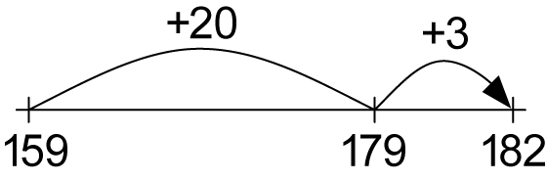
- pose simple addition and subtraction problems and apply appropriate strategies to solve them (Communicating, Problem Solving)
- use a formal written algorithm to record addition and subtraction calculations involving two-, three-, four- and five-digit numbers, eg
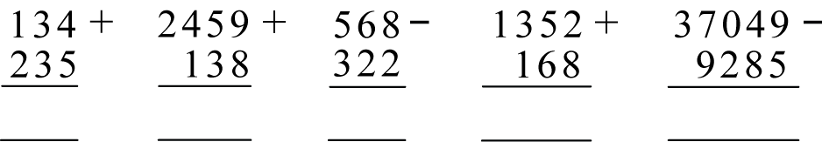
- solve problems involving purchases and the calculation of change to the nearest five cents, with and without the use of digital technologies (ACMNA080)
- solve addition and subtraction problems involving money, with and without the use of digital technologies
- use a variety of strategies to solve unfamiliar problems involving money (Communicating, Problem Solving)
- reflect on their chosen method of solution for a money problem, considering whether it can be improved (Communicating, Reasoning)
- calculate change and round to the nearest five cents
- use estimation to check the reasonableness of solutions to addition and subtraction problems, including those involving money
Background Information
Students should be encouraged to estimate answers before attempting to solve problems in concrete or symbolic form. There is still a need to emphasise mental computation, even though students can now use a formal written method.
When developing a formal written algorithm, it will be necessary to sequence the examples to cover the range of possibilities, which include questions without trading, questions with trading in one or more places, and questions with one or more zeros in the first number.
This example shows a suitable layout for the decomposition method:
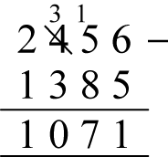
Language
Students should be able to communicate using the following language: plus, add, addition, minus, the difference between, subtract, subtraction, equals, is equal to, empty number line, strategy, digit, estimate, round to, change (noun, in transactions of money).
Word problems requiring subtraction usually fall into two types − either 'take away' or 'comparison'.
Take away – How many remain after some are removed?
eg 'I have 30 apples in a box and give away 12. How many apples do I have left in the box?'
Comparison – How many more need to be added to a group? What is the difference between two groups?
eg 'I have 18 apples. How many more apples do I need to have 30 apples in total?', 'Mary has 30 apples and I have 12 apples. How many more apples than me does Mary have?'
Students need to be able to translate from these different language contexts into a subtraction calculation.
The word 'difference' has a specific meaning in a subtraction context. Difficulties could arise for some students with phrasing in relation to subtraction problems, eg '10 take away 9' should give a response different from that for '10 was taken away from 9'.
Stage 2
Number and Algebra
Multiplication and Division 1
Outcomes
A student:
- uses appropriate terminology to describe, and symbols to represent, mathematical ideas MA2-1WM
- selects and uses appropriate mental or written strategies, or technology, to solve problems MA2-2WM
- checks the accuracy of a statement and explains the reasoning used MA2-3WM
- uses mental and informal written strategies for multiplication and division MA2-6NA
Content
Students:
Recall multiplication facts of two, three, five and ten and related division facts (ACMNA056)
- count by twos, threes, fives or tens using skip counting
- use mental strategies to recall multiplication facts for multiples of two, three, five and ten
- relate 'doubling' to multiplication facts for multiples of two, eg 'Double three is six' (Reasoning)
- recognise and use the symbols for multiplied by (×), divided by (÷) and equals (=)
- link multiplication and division facts using groups or arrays, eg
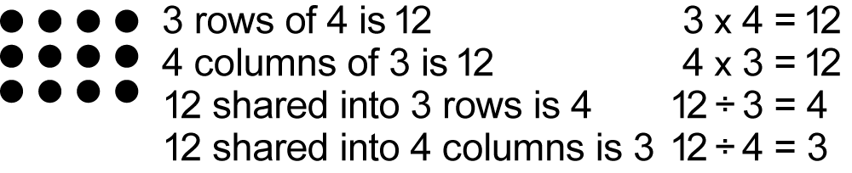
- explain why a rectangular array can be read as a division in two ways by forming vertical or horizontal groups, eg 12 ÷ 3 = 4 or 12 ÷ 4 = 3 (Communicating, Reasoning)
- model and apply the commutative property of multiplication, eg 5 × 8 = 8 × 5
Represent and solve problems involving multiplication using efficient mental and written strategies and appropriate digital technologies (ACMNA057)
- use mental strategies to multiply a one-digit number by a multiple of 10, including:
- repeated addition, eg 3 × 20: 20 + 20 + 20 = 60
- using place value concepts, eg 3 × 20: 3 × 2 tens = 6 tens = 60
- factorising the multiple of 10, eg 3 × 20: 3 × 2 × 10 = 6 × 10 = 60
- apply the inverse relationship of multiplication and division to justify answers, eg 12 ÷ 3 is 4 because 4 × 3 = 12 (Reasoning)
- select, use and record a variety of mental strategies, and appropriate digital technologies, to solve simple multiplication problems
- pose multiplication problems and apply appropriate strategies to solve them (Communicating, Problem Solving)
- explain how an answer was obtained and compare their own method of solution with the methods of other students (Communicating, Reasoning)
- explain problem-solving strategies using language, actions, materials and drawings (Communicating, Problem Solving)
- describe methods used in solving multiplication problems (Communicating)
Background Information
In Stage 2, the emphasis in multiplication and division is on students developing mental strategies and using their own (informal) methods for recording their strategies. Comparing their own method of solution with the methods of other students will lead to the identification of efficient mental and written strategies. One problem may have several acceptable methods of solution.
Students could extend their recall of number facts beyond the multiplication facts to 10 × 10 by also memorising multiples of numbers such as 11, 12, 15, 20 and 25.
An inverse operation is an operation that reverses the effect of the original operation. Addition and subtraction are inverse operations; multiplication and division are inverse operations.
The use of digital technologies includes the use of calculators.
Language
Students should be able to communicate using the following language: group, row, column, horizontal, vertical, array, multiply, multiplied by, multiplication, multiplication facts, double, shared between, divide, divided by, division, equals, strategy, digit, number chart.
When beginning to build and read multiplication facts aloud, it is best to use a language pattern of words that relates back to concrete materials such as arrays. As students become more confident with recalling multiplication facts, they may use less language. For example, 'five rows (or groups) of three' becomes 'five threes' with the 'rows of' or 'groups of' implied. This then leads to 'one three is three', 'two threes are six', 'three threes are nine', and so on.
Stage 2
Number and Algebra
Multiplication and Division 2
Outcomes
A student:
- uses appropriate terminology to describe, and symbols to represent, mathematical ideas MA2-1WM
- selects and uses appropriate mental or written strategies, or technology, to solve problems MA2-2WM
- checks the accuracy of a statement and explains the reasoning used MA2-3WM
- uses mental and informal written strategies for multiplication and division MA2-6NA
Content
Students:
Recall multiplication facts up to 10 × 10 and related division facts (ACMNA075)
- count by fours, sixes, sevens, eights and nines using skip counting
- use the term 'product' to describe the result of multiplying two or more numbers, eg 'The product of 5 and 6 is 30'
- use mental strategies to build multiplication facts to at least 10 × 10, including:
- using the commutative property of multiplication, eg 7 × 9 = 9 × 7
- using known facts to work out unknown facts, eg 5 × 7 is 35, so 6 × 7 is 7 more, which is 42
- using doubling and repeated doubling as a strategy to multiply by 2, 4 and 8, eg 7 × 8 is double 7, double again and then double again
- using the relationship between multiplication facts, eg the multiplication facts for 6 are double the multiplication facts for 3
- factorising one number, eg 5 × 8 is the same as 5 × 2 × 4, which becomes 10 × 4
- recall multiplication facts up to 10 × 10, including zero facts, with automaticity
- find 'multiples' for a given whole number, eg the multiples of 4 are 4, 8, 12, 16, …
- relate multiplication facts to their inverse division facts, eg 6 × 4 = 24, so 24 ÷ 6 = 4 and 24 ÷ 4 = 6
- determine 'factors' for a given whole number, eg the factors of 12 are 1, 2, 3, 4, 6, 12
- use the equals sign to record equivalent number relationships involving multiplication, and to mean 'is the same as', rather than to mean to perform an operation, eg 4 × 3 = 6 × 2
- connect number relationships involving multiplication to factors of a number, eg 'Since 4 × 3 = 6 × 2, then 4, 3, 2 and 6 are factors of 12' (Communicating, Reasoning)
- check number sentences to determine if they are true or false and explain why, eg 'Is 7 × 5 = 8 × 4 true? Why or why not?' (Communicating, Reasoning)
Develop efficient mental and written strategies, and use appropriate digital technologies, for multiplication and for division where there is no remainder (ACMNA076)
- multiply three or more single-digit numbers, eg 5 × 3 × 6
- model and apply the associative property of multiplication to aid mental computation, eg 2 × 3 × 5 = 2 × 5 × 3 = 10 × 3 = 30
- make generalisations about numbers and number relationships, eg 'It doesn't matter what order you multiply two numbers in because the answer is always the same' (Communicating, Reasoning)
- use mental and informal written strategies to multiply a two-digit number by a one-digit number, including:
- using known facts, eg 10 × 9 = 90, so 13 × 9 = 90 + 9 + 9 + 9 = 90 + 27 = 117
- multiplying the tens and then the units, eg 7 × 19: 7 tens + 7 nines is 70 + 63, which is 133
- using an area model, eg 27 × 8
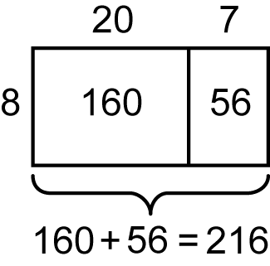

- using doubling and repeated doubling to multiply by 2, 4 and 8, eg 23 × 4 is double 23 and then double again
- using the relationship between multiplication facts, eg 41 × 6 is 41 × 3, which is 123, and then double to obtain 246
- factorising the larger number, eg 18 × 5 = 9 × 2 × 5 = 9 × 10 = 90
- create a table or simple spreadsheet to record multiplication facts, eg a 10 × 10 grid showing multiplication facts (Communicating)
- use mental strategies to divide a two-digit number by a one-digit number where there is no remainder, including:
- using the inverse relationship of multiplication and division, eg 63 ÷ 9 = 7 because 7 × 9 = 63
- recalling known division facts
- using halving and repeated halving to divide by 2, 4 and 8, eg 36 ÷ 4: halve 36 and then halve again
- using the relationship between division facts, eg to divide by 5, first divide by 10 and then multiply by 2
- apply the inverse relationship of multiplication and division to justify answers, eg 56 ÷ 8 = 7 because 7 × 8 = 56 (Problem Solving, Reasoning)
- record mental strategies used for multiplication and division
- select and use a variety of mental and informal written strategies to solve multiplication and division problems
- check the answer to a word problem using digital technologies (Reasoning)
Use mental strategies and informal recording methods for division with remainders
- model division, including where the answer involves a remainder, using concrete materials
- explain why a remainder is obtained in answers to some division problems (Communicating, Reasoning)
- use mental strategies to divide a two-digit number by a one-digit number in problems for which answers include a remainder, eg 27 ÷ 6: if 4 × 6 = 24 and 5 × 6 = 30, the answer is 4 remainder 3
- record remainders to division problems in words, eg 17 ÷ 4 = 4 remainder 1
- interpret the remainder in the context of a word problem, eg 'If a car can safely hold 5 people, how many cars are needed to carry 41 people?'; the answer of 8 remainder 1 means that 9 cars will be needed
Background Information
An inverse operation is an operation that reverses the effect of the original operation. Addition and subtraction are inverse operations; multiplication and division are inverse operations.
Linking multiplication and division is an important understanding for students in Stage 2. They should come to realise that division 'undoes' multiplication and multiplication 'undoes' division. Students should be encouraged to check the answer to a division question by multiplying their answer by the divisor. To divide, students may recall division facts or transform the division into a multiplication and use multiplication facts, eg is the same as 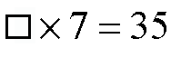.
The use of digital technologies includes the use of calculators.
Language
Students should be able to communicate using the following language: multiply, multiplied by, product, multiplication, multiplication facts, tens, ones, double, multiple, factor, shared between, divide, divided by, division, halve, remainder, equals, is the same as, strategy, digit.
As students become more confident with recalling multiplication facts, they may use less language. For example, 'five rows (or groups) of three' becomes 'five threes' with the 'rows of' or 'groups of' implied. This then leads to 'one three is three', 'two threes are six', 'three threes are nine', and so on.
The term 'product' has a meaning in mathematics that is different from its everyday usage. In mathematics, 'product' refers to the result of multiplying two or more numbers together.
Students need to understand the different uses for the = sign, eg 4 × 3 = 12, where the = sign indicates that the right side of the number sentence contains 'the answer' and should be read to mean 'equals', compared to a statement of equality such as 4 × 3 = 6 × 2, where the = sign should be read to mean 'is the same as'.
Stage 2
Number and Algebra
Fractions and Decimals 1
Outcomes
A student:
- uses appropriate terminology to describe, and symbols to represent, mathematical ideas MA2-1WM
- checks the accuracy of a statement and explains the reasoning used MA2-3WM
- represents, models and compares commonly used fractions and decimals MA2-7NA
Content
Students:
Model and represent unit fractions, including 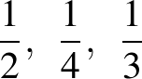 and and their multiples, to a complete whole (ACMNA058)
- model fractions with denominators of 2, 3, 4, 5 and 8 of whole objects, shapes and collections using concrete materials and diagrams, eg
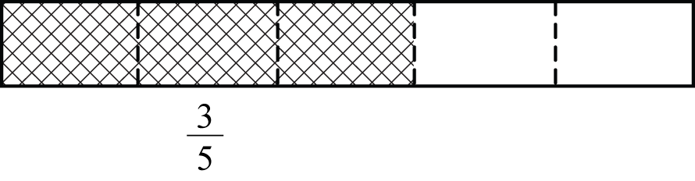
- recognise that as the number of parts that a whole is divided into becomes larger, the size of each part becomes smaller (Reasoning)
- recognise that fractions are used to describe one or more parts of a whole where the parts are equal, eg 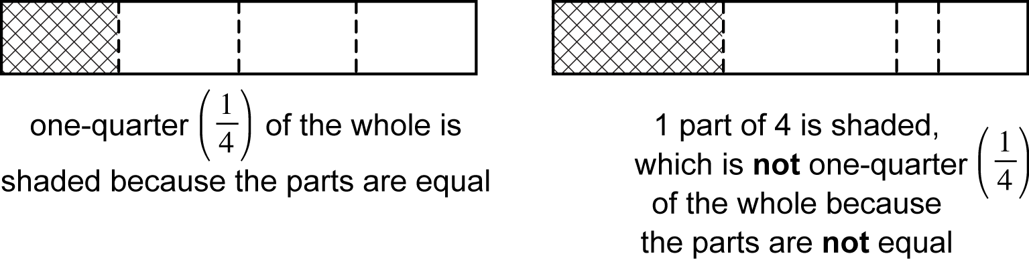 (Communicating, Reasoning)
- name fractions up to one whole, eg 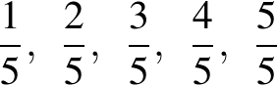
- interpret the denominator as the number of equal parts a whole has been divided into
- interpret the numerator as the number of equal fractional parts, eg means 3 equal parts of 8
- use the terms 'fraction', 'denominator' and 'numerator' appropriately when referring to fractions
Count by quarters, halves and thirds, including with mixed numerals; locate and represent these fractions on a number line (ACMNA078)
- identify and describe 'mixed numerals' as having a whole-number part and a fractional part
- rename 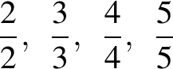 and as 1
- count by halves, thirds and quarters, eg 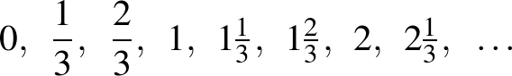
- place halves, quarters, eighths and thirds on number lines between 0 and 1, eg
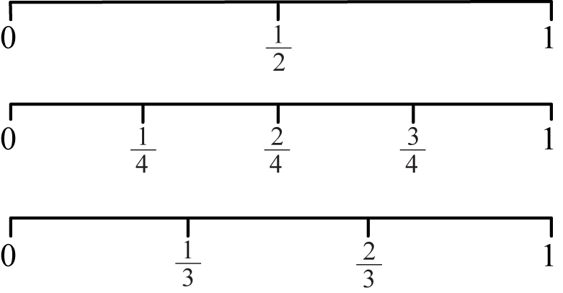
- place halves, thirds and quarters on number lines that extend beyond 1, eg
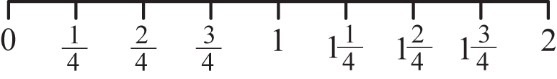
- compare unit fractions using diagrams and number lines and by referring to the denominator, eg is less than
- recognise and explain the relationship between the value of a unit fraction and its denominator (Communicating, Reasoning)
Background Information
In Stage 2 Fractions and Decimals 1, fractions with denominators of 2, 3, 4, 5 and 8 are studied. Denominators of 6, 10 and 100 are introduced in Stage 2 Fractions and Decimals 2.
Fractions are used in different ways: to describe equal parts of a whole; to describe equal parts of a collection of objects; to denote numbers (eg is midway between 0 and 1 on the number line); and as operators related to division (eg dividing a number in half).
A unit fraction is any proper fraction in which the numerator is 1, eg 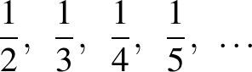
Three Models of Fractions
Continuous model, linear – uses one-directional cuts or folds that compare fractional parts based on length. Cuts or folds may be either vertical or horizontal. This model was introduced in Stage 1.
Continuous model, area – uses multi-directional cuts or folds to compare fractional parts to the whole. This model should be introduced once students have an understanding of the concept of area in Stage 2.
Discrete model – uses separate items in collections to represent parts of the whole group. This model was introduced in Stage 1.
Language
Students should be able to communicate using the following language: whole, part, equal parts, half, quarter, eighth, third, fifth, one-third, one-fifth, fraction, denominator, numerator, mixed numeral, whole number, fractional part, number line.
When expressing fractions in English, the numerator is said first, followed by the denominator. However, in many Asian languages (eg Chinese, Japanese), the opposite is the case: the denominator is said before the numerator.
Stage 2
Number and Algebra
Fractions and Decimals 2
Outcomes
A student:
- uses appropriate terminology to describe, and symbols to represent, mathematical ideas MA2-1WM
- checks the accuracy of a statement and explains the reasoning used MA2-3WM
- represents, models and compares commonly used fractions and decimals MA2-7NA
Content
Students:
Investigate equivalent fractions used in contexts (ACMNA077)
- model, compare and represent fractions with denominators of 2, 4 and 8; 3 and 6; and 5, 10 and 100
- model, compare and represent the equivalence of fractions with related denominators by redividing the whole, using concrete materials, diagrams and number lines, eg
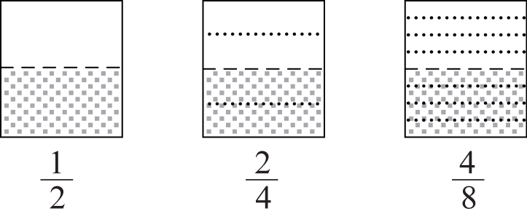
- record equivalent fractions using diagrams and numerals, eg 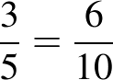
Recognise that the place value system can be extended to tenths and hundredths, and make connections between fractions and decimal notation (ACMNA079)
- recognise and apply decimal notation to express whole numbers, tenths and hundredths as decimals, eg 0.1 is the same as 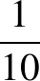
- investigate equivalences using various methods, eg use a number line or a calculator to show that is the same as 0.5 and 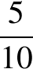 (Communicating, Reasoning)
- identify and interpret the everyday use of fractions and decimals, such as those in advertisements (Communicating, Problem Solving)
- state the place value of digits in decimal numbers of up to two decimal places
- use place value to partition decimals of up to two decimal places, eg 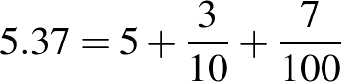
- partition decimals of up to two decimal places in non-standard forms, eg 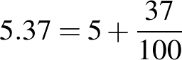
- apply knowledge of hundredths to represent amounts of money in decimal form, eg five dollars and 35 cents is 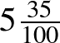, which is the same as $5.35 (Communicating)
- model, compare and represent decimals of up to two decimal places
- apply knowledge of decimals to record measurements, eg 123 cm = 1.23 m (Communicating)
- interpret zero digit(s) at the end of a decimal, eg 0.70 has the same value as 0.7, 3.00 and 3.0 have the same value as 3 (Communicating)
- recognise that amounts of money are written with two decimal places, eg $4.30 is not written as $4.3 (Communicating)
- use one of the symbols for dollars ($) and cents (c) correctly when expressing amounts of money, ie $5.67 and 567c are correct, but $5.67c is not (Communicating)
- use a calculator to create patterns involving decimal numbers, eg 1 ÷ 10, 2 ÷ 10, 3 ÷ 10 (Communicating)
- place decimals of up to two decimal places on a number line, eg place 0.5, 0.25 and 0.75 on a number line
- round a number with one or two decimal places to the nearest whole number
Background Information
In Stage 2 Fractions and Decimals 2, fractions with denominators of 2, 3, 4, 5, 6, 8, 10 and 100 are studied. Denominators of 2, 3, 4, 5 and 8 were introduced in Stage 2 Fractions and Decimals 1.
Fractions are used in different ways: to describe equal parts of a whole; to describe equal parts of a collection of objects; to denote numbers (eg is midway between 0 and 1 on the number line); and as operators related to division (eg dividing a number in half).
Money is an application of decimals to two decimal places.
Refer also to background information in Fractions and Decimals 1.
Language
Students should be able to communicate using the following language: whole, part, equal parts, half, quarter, eighth, third, sixth, fifth, tenth, hundredth, one-sixth, one-tenth, one-hundredth, fraction, numerator, denominator, whole number, number line, is equal to, equivalent fractions, decimal, decimal point, digit, place value, round to, decimal places, dollars, cents.
The decimal 1.12 is read as 'one point one two' and not 'one point twelve'.
Refer also to language in Fractions and Decimals 1.
Stage 2
Number and Algebra
Patterns and Algebra 1
Outcomes
A student:
- uses appropriate terminology to describe, and symbols to represent, mathematical ideas MA2-1WM
- selects and uses appropriate mental or written strategies, or technology, to solve problems MA2-2WM
- checks the accuracy of a statement and explains the reasoning used MA2-3WM
- generalises properties of odd and even numbers, generates number patterns, and completes simple number sentences by calculating missing values MA2-8NA
Content
Students:
Describe, continue and create number patterns resulting from performing addition or subtraction (ACMNA060)
- identify and describe patterns when counting forwards or backwards by threes, fours, sixes, sevens, eights and nines from any starting point
- model, describe and then record number patterns using diagrams, words or symbols
- ask questions about how number patterns have been created and how they can be continued (Communicating)
- create and continue a variety of number patterns that increase or decrease, and describe them in more than one way
Investigate the conditions required for a number to be even or odd and identify even and odd numbers (ACMNA051)
- model even and odd numbers of up to two digits using arrays with two rows
- compare and describe the difference between models of even numbers and models of odd numbers (Communicating)
- recognise the connection between even numbers and the multiplication facts for two (Reasoning)
- describe and generalise the conditions for a number to be even or odd
- recognise the significance of the final digit of a whole number in determining whether a given number is even or odd (Reasoning)
- identify even or odd numbers of up to four digits
Background Information
In Stage 2, number patterns include additive patterns that increase or decrease from any starting point.
Language
Students should be able to communicate using the following language: pattern, goes up by, goes down by, even, odd, rows, digit, multiplication facts.
Stage 2
Number and Algebra
Patterns and Algebra 2
Outcomes
A student:
- uses appropriate terminology to describe, and symbols to represent, mathematical ideas MA2-1WM
- selects and uses appropriate mental or written strategies, or technology, to solve problems MA2-2WM
- checks the accuracy of a statement and explains the reasoning used MA2-3WM
- generalises properties of odd and even numbers, generates number patterns, and completes simple number sentences by calculating missing values MA2-8NA
Content
Students:
Use equivalent number sentences involving addition and subtraction to find unknown quantities (ACMNA083)
- complete number sentences involving addition and subtraction by calculating missing numbers,
eg find the missing numbers: 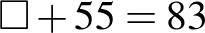,
- use inverse operations to complete number sentences (Problem Solving)
- justify solutions when completing number sentences (Communicating, Reasoning)
- find the missing number in a number sentence involving operations of addition or subtraction on both sides of the equals sign, eg 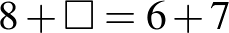
Investigate and use the properties of even and odd numbers (ACMNA071)
- investigate and generalise the result of adding, subtracting and multiplying pairs of even numbers, pairs of odd numbers, or one even and one odd number, eg even + odd = odd, odd × odd = odd
- explain why the result of a calculation is even or odd with reference to the properties of the numbers used in the calculation (Communicating, Reasoning)
- predict whether the answer to a calculation will be even or odd by using the properties of the numbers in the calculation (Reasoning)
Investigate number sequences involving multiples of 3, 4, 6, 7, 8 and 9 (ACMNA074)
- generate number patterns using multiples of 3, 4, 6, 7, 8 and 9, eg 3, 6, 9, 12, ...
- investigate visual number patterns on a number chart (Problem Solving)
Explore and describe number patterns resulting from performing multiplication (ACMNA081)
- use the word 'term' when referring to numbers in a number pattern
- describe the position of each term in a given number pattern, eg 'The first term is 6' (Communicating)
- find a higher term in a number pattern resulting from performing multiplication, given the first few terms, eg determine the next term in the pattern 4, 8, 16, 32, 64, …
- describe how the next term in a number pattern is calculated, eg 'Each term in the pattern is double the previous term' (Communicating)
Solve word problems by using number sentences involving multiplication or division where there is no remainder (ACMNA082)
- complete number sentences involving multiplication and division by calculating missing numbers, eg find the missing numbers: ,
- represent and solve multiplication and division word problems using number sentences, eg 'I buy six pens and the total cost is $24. What is the cost of each pen?' can be represented as or
- discuss whether it is more appropriate to represent the problem using or in order to calculate the solution (Communicating, Reasoning)
- pose a word problem based on a given number sentence, eg given , a problem could be: 'I have 28 cans of drink and stack them into rows of 4. How many rows will there be?' (Communicating, Problem Solving, Reasoning)
Background Information
In Stage 2, the investigation of odd and even numbers leads to understanding what happens to numbers when they are added together or multiplied together. For example, 'An odd number added to an even number always results in an odd number', 'An even number multiplied by an even number always results in an even number'.
Language
Students should be able to communicate using the following language: pattern, term, missing number, odd, even, number sentence, is the same as, equals.
Stage 2
Measurement and Geometry
Length 1
Outcomes
A student:
- uses appropriate terminology to describe, and symbols to represent, mathematical ideas MA2-1WM
- selects and uses appropriate mental or written strategies, or technology, to solve problems MA2-2WM
- checks the accuracy of a statement and explains the reasoning used MA2-3WM
- measures, records, compares and estimates lengths, distances and perimeters in metres, centimetres and millimetres, and measures, compares and records temperatures MA2-9MG
Content
Students:
Measure, order and compare objects using familiar metric units of length (ACMMG061)
- measure lengths and distances using metres and centimetres
- record lengths and distances using metres and centimetres, eg 1 m 25 cm
- compare and order lengths and distances using metres and centimetres
- estimate lengths and distances using metres and centimetres and check by measuring
- explain strategies used to estimate lengths and distances, such as by referring to a known length, eg 'My handspan is 10 cm and my desk is 8 handspans long, so my desk is about 80 cm long' (Communicating, Problem Solving)
- recognise the need for a formal unit smaller than the centimetre to measure length
- recognise that there are 10 millimetres in one centimetre, ie 10 millimetres = 1 centimetre
- use the millimetre as a unit to measure lengths to the nearest millimetre, using a ruler
- describe how a length or distance was measured (Communicating)
- record lengths using the abbreviation for millimetres (mm), eg 5 cm 3 mm or 53 mm
- estimate lengths to the nearest millimetre and check by measuring
Background Information
In Stage 2, measurement experiences enable students to develop an understanding of the size of the metre, centimetre and millimetre, to estimate and measure using these units, and to select the appropriate unit and measuring device.
When recording measurements, a space should be left between the number and the abbreviated unit, eg 3 cm, not 3cm.
Language
Students should be able to communicate using the following language: length, distance, metre, centimetre, millimetre, ruler, measure, estimate, handspan.
Stage 2
Measurement and Geometry
Length 2
Outcomes
A student:
- uses appropriate terminology to describe, and symbols to represent, mathematical ideas MA2-1WM
- selects and uses appropriate mental or written strategies, or technology, to solve problems MA2-2WM
- checks the accuracy of a statement and explains the reasoning used MA2-3WM
- measures, records, compares and estimates lengths, distances and perimeters in metres, centimetres and millimetres, and measures, compares and records temperatures MA2-9MG
Content
Students:
Use scaled instruments to measure and compare lengths (ACMMG084)
- use a tape measure, ruler and trundle wheel to measure lengths and distances
- select and use an appropriate device to measure lengths and distances (Problem Solving)
- explain why two students may obtain different measures for the same length (Communicating, Reasoning)
- select and use an appropriate unit to estimate, measure and compare lengths and distances
- recognise the features of a three-dimensional object associated with length that can be measured, eg length, height, width, perimeter
- use the term 'perimeter' to describe the total distance around a two-dimensional shape
- estimate and measure the perimeters of two-dimensional shapes
- describe when a perimeter measurement might be used in everyday situations, eg determining the length of fencing required to enclose a playground (Communicating)
- convert between metres and centimetres, and between centimetres and millimetres
- describe one centimetre as one-hundredth of a metre and one millimetre as one-tenth of a centimetre (Communicating)
- explain the relationship between the size of a unit and the number of units needed, eg more centimetres than metres will be needed to measure the same length (Communicating, Reasoning)
- record lengths and distances using decimal notation to two decimal places, eg 1.25 m
Use scaled instruments to measure and compare temperatures (ACMMG084)
- identify temperature as a measure of how hot or cold something is
- use everyday language to describe temperature, eg 'cold', 'warm', 'hot'
- recognise the need for formal units to measure temperature
- use a thermometer to measure and compare temperatures to the nearest degree Celsius
- record temperatures to the nearest degree Celsius using the symbol for degrees (°)
- use a thermometer to take and record daily temperature readings (Communicating)
Background Information
It is important that students have a clear understanding of the distinction between perimeter and area.
The use of a thermometer to measure temperature is included in the Length substrand of the syllabus, but it is not anticipated that this skill will be taught as part of learning experiences focused on length. It may be helpful to draw students' attention to the link between negative numbers, which are introduced in Stage 3 Whole Numbers, and a temperature scale.
Language
Students should be able to communicate using the following language: length, distance, metre, centimetre, millimetre, ruler, tape measure, trundle wheel, measure, estimate, perimeter, height, width, temperature, cold, warm, hot, degree (Celsius), thermometer.
'Perimeter' is derived from the Greek words that mean to measure around the outside: peri, meaning 'around', and metron, meaning 'measure'.
The term 'height' usually refers to the distance from the 'base' to the 'top' of an object or shape. The term 'width' usually refers to the shorter side of a rectangle; another word for width is 'breadth'.
Stage 2
Measurement and Geometry
Area 1
Outcomes
A student:
- uses appropriate terminology to describe, and symbols to represent, mathematical ideas MA2-1WM
- selects and uses appropriate mental or written strategies, or technology, to solve problems MA2-2WM
- checks the accuracy of a statement and explains the reasoning used MA2-3WM
- measures, records, compares and estimates areas using square centimetres and square metres MA2-10MG
Content
Students:
Recognise and use formal units to measure and estimate the areas of rectangles
- recognise the need for the square centimetre as a formal unit to measure area
- use a 10 cm × 10 cm tile (or grid) to find the areas of rectangles (including squares) that are less than, greater than or about the same as 100 square centimetres
- measure the areas of rectangles (including squares) in square centimetres
- use efficient strategies for counting large numbers of square centimetres, eg using strips of 10 or squares of 100 (Problem Solving)
- record area in square centimetres using words and the abbreviation for square centimetres (cm²), eg 55 square centimetres, 55 cm²
- estimate the areas of rectangles (including squares) in square centimetres
- discuss strategies used to estimate area in square centimetres, eg visualising repeated units (Communicating, Problem Solving)
- recognise the need for a formal unit larger than the square centimetre to measure area
- construct a square metre and use it to measure the areas of large rectangles (including squares), eg the classroom floor or door
- explain where square metres are used for measuring in everyday situations, eg floor coverings (Communicating, Problem Solving)
- recognise areas that are 'less than a square metre', 'about the same as a square metre' and 'greater than a square metre' (Reasoning)
- recognise that an area of one square metre need not be a square, eg cut a 1 m by 1 m square in half and join the shorter ends of each part together to create an area of one square metre that is rectangular (two metres by half a metre) (Problem Solving, Reasoning)
- record areas in square metres using words and the abbreviation for square metres (m²), eg 6 square metres, 6 m²
- estimate the areas of rectangles (including squares) in square metres
- discuss strategies used to estimate area in square metres, eg visualising repeated units (Communicating, Problem Solving)
Background Information
In Stage 2, students should appreciate that formal units allow for easier and more accurate communication of measures. Measurement experiences should enable students to develop an understanding of the size of a unit, measure and estimate using the unit, and select the appropriate unit. An important understanding in Stage 2 is that an area of one square metre need not be a square. It could, for example, be a rectangle two metres long and half a metre wide.
Language
Students should be able to communicate using the following language: area, surface, measure, grid, row, column, square centimetre, square metre, estimate.
The abbreviation m² is read as 'square metre(s)' and not 'metre(s) squared' or 'metre(s) square'. Similarly, the abbreviation cm² is read as 'square centimetre(s)' and not 'centimetre(s) squared' or 'centimetre(s) square'.
Stage 2
Measurement and Geometry
Area 2
Outcomes
A student:
- uses appropriate terminology to describe, and symbols to represent, mathematical ideas MA2-1WM
- selects and uses appropriate mental or written strategies, or technology, to solve problems MA2-2WM
- measures, records, compares and estimates areas using square centimetres and square metres MA2-10MG
Content
Students:
Compare the areas of regular and irregular shapes by informal means (ACMMG087)
- measure the areas of common two-dimensional shapes using a square-centimetre grid overlay, eg measure the area of a regular hexagon
- compare how different placements of a grid overlay make measuring area easier or harder, eg 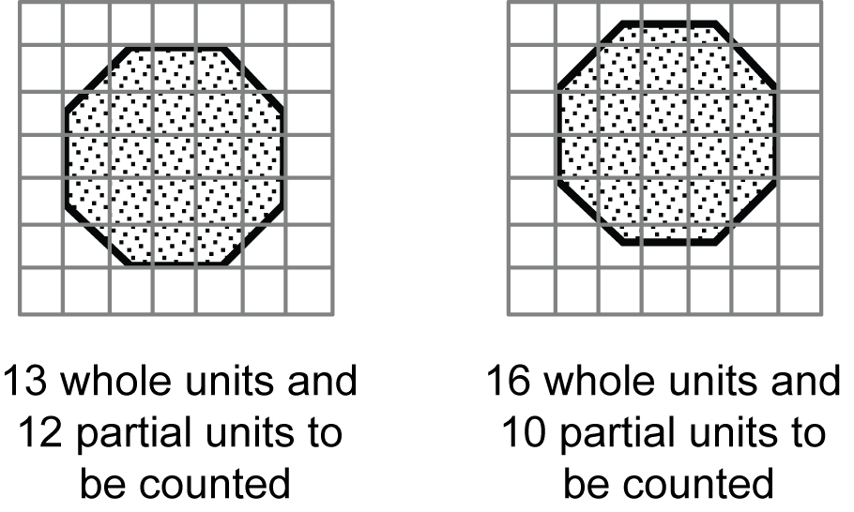(Problem Solving)
- develop strategies for counting partial units in the total area of the shape, eg determine two or more partial units that combine to form one whole unit (Communicating, Problem Solving)
- measure the areas of irregular shapes using a square-centimetre grid overlay, eg
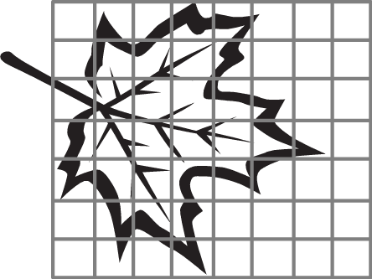
- compare two or more areas by informal means, eg using tiles or a square-centimetre grid overlay
- explain why two students may obtain different measurements of the area of the same irregular shape (Communicating, Reasoning)
Compare objects using familiar metric units of area (ACMMG290)
- estimate the larger of two or more rectangular areas (including the areas of squares) in square centimetres and then measure in square centimetres to compare the areas
- estimate the larger of two or more rectangular areas (including the areas of squares) in square metres and then measure in square metres to compare the areas
Background Information
Area relates to the measurement of two-dimensional space in the same way that volume and capacity relate to the measurement of three-dimensional space.
Students should appreciate that measuring area with a square-centimetre grid overlay is more difficult when the shape to be measured is not rectangular (including not square). This leads to an appreciation of the usefulness of the various algebraic formulas for calculating areas that are developed in later stages.
Language
Students should be able to communicate using the following language: area, irregular area, measure, grid, row, column, parts of (units), square centimetre, square metre, estimate.
Refer also to language in Area 1.
Stage 2
Measurement and Geometry
Volume and Capacity 1
Outcomes
A student:
- uses appropriate terminology to describe, and symbols to represent, mathematical ideas MA2-1WM
- checks the accuracy of a statement and explains the reasoning used MA2-3WM
- measures, records, compares and estimates volumes and capacities using litres, millilitres and cubic centimetres MA2-11MG
Content
Students:
Measure, order and compare objects using familiar metric units of capacity (ACMMG061)
- recognise the need for formal units to measure volume and capacity
- explain the need for formal units to measure volume and capacity (Communicating, Reasoning)
- use the litre as a unit to measure volumes and capacities to the nearest litre
- relate the litre to familiar everyday containers, eg milk cartons (Reasoning)
- recognise that one-litre containers can be a variety of shapes (Reasoning)
- record volumes and capacities using the abbreviation for litres (L)
- compare and order two or more containers by capacity measured in litres
- estimate the capacity of a container in litres and check by measuring
- estimate the number of cups needed to fill a container with a capacity of one litre (Reasoning)
Compare objects using familiar metric units of volume (ACMMG290)
- recognise the advantages of using a cube as a unit when packing and stacking
- use the cubic centimetre as a unit to measure volumes
- pack small containers with cubic-centimetre blocks and describe packing in terms of layers, eg 2 layers of 10 cubic-centimetre blocks (Problem Solving)
- construct three-dimensional objects using cubic-centimetre blocks and count the blocks to determine the volumes of the objects
- devise and explain strategies for counting blocks (Communicating, Problem Solving)
- record volumes using the abbreviation for cubic centimetres (cm³)
- compare the volumes of two or more objects made from cubic-centimetre blocks by counting blocks
- distinguish between mass and volume, eg 'This stone is heavier than the ball but it takes up less space'
Background Information
Volume and capacity relate to the measurement of three-dimensional space, in the same way that area relates to the measurement of two-dimensional space and length relates to the measurement of one dimension.
The attribute of volume is the amount of space occupied by an object or substance and is usually measured in cubic units, eg cubic centimetres (cm³) and cubic metres (m³).
Capacity refers to the amount a container can hold and is measured in units such as millilitres (mL), litres (L) and kilolitres (kL). Capacity is only used in relation to containers and generally refers to liquid measurement. The capacity of a closed container will be slightly less than its volume – capacity is based on the inside dimensions, while volume is determined by the outside dimensions of the container. It is not necessary to refer to these definitions with students (capacity is not taught as a concept separate from volume until Stage 4).
In Stage 2, students should appreciate that formal units allow for easier and more accurate communication of measures. Students should be introduced to the litre, millilitre and cubic centimetre.
Measurement experiences should enable students to develop an understanding of the size of a unit, to estimate and measure using the unit, and to select the appropriate unit and measuring device.
Liquids are commonly measured in litres and millilitres. The capacities of containers used to hold liquids are therefore usually measured in litres and millilitres, eg a litre of milk will fill a container that has a capacity of one litre.
The cubic centimetre can be related to the centimetre as a unit to measure length and the square centimetre as a unit to measure area.
Language
Students should be able to communicate using the following language: capacity, container, litre, volume, layers, cubic centimetre, measure, estimate.
The abbreviation cm³ is read as 'cubic centimetre(s)' and not 'centimetres cubed'.
Stage 2
Measurement and Geometry
Volume and Capacity 2
Outcomes
A student:
- uses appropriate terminology to describe, and symbols to represent, mathematical ideas MA2-1WM
- measures, records, compares and estimates volumes and capacities using litres, millilitres and cubic centimetres MA2-11MG
Content
Students:
Use scaled instruments to measure and compare capacities (ACMMG084)
- recognise the need for a formal unit smaller than the litre to measure volume and capacity
- recognise that there are 1000 millilitres in one litre, ie 1000 millilitres = 1 litre
- relate the millilitre to familiar everyday containers and familiar informal units, eg 250 mL fruit juice containers, 1 teaspoon is approximately 5 mL (Reasoning)
- make a measuring device calibrated in multiples of 100 mL to measure volume and capacity to the nearest 100 mL
- use the millilitre as a unit to measure volume and capacity, using a device calibrated in millilitres, eg place a measuring cylinder under a dripping tap to measure the volume of water lost over a particular period of time
- record volumes and capacities using the abbreviation for millilitres (mL)
- convert between millilitres and litres, eg 1250 mL = 1 litre 250 millilitres
- compare and order the capacities of two or more containers measured in millilitres
- interpret information about volume and capacity on commercial packaging (Communicating)
- estimate the capacity of a container in millilitres and check by measuring
- compare the volumes of two or more objects by marking the change in water level when each is submerged in a container
- estimate the change in water level when an object is submerged (Reasoning)
- measure the overflow in millilitres when different objects are submerged in a container filled to the brim with water
- estimate the volume of a substance in a partially filled container from the information on the label detailing the contents of the container
Background Information
The displacement strategy for finding the volume of an object relies on the fact that an object displaces its own volume when it is totally submerged in a liquid. The strategy may be applied in two ways: using a partially filled, calibrated, clear container and noting the change in the level of the liquid when an object is submerged; or submerging an object in a container filled to the brim with liquid and measuring the overflow.
Refer also to background information in Volume and Capacity 1.
Language
Students should be able to communicate using the following language: capacity, container, litre, millilitre, volume, measure, estimate.
Capacity refers to the amount a container can hold, whereas volume refers to the amount of space an object or substance (including liquids) occupies. For example, we refer to the capacity of a dam (the amount of water it can hold) and the volume of water in the dam, which is usually less than the capacity of the dam.
Stage 2
Measurement and Geometry
Mass 1
Outcomes
A student:
- uses appropriate terminology to describe, and symbols to represent, mathematical ideas MA2-1WM
- checks the accuracy of a statement and explains the reasoning used MA2-3WM
- measures, records, compares and estimates the masses of objects using kilograms and grams MA2-12MG
Content
Students:
Measure, order and compare objects using familiar metric units of mass (ACMMG061)
- recognise the need for a formal unit to measure mass
- use the kilogram as a unit to measure mass, using a pan balance
- associate kilogram measures with familiar objects, eg a standard pack of flour has a mass of 1 kg, a litre of milk has a mass of approximately 1 kg (Reasoning)
- recognise that objects with a mass of one kilogram can be a variety of shapes and sizes (Reasoning)
- record masses using the abbreviation for kilograms (kg)
- use hefting to identify objects that have a mass of 'more than', 'less than' and 'about the same as' one kilogram
- discuss strategies used to estimate mass, eg by referring to a known mass (Communicating, Problem Solving)
- compare and order two or more objects by mass measured to the nearest kilogram
- estimate the number of similar objects that have a total mass of one kilogram and check by measuring
- explain why two students may obtain different measures for the same mass (Communicating, Reasoning)
Background Information
In Stage 2, students should appreciate that formal units allow for easier and more accurate communication of measures. Students are introduced to the kilogram and gram. They should develop an understanding of the size of these units, and use them to measure and estimate.
Language
Students should be able to communicate using the following language: mass, more than, less than, about the same as, pan balance, (level) balance, measure, estimate, kilogram.
'Hefting' is testing the weight of an object by lifting and balancing it. Where possible, students can compare the weights of two objects by using their bodies to balance each object, eg holding one object in each hand.
As the terms 'weigh' and 'weight' are common in everyday usage, they can be accepted in student language should they arise. Weight is a force that changes with gravity, while mass remains constant.
Stage 2
Measurement and Geometry
Mass 2
Outcomes
A student:
- uses appropriate terminology to describe, and symbols to represent, mathematical ideas MA2-1WM
- selects and uses appropriate mental or written strategies, or technology, to solve problems MA2-2WM
- measures, records, compares and estimates the masses of objects using kilograms and grams MA2-12MG
Content
Students:
Use scaled instruments to measure and compare masses (ACMMG084)
- recognise the need for a formal unit smaller than the kilogram
- recognise that there are 1000 grams in one kilogram, ie 1000 grams = 1 kilogram
- use the gram as a unit to measure mass, using a scaled instrument
- associate gram measures with familiar objects, eg a standard egg has a mass of about 60 grams (Reasoning)
- record masses using the abbreviation for grams (g)
- compare two or more objects by mass measured in kilograms and grams, using a set of scales
- interpret statements, and discuss the use of kilograms and grams, on commercial packaging (Communicating, Problem Solving)
- interpret commonly used fractions of a kilogram, including , , , and relate these to the number of grams
- solve problems, including those involving commonly used fractions of a kilogram (Problem Solving)
- record masses using kilograms and grams, eg 1 kg 200 g
Background Information
Refer to background information in Mass 1.
Language
Students should be able to communicate using the following language: mass, measure, scales, kilogram, gram.
The term 'scales', as in a set of scales, may be confusing for some students who associate it with other uses of the word 'scales', eg fish scales, scales on a map, or musical scales. These other meanings should be discussed with students.
Stage 2
Measurement and Geometry
Time 1
Outcomes
A student:
- uses appropriate terminology to describe, and symbols to represent, mathematical ideas MA2-1WM
- reads and records time in one-minute intervals and converts between hours, minutes and seconds MA2-13MG
Content
Students:
Tell time to the minute and investigate the relationship between units of time (ACMMG062)
- recognise the coordinated movements of the hands on an analog clock, including:
- the number of minutes it takes for the minute hand to move from one numeral to the next
- the number of minutes it takes for the minute hand to complete one revolution
- the number of minutes it takes for the hour hand to move from one numeral to the next
- the number of minutes it takes for the minute hand to move from the 12 to any other numeral
- the number of seconds it takes for the second hand to complete one revolution
- read analog and digital clocks to the minute, including using the terms 'past' and 'to', eg 7:35 is read as 'seven thirty-five' or 'twenty-five to eight'
- record in words various times shown on analog and digital clocks
Background Information
The duration of a solar year is actually 365 days 5 hours 48 minutes and 45.7 seconds.
Language
Students should be able to communicate using the following language: time, clock, analog, digital, hour hand, minute hand, second hand, revolution, numeral, hour, minute, second, o'clock, (minutes) past, (minutes) to.
Stage 2
Measurement and Geometry
Time 2
Outcomes
A student:
- uses appropriate terminology to describe, and symbols to represent, mathematical ideas MA2-1WM
- selects and uses appropriate mental or written strategies, or technology, to solve problems MA2-2WM
- reads and records time in one-minute intervals and converts between hours, minutes and seconds MA2-13MG
Content
Students:
Convert between units of time (ACMMG085)
- convert between units of time and recall time facts, eg 60 seconds = 1 minute, 60 minutes = 1 hour, 24 hours = 1 day
- explain the relationship between the size of a unit and the number of units needed, eg fewer hours than minutes will be needed to measure the same duration of time (Communicating, Reasoning)
Use am and pm notation and solve simple time problems (ACMMG086)
- record digital time using the correct notation, including am and pm, eg 9:15 am
- describe times given using am and pm notation in relation to 'midday' (or 'noon') and 'midnight', eg '3:15 pm is three and a quarter hours after midday' (Communicating)
- relate analog notation to digital notation for time, eg ten to nine in the morning is the same time as 8:50 am
- solve simple time problems using appropriate strategies, eg calculate the time spent on particular activities during the school day
Read and interpret simple timetables, timelines and calendars
- read and interpret timetables and timelines
- read and interpret calendars
- explore and use different notations to record the date (Communicating)
- explore and use the various date input and output options of digital technologies (Communicating)
Background Information
Midday and midnight need not be expressed in am or pm form. '12 noon' or '12 midday' and '12 midnight' should be used, even though 12:00 pm and 12:00 am are sometimes seen.
The terms 'am' and 'pm' are used only for the digital form of time recording and not with the 'o'clock' terminology.
It is important to note that there are many different forms used in recording dates, including abbreviated forms.
Different notations for dates are used in different countries, eg 8 December 2014 is usually recorded as 8/12/14 in Australia, but as 12/8/14 in the United States of America.
Refer also to background information in Time 1.
Language
Students should be able to communicate using the following language: calendar, date, timetable, timeline, time, hour, minute, second, midday, noon, midnight, am (notation), pm (notation).
The term 'am' is derived from the Latin ante meridiem, meaning 'before midday', while 'pm' is derived from the Latin post meridiem, meaning 'after midday'.
Stage 2
Measurement and Geometry
Three-Dimensional Space 1
Outcomes
A student:
- uses appropriate terminology to describe, and symbols to represent, mathematical ideas MA2-1WM
- checks the accuracy of a statement and explains the reasoning used MA2-3WM
- makes, compares, sketches and names three-dimensional objects, including prisms, pyramids, cylinders, cones and spheres, and describes their features MA2-14MG
Content
Students:
Make models of three-dimensional objects and describe key features (ACMMG063)
- identify and name three-dimensional objects as prisms (including cubes), pyramids, cylinders, cones and spheres
- recognise and describe the use of three-dimensional objects in a variety of contexts, eg buildings, packaging (Communicating)
- describe and compare curved surfaces and flat surfaces of cylinders, cones and spheres, and faces, edges and vertices of prisms (including cubes) and pyramids
- describe similarities and differences between prisms (including cubes), pyramids, cylinders, cones and spheres (Communicating)
- use a variety of materials to make models of prisms (including cubes), pyramids, cylinders, cones and spheres, given a three-dimensional object, picture or photograph to view
- deconstruct everyday packages that are prisms (including cubes) to create nets, eg cut up tissue boxes
- recognise that a net requires each face to be connected to at least one other face (Reasoning)
- investigate, make and identify the variety of nets that can be used to create a particular prism, such as the variety of nets that can be used to make a cube, eg
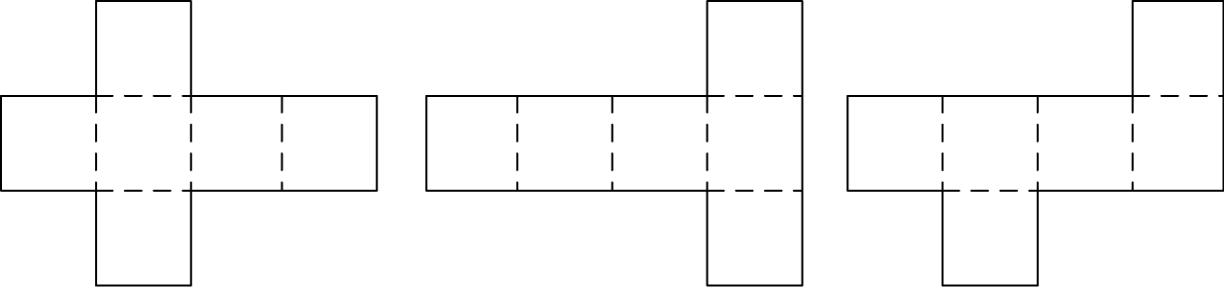
(Communicating, Problem Solving, Reasoning)
- distinguish between (flat) nets, which are 'two-dimensional', and objects created from nets, which are 'three-dimensional' (Communicating, Reasoning)
Background Information
The formal names for particular prisms and pyramids are not introduced in Stage 2. Prisms and pyramids are to be treated as classes for the grouping of all prisms and all pyramids. Names for particular prisms and pyramids are introduced in Stage 3.
Language
Students should be able to communicate using the following language: object, two-dimensional shape (2D shape), three-dimensional object (3D object), cone, cube, cylinder, prism, pyramid, sphere, surface, flat surface, curved surface, face, edge, vertex (vertices), net.
In geometry, the term 'face' refers to a flat surface with only straight edges, as in prisms and pyramids, eg a cube has six faces. Curved surfaces, such as those found in cylinders, cones and spheres, are not classified as 'faces'. Similarly, flat surfaces with curved boundaries, such as the circular surfaces of cylinders and cones, are not 'faces'.
The term 'shape' refers to a two-dimensional figure. The term 'object' refers to a three-dimensional figure.
Stage 2
Measurement and Geometry
Three-Dimensional Space 2
Outcomes
A student:
- uses appropriate terminology to describe, and symbols to represent, mathematical ideas MA2-1WM
- checks the accuracy of a statement and explains the reasoning used MA2-3WM
- makes, compares, sketches and names three-dimensional objects, including prisms, pyramids, cylinders, cones and spheres, and describes their features MA2-14MG
Content
Students:
Investigate and represent three-dimensional objects using drawings
- identify prisms (including cubes), pyramids, cylinders, cones and spheres in the environment and from drawings, photographs and descriptions
- investigate types of three-dimensional objects used in commercial packaging and give reasons for some being more commonly used (Communicating, Reasoning)
- sketch prisms (including cubes), pyramids, cylinders and cones, attempting to show depth
- compare their own drawings of three-dimensional objects with other drawings and photographs of three-dimensional objects (Reasoning)
- draw three-dimensional objects using a computer drawing tool, attempting to show depth (Communicating)
- sketch three-dimensional objects from different views, including top, front and side views
- investigate different two-dimensional representations of three-dimensional objects in the environment, eg in Aboriginal art (Communicating)
- draw different views of an object constructed from connecting cubes on isometric grid paper
- interpret given isometric drawings to make models of three-dimensional objects using connecting cubes
Background Information
When using examples of Aboriginal rock carvings and other Aboriginal art, it is recommended that local examples be used wherever possible. Consult with local Aboriginal communities and education consultants for such examples.
Refer also to background information in Three-Dimensional Space 1.
Language
Students should be able to communicate using the following language: object, two-dimensional shape (2D shape), three-dimensional object (3D object), cone, cube, cylinder, prism, pyramid, sphere, top view, front view, side view, isometric grid paper, isometric drawing, depth.
Refer also to language in Three-Dimensional Space 1.
Stage 2
Measurement and Geometry
Two-Dimensional Space 1
Outcomes
A student:
- uses appropriate terminology to describe, and symbols to represent, mathematical ideas MA2-1WM
- checks the accuracy of a statement and explains the reasoning used MA2-3WM
- manipulates, identifies and sketches two-dimensional shapes, including special quadrilaterals, and describes their features MA2-15MG
Content
Students:
Compare and describe features of two-dimensional shapes, including the special quadrilaterals
- manipulate, compare and describe features of two-dimensional shapes, including the special quadrilaterals: parallelograms, rectangles, rhombuses, squares, trapeziums and kites
- determine the number of pairs of parallel sides, if any, of each of the special quadrilaterals (Reasoning)
- use measurement to establish and describe side properties of the special quadrilaterals, eg the opposite sides of a parallelogram are the same length
- identify and name the special quadrilaterals presented in different orientations, eg
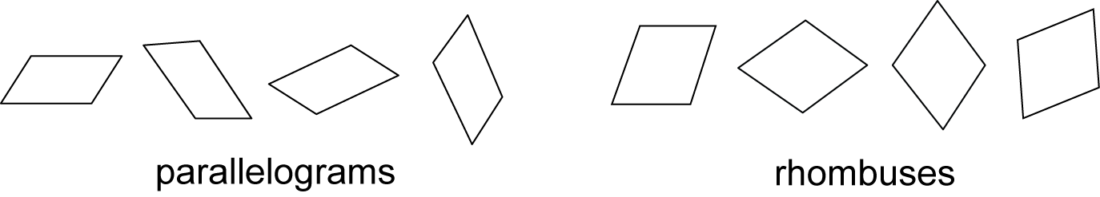
- explain why a particular quadrilateral has a given name, eg 'It is a parallelogram because it has four sides and the opposite sides are parallel' (Communicating, Reasoning)
- name a shape, given a written or verbal description of its features (Reasoning)
- recognise the vertices of two-dimensional shapes as the vertices of angles that have the sides of the shape as their arms
- identify right angles in squares and rectangles
- group parallelograms, rectangles, rhombuses, squares, trapeziums and kites using one or more attributes, eg quadrilaterals with parallel sides and right angles
- identify and describe two-dimensional shapes as either 'regular' or 'irregular', eg 'This shape is a regular pentagon because it has five equal sides and five equal angles'
- identify regular shapes in a group that includes irregular shapes, such as a regular pentagon in a group of pentagons, eg
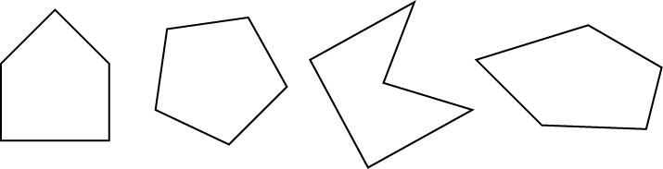 (Reasoning)
- explain the difference between regular and irregular two-dimensional shapes (Communicating, Reasoning)
- recognise that the name of a shape does not change if its size or orientation in space is changed (Reasoning)
- draw representations of regular and irregular two-dimensional shapes in different orientations
- construct regular and irregular two-dimensional shapes from a variety of materials, eg cardboard, straws, pattern blocks
- determine that a triangle cannot be constructed from three straws if the sum of the lengths of the two shorter straws is less than the length of the longest straw (Reasoning)
- compare the rigidity of two-dimensional frames of three sides with the rigidity of those of four or more sides
- construct and manipulate a four-sided frame and explain how adding a brace can make a four-sided frame rigid (Communicating, Reasoning)
Identify symmetry in the environment (ACMMG066)
- identify lines of symmetry in pictures, artefacts, designs and the environment, eg Aboriginal rock carvings or Asian lotus designs
- identify and draw lines of symmetry on given shapes, including the special quadrilaterals and other regular and irregular shapes
- determine and explain whether a given line through a shape is a line of symmetry (Communicating, Reasoning)
- recognise and explain why any line through the centre of (and across) a circle is a line of symmetry (Communicating, Reasoning)
Background Information
The special quadrilaterals are the parallelogram, rectangle, rhombus, square, trapezium and kite.
Regular shapes have all sides equal and all angles equal. In Stage 2, students are expected to be able to distinguish between regular and irregular shapes and to describe a polygon as either regular or irregular, eg a regular pentagon has five equal sides and five equal angles.
It is important for students to have experiences with a variety of shapes in order to develop flexible mental images. Students need to be able to recognise shapes presented in different orientations.
When constructing polygons using materials such as straws of different lengths for sides, students should be guided to an understanding that:
- sometimes a triangle cannot be made from 3 straws
- a figure made from 3 lengths, ie a triangle, is always flat
- a figure made from 4 or more lengths need not be flat
- a unique triangle is formed, if a triangle can be formed, from 3 given lengths
- more than one two-dimensional shape can result if more than 3 lengths are used.
When using examples of Aboriginal rock carvings and other Aboriginal art, it is recommended that local examples be used wherever possible. Consult with local Aboriginal communities and education consultants for such examples.
Language
Students should be able to communicate using the following language: shape, two-dimensional shape (2D shape), circle, triangle, quadrilateral, parallelogram, rectangle, rhombus, square, trapezium, kite, pentagon, hexagon, octagon, regular shape, irregular shape, orientation, features, properties, side, parallel, pair of parallel sides, opposite, length, vertex (vertices), angle, right angle, symmetry, line (axis) of symmetry, rigid.
The term 'polygon' (derived from the Greek words meaning 'many angles') refers to closed shapes with three or more angles and sides. While the angles are the focus for the general naming system used for shapes, polygons are more usually understood in terms of their sides. Students are not expected to use the term 'polygon'. However, some students may explore other polygons and so benefit from being introduced to the collective term.
Students could explore the language origins of the names of polygons.
The term 'diamond' is often used in everyday contexts when describing quadrilaterals with four equal sides. However, 'diamond' is not the correct geometrical term to name such quadrilaterals; the correct term is 'rhombus'.
Stage 2
Measurement and Geometry
Two-Dimensional Space 2
Outcomes
A student:
- uses appropriate terminology to describe, and symbols to represent, mathematical ideas MA2-1WM
- selects and uses appropriate mental or written strategies, or technology, to solve problems MA2-2WM
- checks the accuracy of a statement and explains the reasoning used MA2-3WM
- manipulates, identifies and sketches two-dimensional shapes, including special quadrilaterals, and describes their features MA2-15MG
Content
Students:
Compare and describe two-dimensional shapes that result from combining and splitting common shapes, with and without the use of digital technologies (ACMMG088)
- combine common two-dimensional shapes, including special quadrilaterals, to form other common shapes or designs, eg combine a rhombus and a triangle to form a trapezium
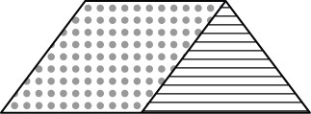
- describe and/or name the shape formed from a combination of common shapes (Communicating)
- follow written or verbal instructions to create a common shape using a specified set of two or more common shapes, eg create an octagon from five squares and four triangles (Communicating, Problem Solving)
- use digital technologies to construct a design or logo by combining common shapes (Communicating)
- split a given shape into two or more common shapes and describe the result, eg 'I split the parallelogram into a rectangle and two equal-sized triangles'
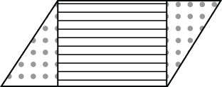
- compare the area of the given shape with the area of each of the shapes it is split into, eg if a pentagon is split into five equal triangles, describe the area of the pentagon as five times the area of one triangle, or the area of one triangle as of the area of the pentagon (Communicating, Reasoning)
- record the arrangements of common shapes used to create other shapes, and the arrangement of shapes formed after splitting a shape, in diagrammatic form, with and without the use of digital technologies
- record different combinations of common shapes that can be used to form a particular regular polygon, eg a hexagon can be created from, or split into, many different arrangements, such as
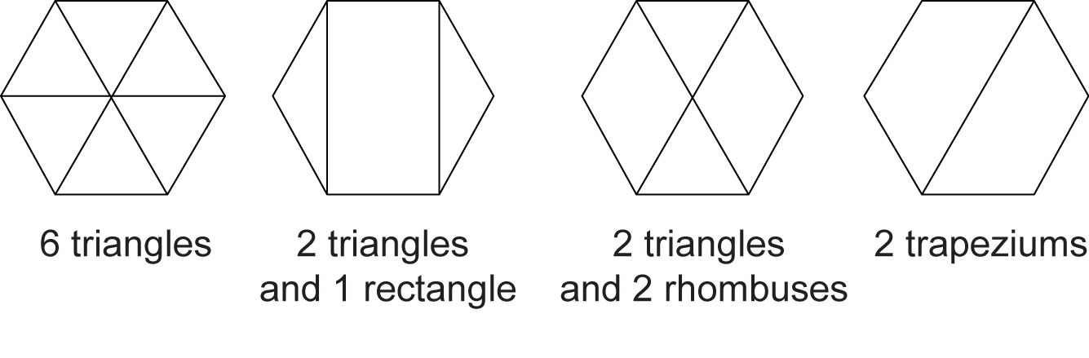
(Communicating, Problem Solving)
Create symmetrical patterns, pictures and shapes, with and without the use of digital technologies (ACMMG091)
- create symmetrical patterns, designs, pictures and shapes by translating (sliding), reflecting (flipping) and rotating (turning) one or more common shapes
- use different types of graph paper to assist in creating symmetrical designs (Communicating)
- use digital technologies to create designs by copying, pasting, reflecting, translating and rotating common shapes (Communicating, Problem Solving)
- apply and describe amounts of rotation, in both 'clockwise' and 'anti-clockwise' directions, including half-turns, quarter-turns and three-quarter-turns, when creating designs (Communicating, Problem Solving)
- describe the creation of symmetrical designs using the terms 'reflect', 'translate' and 'rotate' (Communicating, Reasoning)
- create and record tessellating designs by reflecting, translating and rotating common shapes
- use digital technologies to create tessellating designs (Communicating)
- determine which of the special quadrilaterals can be used to create tessellating designs (Reasoning)
- explain why tessellating shapes are best for measuring area (Communicating, Reasoning)
- identify shapes that do and do not tessellate
- explain why a shape does or does not tessellate (Communicating, Reasoning)
- draw the reflection (mirror image) to complete symmetrical pictures and shapes, given a line of symmetry, with and without the use of digital technologies
Background Information
Students should be given the opportunity to attempt to create tessellating designs with a selection of different shapes, including shapes that do not tessellate.
Language
Students should be able to communicate using the following language: shape, two-dimensional shape (2D shape), triangle, quadrilateral, parallelogram, rectangle, rhombus, square, trapezium, kite, pentagon, hexagon, octagon, line (axis) of symmetry, reflect (flip), translate (slide), rotate (turn), tessellate, clockwise, anti-clockwise, half-turn, quarter-turn, three-quarter-turn.
In Stage 1, students referred to the transformations of shapes using the terms 'slide', 'flip' and 'turn'. In Stage 2, they are expected to progress to the use of the terms 'translate', 'reflect' and 'rotate', respectively.
Stage 2
Measurement and Geometry
Angles 1
Outcomes
A student:
- uses appropriate terminology to describe, and symbols to represent, mathematical ideas MA2-1WM
- identifies, describes, compares and classifies angles MA2-16MG
Content
Students:
Identify angles as measures of turn and compare angle sizes in everyday situations (ACMMG064)
- identify 'angles' with two arms in practical situations, eg the angle between the arms of a clock
- identify the 'arms' and 'vertex' of an angle
- describe informally an angle as the 'amount of turning' between two arms
- recognise that the length of the arms does not affect the size of the angle (Reasoning)
- compare angles directly by placing one angle on top of another and aligning one arm
- identify 'perpendicular' lines in pictures, designs and the environment
- use the term 'right angle' to describe the angle formed when perpendicular lines meet
- describe examples of right angles in the environment (Communicating, Problem Solving)
- identify right angles in two-dimensional shapes and three-dimensional objects (Communicating)
Background Information
In Stage 2, students need informal experiences of creating, identifying and describing a range of angles. This will lead to an appreciation of the need for a formal unit to measure angles.
Paper folding is a quick and simple means of generating a wide range of angles for comparison and copying.
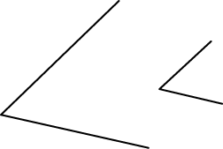
The arms of the angles above are different lengths. However, the angles are the same size, as the amount of turning between the arms is the same. Students may mistakenly judge one angle to be greater in size than another on the basis of the length of the arms of the angles in the diagram.
Language
Students should be able to communicate using the following language: angle, amount of turning, arm, vertex, perpendicular, right angle.
Stage 2
Measurement and Geometry
Angles 2
Outcomes
A student:
- uses appropriate terminology to describe, and symbols to represent, mathematical ideas MA2-1WM
- checks the accuracy of a statement and explains the reasoning used MA2-3WM
- identifies, describes, compares and classifies angles MA2-16MG
Content
Students:
Compare angles and classify them as equal to, greater than or less than a right angle (ACMMG089)
- compare angles using informal means, such as by using an 'angle tester'
- recognise and describe angles as 'less than', 'equal to', 'about the same as' or 'greater than' a right angle
- classify angles as acute, right, obtuse, straight, reflex or a revolution
- describe the size of different types of angles in relation to a right angle, eg acute angles are less than a right angle (Communicating)
- relate the turn of the hour hand on a clock through a right angle or straight angle to the number of hours elapsed, eg a turn through a right angle represents the passing of three hours (Reasoning)
- identify the arms and vertex of the angle in an opening, a slope and/or a turn where one arm is visible and the other arm is invisible, eg the bottom of an open door is the visible arm and the imaginary line on the floor across the doorway is the other arm
- create, draw and classify angles of various sizes, eg by tracing along the adjacent sides of shapes
- draw and classify the angle through which the minute hand of a clock turns from various starting points (Communicating, Reasoning)
Background Information
A simple 'angle tester' can be made by placing a pipe-cleaner inside a straw and bending the straw to form two arms. Another angle tester can be made by joining two narrow straight pieces of card with a split-pin to form the rotatable arms of an angle.
Language
Students should be able to communicate using the following language: angle, arm, vertex, right angle, acute angle, obtuse angle, straight angle, reflex angle, angle of revolution.
The use of the terms 'sharp' and 'blunt' to describe acute and obtuse angles, respectively, is counterproductive in identifying the nature of angles. Such terms should not be used with students as they focus attention on the external points of an angle, rather than on the amount of turning between the arms of the angle.
Stage 2
Measurement and Geometry
Position 1
Outcomes
A student:
- uses appropriate terminology to describe, and symbols to represent, mathematical ideas MA2-1WM
- uses simple maps and grids to represent position and follow routes, including using compass directions MA2-17MG
Content
Students:
Create and interpret simple grid maps to show position and pathways (ACMMG065)
- describe the location of an object using more than one descriptor, eg 'The book is on the third shelf and second from the left'
- use given directions to follow routes on simple maps
- use and follow positional and directional language (Communicating)
- use grid references on maps to describe position, eg 'The lion cage is at B3'
- use grid references in games (Communicating)
- identify and mark particular locations on maps and plans, given their grid references
- draw and label a grid on a given map
- discuss the use of grids in real-world contexts, eg zoo map, map of shopping centre (Reasoning)
- draw simple maps and plans from an aerial view, with and without labelling a grid, eg create a map of the classroom
- create simple maps and plans using digital technologies (Communicating)
- compare different methods of identifying locations in the environment, eg compare the reference system used in Aboriginal Country maps with standard grid-referenced maps (Reasoning)
- draw and describe routes or paths on grid-referenced maps and plans
- use digital technologies involving maps, position and paths (Communicating)
- interpret and use simple maps found in factual texts and in the media
Background Information
By convention when using grid-reference systems, such as those found on maps, the horizontal component of direction is named first, followed by the vertical component. This is a precursor to introducing coordinates on the Cartesian plane in Stage 3 Patterns and Algebra, where the horizontal coordinate is recorded first, followed by the vertical coordinate.
Aboriginal people use an Aboriginal land map to identify and explain the relationship of a particular Aboriginal Country to significant landmarks in the area. They use a standard map of New South Wales to identify nearby towns and their proximity to significant Aboriginal landmarks, demonstrating their unique relationship to land, Country and place.
Language
Students should be able to communicate using the following language: position, location, map, plan, path, route, grid, grid reference, aerial view, directions.
Stage 2
Measurement and Geometry
Position 2
Outcomes
A student:
- uses appropriate terminology to describe, and symbols to represent, mathematical ideas MA2-1WM
- uses simple maps and grids to represent position and follow routes, including using compass directions MA2-17MG
Content
Students:
Use simple scales, legends and directions to interpret information contained in basic maps (ACMMG090)
- use a legend (or key) to locate specific objects on a map
- use a compass to find north and then east, south and west
- use N, E, S and W to indicate north, east, south and west, respectively, on a compass rose
- use an arrow to represent north on a map
- determine the directions north, east, south and west when given one of the directions
- use north, east, south and west to describe the location of a particular object in relation to another object on a simple map, given an arrow that represents north, eg 'The treasure is east of the cave'
- use NE, SE, SW and NW to indicate north-east, south-east, south-west and north-west, respectively, on a compass rose, eg
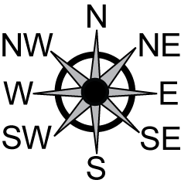
- determine the directions NE, SE, SW and NW when given one of the directions
- use north-east, south-east, south-west and north-west to describe the location of an object on simple maps, given a compass rose, eg 'The tree is south-west of the sign'
- calculate the distance between two points on a map using a simple given scale
- use scales involving multiples of 10 to calculate the distance between two points on maps and plans
- interpret simple scales on maps and plans, eg 'One centimetre on the map represents one metre in real life' (Reasoning)
- give reasons for using a particular scale on a map or plan (Communicating, Reasoning)
- recognise that the same location can be represented by maps or plans using different scales
Background Information
Students need to have experiences identifying north from a compass in their own environment and then determining the other three key directions: east, south and west. This could be done in the playground before introducing students to using these directions on maps to describe the positions of various places. The four directions NE, SE, SW and NW could then be introduced to assist with descriptions of places that lie between N, E, S and W.
Language
Students should be able to communicate using the following language: position, location, map, plan, legend, key, scale, directions, compass, compass rose, north, east, south, west, north-east, south-east, south-west, north-west.
The word 'scale' has different meanings in different contexts. Scale could mean the enlargement or reduction factor for a drawing, the scale marked on a measuring device, a fish scale or a musical scale.
Stage 2
Statistics and Probability
Data 1
Outcomes
A student:
- uses appropriate terminology to describe, and symbols to represent, mathematical ideas MA2-1WM
- selects and uses appropriate mental or written strategies, or technology, to solve problems MA2-2WM
- checks the accuracy of a statement and explains the reasoning used MA2-3WM
- selects appropriate methods to collect data, and constructs, compares, interprets and evaluates data displays, including tables, picture graphs and column graphs MA2-18SP
Content
Students:
Identify questions or issues for categorical variables; identify data sources and plan methods of data collection and recording (ACMSP068)
- recognise that data can be collected either by the user or by others
- identify possible sources of data collected by others, eg newspapers, government data-collection agencies, sporting agencies, environmental groups
- pose questions about a matter of interest to obtain information that can be recorded in categories
- predict and create a list of categories for efficient data collection in relation to a matter of interest, eg 'Which breakfast cereal is the most popular with members of our class?'
- identify issues for data collection and refine investigations, eg 'What if some members of our class don't eat cereal?' (Problem Solving)
Collect data, organise it into categories, and create displays using lists, tables, picture graphs and simple column graphs, with and without the use of digital technologies (ACMSP069)
- collect data and create a list or table to organise the data, eg collect data on the number of each colour of lollies in a packet
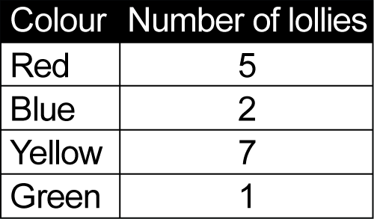
- use computer software to create a table to organise collected data, eg a spreadsheet (Communicating)
- construct vertical and horizontal column graphs and picture graphs that represent data using one-to-one correspondence
- use grid paper to assist in constructing graphs that represent data using one-to-one correspondence (Communicating)
- use the terms 'horizontal axis', 'vertical axis' and 'axes' appropriately when referring to column graphs (Communicating)
- use graphing software to enter data and create column graphs that represent data (Communicating)
- mark equal spaces on axes, name and label axes, and choose appropriate titles for column graphs (Communicating)
- choose an appropriate picture or symbol for a picture graph and state the key used (Communicating)
Interpret and compare data displays (ACMSP070)
- describe and interpret information presented in simple tables, column graphs and picture graphs
- make conclusions about data presented in different data displays, eg 'Football is the most popular sport for students in Year 3 at our school' (Communicating, Reasoning)
- represent the same data set using more than one type of display and compare the displays
- discuss the advantages and/or disadvantages of different representations of the same data (Communicating, Reasoning)
Background Information
Data could be collected from the internet, newspapers or magazines, as well as through students' surveys, votes and questionnaires.
In Stage 2, students should consider the use of graphs in real-world contexts. Graphs are frequently used to persuade and/or influence the reader, and are often biased.
One-to-one correspondence in a column graph means that one unit (eg 1 cm) on the vertical axis is used to represent one response/item.
Categorical data can be separated into distinct groups, eg colour, gender, blood type. Numerical data has variations that are expressed as numbers, eg the heights of students in a class, the number of children in families.
Language
Students should be able to communicate using the following language: information, data, collect, category, display, symbol, list, table, column graph, picture graph, vertical columns, horizontal bars, equal spacing, title, key, vertical axis, horizontal axis, axes, spreadsheet.
Column graphs consist of vertical columns or horizontal bars. However, the term 'bar graph' is reserved for divided bar graphs and should not be used for a column graph with horizontal bars.
Stage 2
Statistics and Probability
Data 2
Outcomes
A student:
- uses appropriate terminology to describe, and symbols to represent, mathematical ideas MA2-1WM
- selects and uses appropriate mental or written strategies, or technology, to solve problems MA2-2WM
- checks the accuracy of a statement and explains the reasoning used MA2-3WM
- selects appropriate methods to collect data, and constructs, compares, interprets and evaluates data displays, including tables, picture graphs and column graphs MA2-18SP
Content
Students:
Select and trial methods for data collection, including survey questions and recording sheets (ACMSP095)
- create a survey and related recording sheet, considering the appropriate organisation of categories for data collection
- choose effective ways to collect and record data for an investigation, eg creating a survey with a scale of 1 to 5 to indicate preferences (1 = don't like, 2 = like a little, 3 = don't know, 4 = like, 5 = like a lot) (Communicating, Problem Solving)
- refine survey questions as necessary after a small trial
- discuss and decide the most suitable question to investigate a particular matter of interest, eg by narrowing the focus of a question from 'What is the most popular playground game?' to 'What is the most popular playground game among Year 3 students at our school?' (Communicating, Reasoning)
- conduct a survey to collect categorical data
- after conducting a survey, discuss and determine possible improvements to the questions or recording sheet (Communicating, Reasoning)
- compare the effectiveness of different methods of collecting and recording data, eg creating categories of playground games and using tally marks, compared to asking open-ended questions such as 'What playground game do you like to play?'
- discuss the advantages and/or disadvantages of open-ended questions in a survey, compared to questions with predetermined categories (Communicating, Reasoning)
Construct suitable data displays, with and without the use of digital technologies, from given or collected data; include tables, column graphs and picture graphs where one picture can represent many data values (ACMSP096)
- represent given or collected categorical data in tables, column graphs and picture graphs, using a scale of many-to-one correspondence, with and without the use of digital technologies
- discuss and determine a suitable scale of many-to-one correspondence to draw graphs for large data sets and state the key used, eg  = 10 people, if there are 200 data values (Communicating, Reasoning)
- use grid paper to assist in drawing graphs that represent data using a scale of many-to-one correspondence (Communicating)
- use data in a spreadsheet to create column graphs with appropriately labelled axes (Communicating, Problem Solving)
- mark equal spaces on axes, name and label axes, and choose appropriate titles for graphs (Communicating)
Evaluate the effectiveness of different displays in illustrating data features, including variability (ACMSP097)
- interpret and evaluate the effectiveness of various data displays found in media and in factual texts, where displays represent data using a scale of many-to-one correspondence
- identify and discuss misleading representations of data (Communicating, Reasoning)
- discuss and compare features of data displays, including considering the number and appropriateness of the categories used, eg a display with only three categories (blue, red, other) for car colour is not likely to be useful (Communicating)
- discuss the advantages and disadvantages of different representations of the same categorical data, eg column graphs compared to picture graphs that represent data using scales of many-to-one correspondence (Communicating)
Background Information
A scale of many-to-one correspondence in a picture graph or column graph uses one symbol or one unit to represent more than one item or response, eg = 10 people, or 1 centimetre represents 5 items/responses.
Language
Students should be able to communicate using the following language: data, collect, survey, recording sheet, rating scale, category, display, symbol, tally mark, table, column graph, picture graph, vertical columns, horizontal bars, scale, equal spacing, title, key, vertical axis, horizontal axis, axes, spreadsheet, misleading.
Refer also to language in Data 1.
Stage 2
Statistics and Probability
Chance 1
Outcomes
A student:
- uses appropriate terminology to describe, and symbols to represent, mathematical ideas MA2-1WM
- checks the accuracy of a statement and explains the reasoning used MA2-3WM
- describes and compares chance events in social and experimental contexts MA2-19SP
Content
Students:
Conduct chance experiments, identify and describe possible outcomes, and recognise variation in results (ACMSP067)
- use the term 'outcome' to describe any possible result of a chance experiment
- predict and list all possible outcomes in a chance experiment, eg list the outcomes when three pegs are randomly selected from a bag containing an equal number of pegs of two colours
- predict and record all possible combinations in a chance situation, eg list all possible outfits when choosing from three different T-shirts and two different pairs of shorts
- predict the number of times each outcome should occur in a chance experiment involving a set number of trials, carry out the experiment, and compare the predicted and actual results
- keep a tally and graph the results of a chance experiment (Communicating)
- explain any differences between expected results and actual results in a chance experiment (Communicating, Reasoning)
- make statements that acknowledge 'randomness' in a situation, eg 'The spinner could stop on any colour' (Communicating, Reasoning)
- repeat a chance experiment several times and discuss why the results vary (Communicating)
Background Information
Random generators include coins, dice and spinners.
Language
Students should be able to communicate using the following language: chance, experiment, outcome, random, trials, tally, expected results, actual results.
Stage 2
Statistics and Probability
Chance 2
Outcomes
A student:
- uses appropriate terminology to describe, and symbols to represent, mathematical ideas MA2-1WM
- describes and compares chance events in social and experimental contexts MA2-19SP
Content
Students:
Describe possible everyday events and order their chances of occurring (ACMSP092)
- use the terms 'equally likely', 'likely' and 'unlikely' to describe the chance of everyday events occurring, eg 'It is equally likely that you will get an odd or an even number when you roll a die'
- compare the chance of familiar events occurring and describe the events as being 'more likely' or 'less likely' to occur than each other
- order events from least likely to most likely to occur, eg 'Having 10 children away sick on the same day is less likely than having one or two away'
- compare the likelihood of obtaining particular outcomes in a simple chance experiment, eg for a collection of 7 red, 13 blue and 10 yellow marbles, name blue as being the colour most likely to be drawn out and recognise that it is impossible to draw out a green marble
Identify everyday events where one occurring cannot happen if the other happens (ACMSP093)
- identify and discuss everyday events occurring that cannot occur at the same time, eg the sun rising and the sun setting
Identify events where the chance of one occurring will not be affected by the occurrence of the other (ACMSP094)
- identify and discuss events where the chance of one event occurring will not be affected by the occurrence of the other, eg obtaining a 'head' when tossing a coin does not affect the chance of obtaining a 'head' on the next toss
- explain why the chance of each of the outcomes of a second toss of a coin occurring does not depend on the result of the first toss, whereas drawing a card from a pack of playing cards and not returning it to the pack changes the chance of obtaining a particular card or cards in future draws (Communicating)
- compare events where the chance of one event occurring is not affected by the occurrence of the other, with events where the chance of one event occurring is affected by the occurrence of the other, eg decide whether taking five red lollies out of a packet containing 10 red and 10 green lollies affects the chance of the next lolly taken out being red, and compare this to what happens if the first five lollies taken out are put back in the jar before the sixth lolly is selected
Background Information
Theoretically, when a fair coin is tossed, there is an equal chance of obtaining a head or a tail. If the coin is tossed and five heads in a row are obtained, there is still an equal chance of a head or a tail on the next toss, since each toss is an independent event.
Language
Students should be able to communicate using the following language: chance, event, possible, impossible, likely, unlikely, less likely, more likely, most likely, least likely, equally likely, experiment, outcome.

Stage 3
Number and Algebra
Whole Numbers 1
Outcomes
A student:
- describes and represents mathematical situations in a variety of ways using mathematical terminology and some conventions MA3-1WM
- selects and applies appropriate problem-solving strategies, including the use of digital technologies, in undertaking investigations MA3-2WM
- orders, reads and represents integers of any size and describes properties of whole numbers MA3-4NA
Content
Students:
Recognise, represent and order numbers to at least tens of millions
- apply an understanding of place value and the role of zero to read and write numbers of any size
- state the place value of digits in numbers of any size
- arrange numbers of any size in ascending and descending order
- record numbers of any size using expanded notation, eg 163 480 = 100 000 + 60 000 + 3000 + 400 + 80
- partition numbers of any size in non-standard forms to aid mental calculation, eg when adding 163 480 and 150 000, 163 480 could be partitioned as 150 000 + 13 480, so that 150 000 could then be doubled and added to 13 480
- use numbers of any size in real-life situations, including in money problems
- interpret information from the internet, the media, the environment and other sources that use large numbers (Communicating, Reasoning)
- recognise different abbreviations of numbers used in everyday contexts, eg $350 K represents $350 000
- round numbers to a specified place value, eg round 5 461 883 to the nearest million
Identify and describe factors and multiples of whole numbers and use them to solve problems (ACMNA098)
- determine all 'factors' of a given whole number, eg 36 has factors 1, 2, 3, 4, 6, 9, 12, 18 and 36
- determine the 'highest common factor' (HCF) of two whole numbers, eg the HCF of 16 and 24 is 8
- determine 'multiples' of a given whole number, eg multiples of 7 are 7, 14, 21, 28, …
- determine the 'lowest common multiple' (LCM) of two whole numbers, eg the LCM of 21 and 63 is 63
- determine whether a particular number is a factor of a given number using digital technologies
- recognise that when a given number is divided by one of its factors, the result must be a whole number (Problem Solving)
- solve problems using knowledge of factors and multiples, eg 'There are 48 people at a party. In how many ways can you set up the tables and chairs, so that each table seats the same number of people and there are no empty chairs?'
Background Information
Students need to develop an understanding of place value relationships, such as 10 thousand = 100 hundreds = 1000 tens = 10 000 ones.
Language
Students should be able to communicate using the following language: ascending order, descending order, zero, ones, tens, hundreds, thousands, tens of thousands, hundreds of thousands, millions, digit, place value, expanded notation, round to, whole number, factor, highest common factor (HCF), multiple, lowest common multiple (LCM).
In some Asian languages, such as Chinese, Japanese and Korean, the natural language structures used when expressing numbers larger than 10 000 are 'tens of thousands' rather than 'thousands', and 'tens of millions' rather than 'millions'. For example, in Chinese (Mandarin), 612 000 is expressed as '61 wàn, 2 qiān', which translates as '61 tens of thousands and 2 thousands'.
The abbreviation 'K' is derived from the Greek word khilios, meaning 'thousand'. It is used in many job advertisements to represent salaries (eg a salary of $70 K or $70 000). It is also used as an abbreviation for the size of computer files (eg a size of 20 K, meaning twenty thousand bytes).
Stage 3
Number and Algebra
Whole Numbers 2
Outcomes
A student:
- describes and represents mathematical situations in a variety of ways using mathematical terminology and some conventions MA3-1WM
- selects and applies appropriate problem-solving strategies, including the use of digital technologies, in undertaking investigations MA3-2WM
- gives a valid reason for supporting one possible solution over another MA3-3WM
- orders, reads and represents integers of any size and describes properties of whole numbers MA3-4NA
Content
Students:
Investigate everyday situations that use integers; locate and represent these numbers on a number line (ACMNA124)
- recognise the location of negative whole numbers in relation to zero and place them on a number line
- use the term 'integers' to describe positive and negative whole numbers and zero
- interpret integers in everyday contexts, eg temperature
- investigate negative whole numbers and the number patterns created when counting backwards on a calculator
- recognise that negative whole numbers can result from subtraction (Reasoning)
- ask 'What if' questions, eg 'What happens if we subtract a larger number from a smaller number on a calculator?' (Communicating)
Identify and describe properties of prime, composite, square and triangular numbers (ACMNA122)
- determine whether a number is prime, composite or neither
- explain whether a whole number is prime, composite or neither by finding the number of factors, eg '13 has two factors (1 and 13) and therefore is prime', '21 has more than two factors (1, 3, 7, 21) and therefore is composite', '1 is neither prime nor composite as it has only one factor, itself' (Communicating, Reasoning)
- explain why a prime number, when modelled as an array, can have only one row (Communicating, Reasoning)
- model square and triangular numbers and record each number group in numerical and diagrammatic form
- explain how square and triangular numbers are created (Communicating, Reasoning)
- explore square and triangular numbers using arrays, grid paper or digital technologies (Communicating, Problem Solving)
- recognise and explain the relationship between the way each pattern of numbers is created and the name of the number group (Communicating, Reasoning)
Background Information
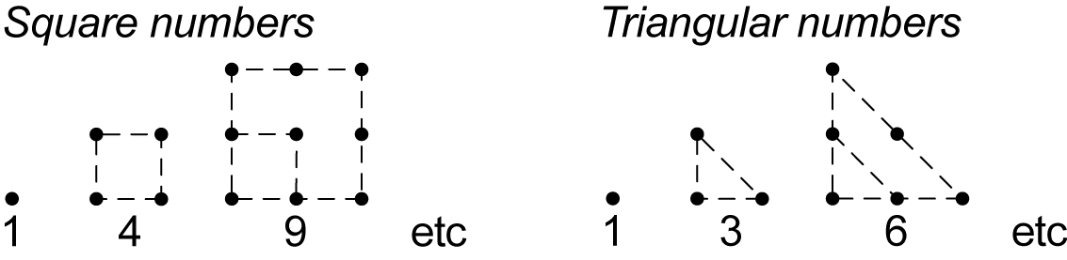
Students could investigate further the properties of square and triangular numbers, such as all square numbers have an odd number of factors, while all non-square numbers have an even number of factors; when two consecutive triangular numbers are added together, the result is always a square number.
Language
Students should be able to communicate using the following language: number line, whole number, zero, positive number, negative number, integer, prime number, composite number, factor, square number, triangular number.
Words such as 'square' have more than one grammatical use in mathematics, eg draw a square (noun), square three (verb), square numbers (adjective) and square metres (adjective).
Stage 3
Number and Algebra
Addition and Subtraction 1
Outcomes
A student:
- describes and represents mathematical situations in a variety of ways using mathematical terminology and some conventions MA3-1WM
- selects and applies appropriate problem-solving strategies, including the use of digital technologies, in undertaking investigations MA3-2WM
- gives a valid reason for supporting one possible solution over another MA3-3WM
- selects and applies appropriate strategies for addition and subtraction with counting numbers of any size MA3-5NA
Content
Students:
Use efficient mental and written strategies and apply appropriate digital technologies to solve problems (ACMNA291)
- use the term 'sum' to describe the result of adding two or more numbers, eg 'The sum of 7 and 5 is 12'
- add three or more numbers with different numbers of digits, with and without the use of digital technologies, eg 42 000 + 5123 + 246
- select and apply efficient mental, written and calculator strategies to solve addition and subtraction word problems, including problems involving money
- interpret the words 'increase' and 'decrease' in addition and subtraction word problems, eg 'If a computer costs $1599 and its price is then decreased by $250, how much do I pay?' (Communicating, Problem Solving)
- record the strategy used to solve addition and subtraction word problems
- use empty number lines to record mental strategies (Communicating, Problem Solving)
- use selected words to describe each step of the solution process (Communicating, Problem Solving)
- check solutions to problems, including by using the inverse operation
Use estimation and rounding to check the reasonableness of answers to calculations (ACMNA099)
- round numbers appropriately when obtaining estimates to numerical calculations
- use estimation to check the reasonableness of answers to addition and subtraction calculations, eg 1438 + 129 is about 1440 + 130
Create simple financial plans (ACMNA106)
- use knowledge of addition and subtraction facts to create a financial plan, such as a budget, eg organise a class celebration on a budget of $60 for all expenses
- record numerical data in a simple spreadsheet (Communicating)
- give reasons for selecting, prioritising and deleting items when creating a budget (Communicating, Reasoning)
Background Information
In Stage 3, mental strategies need to be continually reinforced.
Students may find recording (writing out) informal mental strategies to be more efficient than using formal written algorithms, particularly in the case of subtraction.
For example, 8000 − 673 is easier to calculate mentally than by using a formal algorithm.
Written strategies using informal mental strategies (empty number line):
The jump strategy can be used on an empty number line to count up rather than back.
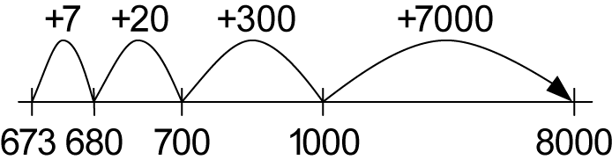
The answer will therefore be 7000 + 300 + 20 + 7 = 7327. Students could share possible approaches and compare them to determine the most efficient.
The difference can be shifted one unit to the left on an empty number line, so that 8000 − 673 becomes 7999 − 672, which is an easier subtraction to calculate.
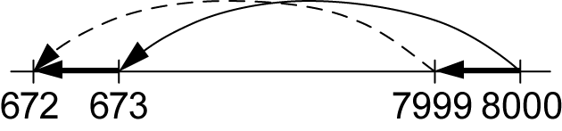
Written strategies using a formal algorithm (decomposition method):
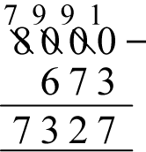
An inverse operation is an operation that reverses the effect of the original operation. Addition and subtraction are inverse operations; multiplication and division are inverse operations.
Language
Students should be able to communicate using the following language: plus, sum, add, addition, increase, minus, the difference between, subtract, subtraction, decrease, equals, is equal to, empty number line, strategy, digit, estimate, round to, budget.
Teachers should model and use a variety of expressions for the operations of addition and subtraction, and should draw students' attention to the fact that the words used for subtraction may require the operation to be performed with the numbers in the reverse order to that in which they are stated in the question. For example, '9 take away 3' and 'reduce 9 by 3' require the operation to be performed with the numbers in the same order as they are presented in the question (ie 9 – 3). However, 'take 9 from 3', 'subtract 9 from 3' and '9 less than 3' require the operation to be performed with the numbers in the reverse order to that in which they are stated in the question (ie 3 – 9).
Stage 3
Number and Algebra
Addition and Subtraction 2
Outcomes
A student:
- describes and represents mathematical situations in a variety of ways using mathematical terminology and some conventions MA3-1WM
- selects and applies appropriate problem-solving strategies, including the use of digital technologies, in undertaking investigations MA3-2WM
- gives a valid reason for supporting one possible solution over another MA3-3WM
- selects and applies appropriate strategies for addition and subtraction with counting numbers of any size MA3-5NA
Content
Students:
Select and apply efficient mental and written strategies and appropriate digital technologies to solve problems involving addition and subtraction with whole numbers (ACMNA123)
- solve addition and subtraction word problems involving whole numbers of any size, including problems that require more than one operation, eg 'I have saved $40 000 to buy a new car. The basic model costs $36 118 and I add tinted windows for $860 and Bluetooth connectivity for $1376. How much money will I have left over?'
- select and apply appropriate mental and written strategies, with and without the use of digital technologies, to solve unfamiliar problems (Problem Solving)
- explain how an answer was obtained for an addition or subtraction problem and justify the selected calculation method (Communicating, Problem Solving, Reasoning)
- reflect on their chosen method of solution for a problem, considering whether it can be improved (Communicating, Reasoning)
- give reasons why a calculator was useful when solving a problem (Communicating, Reasoning)
- record the strategy used to solve addition and subtraction word problems
- use selected words to describe each step of the solution process (Communicating, Problem Solving)
Background Information
Refer to background information in Addition and Subtraction 1.
Language
Students should be able to communicate using the following language: plus, sum, add, addition, increase, minus, the difference between, subtract, subtraction, decrease, equals, is equal to, operation, digit.
When solving word problems, students should be encouraged to write a few key words on the left-hand side of the equals sign to identify what is being found in each step of their working, eg 'amount to pay = …', 'change = …'.
Refer also to language in Addition and Subtraction 1.
Stage 3
Number and Algebra
Multiplication and Division 1
Outcomes
A student:
- describes and represents mathematical situations in a variety of ways using mathematical terminology and some conventions MA3-1WM
- selects and applies appropriate problem-solving strategies, including the use of digital technologies, in undertaking investigations MA3-2WM
- gives a valid reason for supporting one possible solution over another MA3-3WM
- selects and applies appropriate strategies for multiplication and division, and applies the order of operations to calculations involving more than one operation MA3-6NA
Content
Students:
Solve problems involving multiplication of large numbers by one- or two-digit numbers using efficient mental and written strategies and appropriate digital technologies (ACMNA100)
- use mental and written strategies to multiply three- and four-digit numbers by one-digit numbers, including:
- multiplying the thousands, then the hundreds, then the tens and then the ones, eg
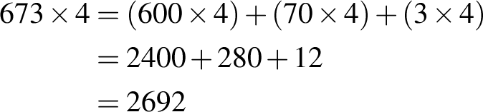
- using an area model, eg 684 × 5
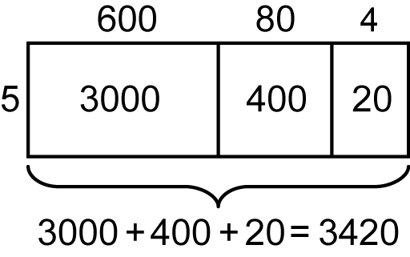
- using the formal algorithm, eg 432 × 5
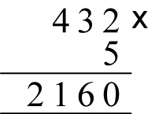
- use mental and written strategies to multiply two- and three-digit numbers by two-digit numbers, including:
- using an area model for two-digit by two-digit multiplication, eg 25 × 26
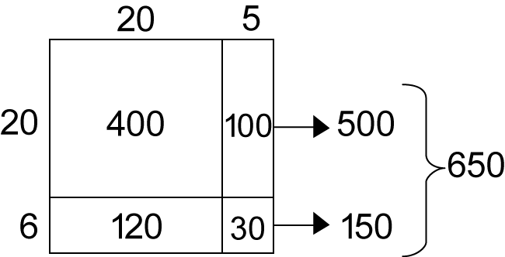
- factorising the numbers, eg 12 × 25 = 3 × 4 × 25 = 3 × 100 = 300
- using the extended form (long multiplication) of the formal algorithm, eg
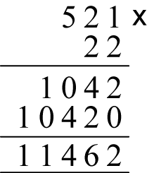
- use digital technologies to multiply numbers of up to four digits
- check answers to mental calculations using digital technologies (Problem Solving)
- apply appropriate mental and written strategies, and digital technologies, to solve multiplication word problems
- use the appropriate operation when solving problems in real-life situations (Problem Solving)
- use inverse operations to justify solutions (Problem Solving, Reasoning)
- record the strategy used to solve multiplication word problems
- use selected words to describe each step of the solution process (Communicating, Problem Solving)
Solve problems involving division by a one-digit number, including those that result in a remainder (ACMNA101)
- use the term 'quotient' to describe the result of a division calculation, eg 'The quotient when 30 is divided by 6 is 5'
- recognise and use different notations to indicate division, eg 25 ÷ 4, 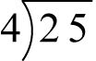, 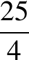
- record remainders as fractions and decimals, eg 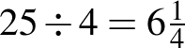 or 6.25
- use mental and written strategies to divide a number with three or more digits by a one-digit divisor where there is no remainder, including:
- dividing the hundreds, then the tens, and then the ones, eg 3248 ÷ 4
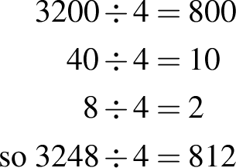
- using the formal algorithm, eg 258 ÷ 6
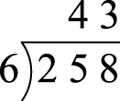
- use mental and written strategies to divide a number with three or more digits by a one-digit divisor where there is a remainder, including:
- dividing the tens and then the ones, eg 243 ÷ 4
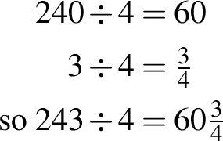
- using the formal algorithm, eg 587 ÷ 6
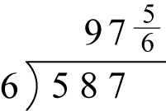
- explain why the remainder in a division calculation is always less than the number divided by (the divisor) (Communicating, Reasoning)
- show the connection between division and multiplication, including where there is a remainder, eg 25 ÷ 4 = 6 remainder 1, so 25 = 4 × 6 + 1
- use digital technologies to divide whole numbers by one- and two-digit divisors
- check answers to mental calculations using digital technologies (Problem Solving)
- apply appropriate mental and written strategies, and digital technologies, to solve division word problems
- recognise when division is required to solve word problems (Problem Solving)
- use inverse operations to justify solutions to problems (Problem Solving, Reasoning)
- use and interpret remainders in solutions to division problems, eg recognise when it is appropriate to round up an answer, such as 'How many 5-seater cars are required to take 47 people to the beach?'
- record the strategy used to solve division word problems
- use selected words to describe each step of the solution process (Communicating, Problem Solving)
Use estimation and rounding to check the reasonableness of answers to calculations (ACMNA099)
- round numbers appropriately when obtaining estimates to numerical calculations
- use estimation to check the reasonableness of answers to multiplication and division calculations, eg '32 × 253 will be about, but more than, 30 × 250'
Background Information
Students could extend their recall of number facts beyond the multiplication facts to 10 × 10 by memorising multiples of numbers such as 11, 12, 15, 20 and 25. They could also utilise mental strategies, eg '14 × 6 is 10 sixes plus 4 sixes'.
In Stage 3, mental strategies need to be continually reinforced.
Students may find recording (writing out) informal mental strategies to be more efficient than using formal written algorithms, particularly in the case of multiplication.
An inverse operation is an operation that reverses the effect of the original operation. Addition and subtraction are inverse operations; multiplication and division are inverse operations.
The area model for two-digit by two-digit multiplication in Stage 3 is a precursor to the use of the area model for the expansion of binomial products in Stage 5.
Language
Students should be able to communicate using the following language: multiply, multiplied by, product, multiplication, multiplication facts, area, thousands, hundreds, tens, ones, double, multiple, factor, divide, divided by, quotient, division, halve, remainder, fraction, decimal, equals, strategy, digit, estimate, round to.
In mathematics, 'quotient' refers to the result of dividing one number by another.
Teachers should model and use a variety of expressions for multiplication and division. They should draw students' attention to the fact that the words used for division may require the operation to be performed with the numbers in the reverse order to that in which they are stated in the question. For example, 'divide 6 by 2' and '6 divided by 2' require the operation to be performed with the numbers in the same order as they are presented in the question (ie 6 ÷ 2). However, 'How many 2s in 6?' requires the operation to be performed with the numbers in the reverse order to that in which they are stated in the question (ie 6 ÷ 2).
The terms 'ratio' and 'rate' are not introduced until Stage 4, but students need to be able to interpret problems involving simple rates as requiring multiplication or division.
Stage 3
Number and Algebra
Multiplication and Division 2
Outcomes
A student:
- describes and represents mathematical situations in a variety of ways using mathematical terminology and some conventions MA3-1WM
- selects and applies appropriate problem-solving strategies, including the use of digital technologies, in undertaking investigations MA3-2WM
- gives a valid reason for supporting one possible solution over another MA3-3WM
- selects and applies appropriate strategies for multiplication and division, and applies the order of operations to calculations involving more than one operation MA3-6NA
Content
Students:
Select and apply efficient mental and written strategies, and appropriate digital technologies, to solve problems involving multiplication and division with whole numbers (ACMNA123)
- select and use efficient mental and written strategies, and digital technologies, to multiply whole numbers of up to four digits by one- and two-digit numbers
- select and use efficient mental and written strategies, and digital technologies, to divide whole numbers of up to four digits by a one-digit divisor, including where there is a remainder
- estimate solutions to problems and check to justify solutions (Problem Solving, Reasoning)
- use mental strategies to multiply and divide numbers by 10, 100, 1000 and their multiples
- solve word problems involving multiplication and division, eg 'A recipe requires 3 cups of flour for 10 people. How many cups of flour are required for 40 people?'
- use appropriate language to compare quantities, eg 'twice as much as', 'half as much as' (Communicating)
- use a table or similar organiser to record methods used to solve problems (Communicating, Problem Solving)
- recognise symbols used to record speed in kilometres per hour, eg 80 km/h
- solve simple problems involving speed, eg 'How long would it take to travel 600 km if the average speed for the trip is 75 km/h?'
Explore the use of brackets and the order of operations to write number sentences (ACMNA134)
- use the term 'operations' to describe collectively the processes of addition, subtraction, multiplication and division
- investigate and establish the order of operations using real-life contexts, eg 'I buy six goldfish costing $10 each and two water plants costing $4 each. What is the total cost?'; this can be represented by the number sentence 6 × 10 + 2 × 4 but, to obtain the total cost, multiplication must be performed before addition
- write number sentences to represent real-life situations (Communicating, Problem Solving)
- recognise that the grouping symbols and are used in number sentences to indicate operations that must be performed first
- recognise that if more than one pair of grouping symbols are used, the operation within the innermost grouping symbols is performed first
- perform calculations involving grouping symbols without the use of digital technologies, eg
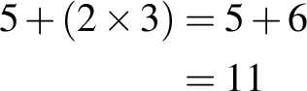
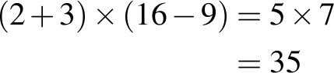
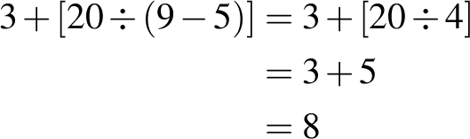
- apply the order of operations to perform calculations involving mixed operations and grouping symbols, without the use of digital technologies, eg
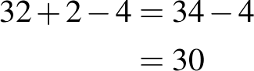 addition and subtraction only, therefore work from left to right
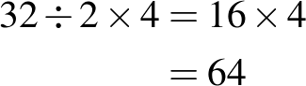 multiplication and division only, therefore work from left to right
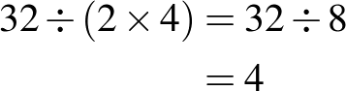 perform operation in grouping symbols first
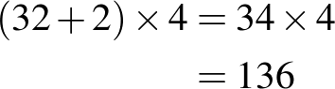 perform operation in grouping symbols first
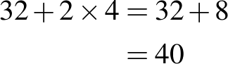 perform multiplication before addition
- investigate whether different digital technologies apply the order of operations (Reasoning)
- recognise when grouping symbols are not necessary, eg 32 + (2 × 4) has the same answer as 32 + 2 × 4
Background Information
Students could extend their recall of number facts beyond the multiplication facts to 10 × 10 by also memorising multiples of numbers such as 11, 12, 15, 20 and 25, or by utilising mental strategies, eg '14 × 6 is 10 sixes plus 4 sixes'.
The simplest multiplication word problems relate to rates, eg 'If four students earn $3 each, how much do they have all together?' Another type of problem is related to ratio and uses language such as 'twice as many as' and 'six times as many as'.
An 'operation' is a mathematical process. The four basic operations are addition, subtraction, multiplication and division. Other operations include raising a number to a power and taking a root of a number. An 'operator' is a symbol that indicates the type of operation, eg +, –, × and ÷.
Refer also to background information in Multiplication and Division 1.
Language
Students should be able to communicate using the following language: multiply, multiplied by, product, multiplication, multiplication facts, area, thousands, hundreds, tens, ones, double, multiple, factor, divide, divided by, quotient, division, halve, remainder, fraction, decimal, equals, strategy, digit, estimate, speed, per, operations, order of operations, grouping symbols, brackets, number sentence, is the same as.
When solving word problems, students should be encouraged to write a few key words on the left-hand side of the equals sign to identify what is being found in each step of their working, eg 'cost of goldfish = …', 'cost of plants = …', 'total cost = …'.
'Grouping symbols' is a collective term used to describe brackets , parentheses  and braces . The term 'brackets' is often used in place of 'parentheses'.
Often in mathematics when grouping symbols have one level of nesting, the inner pair is parentheses and the outer pair is brackets, eg 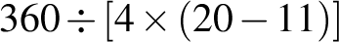.
Stage 3
Number and Algebra
Fractions and Decimals 1
Outcomes
A student:
- describes and represents mathematical situations in a variety of ways using mathematical terminology and some conventions MA3-1WM
- selects and applies appropriate problem-solving strategies, including the use of digital technologies, in undertaking investigations MA3-2WM
- gives a valid reason for supporting one possible solution over another MA3-3WM
- compares, orders and calculates with fractions, decimals and percentages MA3-7NA
Content
Students:
Compare and order common unit fractions and locate and represent them on a number line (ACMNA102)
- place fractions with denominators of 2, 3, 4, 5, 6, 8, 10 and 12 on a number line between 0 and 1, eg
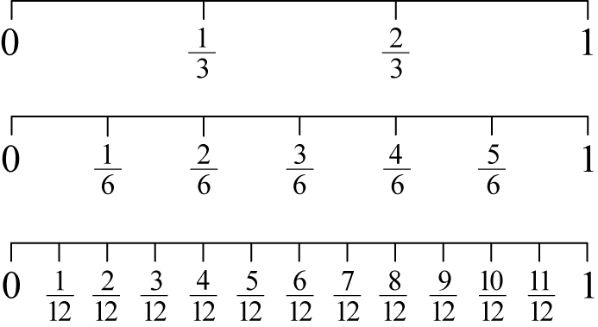
- compare and order unit fractions with denominators of 2, 3, 4, 5, 6, 8, 10, 12 and 100
- compare the relative value of unit fractions by placing them on a number line between 0 and 1 (Communicating, Reasoning)
- investigate and explain the relationship between the value of a unit fraction and its denominator (Communicating, Reasoning)
Investigate strategies to solve problems involving addition and subtraction of fractions with the same denominator (ACMNA103)
- identify and describe 'proper fractions' as fractions in which the numerator is less than the denominator
- identify and describe 'improper fractions' as fractions in which the numerator is greater than the denominator
- express mixed numerals as improper fractions and vice versa, through the use of diagrams and number lines, leading to a mental strategy, eg
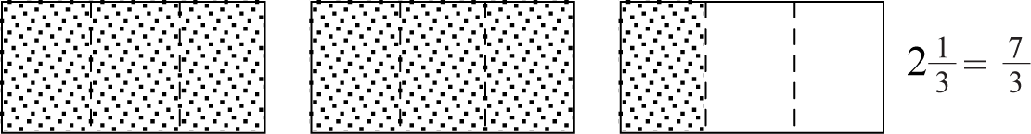
- model and represent strategies, including using diagrams, to add proper fractions with the same denominator, where the result may be a mixed numeral, eg
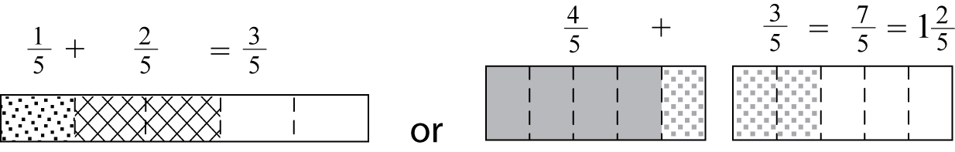
- model and represent a whole number added to a proper fraction, eg 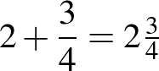
- subtract a proper fraction from another proper fraction with the same denominator, eg 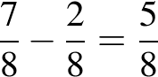
- model and represent strategies, including using diagrams, to add mixed numerals with the same denominator, eg
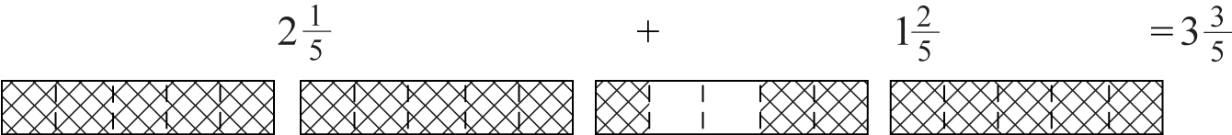
- use diagrams, and mental and written strategies, to subtract a unit fraction from any whole number including 1, eg
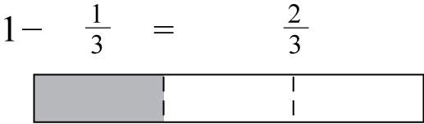
- solve word problems that involve addition and subtraction of fractions with the same denominator, eg 'I eat of a block of chocolate and you eat of the same block. How much of the block of chocolate has been eaten?'
- use estimation to verify that an answer is reasonable (Problem Solving, Reasoning)
Recognise that the place value system can be extended beyond hundredths (ACMNA104)
- express thousandths as decimals
- interpret decimal notation for thousandths, eg 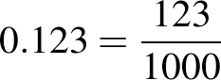
- state the place value of digits in decimal numbers of up to three decimal places
Compare, order and represent decimals (ACMNA105)
- compare and order decimal numbers of up to three decimal places, eg 0.5, 0.125, 0.25
- interpret zero digit(s) at the end of a decimal, eg 0.170 has the same value as 0.17
- place decimal numbers of up to three decimal places on a number line between 0 and 1
Background Information
In Stage 3 Fractions and Decimals, students study fractions with denominators of 2, 3, 4, 5, 6, 8, 10, 12 and 100. A unit fraction is any proper fraction in which the numerator is 1, eg
Fractions may be interpreted in different ways depending on the context, eg two-quarters 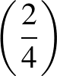 may be thought of as two equal parts of one whole that has been divided into four equal parts.
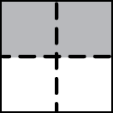
Alternatively, two-quarters may be thought of as two equal parts of two wholes that have each been divided into quarters.
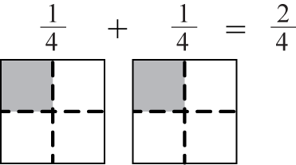
Students need to interpret a variety of word problems and translate them into mathematical diagrams and/or fraction notation. Fractions have different meanings depending on the context, eg show on a diagram three-quarters 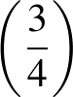 of a pizza, draw a diagram to show how much each child receives when four children share three pizzas.
Language
Students should be able to communicate using the following language: whole, equal parts, half, quarter, eighth, third, sixth, twelfth, fifth, tenth, hundredth, thousandth, one-thousandth, fraction, numerator, denominator, mixed numeral, whole number, number line, proper fraction, improper fraction, decimal, decimal point, digit, place value, decimal places.
The decimal 1.12 is read as 'one point one two' and not 'one point twelve'.
When expressing fractions in English, the numerator is said first, followed by the denominator. However, in many Asian languages (eg Chinese, Japanese), the opposite is the case: the denominator is said before the numerator.
Stage 3
Number and Algebra
Fractions and Decimals 2
Outcomes
A student:
- describes and represents mathematical situations in a variety of ways using mathematical terminology and some conventions MA3-1WM
- selects and applies appropriate problem-solving strategies, including the use of digital technologies, in undertaking investigations MA3-2WM
- gives a valid reason for supporting one possible solution over another MA3-3WM
- compares, orders and calculates with fractions, decimals and percentages MA3-7NA
Content
Students:
Compare fractions with related denominators and locate and represent them on a number line (ACMNA125)
- model, compare and represent fractions with denominator of 2, 3, 4, 5, 6, 8, 10, 12 and 100 of a whole object, a whole shape and a collection of objects
- compare the relative size of fractions drawn on the same diagram, eg
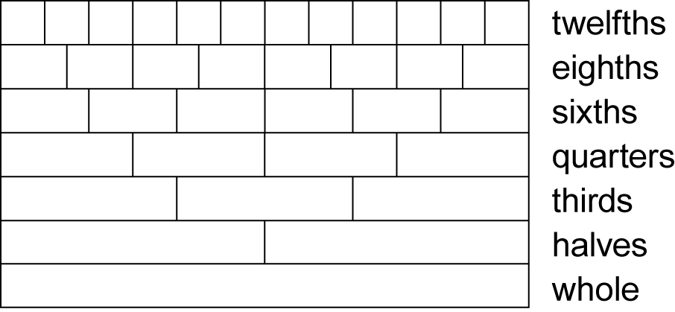 (Reasoning)
- compare and order simple fractions with related denominators using strategies such as diagrams, the number line, or equivalent fractions, eg write 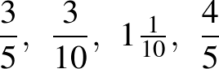 and 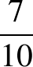 in ascending order
- find equivalent fractions by re-dividing the whole, using diagrams and number lines, eg
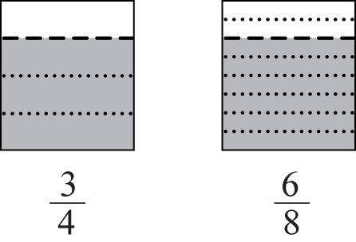
- record equivalent fractions using diagrams and numerals
- develop mental strategies for generating equivalent fractions, such as multiplying or dividing the numerator and the denominator by the same number,
eg 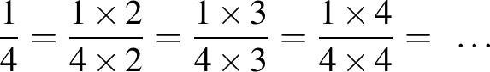, ie 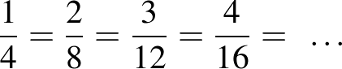
- explain or demonstrate why two fractions are or are not equivalent (Communicating, Reasoning)
- write fractions in their 'simplest form' by dividing the numerator and the denominator by a common factor, eg 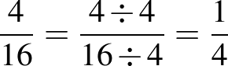
- recognise that a fraction in its simplest form represents the same value as the original fraction (Reasoning)
- apply knowledge of equivalent fractions to convert between units of time, eg 15 minutes is the same as 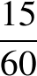 of an hour, which is the same as of an hour (Problem Solving)
Solve problems involving addition and subtraction of fractions with the same or related denominators (ACMNA126)
- add and subtract fractions, including mixed numerals, where one denominator is the same as, or a multiple of, the other, eg 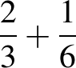, 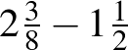, 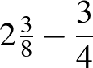
- convert an answer that is an improper fraction to a mixed numeral (Communicating)
- use knowledge of equivalence to simplify answers when adding and subtracting fractions (Communicating, Reasoning)
- recognise that improper fractions may sometimes make calculations involving mixed numerals easier (Communicating)
- solve word problems involving the addition and subtraction of fractions where one denominator is the same as, or a multiple of, the other, eg 'I ate of a cake and my friend ate of the cake. What fraction of the cake remains?'
- multiply simple fractions by whole numbers using repeated addition, leading to a rule,
eg 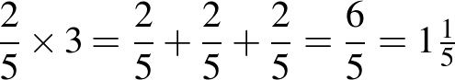 leading to 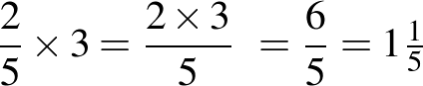
Find a simple fraction of a quantity where the result is a whole number, with and without the use of digital technologies (ACMNA127)
- calculate unit fractions of collections, with and without the use of digital technologies, eg calculate of 30
- describe the connection between finding a unit fraction of a collection and the operation of division (Communicating, Problem Solving)
- calculate a simple fraction of a collection/quantity, with and without the use of digital technologies, eg calculate of 30
- explain how unit fractions can be used in the calculation of simple fractions of collections/quantities, eg 'To calculate of a quantity, I found of the collection first and then multiplied by 3' (Communicating, Reasoning)
- solve word problems involving a fraction of a collection/quantity
Add and subtract decimals, with and without the use of digital technologies, and use estimation and rounding to check the reasonableness of answers (ACMNA128)
- add and subtract decimals with the same number of decimal places, with and without the use of digital technologies
- add and subtract decimals with a different number of decimal places, with and without the use of digital technologies
- relate decimals to fractions to aid mental strategies (Communicating)
- round a number of up to three decimal places to the nearest whole number
- use estimation and rounding to check the reasonableness of answers when adding and subtracting decimals
- describe situations where the estimation of calculations with decimals may be useful, eg to check the total cost of multiple items when shopping (Communicating, Problem Solving)
- solve word problems involving the addition and subtraction of decimals, with and without the use of digital technologies, including those involving money
- use selected words to describe each step of the solution process (Communicating, Problem Solving)
- interpret a calculator display in the context of the problem, eg 2.6 means $2.60 (Communicating)
Multiply decimals by whole numbers and perform divisions by non-zero whole numbers where the results are terminating decimals, with and without the use of digital technologies (ACMNA129)
- use mental strategies to multiply simple decimals by single-digit numbers, eg 3.5 × 2
- multiply decimals of up to three decimal places by whole numbers of up to two digits, with and without the use of digital technologies, eg 'I measured three desks. Each desk was 1.25 m in length, so the total length is 3 × 1.25 = 3.75 m'
- divide decimals by a one-digit whole number where the result is a terminating decimal, eg 5.25 ÷ 5 = 1.05
- solve word problems involving the multiplication and division of decimals, including those involving money, eg determine the 'best buy' for different-sized cartons of cans of soft drink
Multiply and divide decimals by powers of 10 (ACMNA130)
- recognise the number patterns formed when decimals are multiplied and divided by 10, 100 and 1000
- multiply and divide decimals by 10, 100 and 1000
- use a calculator to explore the effect of multiplying and dividing decimals by multiples of 10 (Reasoning)
Make connections between equivalent fractions, decimals and percentages (ACMNA131)
- recognise that the symbol % means 'percent'
- represent common percentages as fractions and decimals, eg '25% means 25 out of 100 or or 0.25'
- recognise fractions, decimals and percentages as different representations of the same value (Communicating)
- recall commonly used equivalent percentages, decimals and fractions, eg 75%, 0.75, (Communicating)
- represent simple fractions as decimals and as percentages
- interpret and explain the use of fractions, decimals and percentages in everyday contexts, eg hour = 45 minutes, percentage of trees in the local area that are native to Australia (Communicating, Reasoning)
- represent decimals as fractions and percentages, eg 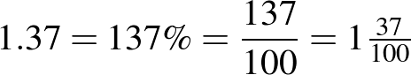
Investigate and calculate percentage discounts of 10%, 25% and 50% on sale items, with and without the use of digital technologies (ACMNA132)
- equate 10% to , 25% to and 50% to
- calculate common percentages (10%, 25%, 50%) of quantities, with and without the use of digital technologies
- choose the most appropriate equivalent form of a percentage to aid calculation,
eg 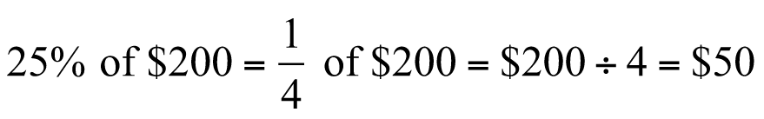 (Problem Solving)
- use mental strategies to estimate discounts of 10%, 25% and 50%, eg '50% off the price of $122.70: 50% is the same as , so the discount is about $60'
- calculate the sale price of an item after a discount of 10%, 25% and 50%, with and without the use of digital technologies, recording the strategy and result
Background Information
In Stage 3 Fractions and Decimals, students study fractions with denominators of 2, 3, 4, 5, 6, 8, 10, 12 and 100. A unit fraction is any proper fraction in which the numerator is 1, eg
The process of writing a fraction in its 'simplest form' involves reducing the fraction to its lowest equivalent form. In Stage 4, this is referred to as 'simplifying' a fraction.
When subtracting mixed numerals, working with the whole-number parts separately from the fractional parts can lead to difficulties, particularly where the subtraction of the fractional parts results in a negative value, eg in the calculation of 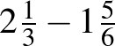, 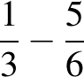 results in a negative value.
Language
Students should be able to communicate using the following language: whole, equal parts, half, quarter, eighth, third, sixth, twelfth, fifth, tenth, hundredth, thousandth, fraction, numerator, denominator, mixed numeral, whole number, number line, proper fraction, improper fraction, is equal to, equivalent, ascending order, descending order, simplest form, decimal, decimal point, digit, round to, decimal places, dollars, cents, best buy, percent, percentage, discount, sale price.
The decimal 1.12 is read as 'one point one two' and not 'one point twelve'.
The word 'cent' is derived from the Latin word centum, meaning 'one hundred'. 'Percent' means 'out of one hundred' or 'hundredths'.
A 'terminating' decimal has a finite number of decimal places, eg 3.25 (2 decimal places), 18.421 (3 decimal places).
Stage 3
Number and Algebra
Patterns and Algebra 1
Outcomes
A student:
- describes and represents mathematical situations in a variety of ways using mathematical terminology and some conventions MA3-1WM
- selects and applies appropriate problem-solving strategies, including the use of digital technologies, in undertaking investigations MA3-2WM
- gives a valid reason for supporting one possible solution over another MA3-3WM
- analyses and creates geometric and number patterns, constructs and completes number sentences, and locates points on the Cartesian plane MA3-8NA
Content
Students:
Describe, continue and create patterns with fractions, decimals and whole numbers resulting from addition and subtraction (ACMNA107)
- identify, continue and create simple number patterns involving addition and subtraction
- describe patterns using the terms 'increase' and 'decrease', eg for the pattern 48, 41, 34, 27, …, 'The terms decrease by seven'
- create, with materials or digital technologies, a variety of patterns using whole numbers, fractions or decimals, eg 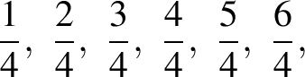 … or 2.2, 2.0, 1.8, 1.6, …
- use a number line or other diagram to create patterns involving fractions or decimals
Use equivalent number sentences involving multiplication and division to find unknown quantities (ACMNA121)
- complete number sentences that involve more than one operation by calculating missing numbers, eg ,
- describe strategies for completing simple number sentences and justify solutions (Communicating, Reasoning)
- identify and use inverse operations to assist with the solution of number sentences, eg becomes
- describe how inverse operations can be used to solve a number sentence (Communicating, Reasoning)
- complete number sentences involving multiplication and division, including those involving simple fractions or decimals, eg
- check solutions to number sentences by substituting the solution into the original question (Reasoning)
- write number sentences to match word problems that require finding a missing number, eg 'I am thinking of a number that when I double it and add 5, the answer is 13. What is the number?'
Background Information
Students should be given opportunities to discover and create patterns and to describe, in their own words, relationships contained in those patterns.
This substrand involves algebra without using letters to represent unknown values. When calculating unknown values, students need to be encouraged to work backwards and to describe the processes using inverse operations, rather than using trial-and-error methods. The inclusion of number sentences that do not have whole-number solutions will aid this process.
To represent equality of mathematical expressions, the terms 'is the same as' and 'is equal to' should be used. Use of the word 'equals' may suggest that the right-hand side of an equation contains 'the answer', rather than a value equivalent to that on the left.
Language
Students should be able to communicate using the following language: pattern, increase, decrease, missing number, number sentence, number line.
In Stage 3, students should be encouraged to use their own words to describe number patterns. Patterns can usually be described in more than one way and it is important for students to hear how other students describe the same pattern. Students' descriptions of number patterns can then become more sophisticated as they experience a variety of ways of describing the same pattern. The teacher could begin to model the use of more appropriate mathematical language to encourage this development.
Stage 3
Number and Algebra
Patterns and Algebra 2
Outcomes
A student:
- describes and represents mathematical situations in a variety of ways using mathematical terminology and some conventions MA3-1WM
- selects and applies appropriate problem-solving strategies, including the use of digital technologies, in undertaking investigations MA3-2WM
- gives a valid reason for supporting one possible solution over another MA3-3WM
- analyses and creates geometric and number patterns, constructs and completes number sentences, and locates points on the Cartesian plane MA3-8NA
Content
Students:
Continue and create sequences involving whole numbers, fractions and decimals; describe the rule used to create the sequence (ACMNA133)
- continue and create number patterns, with and without the use of digital technologies, using whole numbers, fractions and decimals, eg 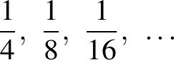 or 1.25, 2.5, 5, …
- describe how number patterns have been created and how they can be continued (Communicating, Problem Solving)
- create simple geometric patterns using concrete materials, eg
- complete a table of values for a geometric pattern and describe the pattern in words, eg
- describe the number pattern in a variety of ways and record descriptions using words, eg 'It looks like the multiplication facts for four'
- determine the rule to describe the pattern by relating the bottom number to the top number in a table, eg 'You multiply the number of squares by four to get the number of matches'
- use the rule to calculate the corresponding value for a larger number, eg 'How many matches are needed to create 100 squares?'
- complete a table of values for number patterns involving one operation (including patterns that decrease) and describe the pattern in words, eg
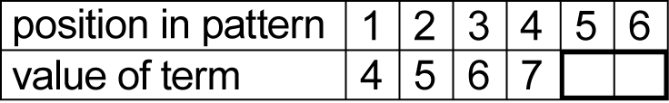
- describe the pattern in a variety of ways and record descriptions in words, eg 'It goes up by ones, starting from four'
- determine a rule to describe the pattern from the table, eg 'To get the value of the term, you add three to the position in the pattern'
- use the rule to calculate the value of the term for a large position number, eg 'What is the 55th term of the pattern?'
- explain why it is useful to describe the rule for a pattern by describing the connection between the 'position in the pattern' and the 'value of the term' (Communicating, Reasoning)
- interpret explanations written by peers and teachers that accurately describe geometric and number patterns (Communicating)
- make generalisations about numbers and number relationships, eg 'If you add a number and then subtract the same number, the result is the number you started with'
Introduce the Cartesian coordinate system using all four quadrants (ACMMG143)
- recognise that the number plane (Cartesian plane) is a visual way of describing location on a grid
- recognise that the number plane consists of a horizontal axis (x-axis) and a vertical axis (y-axis), creating four quadrants
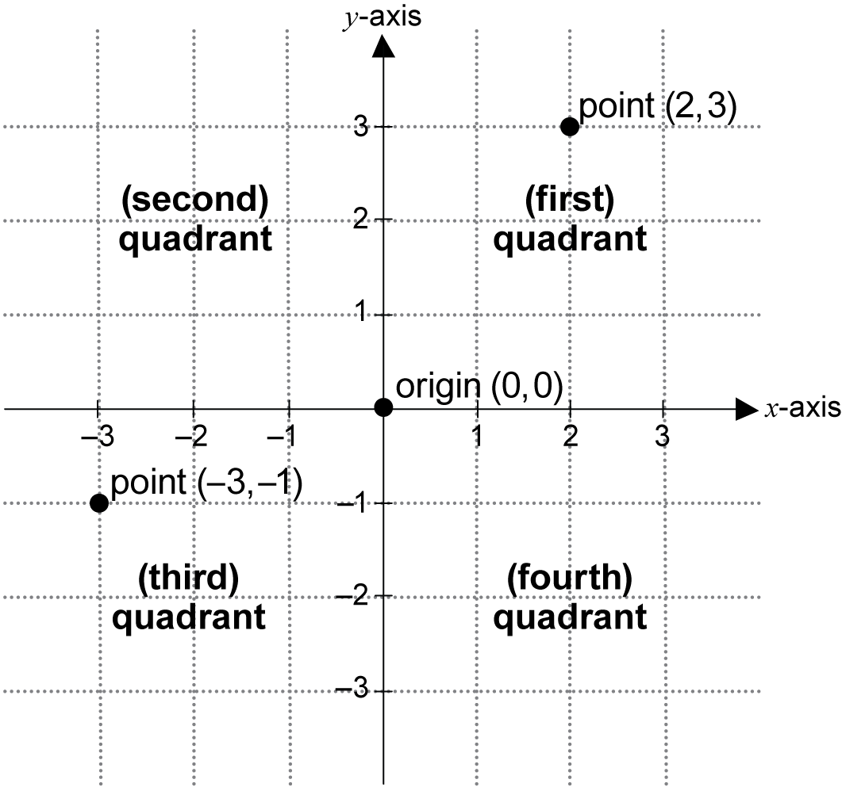
- recognise that the horizontal axis and the vertical axis meet at right angles (Reasoning)
- identify the point of intersection of the two axes as the origin, having coordinates (0, 0)
- plot and label points, given coordinates, in all four quadrants of the number plane
- plot a sequence of coordinates to create a picture (Communicating)
- identify and record the coordinates of given points in all four quadrants of the number plane
- recognise that the order of coordinates is important when locating points on the number plane, eg (2, 3) is a location different from (3, 2) (Communicating)
Background Information
Refer to background information in Patterns and Algebra 1.
In Stage 2, students found the value of the next term in a pattern by performing an operation on the previous term. In Stage 3, they need to connect the value of a particular term in the pattern with its position in the pattern. This is best achieved through a table of values. Students need to see a connection between the two numbers in each column and should describe the pattern in terms of the operation that is performed on the position in the pattern to obtain the value of the term. Describing a pattern by the operation(s) performed on the 'position in the pattern' is more powerful than describing it as an operation performed on the previous term in the pattern, as it allows any term (eg the 100th term) to be calculated without needing to find the value of the term before it. The concept of relating the number in the top row of a table of values to the number in the bottom row forms the basis for work in Linear and Non-Linear Relationships in Stage 4 and Stage 5.
The notion of locating position and plotting coordinates is established in the Position substrand in Stage 2 Measurement and Geometry. It is further developed in this substrand to include negative numbers and the use of the four-quadrant number plane.
The Cartesian plane (commonly referred to as the 'number plane') is named after the French philosopher and mathematician René Descartes (1596–1650), who was one of the first to develop analytical geometry on the number plane. On the number plane, the 'coordinates of a point' refers to the ordered pair 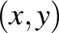 describing the horizontal position x first, followed by the vertical position y.
The Cartesian plane is applied in real-world contexts, eg when determining the incline (slope) of a road between two points.
The Cartesian plane is used in algebra in Stages 4 to 6 to describe patterns and relationships between numbers.
Language
Students should be able to communicate using the following language: pattern, increase, decrease, term, value, table of values, rule, position in pattern, value of term, number plane (Cartesian plane), horizontal axis (x-axis), vertical axis (y-axis), axes, quadrant, intersect, point of intersection, right angles, origin, coordinates, point, plot.
Stage 3
Measurement and Geometry
Length 1
Outcomes
A student:
- describes and represents mathematical situations in a variety of ways using mathematical terminology and some conventions MA3-1WM
- gives a valid reason for supporting one possible solution over another MA3-3WM
- selects and uses the appropriate unit and device to measure lengths and distances, calculates perimeters, and converts between units of length MA3-9MG
Content
Students:
Choose appropriate units of measurement for length (ACMMG108)
- recognise the need for a formal unit longer than the metre for measuring distance
- recognise that there are 1000 metres in one kilometre, ie 1000 metres = 1 kilometre
- describe one metre as one thousandth of a kilometre (Communicating)
- measure a kilometre and a half-kilometre
- record distances using the abbreviation for kilometres (km)
- select and use the appropriate unit and measuring device to measure lengths and distances
- describe how a length or distance was estimated and measured (Communicating, Problem Solving)
- question and explain why two students may obtain different measures for the same length, distance or perimeter (Communicating, Reasoning)
- estimate lengths and distances using an appropriate unit and check by measuring
- record lengths and distances using combinations of millimetres, centimetres, metres and kilometres, eg 1 km 200 m
Calculate the perimeters of rectangles using familiar metric units (ACMMG109)
- use the term 'dimensions' to describe the 'lengths' and 'widths' of rectangles
- measure and calculate the perimeter of a large rectangular section of the school, eg a playground, netball courts
- calculate perimeters of common two-dimensional shapes, including squares, rectangles, triangles and regular polygons with more than four sides (ie regular polygons other than equilateral triangles and squares)
- recognise that rectangles with the same perimeter may have different dimensions (Reasoning)
- explain that the perimeters of two-dimensional shapes can be found by finding the sum of the side lengths (Communicating)
- explain the relationship between the lengths of the sides and the perimeters for regular polygons (including equilateral triangles and squares) (Communicating, Reasoning)
- record calculations used to find the perimeters of two-dimensional shapes
Background Information
When students are able to measure efficiently and effectively using formal units, they should be encouraged to apply their knowledge and skills in a variety of contexts. Following this, they should be encouraged to generalise their method for calculating the perimeters of squares, rectangles and triangles.
When recording measurements, a space should be left between the number and the abbreviated unit, eg 3 cm, not 3cm.
Language
Students should be able to communicate using the following language: length, distance, kilometre, metre, centimetre, millimetre, measure, measuring device, ruler, tape measure, trundle wheel, estimate, perimeter, dimensions, width.
'Perimeter' is derived from the Greek words that mean to measure around the outside: peri, meaning 'around', and metron, meaning 'measure'.
Stage 3
Measurement and Geometry
Length 2
Outcomes
A student:
- describes and represents mathematical situations in a variety of ways using mathematical terminology and some conventions MA3-1WM
- selects and applies appropriate problem-solving strategies, including the use of digital technologies, in undertaking investigations MA3-2WM
- gives a valid reason for supporting one possible solution over another MA3-3WM
- selects and uses the appropriate unit and device to measure lengths and distances, calculates perimeters, and converts between units of length MA3-9MG
Content
Students:
Connect decimal representations to the metric system (ACMMG135)
- recognise the equivalence of whole-number and decimal representations of measurements of length, eg 165 cm is the same as 1.65 m
- interpret decimal notation for lengths and distances, eg 13.5 cm is 13 centimetres and 5 millimetres
- record lengths and distances using decimal notation to three decimal places, eg 2.753 km
Convert between common metric units of length (ACMMG136)
- convert between metres and kilometres
- convert between millimetres, centimetres and metres to compare lengths and distances
- explain and use the relationship between the size of a unit and the number of units needed to assist in determining whether multiplication or division is required when converting between units, eg 'More metres than kilometres will be needed to measure the same distance, and so to convert from kilometres to metres, I need to multiply' (Communicating, Reasoning)
Solve problems involving the comparison of lengths using appropriate units (ACMMG137)
- investigate and compare perimeters of rectangles with the same area
- determine the number of different rectangles that can be formed using whole-number dimensions for a given area (Problem Solving, Reasoning)
- solve a variety of problems involving length and perimeter, including problems involving different units of length, eg 'Find the total length of three items measuring 5 mm, 20 cm and 1.2 m'
Background Information
Refer to background information in Length 1.
Language
Students should be able to communicate using the following language: length, distance, kilometre, metre, centimetre, millimetre, perimeter, dimensions, width.
Stage 3
Measurement and Geometry
Area 1
Outcomes
A student:
- describes and represents mathematical situations in a variety of ways using mathematical terminology and some conventions MA3-1WM
- selects and uses the appropriate unit to calculate areas, including areas of squares, rectangles and triangles MA3-10MG
Content
Students:
Choose appropriate units of measurement for area (ACMMG108)
- recognise the need for a formal unit larger than the square metre
- identify situations where square kilometres are used for measuring area, eg a suburb
- recognise and explain the need for a more convenient unit than the square kilometre
- recognise that there are 10 000 square metres in one hectare, ie 10 000 square metres = 1 hectare
- equate one hectare to the area of a square with side lengths of 100 m (Communicating)
- relate the hectare to common large pieces of land, including courts and fields for sports, eg a tennis court is about one-quarter of a hectare (Reasoning)
- determine the dimensions of different rectangles with an area of one hectare (Problem Solving)
- record areas using the abbreviations for square kilometres (km²) and hectares (ha)
Calculate the areas of rectangles using familiar metric units (ACMMG109)
- establish the relationship between the lengths, widths and areas of rectangles (including squares)
- explain that the area of a rectangle can be found by multiplying the length by the width (Communicating, Reasoning)
- record, using words, the method for finding the area of any rectangle, eg 'Area of rectangle = length × width'
- calculate areas of rectangles (including squares) in square centimetres and square metres
- recognise that rectangles with the same area may have different dimensions (Reasoning)
- connect factors of a number with the whole-number dimensions of different rectangles with the same area (Reasoning)
- record calculations used to find the areas of rectangles (including squares)
- apply measurement skills to solve problems involving the areas of rectangles (including squares) in everyday situations, eg determine the area of a basketball court
- measure the dimensions of a large rectangular piece of land in metres and calculate its area in hectares, eg the local park
Background Information
Students should have a clear understanding of the distinction between perimeter and area.
It is important in Stage 3 that students establish a real reference for the square kilometre and the hectare, eg locating an area of one square kilometre or an area of one hectare on a local map.
When students are able to measure efficiently and effectively using formal units, they should be encouraged to apply their knowledge and skills in a variety of contexts.
Students could be encouraged to find more efficient ways of counting when determining area, such as finding how many squares in one row and multiplying this by the number of rows. They should then begin to generalise their methods to calculate the areas of rectangles (including squares) and triangles.
When generalising their methods to calculate areas, students in Stage 3 should use words. Algebraic formulas for areas are not introduced until Stage 4.
Language
Students should be able to communicate using the following language: area, measure, square centimetre, square metre, square kilometre, hectare, dimensions, length, width.
The abbreviation m² is read as 'square metre(s)' and not 'metre(s) squared' or 'metre(s) square'.
The abbreviation cm² is read as 'square centimetre(s)' and not 'centimetre(s) squared' or 'centimetre(s) square'.
Stage 3
Measurement and Geometry
Area 2
Outcomes
A student:
- describes and represents mathematical situations in a variety of ways using mathematical terminology and some conventions MA3-1WM
- selects and applies appropriate problem-solving strategies, including the use of digital technologies, in undertaking investigations MA3-2WM
- selects and uses the appropriate unit to calculate areas, including areas of squares, rectangles and triangles MA3-10MG
Content
Students:
Solve problems involving the comparison of areas using appropriate units (ACMMG137)
- investigate the area of a triangle by comparing the area of a given triangle to the area of the rectangle of the same length and perpendicular height, eg use a copy of the given triangle with the given triangle to form a rectangle
- explain the relationship between the area of a triangle and the area of the rectangle of the same length and perpendicular height (Communicating, Reasoning)
- establish the relationship between the base length, perpendicular height and area of a triangle
- record, using words, the method for finding the area of any triangle, eg
'Area of triangle = × base × perpendicular height'
- investigate and compare the areas of rectangles that have the same perimeter, eg compare the areas of all possible rectangles with whole-number dimensions and a perimeter of 20 centimetres
- determine the number of different rectangles that can be formed using whole-number dimensions for a given perimeter (Problem Solving, Reasoning)
- solve a variety of problems involving the areas of rectangles (including squares) and triangles
Background Information
Refer to background information in Area 1.
Language
Students should be able to communicate using the following language: area, square centimetre, square metre, dimensions, length, width, base (of triangle), perpendicular height.
Stage 3
Measurement and Geometry
Volume and Capacity 1
Outcomes
A student:
- describes and represents mathematical situations in a variety of ways using mathematical terminology and some conventions MA3-1WM
- gives a valid reason for supporting one possible solution over another MA3-3WM
- selects and uses the appropriate unit to estimate, measure and calculate volumes and capacities, and converts between units of capacity MA3-11MG
Content
Students:
Choose appropriate units of measurement for volume and capacity (ACMMG108)
- select and use appropriate units to measure the capacities of a variety of containers, eg millilitres for a drinking glass, litres for a water urn
- measure the volumes of rectangular containers by packing them with cubic-centimetre blocks
- explain the advantages and disadvantages of using cubic-centimetre blocks as a unit to measure volume (Communicating, Reasoning)
- describe arrangements of cubic-centimetre blocks in containers in terms of layers, eg 5 layers of 8 cubic-centimetre blocks (Problem Solving)
- recognise the need for a formal unit larger than the cubic centimetre
- construct and use the cubic metre as a unit to measure larger volumes
- explain why volume is measured in cubic metres in certain situations, eg wood bark, soil, concrete (Communicating, Reasoning)
- recognise that a cubic metre can have dimensions other than a cube of side 1 metre,
eg 2 metres by metre by 1 metre (Problem Solving)
- record volumes using the abbreviation for cubic metres (m³)
- estimate the size of a cubic metre, half a cubic metre and two cubic metres
- select and use appropriate units to estimate the volumes of a variety of objects, eg cubic centimetres for a lolly jar, cubic metres for the classroom
Background Information
The attribute of volume is the amount of space occupied by an object or substance and is usually measured in cubic units, eg cubic centimetres (cm³) and cubic metres (m³).
Capacity refers to the amount a container can hold and is measured in units, such as millilitres (mL), litres (L) and kilolitres (kL). Capacity is only used in relation to containers and generally refers to liquid measurement. The capacity of a closed container will be slightly less than its volume – capacity is based on the inside dimensions, while volume is determined by the outside dimensions of the container. It is not necessary to refer to these definitions with students (capacity is not taught as a concept separate from volume until Stage 4).
Once students are able to measure efficiently and effectively using formal units, they could use centimetre cubes to construct rectangular prisms, counting the number of cubes to determine volume, and then begin to generalise their method for calculating the volume.
The cubic metre can be related to the metre as a unit to measure length and the square metre as a unit to measure area. It is important that students are given opportunities to reflect on their understanding of length and area so that they can use this to calculate volume.
Language
Students should be able to communicate using the following language: capacity, container, volume, layers, cubic centimetre, cubic metre, measure, estimate.
The abbreviation m³ is read as 'cubic metre(s)' and not 'metre(s) cubed'.
Stage 3
Measurement and Geometry
Volume and Capacity 2
Outcomes
A student:
- describes and represents mathematical situations in a variety of ways using mathematical terminology and some conventions MA3-1WM
- selects and applies appropriate problem-solving strategies, including the use of digital technologies, in undertaking investigations MA3-2WM
- gives a valid reason for supporting one possible solution over another MA3-3WM
- selects and uses the appropriate unit to estimate, measure and calculate volumes and capacities, and converts between units of capacity MA3-11MG
Content
Students:
Connect volume and capacity and their units of measurement (ACMMG138)
- select the appropriate unit to measure volume and capacity
- demonstrate that a cube of side 10 cm will displace 1 litre of water
- demonstrate, by using a medicine cup, that a cube of side 1 cm will displace 1 mL of water
- equate 1 cubic centimetre to 1 millilitre and 1000 cubic centimetres to 1 litre
- find the volumes of irregular solids in cubic centimetres using a displacement strategy
Connect decimal representations to the metric system (ACMMG135)
- recognise the equivalence of whole-number and decimal representations of measurements of capacities, eg 375 mL is the same as 0.375 L
- interpret decimal notation for volumes and capacities, eg 8.7 L is the same as 8 litres and 700 millilitres
- record volume and capacity using decimal notation to three decimal places, eg 1.275 L
Convert between common metric units of capacity (ACMMG136)
- convert between millilitres and litres
- explain and use the relationship between the size of a unit and the number of units needed to assist in determining whether multiplication or division is required when converting between units, eg 'Fewer litres than millilitres will be needed to measure the same capacity, and so to convert from millilitres to litres, I need to divide' (Communicating, Reasoning)
Calculate the volumes of rectangular prisms (ACMMG160)
- describe the 'length', 'width' and 'height' of a rectangular prism as the 'dimensions' of the prism
- construct rectangular prisms using cubic-centimetre blocks and count the blocks to determine the volumes of the prisms
- construct different rectangular prisms that have the same volume (Problem Solving)
- explain that objects with the same volume may be different shapes (Communicating, Reasoning)
- describe rectangular prisms in terms of layers, eg 'There are 3 layers of 8 cubic-centimetre blocks' (Communicating)
- use repeated addition to find the volumes of rectangular prisms, eg 'My rectangle has 3 layers of 6 cubes, so the total number of cubes is 6 plus 6 plus 6, or 18'
- establish the relationship between the number of cubes in one layer, the number of layers, and the volume of a rectangular prism
- explain that the volume of a rectangular prism can be found by finding the number of cubes in one layer and multiplying by the number of layers (Communicating, Reasoning)
- record, using words, the method for finding the volumes of rectangular prisms, eg
'Volume of rectangular prism = number of cubes in one layer × number of layers'
- calculate the volumes of rectangular prisms in cubic centimetres and cubic metres
- recognise that rectangular prisms with the same volume may have different dimensions (Reasoning)
- record calculations used to find the volumes of rectangular prisms
Background Information
Refer to background information in Volume and Capacity 1.
Language
Students should be able to communicate using the following language: capacity, container, litre, millilitre, volume, dimensions, length, width, height, layers, cubic centimetre, cubic metre.
Refer also to language in Volume and Capacity 1.
Stage 3
Measurement and Geometry
Mass 1
Outcomes
A student:
- describes and represents mathematical situations in a variety of ways using mathematical terminology and some conventions MA3-1WM
- selects and applies appropriate problem-solving strategies, including the use of digital technologies, in undertaking investigations MA3-2WM
- selects and uses the appropriate unit and device to measure the masses of objects, and converts between units of mass MA3-12MG
Content
Students:
Choose appropriate units of measurement for mass (ACMMG108)
- recognise the need for a formal unit larger than the kilogram
- use the tonne to record large masses, eg sand, soil, vehicles
- record masses using the abbreviation for tonnes (t)
- distinguish between the ‘gross mass’ and the ‘net mass’ of containers holding substances, eg cans of soup
- interpret information about mass on commercial packaging (Communicating)
- solve problems involving gross mass and net mass, eg find the mass of a container given the gross mass and the net mass (Problem Solving)
- select and use the appropriate unit and device to measure mass, eg electronic scales, kitchen scales
- determine the net mass of the contents of a container after measuring the gross mass and the mass of the container (Problem Solving)
- find the approximate mass of a small object by establishing the mass of a number of that object, eg 'The stated weight of a box of chocolates is 250 g. If there are 20 identical chocolates in the box, what does each chocolate weigh?'
Background Information
Gross mass is the mass of the contents of a container and the container. Net mass is the mass of the contents only.
Local industries and businesses could provide sources for the study of measurement in tonnes, eg weighbridges, cranes, hoists.
Language
Students should be able to communicate using the following language: mass, gross mass, net mass, measure, device, scales, tonne, kilogram, gram.
As the terms 'weigh' and 'weight' are common in everyday usage, they can be accepted in student language should they arise. Weight is a force that changes with gravity, while mass remains constant.
Stage 3
Measurement and Geometry
Mass 2
Outcomes
A student:
- describes and represents mathematical situations in a variety of ways using mathematical terminology and some conventions MA3-1WM
- selects and applies appropriate problem-solving strategies, including the use of digital technologies, in undertaking investigations MA3-2WM
- selects and uses the appropriate unit and device to measure the masses of objects, and converts between units of mass MA3-12MG
Content
Students:
Connect decimal representations to the metric system (ACMMG135)
- recognise the equivalence of whole-number and decimal representations of measurements of mass, eg 3 kg 250 g is the same as 3.25 kg
- interpret decimal notation for masses, eg 2.08 kg is the same as 2 kilograms and 80 grams
- measure mass using scales and record using decimal notation of up to three decimal places, eg 0.875 kg
Convert between common metric units of mass (ACMMG136)
- convert between kilograms and grams and between kilograms and tonnes
- explain and use the relationship between the size of a unit and the number of units needed to assist in determining whether multiplication or division is required when converting between units, eg 'More grams than kilograms will be needed to measure the same mass, and so to convert from kilograms to grams, I need to multiply' (Communicating, Reasoning)
- solve problems involving different units of mass, eg find the total mass of three items weighing 50 g, 750 g and 2.5 kg
- relate the mass of one litre of water to one kilogram
Background Information
One litre of water has a mass of one kilogram and a volume of 1000 cubic centimetres. While the relationship between volume and capacity is constant for all substances, the same volumes of substances other than water may have different masses, eg 1 litre of oil is lighter than 1 litre of water, which in turn is lighter than 1 litre of honey. This can be demonstrated using digital scales.
Refer also to background information in Mass 1.
Language
Students should be able to communicate using the following language: mass, measure, scales, tonne, kilogram, gram.
Refer also to language in Mass 1.
Stage 3
Measurement and Geometry
Time 1
Outcomes
A student:
- describes and represents mathematical situations in a variety of ways using mathematical terminology and some conventions MA3-1WM
- uses 24-hour time and am and pm notation in real-life situations, and constructs timelines MA3-13MG
Content
Students:
Compare 12- and 24-hour time systems and convert between them (ACMMG110)
- tell the time accurately using 24-hour time, eg '2330 is the same as 11:30 pm'
- describe circumstances in which 24-hour time is used, eg transport, armed forces, digital technologies (Communicating)
- convert between 24-hour time and time given using am or pm notation
- compare the local times in various time zones in Australia, including during daylight saving
Determine and compare the duration of events
- select an appropriate unit to measure a particular period of time
- use a stopwatch to measure and compare the duration of events
- order a series of events according to the time taken to complete each one
- use start and finish times to calculate the elapsed time of events, eg the time taken to travel from home to school
Background Information
Australia is divided into three time zones. In non-daylight saving periods, time in Queensland, New South Wales, Victoria and Tasmania is Eastern Standard Time (EST), time in South Australia and the Northern Territory is half an hour behind EST, and time in Western Australia is two hours behind EST.
Typically, 24-hour time is recorded without the use of the colon (:), eg 3:45 pm is written as 1545 or 1545 h and read as 'fifteen forty-five hours'.
Language
Students should be able to communicate using the following language: 12-hour time, 24-hour time, time zone, daylight saving, local time, hour, minute, second, am (notation), pm (notation).
Stage 3
Measurement and Geometry
Time 2
Outcomes
A student:
- describes and represents mathematical situations in a variety of ways using mathematical terminology and some conventions MA3-1WM
- selects and applies appropriate problem-solving strategies, including the use of digital technologies, in undertaking investigations MA3-2WM
- uses 24-hour time and am and pm notation in real-life situations, and constructs timelines MA3-13MG
Content
Students:
Interpret and use timetables (ACMMG139)
- read, interpret and use timetables from real-life situations, including those involving 24-hour time
- use bus, train, ferry and airline timetables, including those accessed on the internet, to prepare simple travel itineraries
- interpret timetable information to solve unfamiliar problems using a variety of strategies (Problem Solving)
Draw and interpret timelines using a given scale
- determine a suitable scale and draw an accurate timeline using the scale, eg represent events using a many-to-one scale of 1 cm = 10 years
- interpret a given timeline using the given scale
Background Information
Refer to background information in Time 1.
Language
Students should be able to communicate using the following language: timetable, timeline, scale, 12-hour time, 24-hour time, hour, minute, second, am (notation), pm (notation).
Stage 3
Measurement and Geometry
Three-Dimensional Space 1
Outcomes
A student:
- describes and represents mathematical situations in a variety of ways using mathematical terminology and some conventions MA3-1WM
- gives a valid reason for supporting one possible solution over another MA3-3WM
- identifies three-dimensional objects, including prisms and pyramids, on the basis of their properties, and visualises, sketches and constructs them given drawings of different views MA3-14MG
Content
Students:
Compare, describe and name prisms and pyramids
- identify and determine the number of pairs of parallel faces of three-dimensional objects, eg 'A rectangular prism has three pairs of parallel faces'
- identify the 'base' of prisms and pyramids
- recognise that the base of a prism is not always the face where the prism touches the ground (Reasoning)
- name prisms and pyramids according to the shape of their base, eg rectangular prism, square pyramid
- visualise and draw the resulting cut face (plane section) when a three-dimensional object receives a straight cut
- recognise that prisms have a 'uniform cross-section' when the section is parallel to the base
- recognise that the base of a prism is identical to the uniform cross-section of the prism (Reasoning)
- recognise a cube as a special type of prism (Communicating)
- recognise that pyramids do not have a uniform cross-section when the section is parallel to the base
- identify, describe and compare the properties of prisms and pyramids, including:
- number of faces
- shape of faces
- number and type of identical faces
- number of vertices
- number of edges
- describe similarities and differences between prisms and pyramids, eg between a triangular prism and a hexagonal prism, between a rectangular prism and a rectangular(-based) pyramid (Communicating, Reasoning)
- determine that the faces of prisms are always rectangles except the base faces, which may not be rectangles (Reasoning)
- determine that the faces of pyramids are always triangles except the base face, which may not be a triangle (Reasoning)
- use the term 'apex' to describe the highest point above the base of a pyramid or cone
Connect three-dimensional objects with their nets and other two-dimensional representations (ACMMG111)
- visualise and sketch three-dimensional objects from different views, including top, front and side views
- reflect on their own drawing of a three-dimensional object and consider how it can be improved (Reasoning)
- examine a diagram to determine whether it is or is not the net of a closed three-dimensional object
- explain why a given net will not form a closed three-dimensional object (Communicating, Reasoning)
- visualise and sketch nets for given three-dimensional objects
- recognise whether a diagram is a net of a particular three-dimensional object (Reasoning)
- visualise and name prisms and pyramids, given diagrams of their nets
- select the correct diagram of a net for a given prism or pyramid from a group of similar diagrams where the others are not valid nets of the object (Reasoning)
- show simple perspective in drawings by showing depth
Background Information
In Stage 3, the formal names for particular prisms and pyramids are introduced while students are engaged in their construction and representation. (Only 'family' names, such as prism, were introduced in Stage 2.) This syllabus names pyramids in the following format: square pyramid, pentagonal pyramid, etc. However, it is also acceptable to name pyramids using the word 'based', eg square-based pyramid, pentagonal-based pyramid.
Prisms have two bases that are the same shape and size. The bases of a prism may be squares, rectangles, triangles or other polygons. The other faces are rectangular if the faces are perpendicular to the bases. The base of a prism is the shape of the uniform cross-section, not necessarily the face on which it is resting.
Pyramids differ from prisms as they have only one base and all the other faces are triangular. The triangular faces meet at a common vertex (the apex). Pyramids do not have a uniform cross-section.
Spheres, cones and cylinders do not fit into the classification of prisms or pyramids as they have curved surfaces, not faces, eg a cylinder has two flat surfaces and one curved surface.
A section is a representation of an object as it would appear if cut by a plane, eg if the corner were cut off a cube, the resulting cut face would be a triangle. An important understanding in Stage 3 is that the cross-sections parallel to the base of a prism are uniform and the cross-sections parallel to the base of a pyramid are not.
Students could explore these ideas by stacking uniform objects to model prisms, and by stacking sets of seriated shapes to model pyramids, eg
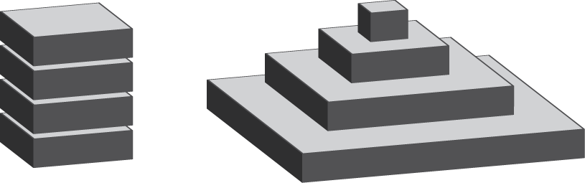
Note: such stacks are not strictly pyramids, but they do assist understanding.
In geometry, a three-dimensional object is called a solid. The three-dimensional object may in fact be hollow, but it is still defined as a geometrical solid.
Language
Students should be able to communicate using the following language: object, shape, three-dimensional object (3D object), prism, cube, pyramid, base, uniform cross-section, face, edge, vertex (vertices), apex, top view, front view, side view, depth, net.
In Stage 1, students were introduced to the terms 'flat surface' and 'curved surface' for use in describing cones, cylinders and spheres, and the terms 'faces', 'edges' and 'vertices' for use in describing prisms and pyramids.
Stage 3
Measurement and Geometry
Three-Dimensional Space 2
Outcomes
A student:
- describes and represents mathematical situations in a variety of ways using mathematical terminology and some conventions MA3-1WM
- identifies three-dimensional objects, including prisms and pyramids, on the basis of their properties, and visualises, sketches and constructs them given drawings of different views MA3-14MG
Content
Students:
Construct simple prisms and pyramids (ACMMG140)
- create prisms and pyramids using a variety of materials, eg plasticine, paper or cardboard nets, connecting cubes
- construct as many rectangular prisms as possible using a given number of connecting cubes (Problem Solving)
- create skeletal models of prisms and pyramids, eg using toothpicks and modelling clay or straws and tape
- connect the edges of prisms and pyramids with the construction of their skeletal models (Problem Solving)
- construct three-dimensional models of prisms and pyramids and sketch the front, side and top views
- describe to another student how to construct or draw a three-dimensional object (Communicating)
- construct three-dimensional models of prisms and pyramids, given drawings of different views
Background Information
In Stage 3, students are continuing to develop their skills of visual imagery, including the ability to perceive and hold an appropriate mental image of an object or arrangement, and to predict the orientation or shape of an object that has been moved or altered.
Refer also to background information in Three-Dimensional Space 1.
Language
Students should be able to communicate using the following language: object, shape, three-dimensional object (3D object), prism, cube, pyramid, base, uniform cross-section, face, edge, vertex (vertices), top view, front view, side view, net.
Stage 3
Measurement and Geometry
Two-Dimensional Space 1
Outcomes
A student:
- describes and represents mathematical situations in a variety of ways using mathematical terminology and some conventions MA3-1WM
- selects and applies appropriate problem-solving strategies, including the use of digital technologies, in undertaking investigations MA3-2WM
- gives a valid reason for supporting one possible solution over another MA3-3WM
- manipulates, classifies and draws two-dimensional shapes, including equilateral, isosceles and scalene triangles, and describes their properties MA3-15MG
Content
Students:
Classify two-dimensional shapes and describe their features
- manipulate, identify and name right-angled, equilateral, isosceles and scalene triangles
- recognise that a triangle can be both right-angled and isosceles or right-angled and scalene (Reasoning)
- compare and describe features of the sides of equilateral, isosceles and scalene triangles
- explore by measurement side and angle properties of equilateral, isosceles and scalene triangles
- explore by measurement angle properties of squares, rectangles, parallelograms and rhombuses
- select and classify a two-dimensional shape from a description of its features
- recognise that two-dimensional shapes can be classified in more than one way, eg a rhombus can be more simply classified as a parallelogram (Communicating, Reasoning)
- identify and draw regular and irregular two-dimensional shapes from descriptions of their side and angle properties
- use tools such as templates, rulers, set squares and protractors to draw regular and irregular two-dimensional shapes (Communicating, Problem Solving)
- explain the difference between regular and irregular shapes (Communicating)
- use computer drawing tools to construct a shape from a description of its side and angle properties (Communicating, Problem Solving)
Describe translations, reflections and rotations of two-dimensional shapes (ACMMG114)
- use the terms 'translate', 'reflect' and 'rotate' to describe the movement of two-dimensional shapes
- rotate a graphic or object through a specified angle about a particular point, including by using the rotate function in a computer drawing program (Communicating)
- describe the effect when a two-dimensional shape is translated, reflected or rotated, eg when a vertical arrow is rotated 90°, the resulting arrow is horizontal
- recognise that the properties of shapes do not change when shapes are translated, reflected or rotated (Reasoning)
Identify line and rotational symmetries (ACMMG114)
- identify and quantify the total number of lines (axes) of symmetry (if any exist) of two-dimensional shapes, including the special quadrilaterals and triangles
- identify shapes that have rotational symmetry and determine the 'order' of rotational symmetry
- construct designs with rotational symmetry, with and without the use of digital technologies (Communicating, Problem Solving)
Apply the enlargement transformation to familiar two-dimensional shapes and explore the properties of the resulting image compared with the original (ACMMG115)
- make enlargements of two-dimensional shapes, pictures and maps, with and without the use of digital technologies
- overlay an image with a grid composed of small squares (eg 5 mm by 5 mm) and create an enlargement by drawing the contents of each square onto a grid composed of larger squares (eg 2 cm by 2 cm) (Communicating, Problem Solving)
- investigate and use functions of digital technologies that allow shapes and images to be enlarged without losing the relative proportions of the image (Problem Solving)
- compare representations of shapes, pictures and maps in different sizes, eg student drawings enlarged on a photocopier
- measure an interval on an original representation and its enlargement to determine how many times larger than the original the enlargement is (Problem Solving, Reasoning)
Background Information
A shape has rotational symmetry if a tracing of the shape, rotated part of a full turn around its centre, matches the original shape exactly.
The order of rotational symmetry refers to the number of times a figure coincides with its original position in turning through one full rotation, eg
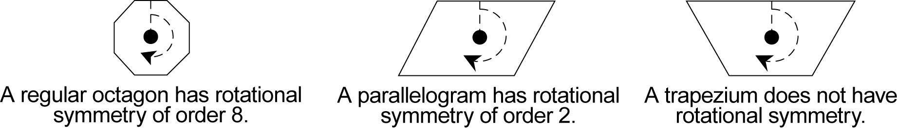
'Scalene' is derived from the Greek word skalenos, meaning 'uneven'; our English word 'scale' is derived from the same word. 'Isosceles' is derived from the Greek words isos, meaning 'equals', and skelos, meaning 'leg'. 'Equilateral' is derived from the Latin words aequus, meaning 'equal', and latus, meaning 'side'. 'Equiangular' is derived from aequus and another Latin word, angulus, meaning 'corner'.
Language
Students should be able to communicate using the following language: shape, two-dimensional shape (2D shape), triangle, equilateral triangle, isosceles triangle, scalene triangle, right-angled triangle, quadrilateral, parallelogram, rectangle, rhombus, square, trapezium, kite, pentagon, hexagon, octagon, regular shape, irregular shape, features, properties, side, parallel, pair of parallel sides, opposite, length, vertex (vertices), angle, right angle, line (axis) of symmetry, rotational symmetry, order of rotational symmetry, translate, reflect, rotate, enlarge.
A 'feature' of a shape or object is a generally observable attribute of a shape or object. A 'property' of a shape or object is an attribute that requires mathematical knowledge to be identified.
Stage 3
Measurement and Geometry
Two-Dimensional Space 2
Outcomes
A student:
- describes and represents mathematical situations in a variety of ways using mathematical terminology and some conventions MA3-1WM
- selects and applies appropriate problem-solving strategies, including the use of digital technologies, in undertaking investigations MA3-2WM
- manipulates, classifies and draws two-dimensional shapes, including equilateral, isosceles and scalene triangles, and describes their properties MA3-15MG
Content
Students:
Investigate the diagonals of two-dimensional shapes
- identify and name 'diagonals' of convex two-dimensional shapes
- recognise the endpoints of the diagonals of a shape as the vertices of the shape (Communicating)
- determine and draw all the diagonals of convex two-dimensional shapes
- compare and describe diagonals of different convex two-dimensional shapes
- use measurement to determine which of the special quadrilaterals have diagonals that are equal in length (Problem Solving)
- determine whether any of the diagonals of a particular shape are also lines (axes) of symmetry of the shape (Problem Solving)
Identify and name parts of circles
- create a circle by finding points that are all the same distance from a fixed point (the centre)
- identify and name parts of a circle, including the centre, radius, diameter, circumference, sector, semicircle and quadrant
Investigate combinations of translations, reflections and rotations, with and without the use of digital technologies (ACMMG142)
- identify whether a two-dimensional shape has been translated, reflected or rotated, or has undergone a number of transformations, eg 'The parallelogram has been rotated clockwise through 90° once and then reflected once'
- construct patterns of two-dimensional shapes that involve translations, reflections and rotations using computer software
- predict the next translation, reflection or rotation in a pattern, eg 'The arrow is being rotated 90° anti-clockwise each time'
- choose the correct pattern from a number of options when given information about a combination of transformations (Reasoning)
Background information
When drawing diagonals, students need to be careful that the endpoints of their diagonals pass through the vertices of the shape.
Language
Students should be able to communicate using the following language: shape, two-dimensional shape (2D shape), circle, centre, radius, diameter, circumference, sector, semicircle, quadrant, triangle, equilateral triangle, isosceles triangle, scalene triangle, right-angled triangle, quadrilateral, parallelogram, rectangle, rhombus, square, trapezium, kite, pentagon, hexagon, octagon, regular shape, irregular shape, diagonal, vertex (vertices), line (axis) of symmetry, translate, reflect, rotate, clockwise, anti-clockwise.
A diagonal of a two-dimensional shape is an interval joining two non-adjacent vertices of the shape. The diagonals of a convex two-dimensional shape lie inside the figure.
Stage 3
Measurement and Geometry
Angles 1
Outcomes
A student:
- describes and represents mathematical situations in a variety of ways using mathematical terminology and some conventions MA3-1WM
- measures and constructs angles, and applies angle relationships to find unknown angles MA3-16MG
Content
Students:
Estimate, measure and compare angles using degrees (ACMMG112)
- identify the arms and vertex of an angle where both arms are invisible, such as for rotations and rebounds
- recognise the need for a formal unit for the measurement of angles
- record angle measurements using the symbol for degrees (°)
- measure angles of up to 360° using a protractor
- explain how a protractor is used to measure an angle (Communicating)
- explore and explain how to use a semicircular protractor to measure a reflex angle (Communicating, Reasoning)
- extend the arms of an angle where necessary to facilitate measurement of the angle using a protractor (Problem Solving)
Construct angles using a protractor (ACMMG112)
- construct angles of up to 360° using a protractor
- identify that a right angle is 90°, a straight angle is 180° and an angle of revolution is 360°
- identify and describe angle size in degrees for each of the classifications acute, obtuse and reflex
- use the words 'between', 'greater than' and 'less than' to describe angle size in degrees (Communicating)
- compare the sizes of two or more angles in degrees, eg compare angles in different two-dimensional shapes
- estimate angles in degrees and check by measuring
Background Information
A circular protractor calibrated from 0° to 360° may be easier for students to use to measure reflex angles than a semicircular protractor calibrated from 0° to 180°.
Language
Students should be able to communicate using the following language: angle, arm, vertex, protractor, degree.
Stage 3
Measurement and Geometry
Angles 2
Outcomes
A student:
- describes and represents mathematical situations in a variety of ways using mathematical terminology and some conventions MA3-1WM
- measures and constructs angles, and applies angle relationships to find unknown angles MA3-16MG
Content
Students:
Investigate, with and without the use of digital technologies, angles on a straight line, angles at a point, and vertically opposite angles; use the results to find unknown angles (ACMMG141)
- identify and name angle types formed by the intersection of straight lines, including right angles, 'angles on a straight line', 'angles at a point' that form an angle of revolution, and 'vertically opposite angles'
- recognise right angles, angles on a straight line, and angles of revolution embedded in diagrams (Reasoning)
- identify the vertex and arms of angles formed by intersecting lines (Communicating)
- recognise vertically opposite angles in different orientations and embedded in diagrams (Reasoning)
- investigate, with and without the use of digital technologies, adjacent angles that form a right angle and establish that they add to 90°
- investigate, with and without the use of digital technologies, adjacent angles on a straight line and establish that they form a straight angle and add to 180°
- investigate, with and without the use of digital technologies, angles at a point and establish that they form an angle of revolution and add to 360°
- use the results established for adjacent angles that form right angles, straight angles and angles of revolution to find the size of unknown angles in diagrams
- explain how the size of an unknown angle in a diagram was calculated (Communicating, Reasoning)
- investigate, with and without the use of digital technologies, vertically opposite angles and establish that they are equal in size
- use the equality of vertically opposite angles to find the size of unknown angles in diagrams
Background Information
Students should be encouraged to give reasons when finding unknown angles.
Language
Students should be able to communicate using the following language: angle, right angle, straight angle, angles on a straight line, angle of revolution, angles at a point, vertically opposite angles.
A pair of adjacent angles has a common vertex and a common arm.
Stage 3
Measurement and Geometry
Position
Outcomes
A student:
- describes and represents mathematical situations in a variety of ways using mathematical terminology and some conventions MA3-1WM
- locates and describes position on maps using a grid-reference system MA3-17MG
Content
Students:
Use a grid-reference system to describe locations (ACMMG113)
- find locations on maps, including maps with legends, given their grid references
- describe particular locations on grid-referenced maps, including maps with a legend, eg 'The post office is at E4'
Describe routes using landmarks and directional language (ACMMG113)
- find a location on a map that is in a given direction from a town or landmark, eg locate a town that is north-east of Broken Hill
- describe the direction of one location relative to another, eg 'Darwin is north-west of Sydney'
- follow a sequence of two or more directions, including compass directions, to find and identify a particular location on a map
- use a given map to plan and show a route from one location to another, eg draw a possible route to the local park or use an Aboriginal land map to plan a route
- use a street directory or online map to find the route to a given location (Problem Solving)
- describe a route taken on a map using landmarks and directional language, including compass directions, eg 'Start at the post office, go west to the supermarket and then go south-west to the park'
Background Information
In Stage 2, students were introduced to the compass directions north, east, south and west, and north-east, south-east, south-west and north-west. In Stage 3, students are expected to use these compass directions when describing routes between locations on maps.
By convention when using grid-reference systems, the horizontal component of direction is named first, followed by the vertical component. This connects with plotting points on the Cartesian plane in Stage 3 Patterns and Algebra, where the horizontal coordinate is recorded first, followed by the vertical coordinate.
Language
Students should be able to communicate using the following language: position, location, map, plan, street directory, route, grid, grid reference, legend, key, scale, directions, compass, north, east, south, west, north-east, south-east, south-west, north-west.
Stage 3
Statistics and Probability
Data 1
Outcomes
A student:
- describes and represents mathematical situations in a variety of ways using mathematical terminology and some conventions MA3-1WM
- gives a valid reason for supporting one possible solution over another MA3-3WM
- uses appropriate methods to collect data and constructs, interprets and evaluates data displays, including dot plots, line graphs and two-way tables MA3-18SP
Content
Students:
Pose questions and collect categorical or numerical data by observation or survey (ACMSP118)
- pose and refine questions to construct a survey to obtain categorical and numerical data about a matter of interest
- collect categorical and numerical data through observation or by conducting surveys, eg observe the number of a particular type of insect in one square metre of the playground over time
Construct displays, including column graphs, dot plots and tables, appropriate for data type, with and without the use of digital technologies (ACMSP119)
- tabulate collected data, including numerical data, with and without the use of digital technologies such as spreadsheets
- construct column and line graphs of numerical data using a scale of many-to-one correspondence, with and without the use of digital technologies
- name and label the horizontal and vertical axes when constructing graphs (Communicating)
- choose an appropriate title to describe the data represented in a data display (Communicating)
- determine an appropriate scale of many-to-one correspondence to represent the data in a data display (Reasoning)
- mark equal spaces on the axes when constructing graphs, and use the scale to label the markers (Communicating)
- construct dot plots for numerical data, eg the number of siblings of each student in the class
- consider the data type to determine and draw the most appropriate display(s), such as column graphs, dot plots and line graphs
- discuss and justify the choice of data display used (Communicating, Reasoning)
- recognise that line graphs are used to represent data that demonstrates continuous change, eg hourly temperature (Communicating)
- recognise which types of data display are most appropriate to represent categorical data (Communicating)
Describe and interpret different data sets in context (ACMSP120)
- interpret line graphs using the scales on the axes
- describe and interpret data presented in tables, dot plots, column graphs and line graphs, eg 'The graph shows that the heights of all children in the class are between 125 cm and 154 cm'
- determine the total number of data values represented in dot plots and column graphs, eg find the number of students in the class from a display representing the heights of all children in the class (Problem Solving, Reasoning)
- identify and describe relationships that can be observed in data displays, eg 'There are four times as many children in Year 5 whose favourite food is noodles compared to children whose favourite food is chicken' (Communicating, Reasoning)
- use information presented in data displays to aid decision making, eg decide how many of each soft drink to buy for a school fundraising activity by collecting and graphing data about favourite soft drinks for the year group or school (Reasoning)
Background Information
Column graphs are useful in recording categorical data, including results obtained from simple probability experiments.
A scale of many-to-one correspondence in a column graph or line graph means that one unit is used to represent more than one of what is being counted or measured, eg 1 cm on the vertical axis used to represent 20 cm of body height.
Line graphs should only be used where meaning can be attached to the points on the line between plotted points, eg temperature readings over time.
Dot plots are an alternative to a column graph when there are only a small number of data values. Each value is recorded as a dot so that the frequencies for each of the values can be counted easily.
Students need to be provided with opportunities to discuss what information can be drawn from various data displays. Advantages and disadvantages of different representations of the same data should be explicitly taught.
Categorical data can be separated into distinct groups, eg colour, gender, blood type. Numerical data is expressed as numbers and obtained by counting, or by measurement of a physical attribute, eg the number of students in a class (count) or the heights of students in a class (measurement).
Language
Students should be able to communicate using the following language: data, survey, category, display, tabulate, table, column graph, vertical columns, horizontal bars, equal spacing, title, scale, vertical axis, horizontal axis, axes, line graph, dot plots, spreadsheet.
Stage 3
Statistics and Probability
Data 2
Outcomes
A student:
- describes and represents mathematical situations in a variety of ways using mathematical terminology and some conventions MA3-1WM
- gives a valid reason for supporting one possible solution over another MA3-3WM
- uses appropriate methods to collect data and constructs, interprets and evaluates data displays, including dot plots, line graphs and two-way tables MA3-18SP
Content
Students:
Interpret and compare a range of data displays, including side-by-side column graphs for two categorical variables (ACMSP147)
- interpret data presented in two-way tables
- create a two-way table to organise data involving two categorical variables, eg
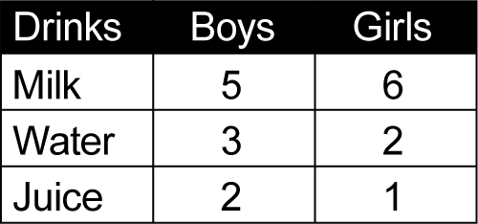
- interpret side-by-side column graphs for two categorical variables, eg favourite television show of students in Year 1 compared to that of students in Year 6
- interpret and compare different displays of the same data set to determine the most appropriate display for the data set
- compare the effectiveness of different student-created data displays (Communicating)
- discuss the advantages and disadvantages of different representations of the same data (Communicating)
- explain which display is the most appropriate for interpretation of a particular data set (Communicating, Reasoning)
- compare representations of the same data set in a side-by-side column graph and in a two-way table (Reasoning)
Interpret secondary data presented in digital media and elsewhere (ACMSP148)
- interpret data representations found in digital media and in factual texts
- interpret tables and graphs from the media and online sources, eg data about different sports teams (Reasoning)
- identify and describe conclusions that can be drawn from a particular representation of data (Communicating, Reasoning)
- critically evaluate data representations found in digital media and related claims
- discuss the messages that those who created a particular data representation might have wanted to convey (Communicating)
- identify sources of possible bias in representations of data in the media by discussing various influences on data collection and representation, eg who created or paid for the data collection, whether the representation is part of an advertisement (Communicating, Reasoning)
- identify misleading representations of data in the media, eg broken axes, graphics that are not drawn to scale (Reasoning)
Background Information
Data selected for interpretation can include census data, environmental audits of resources such as water and energy, and sports statistics.
Refer also to background information in Data 1.
Language
Students should be able to communicate using the following language: data, collect, category, display, table, column graph, scale, axes, two-way table, side-by-side column graph, misleading, bias.
Refer also to language in Data 1.
Stage 3
Statistics and Probability
Chance 1
Outcomes
A student:
- describes and represents mathematical situations in a variety of ways using mathematical terminology and some conventions MA3-1WM
- conducts chance experiments and assigns probabilities as values between 0 and 1 to describe their outcomes MA3-19SP
Content
Students:
List outcomes of chance experiments involving equally likely outcomes and represent probabilities of those outcomes using fractions (ACMSP116)
- use the term 'probability' to describe the numerical value that represents the likelihood of an outcome of a chance experiment
- recognise that outcomes are described as 'equally likely' when any one outcome has the same chance of occurring as any other outcome
- list all outcomes in chance experiments where each outcome is equally likely to occur
- represent probabilities of outcomes of chance experiments using fractions, eg for one throw of a standard six-sided die or for one spin of an eight-sector spinner
- determine the likelihood of winning simple games by considering the number of possible outcomes, eg in a 'rock-paper-scissors' game (Problem Solving, Reasoning)
Recognise that probabilities range from 0 to 1 (ACMSP117)
- establish that the sum of the probabilities of the outcomes of any chance experiment is equal to 1
- order commonly used chance words on an interval from zero ('impossible') to one ('certain'), eg 'equally likely' would be placed at (or 0.5)
- describe events that are impossible and events that are certain (Communicating)
- describe the likelihood of a variety of events as being more or less than a half (or 0.5) and order the events on an interval (Communicating)
Background Information
Students will need some prior experience in ordering fractions and decimals on a number line from 0 to 1.
The probability of chance events occurring can be ordered on a scale from 0 to 1. A probability of 0 describes the probability of an event that is impossible. A probability of 1 describes the probability of an event that is certain. Events with an equal likelihood of occurring or not occurring can be described as having a probability of (or 0.5 or 50%). Other expressions of probability fall between 0 and 1, eg events described as 'unlikely' will have a numerical value somewhere between 0 and (or 0.5 or 50%).
The sum of the probabilities of the outcomes of any chance experiment is equal to 1. This can be demonstrated by adding the probabilities of all of the outcomes of a chance experiment, such as rolling a die.
Language
Students should be able to communicate using the following language: chance, event, likelihood, certain, possible, likely, unlikely, impossible, experiment, outcome, probability.
The probability of an outcome is the value (between 0 and 1) used to describe the chance that the outcome will occur.
A list of all of the outcomes for a chance experiment is known as the 'sample space'; however, this term is not introduced until Stage 4.
Stage 3
Statistics and Probability
Chance 2
Outcomes
A student:
- describes and represents mathematical situations in a variety of ways using mathematical terminology and some conventions MA3-1WM
- selects and applies appropriate problem-solving strategies, including the use of digital technologies, in undertaking investigations MA3-2WM
- gives a valid reason for supporting one possible solution over another MA3-3WM
- conducts chance experiments and assigns probabilities as values between 0 and 1 to describe their outcomes MA3-19SP
Content
Students:
Compare observed frequencies across experiments with expected frequencies (ACMSP146)
- use the term 'frequency' to describe the number of times a particular outcome occurs in a chance experiment
- distinguish between the 'frequency' of an outcome and the 'probability' of an outcome in a chance experiment (Communicating)
- compare the expected frequencies of outcomes of chance experiments with observed frequencies, including where the outcomes are not equally likely
- recognise that some random generators have outcomes that are not equally likely and discuss the effect on expected outcomes, eg on this spinner, green is more likely to occur than red or grey or blue
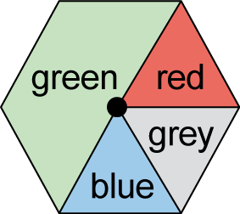 (Reasoning)
- discuss the 'fairness' of simple games involving chance (Communicating, Reasoning)
- explain why observed frequencies of outcomes in chance experiments may differ from expected frequencies (Communicating, Reasoning)
Describe probabilities using fractions, decimals and percentages (ACMSP144)
- list the outcomes for chance experiments where the outcomes are not equally likely to occur and assign probabilities to the outcomes using fractions
- use knowledge of equivalent fractions, decimals and percentages to assign probabilities to the likelihood of outcomes, eg there is a 'five in ten', , 50%, 0.5 or 'one in two' chance of a particular event occurring
- use probabilities in real-life contexts, eg 'My football team has a 50% chance of winning the game' (Communicating, Reasoning)
- design a spinner or label a die so that a particular outcome is more likely than another and discuss the probabilities of the outcomes (Communicating, Problem Solving)
Conduct chance experiments with both small and large numbers of trials using appropriate digital technologies (ACMSP145)
- assign expected probabilities to outcomes in chance experiments with random generators, including digital simulators, and compare the expected probabilities with the observed probabilities after both small and large numbers of trials
- determine and discuss the differences between the expected probabilities and the observed probabilities after both small and large numbers of trials (Communicating, Reasoning)
- explain what happens to the observed probabilities as the number of trials increases (Communicating, Reasoning)
- use samples to make predictions about a larger 'population' from which the sample comes, eg take a random sample of coloured lollies from a bag, calculate the probability of obtaining each colour of lolly when drawing a lolly from the bag, and use these probabilities and the total number of lollies in the bag to predict the number of each colour of lolly in the bag
- discuss whether a prediction about a larger population, from which a sample comes, would be the same if a different sample were used (Communicating, Reasoning)
Background Information
Random generators include coins, dice, spinners and digital simulators.
As the number of trials in a chance experiment increases, the observed probabilities should become closer in value to the expected probabilities.
Refer also to background information in Chance 1.
Language
Students should be able to communicate using the following language: chance, event, likelihood, equally likely, experiment, outcome, expected outcomes, random, fair, trials, probability, expected probability, observed probability, frequency, expected frequency, observed frequency.
The term 'frequency' is used in this substrand to describe the number of times a particular outcome occurs in a chance experiment. In Stage 4, students will also use 'frequency' to describe the number of times a particular data value occurs in a data set.

Stage 4
Number and Algebra
Computation with Integers
Outcomes
A student:
- communicates and connects mathematical ideas using appropriate terminology, diagrams and symbols MA4-1WM
- applies appropriate mathematical techniques to solve problems MA4-2WM
- recognises and explains mathematical relationships using reasoning MA4-3WM
- compares, orders and calculates with integers, applying a range of strategies to aid computation MA4-4NA
Related Life Skills outcomes: MALS-4NA, MALS-5NA, MALS-6NA, MALS-7NA, MALS-10NA, MALS-11NA
Content
Students:
Apply the associative, commutative and distributive laws to aid mental and written computation (ACMNA151)
- use an appropriate non-calculator method to divide two- and three-digit numbers by a two-digit number
- compare initial estimates with answers obtained by written methods and check by using a calculator (Problem Solving)
- show the connection between division and multiplication, including where there is a remainder, eg 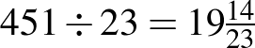 means that 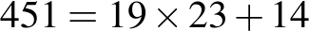
- apply a practical understanding of commutativity to aid mental computation, eg 3 + 9 = 9 + 3 = 12, 3 × 9 = 9 × 3 = 27
- apply a practical understanding of associativity to aid mental computation, eg 3 + 8 + 2 = (3 + 8) + 2 = 3 + (8 + 2) = 13, 2 × 7 × 5 = (2 × 7) × 5 = 2 × (7 × 5) = 70
- determine by example that associativity holds true for multiplication of three or more numbers but does not apply to calculations involving division, eg (80 ÷ 8) ÷ 2 is not equivalent to 80 ÷ (8 ÷ 2) (Communicating)
- apply a practical understanding of the distributive law to aid mental computation, eg to multiply any number by 13, first multiply by 10 and then add 3 times the number
- use factors of a number to aid mental computation involving multiplication and division, eg to multiply a number by 12, first multiply the number by 6 and then multiply the result by 2
Compare, order, add and subtract integers (ACMNA280)
- recognise and describe the 'direction' and 'magnitude' of integers
- construct a directed number sentence to represent a real-life situation (Communicating)
- recognise and place integers on a number line
- compare the relative value of integers, including recording the comparison by using the symbols and
- order integers
- interpret different meanings (direction or operation) for the + and – signs, depending on the context
- add and subtract integers using mental and written strategies
- determine, by developing patterns or using a calculator, that subtracting a negative number is the same as adding a positive number (Reasoning)
- apply integers to problems involving money and temperature (Problem Solving)
Carry out the four operations with rational numbers and integers, using efficient mental and written strategies and appropriate digital technologies (ACMNA183)
- multiply and divide integers using mental and written strategies
- investigate, by developing patterns or using a calculator, the rules associated with multiplying and dividing integers (Reasoning)
- use a calculator to perform the four operations with integers
- decide whether it is more appropriate to use mental strategies or a calculator when performing certain operations with integers (Communicating)
- use grouping symbols as an operator with integers
- apply the order of operations to mentally evaluate expressions involving integers, including where an operator is contained within the numerator or denominator of a fraction,
eg 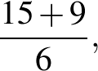 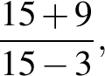 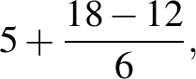 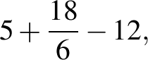 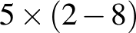
- investigate whether different digital technologies, such as those found in computer software and on mobile devices, apply the order of operations (Problem Solving)
Background Information
To divide two- and three-digit numbers by a two-digit number, students may be taught the long division algorithm or, alternatively, to transform the division into a multiplication.
So, becomes . Knowing that there are two fifties in each 100, students may try 7, obtaining 52 × 7 = 364, which is too large. They may then try 6, obtaining 52 × 6 = 312. The answer is 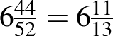.
Students also need to be able to express a division in the following form in order to relate multiplication and division: 356 = 6 × 52 + 44, and then division by 52 gives 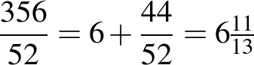.
Students should have some understanding of integers, as the concept is introduced in Stage 3 Whole Numbers 2. However, operations with integers are introduced in Stage 4.
Complex recording formats for integers, such as raised signs, can be confusing. On printed materials, the en-dash ( – ) should be used to indicate a negative number and the operation of subtraction. The hyphen ( - ) should not be used in either context. The following formats are recommended:
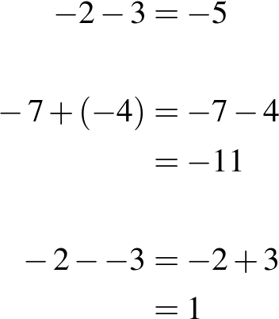
Brahmagupta (c598–c665), an Indian mathematician and astronomer, is noted for the introduction of zero and negative numbers in arithmetic.
Purpose/Relevance of Substrand
The positive integers (1, 2, 3, …) and 0 allow us to answer many questions involving 'How many?', 'How much?', 'How far?', etc, and so carry out a wide range of daily activities. The negative integers (…, –3, –2, –1) are used to represent 'downwards', 'below', 'to the left', etc, and appear in relation to everyday situations such as the weather (eg a temperature of –5° is 5° below zero), altitude (eg a location given as –20 m is 20 m below sea level), and sport (eg a golfer at –6 in a tournament is 6 under par). The Computation with Integers substrand includes the use of mental strategies, written strategies, etc to obtain answers – which are very often integers themselves – to questions or problems through addition, subtraction, multiplication and division.
Language
Teachers should model and use a variety of expressions for mathematical operations and should draw students' attention to the fact that the words used for subtraction and division questions may require the order of the numbers to be reversed when performing the operation. For example, '9 take away 3' and 'reduce 9 by 3' require the operation to be performed with the numbers in the same order as they are presented in the question (ie 9 – 3), but 'take 9 from 3', 'subtract 9 from 3' and '9 less than 3' require the operation to be performed with the numbers in the reverse order to that in which they are stated in the question (ie 3 – 9).
Similarly, 'divide 6 by 2' and '6 divided by 2' require the operation to be performed with the numbers in the same order as they are presented in the question (ie 6 ÷ 2), but 'how many 2s in 6?' requires the operation to be performed with the numbers in the reverse order to that in which they appear in the question (ie 6 ÷ 2).
Stage 4
Number and Algebra
Fractions, Decimals and Percentages
Outcomes
A student:
- communicates and connects mathematical ideas using appropriate terminology, diagrams and symbols MA4-1WM
- applies appropriate mathematical techniques to solve problems MA4-2WM
- recognises and explains mathematical relationships using reasoning MA4-3WM
- operates with fractions, decimals and percentages MA4-5NA
Related Life Skills outcomes: MALS-8NA, MALS-9NA
Content
Students:
Compare fractions using equivalence; locate and represent positive and negative fractions and mixed numerals on a number line (ACMNA152)
- determine the highest common factor (HCF) of numbers and the lowest common multiple (LCM) of numbers
- generate equivalent fractions
- write a fraction in its simplest form
- express improper fractions as mixed numerals and vice versa
- place positive and negative fractions, mixed numerals and decimals on a number line to compare their relative values
- interpret a given scale to determine fractional values represented on a number line (Problem Solving)
- choose an appropriate scale to display given fractional values on a number line, eg when plotting thirds or sixths, a scale of 3 cm for every whole is easier to use than a scale of 1 cm for every whole (Communicating, Reasoning)
Solve problems involving addition and subtraction of fractions, including those with unrelated denominators (ACMNA153)
- add and subtract fractions, including mixed numerals and fractions with unrelated denominators, using written and calculator methods
- recognise and explain incorrect operations with fractions, eg explain why 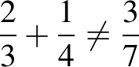 (Communicating, Reasoning)
- interpret fractions and mixed numerals on a calculator display (Communicating)
- subtract a fraction from a whole number using mental, written and calculator methods,
eg 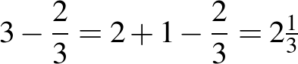
Multiply and divide fractions and decimals using efficient written strategies and digital technologies (ACMNA154)
- determine the effect of multiplying or dividing by a number with magnitude less than one
- multiply and divide decimals by powers of 10
- multiply and divide decimals using written methods, limiting operators to two digits
- compare initial estimates with answers obtained by written methods and check by using a calculator (Problem Solving)
- multiply and divide fractions and mixed numerals using written methods
- demonstrate multiplication of a fraction by another fraction using a diagram to illustrate the process (Communicating, Reasoning)
- explain, using a numerical example, why division by a fraction is equivalent to multiplication by its reciprocal (Communicating, Reasoning)
- multiply and divide fractions and decimals using a calculator
- calculate fractions and decimals of quantities using mental, written and calculator methods
- choose the appropriate equivalent form for mental computation, eg 0.25 of $60 is equivalent to of $60, which is equivalent to $60 ÷ 4 (Communicating)
Express one quantity as a fraction of another, with and without the use of digital technologies (ACMNA155)
- express one quantity as a fraction of another
- choose appropriate units to compare two quantities as a fraction, eg 15 minutes is 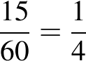 of an hour (Communicating)
Round decimals to a specified number of decimal places (ACMNA156)
- round decimals to a given number of decimal places
- use symbols for approximation, eg or
Investigate terminating and recurring decimals (ACMNA184)
- use the notation for recurring (repeating) decimals, eg 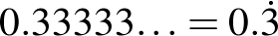, , 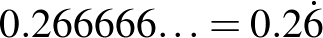
- convert fractions to terminating or recurring decimals as appropriate
- recognise that calculators may show approximations to recurring decimals, and explain why,
eg displayed as (Communicating, Reasoning)
Connect fractions, decimals and percentages and carry out simple conversions (ACMNA157)
- classify fractions, terminating decimals, recurring decimals and percentages as 'rational' numbers, as they can be written in the form where and are integers and 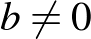
- convert fractions to decimals (terminating and recurring) and percentages
- convert terminating decimals to fractions and percentages
- convert percentages to fractions and decimals (terminating and recurring)
- evaluate the reasonableness of statements in the media that quote fractions, decimals or percentages, eg 'The number of children in the average family is 2.3' (Communicating, Problem Solving)
- order fractions, decimals and percentages
Investigate the concept of irrational numbers, including (ACMNA186)
- investigate 'irrational' numbers, such as and 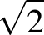
- describe, informally, the properties of irrational numbers (Communicating)
Find percentages of quantities and express one quantity as a percentage of another, with and without the use of digital technologies (ACMNA158)
- calculate percentages of quantities using mental, written and calculator methods
- choose an appropriate equivalent form for mental computation of percentages of quantities, eg 20% of $40 is equivalent to × $40, which is equivalent to $40 ÷ 5 (Communicating)
- express one quantity as a percentage of another, using mental, written and calculator methods, eg 45 minutes is 75% of an hour
Solve problems involving the use of percentages, including percentage increases and decreases, with and without the use of digital technologies (ACMNA187)
- increase and decrease a quantity by a given percentage, using mental, written and calculator methods
- recognise equivalences when calculating percentage increases and decreases, eg multiplication by 1.05 will increase a number or quantity by 5%, multiplication by 0.87 will decrease a number or quantity by 13% (Reasoning)
- interpret and calculate percentages greater than 100, eg an increase from $2 to $5 is an increase of 150%
- solve a variety of real-life problems involving percentages, including percentage composition problems and problems involving money
- interpret calculator displays in formulating solutions to problems involving percentages by appropriately rounding decimals (Communicating)
- use the unitary method to solve problems involving percentages, eg find the original value, given the value after an increase of 20% (Problem Solving)
- interpret and use nutritional information panels on product packaging where percentages are involved (Problem Solving)
- interpret and use media and sport reports involving percentages (Problem Solving)
- interpret and use statements about the environment involving percentages, eg energy use for different purposes, such as lighting (Problem Solving)
Background Information
In Stage 3, the study of fractions is limited to denominators of 2, 3, 4, 5, 6, 8, 10, 12 and 100 and calculations involve related denominators only.
Students are unlikely to have had any experience with rounding to a given number of decimal places prior to Stage 4. The term 'decimal place' may need to be clarified. Students should be aware that rounding is a process of 'approximating' and that a rounded number is an 'approximation'.
All recurring decimals are non-terminating decimals, but not all non-terminating decimals are recurring.
The earliest evidence of fractions can be traced to the Egyptian papyrus of the scribe Ahmes (about 1650 BC). In the seventh century AD, the method of writing fractions as we write them now was invented in India, but without the fraction bar (vinculum), which was introduced by the Arabs. Fractions were widely in use by the twelfth century.
One-cent and two-cent coins were withdrawn by the Australian Government in 1990. When an amount of money is calculated, it may have 1, 2, 3 or more decimal places, eg when buying petrol or making interest payments. When paying electronically, the final amount is paid correct to the nearest cent. When paying with cash, the final amount is rounded correct to the nearest five cents, eg
$25.36, $25.37 round to $25.35
$25.38, $25.39, $25.41, $25.42 round to $25.40
$25.43, $25.44 round to $25.45.
Purpose/Relevance of Substrand
There are many everyday situations where things, amounts or quantities are 'fractions' or parts (or 'portions') of whole things, whole amounts or whole quantities. Fractions are very important when taking measurements, such as when buying goods (eg three-quarters of a metre of cloth) or following a recipe (eg a third of a cup of sugar), when telling the time (eg a quarter past five), when receiving discounts while shopping (eg 'half price', 'half off'), and when sharing a cake or pizza (eg 'There are five of us, so we'll get one-fifth of the pizza each'). 'Decimals' and 'percentages' represent different ways of expressing fractions (and whole numbers), and so are other ways of representing a part of a whole. Fractions (and decimals and percentages) are of fundamental importance in calculation, allowing us to calculate with parts of wholes and to express answers that are not whole numbers, eg 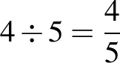 (or 0.8 or 80%).
Language
In questions that require calculating a fraction or percentage of a quantity, some students may benefit from first writing an expression using the word 'of', before replacing it with the multiplication sign (×).
Students may need assistance with the subtleties of the English language when solving word problems. The different processes required by the words 'to' and 'by' in questions such as 'find the percentage increase if $2 is increased to $3' and 'find the percentage increase if $2 is increased by $3' should be made explicit.
When solving word problems, students should be encouraged to write a few key words on the left-hand side of the equals sign to identify what is being found in each step of their working.
The word 'cent' is derived from the Latin word centum, meaning 'one hundred'. 'Percent' means 'out of one hundred' or 'hundredths'.
When expressing fractions in English, the numerator is said first, followed by the denominator. However, in many Asian languages (eg Chinese, Japanese), the opposite is the case: the denominator is said before the numerator.
Stage 4
Number and Algebra
Financial Mathematics
Outcomes
A student:
- communicates and connects mathematical ideas using appropriate terminology, diagrams and symbols MA4-1WM
- applies appropriate mathematical techniques to solve problems MA4-2WM
- recognises and explains mathematical relationships using reasoning MA4-3WM
- solves financial problems involving purchasing goods MA4-6NA
Related Life Skills outcomes: MALS-12NA, MALS-13NA, MALS-14NA, MALS-15NA, MALS-16NA, MALS-17NA
Content
Students:
Investigate and calculate the Goods and Services Tax (GST), with and without the use of digital technologies
- calculate GST and GST-inclusive prices for goods purchased in Australia, given the pre-GST price
- interpret GST information contained on receipts (Communicating)
- investigate efficient methods of computing the GST and GST-inclusive prices (Problem Solving)
- explain why the value of the GST itself is not equivalent to 10% of the GST-inclusive price (Communicating, Reasoning)
- determine the pre-GST prices for goods, given the GST-inclusive price
- explain why the pre-GST price is not equivalent to 10% off the GST-inclusive price (Communicating, Reasoning)
Investigate and calculate 'best buys', with and without the use of digital technologies (ACMNA174)
- solve problems involving discounts, including calculating the percentage discount
- evaluate special offers, such as percentage discounts, 'buy-two-get-one-free', 'buy-one-get-another-at-half-price', etc, to determine how much is saved (Communicating, Problem Solving)
- calculate 'best buys' by comparing price per unit, or quantity per monetary unit, eg 500 grams for $4.50 compared with 300 grams for $2.75
- investigate 'unit pricing' used by retailers and use this to determine the best buy (Problem Solving)
- recognise that in practical situations there are considerations other than just the 'best buy', eg the amount required, waste due to spoilage (Reasoning)
- use price comparison websites to make informed decisions related to purchases under given conditions (Problem Solving)
Solve problems involving profit and loss, with and without the use of digital technologies (ACMNA189)
- calculate the selling price, given the percentage profit/loss on the cost price
- express profit/loss as a percentage of the cost price
- calculate the cost price, given the selling price and percentage profit/loss
Background Information
The Goods and Services Tax (GST) in Australia is a value-added tax on the supply of goods and services. It was introduced by the Australian Government and took effect from 1 July 2000. Prior to the GST, Australia operated a wholesale sales tax implemented in the 1930s, when its economy was dominated by the production and sale of goods. In Australia, the GST is levied at a flat rate of 10% on most goods and services, apart from GST-exempt items (which include basic necessities such as milk and bread).
Purpose/Relevance of Substrand
'Financial mathematics' is used in important areas relating to an individual's daily financial transactions, money management, and financial decision making. Such areas include earning and spending money (eg calculating 'best buys', discounts, GST, personal taxation, profit and loss, investing money, credit and borrowing, hire purchase, simple and compound interest, loan repayments, and depreciation.
Language
GST stands for 'Goods and Services Tax'. The difference between the GST-inclusive price, the pre-GST price, and the amount of the GST itself should be made explicit.
When solving financial problems, students should be encouraged to write a few key words on the left-hand side of the equals sign to identify what is being found in each step of their working, and to conclude with a statement in words.
Students' understanding may be increased if they write calculations in words first, before substituting the appropriate values, eg 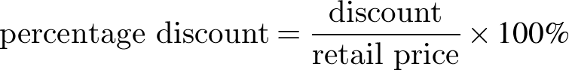.
Students may need assistance with the subtleties of language used in relation to financial transactions, eg the difference between '$100 has been discounted by $10' and '$100 has been discounted to $10'.
Stage 4
Number and Algebra
Ratios and Rates
Outcomes
A student:
- communicates and connects mathematical ideas using appropriate terminology, diagrams and symbols MA4-1WM
- applies appropriate mathematical techniques to solve problems MA4-2WM
- recognises and explains mathematical relationships using reasoning MA4-3WM
- operates with ratios and rates, and explores their graphical representation MA4-7NA
Related Life Skills outcome: MALS-19NA
Content
Students:
Recognise and solve problems involving simple ratios (ACMNA173)
- use ratios to compare quantities measured in the same units
- write ratios using the symbol, eg
- express one part of a ratio as a fraction of the whole, eg in the ratio , the first part is 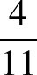 of the whole (Communicating)
- simplify ratios, eg , 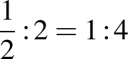,
- apply the unitary method to ratio problems
- divide a quantity in a given ratio
Solve a range of problems involving ratios and rates, with and without the use of digital technologies (ACMNA188)
- interpret and calculate ratios that involve more than two numbers
- solve a variety of real-life problems involving ratios, eg scales on maps, mixes for fuels or concrete
- use rates to compare quantities measured in different units
- distinguish between ratios, where the comparison is of quantities measured in the same units, and rates, where the comparison is of quantities measured in different units
- convert given information into a simplified rate, eg 150 kilometres travelled in 2 hours = 75 km/h
- solve a variety of real-life problems involving rates, including problems involving rate of travel (speed)
Investigate, interpret and analyse graphs from authentic data (ACMNA180)
- interpret distance/time graphs (travel graphs) made up of straight-line segments
- write or tell a story that matches a given distance/time graph (Communicating)
- match a distance/time graph to a description of a particular journey and explain the reasons for the choice (Communicating, Reasoning)
- compare distance/time graphs of the same situation, decide which one is the most appropriate, and explain why (Communicating, Reasoning)
- recognise concepts such as change of speed and direction in distance/time graphs
- describe the meaning of straight-line segments with different gradients in the graph of a particular journey (Communicating)
- calculate speeds for straight-line segments of given distance/time graphs (Problem Solving)
- recognise the significance of horizontal line segments in distance/time graphs
- determine which variable should be placed on the horizontal axis in distance/time graphs
- draw distance/time graphs made up of straight-line segments
- sketch informal graphs to model familiar events, eg noise level during a lesson
- record the distance of a moving object from a fixed point at equal time intervals and draw a graph to represent the situation, eg move along a measuring tape for 30 seconds using a variety of activities that involve a constant rate, such as walking forwards or backwards slowly, and walking or stopping for 10-second increments (Problem Solving)
- use the relative positions of two points on a line graph, rather than a detailed scale, to interpret information
Background Information
Work with ratios may be linked to the 'golden rectangle'. Many windows are golden rectangles, as are rectangles used in some of the ancient buildings in Athens, such as the Parthenon.
The relationship between the ratios involving the dimensions of the golden rectangle was known to the Greeks in the sixth century BC: 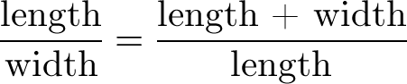.
In Stage 4, the focus is on examining situations where the data yields a constant rate of change. It is possible that some practical situations may yield a variable rate of change. This is the focus in Ratios and Rates in Stage 5.3.
It is the usual practice in mathematics to place the independent variable on the horizontal axis and the dependent variable on the vertical axis. This is not always the case in other subjects, such as economics.
Purpose/Relevance of Substrand
As we often need to compare two numbers, amounts or quantities in our daily lives, ratios and rates are important aspects of our study of mathematics. Ratios are used to compare two (or more) numbers, amounts or quantities of the same kind (eg objects, people, weights, heights) and can be expressed as ' to ' or . In simple terms, a ratio represents that for a given number or amount of one thing, there is a certain number or amount of another thing (eg 'I have 4 ties for every shirt, so the ratio of ties:shirts is 4:1 and the ratio of shirts:ties is 1:4'). A rate is a particular type of ratio that is used to compare two measurements of different kinds. Speed is a rate in which the distance travelled (by a person, car, etc) is compared to the time taken (to cover the distance travelled). It follows that speed is measured (or expressed) in units such as metres per second and kilometres per hour. Other examples of rates that are important in our everyday lives include interest rates, exchange rates, heart rates, birth rates and death rates.
Language
The use of the word 'per', meaning 'for every', in rates should be made explicit to students.
When solving ratio and rate problems, students should be encouraged to write a few key words on the left-hand side of the equals sign to identify what is being found in each step of their working, and to conclude with a statement in words.
When describing distance/time graphs (travel graphs), supply a modelled story and graph first, or jointly construct a story with students before independent work is required. When constructing stories and interpreting distance/time graphs, students can use present tense, 'The man travels …', or past tense, 'The man travelled …'.
Students should be aware that 'gradient' may be referred to as 'slope' in some contexts.
Stage 4
Number and Algebra
Algebraic Techniques 1
Outcomes
A student:
- communicates and connects mathematical ideas using appropriate terminology, diagrams and symbols MA4-1WM
- recognises and explains mathematical relationships using reasoning MA4-3WM
- generalises number properties to operate with algebraic expressions MA4-8NA
Related Life Skills outcome: MALS-18NA
Content
Students:
Introduce the concept of variables as a way of representing numbers using letters (ACMNA175)
- develop the concept that pronumerals (letters) can be used to represent numerical values
- recognise that pronumerals can represent one or more numerical values (when more than one numerical value, pronumerals may then be referred to as 'variables') (Communicating, Reasoning)
- model the following using concrete materials or otherwise:
- expressions that involve a pronumeral, and a pronumeral added to a constant, eg a, a + 1
- expressions that involve a pronumeral multiplied by a constant, eg 2a, 3a
- sums and products, eg 2a + 1, 2(a + 1)
- equivalent expressions, eg
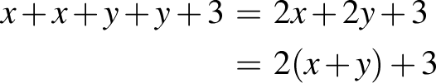
- simplifying expressions, eg
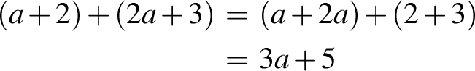
- recognise and use equivalent algebraic expressions, eg
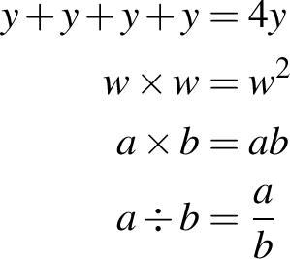
- use algebraic symbols to represent mathematical operations written in words and vice versa, eg the product of x and y is xy, 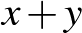 is the sum of x and y
Extend and apply the laws and properties of arithmetic to algebraic terms and expressions (ACMNA177)
- recognise like terms and add and subtract them to simplify algebraic expressions, eg
- verify whether a simplified expression is correct by substituting numbers for pronumerals (Communicating, Reasoning)
- connect algebra with the commutative and associative properties of arithmetic to determine that 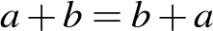 and 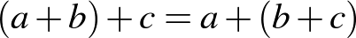 (Communicating)
- recognise the role of grouping symbols and the different meanings of expressions, such as 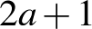 and 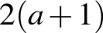
- simplify algebraic expressions that involve multiplication and division, eg , , , 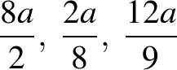
- recognise the equivalence of algebraic expressions involving multiplication, eg (Communicating)
- connect algebra with the commutative and associative properties of arithmetic to determine that and 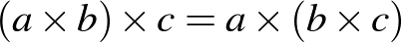 (Communicating)
- recognise whether particular algebraic expressions involving division are equivalent or not, eg is equivalent to 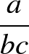 and 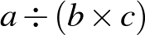, but is not equivalent to or 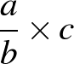 (Communicating)
- translate from everyday language to algebraic language and vice versa
- use algebraic symbols to represent simple situations described in words, eg write an expression for the number of cents in x dollars (Communicating)
- interpret statements involving algebraic symbols in other contexts, eg cell references when creating and formatting spreadsheets (Communicating)
Simplify algebraic expressions involving the four operations (ACMNA192)
- simplify a range of algebraic expressions, including those involving mixed operations
- apply the order of operations to simplify algebraic expressions (Problem Solving)
Background Information
It is important to develop an understanding of the use of pronumerals (letters) as algebraic symbols to represent one or more numerical values.
The recommended approach is to spend time on the conventions for the use of algebraic symbols for first-degree expressions and to situate the translation of generalisations from words to symbols as an application of students' knowledge of the symbol system, rather than as an introduction to the symbol system.
The recommended steps for moving into symbolic algebra are:
- the variable notion, associating letters with a variety of different numerical values
- symbolism for a pronumeral plus a constant
- symbolism for a pronumeral times a constant
- symbolism for sums, differences, products and quotients.
So, if a = 6, a + a = 6 + 6, but 2a = 2 × 6 and not 26.
To gain an understanding of algebra, students must be introduced to the concepts of pronumerals, expressions, unknowns, equations, patterns, relationships and graphs in a wide variety of contexts. For each successive context, these ideas need to be redeveloped. Students need gradual exposure to abstract ideas as they begin to relate algebraic terms to real situations.
It is suggested that the introduction of representation through the use of algebraic symbols precede Linear Relationships in Stage 4, since this substrand presumes that students are able to manipulate algebraic symbols and will use them to generalise patterns.
Purpose/Relevance of Substrand
Algebra is used to some extent throughout our daily lives. People are solving equations (usually mentally) when, for example, they are working out the right quantity of something to buy, or the right amount of an ingredient to use when adapting a recipe. Algebra requires, and its use results in, learning how to apply logical reasoning and problem-solving skills. It is used more extensively in other areas of mathematics, the sciences, business, accounting, etc. The widespread use of algebra is readily seen in the writing of formulas in spreadsheets.
Language
For the introduction of algebra in Stage 4, the term 'pronumeral' rather than 'variable' is preferred when referring to unknown numbers. In an algebraic expression such as 2x + 5, x can take any value (ie x is variable and a pronumeral). However, in an equation such as 2x + 5 = 11, x represents one particular value (ie x is not a variable but is a pronumeral). In equations such as x + y = 11, x and y can take any values that sum to 11 (ie x and y are variables and pronumerals).
'Equivalent' is the adjective for 'equal', although 'equal' can also be used as an adjective, ie 'equivalent expressions' or 'equal expressions'.
Some students may confuse the order in which terms or numbers are to be used when a question is expressed in words. This is particularly apparent for word problems that involve subtraction or division to obtain the required result, eg '5x less than x' and 'take 5x from x' both require the order of the terms to be reversed to x – 5x in the solution.
Students need to be familiar with the terms 'sum', 'difference', 'product' and 'quotient' to describe the results of adding, subtracting, multiplying and dividing, respectively.
Stage 4
Number and Algebra
Algebraic Techniques 2
Outcomes
A student:
- communicates and connects mathematical ideas using appropriate terminology, diagrams and symbols MA4-1WM
- applies appropriate mathematical techniques to solve problems MA4-2WM
- recognises and explains mathematical relationships using reasoning MA4-3WM
- generalises number properties to operate with algebraic expressions MA4-8NA
Related Life Skills outcome: MALS-18NA
Content
Students:
Create algebraic expressions and evaluate them by substituting a given value for each variable (ACMNA176)
- substitute into algebraic expressions and evaluate the result
- calculate and compare the values of x² for values of x with the same magnitude but opposite sign (Reasoning)
- generate a number pattern from an algebraic expression, eg
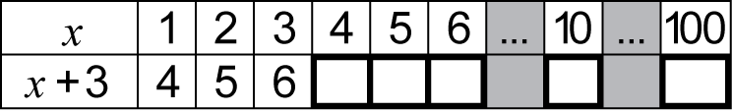
Extend and apply the distributive law to the expansion of algebraic expressions (ACMNA190)
- expand algebraic expressions by removing grouping symbols, eg
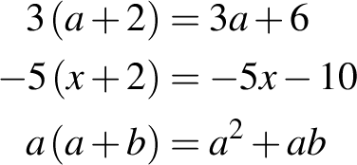
- connect algebra with the distributive property of arithmetic to determine that 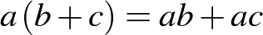 (Communicating)
Factorise algebraic expressions by identifying numerical factors (ACMNA191)
- factorise a single algebraic term, eg
- factorise algebraic expressions by finding a common numerical factor, eg
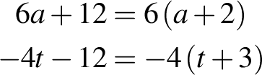
- check expansions and factorisations by performing the reverse process (Reasoning)
Factorise algebraic expressions by identifying algebraic factors
- factorise algebraic expressions by finding a common algebraic factor, eg
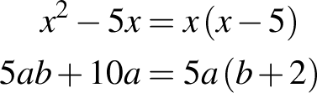
Background Information
When evaluating expressions, there should be an explicit direction to replace the pronumeral with the number to ensure that full understanding of notation occurs.
Language
The meaning of the imperatives 'expand', 'remove the grouping symbols' and 'factorise' and the expressions 'the expansion of' and 'the factorisation of' should be made explicit to students.
Stage 4
Number and Algebra
Indices
Outcomes
A student:
- communicates and connects mathematical ideas using appropriate terminology, diagrams and symbols MA4-1WM
- applies appropriate mathematical techniques to solve problems MA4-2WM
- recognises and explains mathematical relationships using reasoning MA4-3WM
- operates with positive-integer and zero indices of numerical bases MA4-9NA
Content
Students:
Investigate index notation and represent whole numbers as products of powers of prime numbers (ACMNA149)
- describe numbers written in 'index form' using terms such as 'base', 'power', 'index', 'exponent'
- use index notation to express powers of numbers (positive indices only), eg 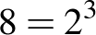
- evaluate numbers expressed as powers of integers, eg 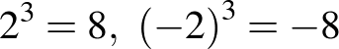
- investigate and generalise the effect of raising a negative number to an odd or even power on the sign of the result (Communicating)
- apply the order of operations to evaluate expressions involving indices, with and without using a calculator, eg 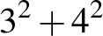, 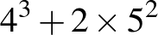
- determine and apply tests of divisibility for 2, 3, 4, 5, 6 and 10
- verify the various tests of divisibility using a calculator (Problem Solving)
- apply tests of divisibility mentally as an aid to calculation (Problem Solving)
- express a number as a product of its prime factors, using index notation where appropriate
- recognise that if a given number is divisible by a composite number, then it is also divisible by the factors of that number, eg since 660 is divisible by 6, then 660 is also divisible by factors of 6, which are 2 and 3 (Reasoning)
- find the highest common factor of large numbers by first expressing the numbers as products of prime factors (Communicating, Problem Solving)
Investigate and use square roots of perfect square numbers (ACMNA150)
- use the notations for square root 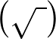 and cube root 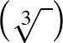
- recognise the link between squares and square roots and between cubes and cube roots,
eg 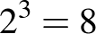 and 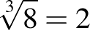
- determine through numerical examples that:
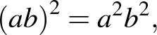 eg 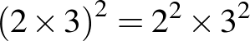
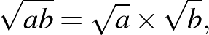 eg 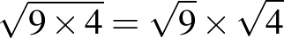
- express a number as a product of its prime factors to determine whether its square root and/or cube root is an integer
- find square roots and cube roots of any non-square whole number using a calculator, after first estimating
- determine the two integers between which the square root of a non-square whole number lies (Reasoning)
- apply the order of operations to evaluate expressions involving square roots and cube roots, with and without using a calculator, eg 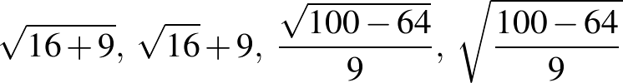
- explain the difference between pairs of numerical expressions that appear similar, eg 'Is 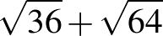 equivalent to 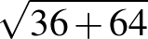 ?' (Communicating, Reasoning)
Use index notation with numbers to establish the index laws with positive-integer indices and the zero index (ACMNA182)
- develop index laws with positive-integer indices and numerical bases by expressing each term in expanded form, eg
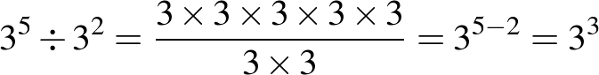
- verify the index laws using a calculator, eg use a calculator to compare the values of 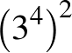 and 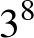 (Reasoning)
- explain the incorrect use of index laws, eg explain why 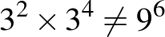 (Communicating, Reasoning)
- establish the meaning of the zero index, eg by patterns
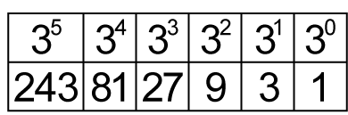
- verify the zero index law using a calculator (Reasoning)
- use index laws to simplify expressions with numerical bases, eg 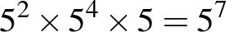
Background Information
Students have not used indices prior to Stage 4 and so the meaning and use of index notation will need to be made explicit. However, students should have some experience from Stage 3 in multiplying more than two numbers together at the same time.
In Stage 3, students used the notion of factorising a number as a mental strategy for multiplication. Teachers may like to make an explicit link to this in the introduction of the prime factorisation of a number in Stage 4, eg in Stage 3, 18 × 5 would have been calculated as 9 × 2 × 5; in Stage 4, 18 × 5 can be factorised as a product of primes, as 3 × 3 × 2 × 5.
The square root sign signifies a positive number (or zero). So, 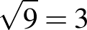 (only). However, the two numbers whose square is 9 are 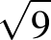 and 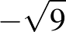, ie 3 and –3.
Purpose/Relevance of Substrand
Indices are important in mathematics and in everyday situations. Among their most significant uses is that they allow us to write large and small numbers more simply, and to perform calculations with large and small numbers more easily. For example, without the use of indices, 2¹⁰⁰⁰ would be written as 2 × 2 × 2 × 2 …, until '2' appeared exactly 1000 times.
Language
Students need to be able to express the concept of divisibility in different ways, such as '12 is divisible by 2', '2 divides (evenly) into 12', '2 goes into 12 (evenly)'.
A 'product of prime factors' can also be referred to as a 'product of primes'.
Students are introduced to indices in Stage 4. The different expressions used when referring to indices should be modelled by teachers. Teachers should use fuller expressions before shortening them, eg 2⁴ should be expressed as '2 raised to the power of 4', before '2 to the power of 4' and finally '2 to the 4'. Students are expected to use the words 'squared' and 'cubed' when saying expressions containing indices of 2 and 3, respectively, eg 4² is 'four squared', 4³ is 'four cubed'.
Words such as 'product', 'prime', 'power', 'base' and 'index' have different meanings outside of mathematics. Words such as 'base', 'square' and 'cube' also have different meanings within mathematics, eg 'the base of the triangle' versus 'the base of 3² is 3', 'the square of length 3 cm' versus 'the square of 3'. Discussing the relationship between the use of the words 'square' and 'cube' when working with indices and the use of the same words in geometry may assist some students with their understanding.
Stage 4
Number and Algebra
Equations
Outcomes
A student:
- communicates and connects mathematical ideas using appropriate terminology, diagrams and symbols MA4-1WM
- applies appropriate mathematical techniques to solve problems MA4-2WM
- recognises and explains mathematical relationships using reasoning MA4-3WM
- uses algebraic techniques to solve simple linear and quadratic equations MA4-10NA
Related Life Skills outcome: MALS-19NA
Content
Students:
Solve simple linear equations (ACMNA179)
- distinguish between algebraic expressions where pronumerals are used as variables, and equations where pronumerals are used as unknowns
- solve simple linear equations using concrete materials, such as the balance model or cups and counters, stressing the notion of performing the same operation on both sides of an equation
- solve linear equations that may have non-integer solutions, using algebraic techniques that involve up to two steps in the solution process, eg
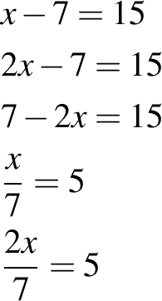
- compare and contrast strategies to solve a variety of linear equations (Communicating, Reasoning)
- generate equations with a given solution, eg find equations that have the solution x = 5 (Problem Solving)
Solve linear equations using algebraic techniques and verify solutions by substitution (ACMNA194)
- solve linear equations that may have non-integer solutions, using algebraic techniques that involve up to three steps in the solution process, eg
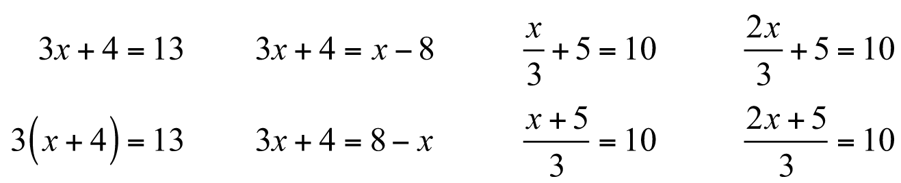
- check solutions to equations by substituting
Solve simple quadratic equations
- determine that if then there are two values of that solve a simple quadratic equation of the form 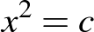
- explain why quadratic equations could be expected to have two solutions (Communicating, Reasoning)
- recognise that does not have a solution if is a negative number (Communicating, Reasoning)
- solve simple quadratic equations of the form , leaving answers in 'exact form' and as decimal approximations
Background Information
The solution of simple equations can be introduced using a variety of models. Such models include using a two-pan balance with objects such as centicubes and a wrapped 'unknown', or using some objects hidden in a container as an 'unknown' to produce a number sentence.
The solution of simple quadratic equations in Stage 4 enables students to determine side lengths in right-angled triangles through the application of Pythagoras' theorem.
Purpose/Relevance of Substrand
An equation is a statement that two quantities or expressions are equal, usually through the use of numbers and/or symbols. Equations are used throughout mathematics and in our daily lives in obtaining solutions to problems of all levels of complexity. People are solving equations (usually mentally) when, for example, they are working out the right quantity of something to buy, or the right amount of an ingredient to use when adapting a recipe.
Language
Describing the steps in the solution of equations provides students with the opportunity to practise using mathematical imperatives in context, eg 'add 5 to both sides', 'increase both sides by 5', 'subtract 3 from both sides', 'take 3 from both sides', 'decrease both sides by 3', 'reduce both sides by 3', 'multiply both sides by 2', 'divide both sides by 2'.
Stage 4
Number and Algebra
Linear Relationships
Outcomes
A student:
- communicates and connects mathematical ideas using appropriate terminology, diagrams and symbols MA4-1WM
- recognises and explains mathematical relationships using reasoning MA4-3WM
- creates and displays number patterns; graphs and analyses linear relationships; and performs transformations on the Cartesian plane MA4-11NA
Related Life Skills outcomes: MALS-32MG, MALS-33MG, MALS-34MG
Content
Students:
Given coordinates, plot points on the Cartesian plane, and find coordinates for a given point (ACMNA178)
- plot and label points on the Cartesian plane, given coordinates, including those with coordinates that are not whole numbers
- identify and record the coordinates of given points on the Cartesian plane, including those with coordinates that are not whole numbers
Describe translations, reflections in an axis, and rotations of multiples of 90° on the Cartesian plane using coordinates (ACMMG181)
- use the notation  to name the 'image' resulting from a transformation of a point on the Cartesian plane
- plot and determine the coordinates for resulting from translating one or more times
- plot and determine the coordinates for resulting from reflecting in either the x- or y-axis
- investigate and describe the relationship between the coordinates of and following a reflection in the x- or y-axis, eg if is reflected in the x-axis, has the same x-coordinate, and its y-coordinate has the same magnitude but opposite sign (Communicating)
- recognise that a translation can produce the same result as a single reflection and vice versa (Reasoning)
- plot and determine the coordinates for resulting from rotating by a multiple of 90° about the origin
- investigate and describe the relationship between the coordinates of and following a rotation of 180° about the origin, eg if is rotated 180° about the origin, the x- and y-coordinates of have the same magnitude but opposite sign (Communicating)
- recognise that a combination of translations and/or reflections can produce the same result as a single rotation and that a combination of rotations can produce the same result as a single translation and/or reflection (Reasoning)
Plot linear relationships on the Cartesian plane, with and without the use of digital technologies (ACMNA193)
- use objects to build a geometric pattern, record the results in a table of values, describe the pattern in words and algebraic symbols, and represent the relationship on a number grid, eg
- check pattern descriptions by substituting further values (Reasoning)
- replace written statements describing patterns with equations written in algebraic symbols, eg 'You multiply the number of pentagons by four and add one to get the number of matches' could be replaced with '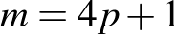' (Communicating, Reasoning)
- determine whether a particular pattern can be described using algebraic symbols (Problem Solving)
- represent the pattern formed by plotting points from a table and suggest another set of points that might form the same pattern (Communicating, Reasoning)
- explain why it is useful to describe the rule for a pattern in terms of the connection between the top row and the bottom row of the table (Communicating, Reasoning)
- recognise a given number pattern (including decreasing patterns), complete a table of values, describe the pattern in words and algebraic symbols, and represent the relationship on a number grid
- generate a variety of number patterns that increase or decrease and record them in more than one way (Communicating)
- determine a rule in words to describe the pattern by relating the 'position in the pattern' to the 'value of the term' (Communicating, Problem Solving)
- explain why a particular relationship or rule for a given pattern is better than another (Communicating, Reasoning)
- distinguish between graphs that represent an increasing number pattern and those that represent a decreasing number pattern (Communicating, Reasoning)
- determine whether a particular number pattern forms a linear or non-linear relationship by examining its representation on a number grid (Problem Solving)
- use a rule generated from a pattern to calculate the corresponding value for a larger number
- form a table of values for a linear relationship by substituting a set of appropriate values for either of the pronumerals and graph the number pairs on the Cartesian plane, eg given 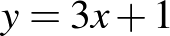, form a table of values using x = 0, 1 and 2 and then graph the number pairs on the Cartesian plane with an appropriate scale
- explain why 0, 1 and 2 are frequently chosen as x-values in a table of values (Communicating, Reasoning)
- extend the line joining a set of points on the Cartesian plane to show that there is an infinite number of ordered pairs that satisfy a given linear relationship
- interpret the meaning of the continuous line joining the points that satisfy a given number pattern (Communicating, Reasoning)
- read coordinates from the graph of a linear relationship to demonstrate that there are many points on the line (Communicating)
- derive a rule for a set of points that has been graphed on the Cartesian plane
- graph more than one line on the same set of axes using digital technologies and compare the graphs to determine similarities and differences, eg parallel, pass through the same point
- identify similarities and differences between groups of linear relationships, eg
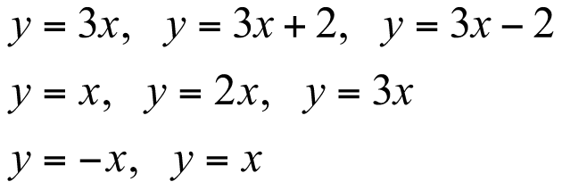 (Reasoning)
- determine which term of the rule affects the gradient of a graph, making it increase or decrease (Reasoning)
- use digital technologies to graph linear and simple non-linear relationships, such as 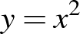
- recognise and explain that not all patterns form a linear relationship (Communicating)
- determine and explain differences between equations that represent linear relationships and those that represent non-linear relationships (Communicating)
Solve linear equations using graphical techniques (ACMNA194)
- recognise that each point on the graph of a linear relationship represents a solution to a particular linear equation
- use graphs of linear relationships to solve a corresponding linear equation, with and without the use of digital technologies, eg use the graph of 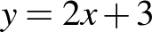 to find the solution of the equation 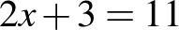
- graph two intersecting lines on the same set of axes and read off the point of intersection
- explain the significance of the point of intersection of two lines in relation to it representing the only solution that satisfies both equations (Communicating, Reasoning)
Background Information
When describing number patterns algebraically, it is important that students develop an understanding of the use of pronumerals as algebraic symbols for numbers of objects rather than for the objects themselves.
In Linear Relationships, the study of patterns focuses on those that are linear. However, teachers may include a few simple non-linear patterns so that students realise that not all patterns are linear.
The Cartesian plane (commonly referred to as the 'number plane') is named after the French philosopher and mathematician René Descartes (1596–1650), who was one of the first to develop analytical geometry on the number plane. On the Cartesian plane, the coordinates of a point refer to an ordered pair describing the horizontal position x first, followed by the vertical position y.
Students are introduced to the four quadrants of the Cartesian plane in Stage 3. However, they may not be familiar with the terms 'Cartesian plane', 'x-axis' and 'y-axis', as in Stage 3 these are generally referred to as the 'number plane', 'horizontal axis' and 'vertical axis', respectively.
Purpose/Relevance of Substrand
Linear relationships are very common in mathematics and science. The graph of two quantities that have a linear relationship is a straight line. A linear relationship may be a direct relationship or an inverse relationship. In a direct relationship, as one quantity increases, the other quantity also increases, or as one quantity decreases, the other quantity also decreases. In an inverse relationship, as one quantity increases, the other quantity decreases. Examples of linear relationships familiar in everyday life include the distance travelled and time taken, the conversion of one currency to another, the cost of printing involving an initial set-up cost and a dollar rate per item, the cost of taxi fares involving a hiring charge and a dollar rate per kilometre, and the cost of catering involving a base amount for a set number of people plus a rate for each extra attendee. Coordinate geometry facilitates the exploration and interpretation of linear relationships.
Language
In Stage 3, students were introduced to patterns involving one operation and used the terms 'position in the pattern' and 'value of the term' when describing a rule for a pattern from a table of values, eg 'The value of the term is three times the position in the pattern'.
Students will need to become familiar with and be able to use new terms, including 'coefficient', 'constant term' and 'intercept'.
Students should be aware that 'gradient' may be referred to as 'slope' in some contexts.
Stage 4
Measurement and Geometry
Length
Outcomes
A student:
- communicates and connects mathematical ideas using appropriate terminology, diagrams and symbols MA4-1WM
- applies appropriate mathematical techniques to solve problems MA4-2WM
- calculates the perimeters of plane shapes and the circumferences of circles MA4-12MG
Related Life Skills outcomes: MALS-25MG, MALS-26MG
Content
Students:
Find perimeters of parallelograms, trapeziums, rhombuses and kites (ACMMG196)
- find the perimeters of a range of plane shapes, including parallelograms, trapeziums, rhombuses, kites and simple composite figures
- compare perimeters of rectangles with the same area (Problem Solving)
- solve problems involving the perimeters of plane shapes, eg find the dimensions of a rectangle, given its perimeter and the length of one side
Investigate the concept of irrational numbers, including
(ACMNA186)
- demonstrate by practical means that the ratio of the circumference to the diameter of a circle is constant, eg measure and compare the diameters and circumferences of various cylinders or use dynamic geometry software to measure circumferences and diameters
- define the number as the ratio of the circumference to the diameter of any circle
- compare the various approximations for used throughout the ages and investigate the concept of irrational numbers (Communicating)
- recognise that the symbol is used to represent a constant numerical value (Communicating)
Investigate the relationship between features of circles, such as the circumference, radius and diameter; use formulas to solve problems involving circumference (ACMMG197)
- identify and name parts of a circle and related lines, including arc, tangent, chord, sector and segment
- develop and use the formulas to find the circumferences of circles in terms of the diameter d or radius r:
- use mental strategies to estimate the circumferences of circles, using an approximate value of such as 3 (Problem Solving)
- find the diameter and/or radius of a circle, given its circumference (Problem Solving)
- find the perimeters of quadrants and semicircles
- find the perimeters of simple composite figures consisting of two shapes, including quadrants and semicircles
- find arc lengths and the perimeters of sectors
- solve a variety of practical problems involving circles and parts of circles, giving an exact answer in terms of and an approximate answer using a calculator's approximation for
Background Information
Students should develop a sense of the levels of accuracy that are appropriate to a particular situation, eg the length of a bridge may be measured in metres to estimate a quantity of paint needed, but would need to be measured much more accurately for engineering work.
The number is known to be irrational (not a fraction) and also transcendental (not the solution of any polynomial equation with integer coefficients). In Stage 4, students only need to know that the digits in its decimal expansion do not repeat (all this means is that it is not a fraction) and in fact have no known pattern.
Purpose/Relevance of Substrand
This substrand focuses on the 'perimeter' (or length of the boundary) of shapes (including the 'circumference' of a circle). The ability to determine the perimeters of two-dimensional shapes is of fundamental importance in many everyday situations, such as framing a picture, furnishing a room, fencing a garden or a yard, and measuring land for farming or building construction.
Language
Pi 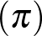 is the Greek letter equivalent to 'p' and is the first letter of the Greek word perimetron, meaning 'perimeter'. The symbol for pi was first used to represent the ratio of the circumference to the diameter of a circle in the early eighteenth century.
The names for some parts of the circle (centre, radius, diameter, circumference, sector, semicircle and quadrant) are introduced in Stage 3. The terms 'arc', 'tangent', 'chord' and 'segment' are introduced in Stage 4.
Some students may find the use of the terms 'length/long', 'breadth/broad', 'width/wide' and 'height/high' difficult. Teachers should model the use of these terms in sentences, both verbally and in written form, when describing diagrams. Students should be encouraged to speak about, listen to, read about and write about the dimensions of given shapes using various combinations of these words, eg 'The length of this rectangle is 7 metres and the width is 4 metres', 'The rectangle is 7 metres long and 4 metres wide'. Students may also benefit from drawing and labelling a shape, given a description of its features in words, eg 'The base of an isosceles triangle is 6 metres long and its perimeter is 20 metres. Draw the triangle and mark on it the lengths of the three sides'.
In Stage 3, students were introduced to the term 'dimensions' to describe the length and width of a rectangle. However, some students may need to be reminded of this.
Stage 4
Measurement and Geometry
Area
Outcomes
A student:
- communicates and connects mathematical ideas using appropriate terminology, diagrams and symbols MA4-1WM
- applies appropriate mathematical techniques to solve problems MA4-2WM
- uses formulas to calculate the areas of quadrilaterals and circles, and converts between units of area MA4-13MG
Related Life Skills outcome: MALS-29MG
Content
Students:
Choose appropriate units of measurement for area and convert from one unit to another (ACMMG195)
- choose an appropriate unit to measure the areas of different shapes and surfaces, eg floor space, fields
- use the areas of familiar surfaces to assist with the estimation of larger areas, eg the areas of courts and fields for sport (Problem Solving)
- convert between metric units of area using 1 cm² = 100 mm², 1 m² = 1 000 000 mm², 1 ha = 10 000 m², 1 km² = 1 000 000 m² = 100 ha
Establish the formulas for areas of rectangles, triangles and parallelograms and use these in problem solving (ACMMG159)
- develop and use the formulas to find the areas of rectangles and squares:
where l is the length and b is the breadth (or width) of the rectangle
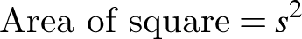 where s is the side length of the square
- explain the relationship that multiplying, dividing, squaring and factoring have with the areas of rectangles and squares with integer side lengths (Communicating)
- explain the relationship between the formulas for the areas of rectangles and squares (Communicating)
- compare areas of rectangles with the same perimeter (Problem Solving)
- develop, with or without the use of digital technologies, and use the formulas to find the areas of parallelograms and triangles, including triangles for which the perpendicular height needs to be shown outside the shape:
where b is the length of the base and h is the perpendicular height
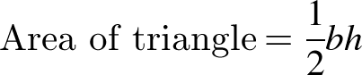 where b is the length of the base and h is the perpendicular height
- identify the perpendicular heights of parallelograms and triangles in different orientations (Reasoning)
- find the areas of simple composite figures that may be dissected into rectangles, squares, parallelograms and triangles
Find areas of trapeziums, rhombuses and kites (ACMMG196)
- develop, with or without the use of digital technologies, and use the formula to find the areas of kites and rhombuses:
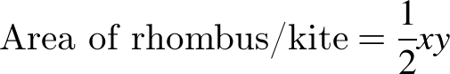 where x and y are the lengths of the diagonals
- develop and use the formula to find the areas of trapeziums:
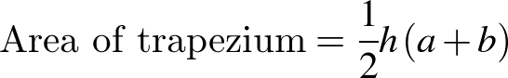 where h is the perpendicular height and a and b are the lengths of the parallel sides
- identify the perpendicular heights of various trapeziums in different orientations (Reasoning)
- select and use the appropriate formula to find the area of any of the special quadrilaterals
- solve a variety of practical problems relating to the areas of triangles and quadrilaterals
- convert between metric units of length and area as appropriate when solving area problems (Problem Solving)
Investigate the relationship between features of circles, such as the area and the radius; use formulas to solve problems involving area (ACMMG197)
- develop, with or without the use of digital technologies, and use the formula to find the areas of circles:
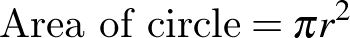 where r is the length of the radius
- find the radii of circles, given their circumference or area (Problem Solving)
- find the areas of quadrants, semicircles and sectors
- solve a variety of practical problems involving circles and parts of circles, giving an exact answer in terms of and an approximate answer using a calculator's approximation for
Background Information
The area formulas for the triangle, the special quadrilaterals and the circle should be developed by practical means and/or by the use of dynamic geometry software, such as prepared applets.
The area formulas for the triangle and the parallelogram should be related to the area of a rectangle. Applets may be particularly useful in demonstrating that the respective formulas hold for all triangles and parallelograms, including those for which the perpendicular height needs to be drawn outside the shape.
The area formula for the rhombus or kite depends upon the fact that the diagonals are perpendicular, and so is linked with the geometry of special quadrilaterals. The formula applies to any quadrilateral in which the diagonals are perpendicular. Students should also be aware that because the rhombus is a special type of parallelogram, the area can be found using the formula .
The area formula for the trapezium can be developed using various dissections and techniques. Students need to be able to apply the area formula for the trapezium appropriately to trapeziums in any form or orientation.
The area formula for the circle may be established by using one or both of the following dissections:
- cut a circle into a large number of sectors and arrange the sectors alternately point-up and point-down to form a rectangle with height and base length
- inscribe a number of congruent triangles in a circle, all with corresponding vertex at the centre, and show that the area of the inscribed polygon is half the length of the perimeter times the perpendicular height of the triangles.
Students should be made aware that the perpendicular height of a triangle is the shortest distance from the base to the opposite angle. They may also need to be explicitly taught that the shortest distance between the parallel sides of a quadrilateral is the perpendicular distance between these sides.
Finding the areas of rectangles and squares with integer side lengths is an important link between geometry and multiplying, dividing, factoring and squaring. Expressing a number as the product of two of its factors is equivalent to forming a rectangle with those factors as the side lengths, and (where possible) expressing a number as the square of one of its factors is equivalent to forming a square with that factor as the side length.
Graphing the relationship between the length of a rectangle with a constant perimeter and possible areas of the rectangle links to non-linear graphs.
Purpose/Relevance of Substrand
The ability to determine the areas of two-dimensional shapes and solve related problems is of fundamental importance in many everyday situations, such as carpeting a floor, painting a room, planting a garden, establishing and maintaining a lawn, installing concrete and paving, and measuring land for farming or building construction. Knowledge and understanding with regard to determining the areas of simple two-dimensional shapes can be readily applied to determining the surface areas of simple (and composite) three-dimensional objects such as cubes, other rectangular prisms, triangular prisms, cylinders, pyramids, cones and spheres.
Language
Teachers should reinforce with students the use of the term 'perpendicular height', rather than simply 'height', when referring to this attribute of a triangle. Students should also benefit from drawing and labelling a triangle when given a description of its features in words.
Students may improve their understanding and retention of the area formulas by expressing them in different ways, eg 'The area of a trapezium is half the perpendicular height multiplied by the sum of the lengths of the parallel sides', 'The area of a trapezium is half the product of the perpendicular height and the sum of the lengths of the parallel sides'.
The use of the term 'respectively' in measurement word problems should be modelled and the importance of the order of the words explained, eg in the sentence 'The perpendicular height and base of a triangle are 5 metres and 8 metres, respectively', the first attribute (perpendicular height) mentioned refers to the first measurement (5 metres), and so on.
The abbreviation m² is read as 'square metre(s)' and not 'metre(s) squared' or 'metre(s) square'. Similarly, the abbreviation cm² is read as 'square centimetre(s)' and not 'centimetre(s) squared' or 'centimetre(s) square'.
When units are not provided in an area question, students should record the area in 'square units'.
Stage 4
Measurement and Geometry
Volume
Outcomes
A student:
- communicates and connects mathematical ideas using appropriate terminology, diagrams and symbols MA4-1WM
- applies appropriate mathematical techniques to solve problems MA4-2WM
- uses formulas to calculate the volumes of prisms and cylinders, and converts between units of volume MA4-14MG
Related Life Skills outcomes: MALS-28MG, MALS-30MG, MALS-31MG
Content
Students:
Draw different views of prisms and solids formed from combinations of prisms (ACMMG161)
- draw (in two dimensions) prisms, and solids formed from combinations of prisms, from different views, including top, side, front and back views
- identify and draw the cross-sections of different prisms
- recognise that the cross-sections of prisms are uniform (Reasoning)
- visualise, construct and draw various prisms from a given cross-sectional diagram
- determine if a particular solid has a uniform cross-section
- distinguish between solids with uniform and non-uniform cross-sections (Reasoning)
Choose appropriate units of measurement for volume and convert from one unit to another (ACMMG195)
- recognise that 1000 litres is equal to one kilolitre and use the abbreviation for kilolitres (kL)
- recognise that 1000 kilolitres is equal to one megalitre and use the abbreviation for megalitres (ML)
- choose an appropriate unit to measure the volumes or capacities of different objects, eg swimming pools, household containers, dams
- use the capacities of familiar containers to assist with the estimation of larger capacities (Reasoning)
- convert between metric units of volume and capacity, using 1 cm³ = 1000 mm³, 1 L = 1000 mL = 1000 cm³, 1 m³ = 1000 L = 1 kL, 1000 kL = 1 ML
Develop the formulas for the volumes of rectangular and triangular prisms and of prisms in general; use formulas to solve problems involving volume (ACMMG198)
- develop the formula for the volume of prisms by considering the number and volume of 'layers' of identical shape:
leading to
- recognise the area of the 'base' of a prism as being identical to the area of its uniform cross-section (Communicating, Reasoning)
- find the volumes of prisms, given their perpendicular heights and the areas of their uniform cross-sections
- find the volumes of prisms with uniform cross-sections that are rectangular or triangular
- solve a variety of practical problems involving the volumes and capacities of right prisms
Calculate the volumes of cylinders and solve related problems (ACMMG217)
- develop and use the formula to find the volumes of cylinders:
where r is the length of the radius of the base and h is the perpendicular height
- recognise and explain the similarities between the volume formulas for cylinders and prisms (Communicating)
- solve a variety of practical problems involving the volumes and capacities of right prisms and cylinders, eg find the capacity of a cylindrical drink can or a water tank
Background Information
When developing the volume formula for a prism, students require an understanding of the idea of a uniform cross-section and should visualise, for example, stacking unit cubes, layer by layer, into a rectangular prism, or stacking planks into a pile. In the formula for the volume of a prism, , refers to the 'area of the base', which can also be referred to as the 'area of the uniform cross-section'.
'Oblique' prisms, cylinders, pyramids and cones are those that are not 'right' prisms, cylinders, pyramids and cones, respectively. The focus here is on right prisms and cylinders, although the formulas for volume also apply to oblique prisms and cylinders provided that the perpendicular height is used. In a right prism, the base and top are perpendicular to the other faces. In a right pyramid or cone, the base has a centre of rotation, and the interval joining that centre to the apex is perpendicular to the base (and therefore is its axis of rotation).
The volumes of rectangular prisms and cubes are linked with multiplication, division, powers and factorisation. Expressing a number as the product of three of its factors is equivalent to forming a rectangular prism with those factors as the side lengths, and (where possible) expressing a number as the cube of one of its factors is equivalent to forming a cube with that factor as the side length.
The abbreviation for megalitres is ML. Students will need to be careful not to confuse this with the abbreviation mL used for millilitres.
Purpose/Relevance of Substrand
The ability to determine the volumes of three-dimensional objects and the capacities of containers, and to solve related problems, is of fundamental importance in many everyday activities, such as calculating the number of cubic metres of concrete, soil, sand, gravel, mulch or other materials needed for building or gardening projects; the amount of soil that needs to be removed for the installation of a swimming pool; and the appropriate size in litres of water tanks and swimming pools. Knowledge and understanding with regard to determining the volumes of simple three-dimensional objects (including containers) such as cubes, other rectangular prisms, triangular prisms, cylinders, pyramids, cones and spheres can be readily applied to determining the volumes and capacities of composite objects (including containers).
Language
The word 'base' may cause confusion for some students. The 'base' in relation to two-dimensional shapes is linear, whereas in relation to three-dimensional objects, 'base' refers to a surface. In everyday language, the word 'base' is used to refer to that part of an object on, or closest to, the ground. In the mathematics of three-dimensional objects, the term 'base' is used to describe the face by which a prism or pyramid is named, even though it may not be the face on, or closest to, the ground. In Stage 3, students were introduced to the naming of a prism or pyramid according to the shape of its base. In Stage 4, students should be encouraged to make the connection that the name of a particular prism refers not only to the shape of its base, but also to the shape of its uniform cross-section.
Students should be aware that a cube is a special prism that has six congruent faces.
The abbreviation m³ is read as 'cubic metre(s)' and not 'metre(s) cubed' or 'metre(s) cube'. The abbreviation cm³ is read as 'cubic centimetre(s)' and not 'centimetre(s) cubed' or 'centimetre(s) cube'.
When units are not provided in a volume question, students should record the volume in 'cubic units'.
Stage 4
Measurement and Geometry
Time
Outcomes
A student:
- communicates and connects mathematical ideas using appropriate terminology, diagrams and symbols MA4-1WM
- applies appropriate mathematical techniques to solve problems MA4-2WM
- performs calculations of time that involve mixed units, and interprets time zones MA4-15MG
Related Life Skills outcomes: MALS-20MG, MALS-21MG, MALS-22MG, MALS-23MG, MALS-24MG
Content
Students:
Solve problems involving duration, including using 12-hour and 24-hour time within a single time zone (ACMMG199)
- add and subtract time mentally using bridging strategies, eg from 2:45 to 3:00 is 15 minutes and from 3:00 to 5:00 is 2 hours, so the time from 2:45 until 5:00 is 15 minutes + 2 hours = 2 hours 15 minutes
- add and subtract time with a calculator, including by using the 'degrees, minutes, seconds' button
- round answers to time calculations to the nearest minute or hour
- interpret calculator displays for time calculations, eg 2.25 on a calculator display for a time calculation means 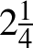 hours or 2 hours 15 minutes
- solve a variety of problems involving duration, including where times are expressed in 12-hour and 24-hour notation, that require the use of mixed units (years, months, days, hours and/or minutes)
Solve problems involving international time zones
- compare times in, and calculate time differences between, major cities of the world, eg 'Given that London is 10 hours behind Sydney, what time is it in London when it is 6:00 pm in Sydney?'
- interpret and use information related to international time zones from maps (Problem Solving)
- solve problems involving international time as it relates to everyday life, eg determine whether a particular soccer game can be watched live on television during normal waking hours (Problem Solving)
Background Information
Calculations involving time can be made on a scientific calculator either by using fractions and decimals or by using the 'degrees, minutes, seconds' button. Students should be familiar with both approaches.
Purpose/Relevance of Substrand
The relevance of this substrand to everyday situations has been seen in earlier stages, as it has involved sequencing events; describing, comparing and ordering the durations of events; reading the time on analog and digital clocks (including 24-hour time); converting between hours, minutes and seconds; using am and pm notation in real-life situations; and constructing timelines. In Stage 4, students learn the very important everyday-life skills of adding and subtracting time in mixed units (both mentally and by using a calculator) and solve related problems, as well as problems involving international time zones. The ability to compare times in, and calculate time differences between, major cities and areas of the world is of fundamental importance in international travel and also in everyday and work situations, such as communicating with people in other countries, watching overseas sporting events live on television, and conducting international business.
Language
The words 'minute' (meaning 'small') and 'minute' (a time measure), although pronounced differently, are really the same word. A minute (time) is a minute (small) part of one hour. A minute (angle) is a minute (small) part of a right angle.
Stage 4
Measurement and Geometry
Right-Angled Triangles (Pythagoras)
Outcomes
A student:
- communicates and connects mathematical ideas using appropriate terminology, diagrams and symbols MA4-1WM
- applies appropriate mathematical techniques to solve problems MA4-2WM
- applies Pythagoras’ theorem to calculate side lengths in right-angled triangles, and solves related problems MA4-16MG
Content
Students:
Investigate Pythagoras' theorem and its application to solving simple problems involving right-angled triangles (ACMMG222)
- identify the hypotenuse as the longest side in any right-angled triangle and also as the side opposite the right angle
- establish the relationship between the lengths of the sides of a right-angled triangle in practical ways, including with the use of digital technologies
- describe the relationship between the sides of a right-angled triangle (Communicating)
- use Pythagoras' theorem to find the length of an unknown side in a right-angled triangle
- explain why the negative solution of the relevant quadratic equation is not feasible when solving problems involving Pythagoras' theorem (Communicating, Reasoning)
- write answers to a specified or sensible level of accuracy, using an 'approximately equals' sign, ie or
- solve a variety of practical problems involving Pythagoras' theorem, approximating the answer as a decimal
- apply Pythagoras' theorem to solve problems involving the perimeters and areas of plane shapes (Problem Solving)
- identify a Pythagorean triad as a set of three numbers such that the sum of the squares of the first two equals the square of the third
- use the converse of Pythagoras' theorem to establish whether a triangle has a right angle
Investigate the concept of irrational numbers (ACMNA186)
- use technology to explore decimal approximations of surds
- recognise that surds can be represented by decimals that are neither terminating nor have a repeating pattern (Communicating)
- solve a variety of practical problems involving Pythagoras' theorem, giving exact answers (ie as surds where appropriate), eg 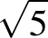
Background Information
Students should gain an understanding of Pythagoras' theorem, rather than just being able to recite the formula. By dissecting squares and rearranging the dissected parts, they will appreciate that the theorem is a statement of a relationship among the areas of squares.
In Stage 5, Pythagoras' theorem becomes the formula for the circle on the Cartesian plane. These links can be developed later in the context of circle geometry and the trigonometry of the general angle.
Pythagoras' theorem is named for the Greek philosopher and mathematician Pythagoras (c580–c500 BC), who is credited with its discovery. However, it is probable that the theorem was known to the Babylonians 1000 years earlier.
In the 1990s, the British mathematician Andrew Wiles (b 1953) finally proved a famous conjecture made by the French lawyer and mathematician Pierre de Fermat (1601–1665), known as 'Fermat's last theorem', which states that if is an integer greater than 2, then 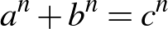 has no positive-integer solutions.
Purpose/Relevance of Substrand
Pythagoras' theorem is of great importance in the mathematics learned in secondary school and is also important in many areas of further mathematics and science study. The theorem is part of the foundations of trigonometry, an important area of mathematics introduced in Stage 5, which allows the user to determine unknown sides and angles in both right-angled and non-right-angled triangles. Pythagoras' theorem has many everyday applications, such as building construction (to ensure that buildings, rooms, additions, etc are square) and determining the length of any diagonal (eg the screen size of a television, the shortest distance between two points).
Language
Students need to understand the difference between an 'exact' answer and an 'approximate' answer.
They may find some of the terminology encountered in word problems involving Pythagoras' theorem difficult to interpret, eg 'foot of a ladder', 'inclined', 'guy wire', 'wire stay', 'vertical', 'horizontal'. Teachers should provide students with a variety of word problems and explain such terms explicitly.
Stage 4
Measurement and Geometry
Properties of Geometrical Figures 1
Outcomes
A student:
- communicates and connects mathematical ideas using appropriate terminology, diagrams and symbols MA4-1WM
- applies appropriate mathematical techniques to solve problems MA4-2WM
- recognises and explains mathematical relationships using reasoning MA4-3WM
- classifies, describes and uses the properties of triangles and quadrilaterals, and determines congruent triangles to find unknown side lengths and angles MA4-17MG
Related Life Skills outcomes: MALS-30MG, MALS-31MG
Content
Students:
Classify triangles according to their side and angle properties and describe quadrilaterals (ACMMG165)
- label and name triangles (eg triangle or ) and quadrilaterals (eg ) in text and on diagrams
- use the common conventions to mark equal intervals on diagrams
- recognise and classify types of triangles on the basis of their properties (acute-angled triangles, right-angled triangles, obtuse-angled triangles, equilateral triangles, isosceles triangles and scalene triangles)
- recognise that a given triangle may belong to more than one class (Reasoning)
- explain why the longest side of a triangle is always opposite the largest angle (Reasoning)
- explain why the sum of the lengths of two sides of a triangle must be greater than the length of the third side (Communicating, Reasoning)
- sketch and label triangles from a worded or verbal description (Communicating)
- distinguish between convex and non-convex quadrilaterals (the diagonals of a convex quadrilateral lie inside the figure)
- investigate the properties of special quadrilaterals (parallelograms, rectangles, rhombuses, squares, trapeziums and kites), including whether:
- the opposite sides are parallel
- the opposite sides are equal
- the adjacent sides are perpendicular
- the opposite angles are equal
- the diagonals are equal
- the diagonals bisect each other
- the diagonals bisect each other at right angles
- the diagonals bisect the angles of the quadrilateral
- use techniques such as paper folding or measurement, or dynamic geometry software, to investigate the properties of quadrilaterals (Problem Solving, Reasoning)
- sketch and label quadrilaterals from a worded or verbal description (Communicating)
- classify special quadrilaterals on the basis of their properties
- describe a quadrilateral in sufficient detail for it to be sketched (Communicating)
Identify line and rotational symmetries (ACMMG181)
- investigate and determine lines (axes) of symmetry and the order of rotational symmetry of polygons, including the special quadrilaterals
- determine if particular triangles and quadrilaterals have line and/or rotational symmetry (Problem Solving)
- investigate the line and rotational symmetries of circles and of diagrams involving circles, such as a sector or a circle with a marked chord or tangent
- identify line and rotational symmetries in pictures and diagrams, eg artistic and cultural designs
Demonstrate that the angle sum of a triangle is 180° and use this to find the angle sum of a quadrilateral (ACMMG166)
- justify informally that the interior angle sum of a triangle is 180°, and that any exterior angle equals the sum of the two interior opposite angles
- use dynamic geometry software or other methods to investigate the interior angle sum of a triangle, and the relationship between any exterior angle and the sum of the two interior opposite angles (Reasoning)
- use the angle sum of a triangle to establish that the angle sum of a quadrilateral is 360°
- use the angle sum results for triangles and quadrilaterals to determine unknown angles in triangles and quadrilaterals, giving reasons
Use the properties of special triangles and quadrilaterals to solve simple numerical problems with appropriate reasoning
- find unknown sides and angles embedded in diagrams, using the properties of special triangles and quadrilaterals, giving reasons
- recognise special types of triangles and quadrilaterals embedded in composite figures or drawn in various orientations (Reasoning)
Background Information
The properties of special quadrilaterals are important in the Measurement and Geometry strand. For example, the perpendicularity of the diagonals of a rhombus and a kite allows a rectangle of twice the size to be constructed around them, leading to formulas for finding area.
In Stage 4, the treatment of triangles and quadrilaterals is still informal, with students consolidating their understanding of different triangles and quadrilaterals and being able to identify them from their properties.
Students who recognise class inclusivity and minimum requirements for definitions may address this Stage 4 content concurrently with content in Stage 5 Properties of Geometrical Figures, where properties of triangles and quadrilaterals are deduced from formal definitions.
Students should give reasons orally and in written form for their findings and answers. For some students, formal setting out could be introduced.
A range of examples of the various triangles and quadrilaterals should be given, including quadrilaterals containing a reflex angle and figures presented in different orientations.
Dynamic geometry software and prepared applets are useful tools for investigating properties of geometrical figures.
When using examples of Aboriginal rock carvings and other Aboriginal art, it is recommended, wherever possible, that local examples be used. Consult with local Aboriginal communities and education consultants for such examples.
Purpose/Relevance of Substrand
In geometry, students study two-dimensional shapes, three-dimensional objects, and position, before moving on to the study and application of angle relationships and the properties of geometrical figures. As the focus moves to relationships and properties, students learn to analyse geometry problems. They develop geometric and deductive reasoning skills, as well as problem-solving skills. Students also develop an understanding that geometry is linked to measurement and is very important in the work of architects, engineers, designers, builders, physicists, land surveyors, etc. However, they also learn that geometry is common and important in everyday situations, including in nature, sports, buildings, astronomy, art, etc.
Language
In Stage 4, students should use full sentences to describe the properties of plane shapes, eg 'The diagonals of a parallelogram bisect each other'. Students may not realise that in this context, the word 'the' implies 'all' and so this should be made explicit. Using the full name of the quadrilateral when describing its properties should assist students in remembering the geometrical properties of each particular shape.
Students in Stage 4 should write geometrical reasons without the use of abbreviations to assist them in learning new terminology, and in understanding and retaining geometrical concepts.
This syllabus uses the phrase 'line(s) of symmetry', although 'axis/axes of symmetry' may also be used.
'Scalene' is derived from the Greek word skalenos, meaning 'uneven'. 'Isosceles' is derived from the Greek words isos, meaning 'equals', and skelos, meaning 'leg'. 'Equilateral' is derived from the Latin words aequus, meaning 'equal', and latus, meaning 'side'. 'Equiangular' is derived from aequus and another Latin word, angulus, meaning 'corner'.
Stage 4
Measurement and Geometry
Properties of Geometrical Figures 2
Outcomes
A student:
- communicates and connects mathematical ideas using appropriate terminology, diagrams and symbols MA4-1WM
- applies appropriate mathematical techniques to solve problems MA4-2WM
- recognises and explains mathematical relationships using reasoning MA4-3WM
- classifies, describes and uses the properties of triangles and quadrilaterals, and determines congruent triangles to find unknown side lengths and angles MA4-17MG
Related Life Skills outcomes: MALS-30MG, MALS-31MG
Content
Students:
Define congruence of plane shapes using transformations (ACMMG200)
- identify congruent figures by superimposing them through a combination of rotations, reflections and translations
- recognise congruent figures in tessellations, art and design work, eg mosaics (Reasoning)
- recognise that area, lengths of matching sides, and angle sizes are preserved in congruent figures (Reasoning)
- match sides and angles of two congruent polygons
- name vertices in matching order when using the symbol in statements regarding congruence
- determine the condition for two circles to be congruent (equal radii)
Develop the conditions for congruence of triangles (ACMMG201)
- investigate the minimum conditions needed, and establish the four tests, for two triangles to be congruent:
- if the three sides of a triangle are respectively equal to the three sides of another triangle, then the two triangles are congruent (SSS test)
- if two sides and the included angle of a triangle are respectively equal to two sides and the included angle of another triangle, then the two triangles are congruent (SAS test)
- if two angles and one side of a triangle are respectively equal to two angles and the matching side of another triangle, then the two triangles are congruent (AAS test)
- if the hypotenuse and a second side of a right-angled triangle are respectively equal to the hypotenuse and a second side of another right-angled triangle, then the two triangles are congruent (RHS test)
- use dynamic geometry software and/or geometrical instruments to investigate what information is needed to show that two triangles are congruent (Problem Solving)
- explain why the angle in the SAS test must be the included angle (Communicating, Reasoning)
- demonstrate that three pairs of equal matching angles is not a sufficient condition for triangles to be congruent (Communicating, Reasoning)
- use the congruency tests to identify a pair of congruent triangles from a selection of three or more triangles or from triangles embedded in a diagram
Establish properties of quadrilaterals using congruent triangles and angle properties, and solve related numerical problems using reasoning (ACMMG202)
- apply the properties of congruent triangles to find an unknown side and/or angle in a diagram, giving a reason
- use transformations of congruent triangles to verify some of the properties of special quadrilaterals, including properties of the diagonals, eg the diagonals of a parallelogram bisect each other
Background Information
For some students, formal setting out of proofs of congruent triangles could be introduced.
Dynamic geometry software and prepared applets are useful tools for investigating properties of congruent figures through transformations.
Congruent figures are embedded in a variety of designs, eg tapa cloth, Aboriginal designs, Indonesian ikat designs, Islamic designs, designs used in ancient Egypt and Persia, window lattice, woven mats and baskets. Computer drawing programs enable students to prepare tessellation designs and to compare these with other designs, such as those of the Dutch artist M C Escher (1898–1972).
Language
The meaning of the term 'included angle' should be taught explicitly. Similarly, the use of the adjective 'matching' when referring to the sides and angles of congruent shapes should be made explicit.
The term 'corresponding' is often used in relation to congruent and similar figures to refer to angles or sides in the same position, but it also has a specific meaning when used to describe a pair of angles in relation to lines cut by a transversal. This syllabus has used 'matching' to describe angles and sides in the same position; however, the use of the word 'corresponding' is not incorrect.
The term 'superimpose' is used to describe the placement of one figure upon another in such a way that the parts of one coincide with the parts of the other.
Stage 4
Measurement and Geometry
Angle Relationships
Outcomes
A student:
- communicates and connects mathematical ideas using appropriate terminology, diagrams and symbols MA4-1WM
- applies appropriate mathematical techniques to solve problems MA4-2WM
- recognises and explains mathematical relationships using reasoning MA4-3WM
- identifies and uses angle relationships, including those related to transversals on sets of parallel lines MA4-18MG
Content
Students:
Use the language, notation and conventions of geometry
- define, label and name points, lines and intervals using capital letters
- label the vertex and arms of an angle with capital letters
- label and name angles using or 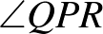 notation
- use the common conventions to indicate right angles and equal angles on diagrams
Recognise the geometrical properties of angles at a point
- use the terms 'complementary' and 'supplementary' for angles adding to 90° and 180°, respectively, and the associated terms 'complement' and 'supplement'
- use the term 'adjacent angles' to describe a pair of angles with a common arm and a common vertex
- identify and name right angles, straight angles, angles of complete revolution and vertically opposite angles embedded in diagrams
- recognise that adjacent angles can form right angles, straight angles and angles of revolution (Communicating, Reasoning)
Identify corresponding, alternate and co-interior angles when two straight lines are crossed by a transversal (ACMMG163)
- identify and name perpendicular lines using the symbol for 'is perpendicular to' (), eg
- use the common conventions to indicate parallel lines on diagrams
- identify and name pairs of parallel lines using the symbol for 'is parallel to' , eg 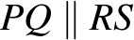
- define and identify 'transversals', including transversals of parallel lines
- identify, name and measure alternate angle pairs, corresponding angle pairs and co-interior angle pairs for two lines cut by a transversal
- use dynamic geometry software to investigate angle relationships formed by parallel lines and a transversal (Problem Solving, Reasoning)
- recognise the equal and supplementary angles formed when a pair of parallel lines is cut by a transversal
Investigate conditions for two lines to be parallel (ACMMG164)
- use angle properties to identify parallel lines
- explain why two lines are either parallel or not parallel, giving a reason (Communicating, Reasoning)
Solve simple numerical problems using reasoning (ACMMG164)
- find the sizes of unknown angles embedded in diagrams using angle relationships, including angles at a point and angles associated with parallel lines, giving reasons
- explain how the size of an unknown angle was calculated (Communicating, Reasoning)
Background Information
Dynamic geometry software and prepared applets are useful tools for investigating angle relationships; angles and lines can be dragged to new positions while angle measurements update automatically.
Students could explore the results relating to angles associated with parallel lines cut by a transversal by starting with corresponding angles and moving one vertex and all four angles to the other vertex by a translation. The other two results then follow, using vertically opposite angles and angles on a straight line. Alternatively, the equality of the alternate angles can be seen by rotation about the midpoint of the transversal.
Students should give reasons when finding the sizes of unknown angles. For some students, formal setting out could be introduced. For example,
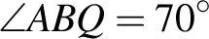 (corresponding angles, ).
In his calculation of the circumference of the Earth, the Greek mathematician, geographer and astronomer Eratosthenes (c276–c194 BC) used parallel line results.
Purpose/Relevance of Substrand
The development of knowledge and understanding of angle relationships, including the associated terminology, notation and conventions, is of fundamental importance in developing an appropriate level of knowledge, skills and understanding in geometry. Angle relationships and their application play an integral role in students learning to analyse geometry problems and developing geometric and deductive reasoning skills, as well as problem-solving skills. Angle relationships are key to the geometry that is important in the work of architects, engineers, designers, builders, physicists, land surveyors, etc, as well as the geometry that is common and important in everyday situations, such as in nature, sports, buildings, astronomy, art, etc.
Language
Students in Stage 4 should write geometrical reasons without the use of abbreviations to assist them in learning new terminology, and in understanding and retaining geometrical concepts, eg 'When a transversal cuts parallel lines, the co-interior angles formed are supplementary'.
Some students may find the use of the terms 'complementary' and 'supplementary' (adjectives) and 'complement' and 'supplement' (nouns) difficult. Teachers should model the use of these terms in sentences, both verbally and in written form, eg, '50° and 40° are complementary angles', 'The complement of 50° is 40°'.
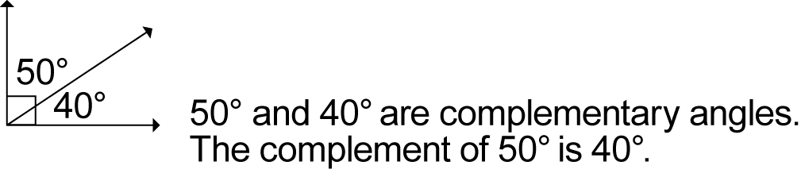
Students should be aware that complementary and supplementary angles may or may not be adjacent.
Stage 4
Statistics and Probability
Data Collection and Representation
Outcomes
A student:
- communicates and connects mathematical ideas using appropriate terminology, diagrams and symbols MA4-1WM
- recognises and explains mathematical relationships using reasoning MA4-3WM
- collects, represents and interprets single sets of data, using appropriate statistical displays MA4-19SP
Related Life Skills outcomes: MALS-35SP, MALS-36SP, MALS-37SP
Content
Students:
Investigate techniques for collecting data, including census, sampling and observation (ACMSP284)
- define 'variable' in the context of statistics as something measurable or observable that is expected to change over time or between individual observations
- recognise variables as categorical or numerical (either discrete or continuous)
- identify examples of categorical variables (eg colour, gender), discrete numerical variables (eg number of students, shoe size) and continuous numerical variables (eg height, weight) (Communicating)
- recognise that data collected on a rating scale (Likert-type scale) is categorical, eg 1 = dislike, 2 = neutral, 3 = like (Communicating)
- recognise and explain the difference between a 'population' and a 'sample' selected from a population when collecting data
- investigate and determine the differences between collecting data by observation, census and sampling
- identify examples of variables for which data could be collected by observation, eg direction travelled by vehicles arriving at an intersection, native animals in a local area (Communicating)
- identify examples of variables for which data could be collected by a census or by a sample, eg a census to collect data about the income of Australians, a sample for TV ratings (Communicating)
- discuss the practicalities of collecting data through a census compared to a sample, including limitations due to population size, eg in countries such as China and India, a census is conducted only once per decade (Communicating, Reasoning)
Explore the practicalities and implications of obtaining data through sampling using a variety of investigative processes (ACMSP206)
- collect data using a random process, eg numbers from a page in a phone book, or from a random number generator
- identify issues that may make it difficult to obtain representative data from either primary or secondary sources
- discuss constraints that may limit the collection of data or result in unreliable data, eg lack of proximity to the location where data could be collected, lack of access to digital technologies, or cultural sensitivities that may influence the results (Communicating, Reasoning)
- investigate and question the selection of data used to support a particular viewpoint, eg the selective use of data in product advertising
Identify and investigate issues involving numerical data collected from primary and secondary sources (ACMSP169)
- identify the difference between data collected from primary and secondary sources, eg data collected in the classroom compared with data drawn from a media source
- explore issues involved in constructing and conducting surveys, such as sample size, bias, type of data required, and ethics
- discuss the effect of different sample sizes (Communicating, Reasoning)
- describe, in practical terms, how a random sample may be selected in order to collect data about a matter of interest (Communicating, Problem Solving)
- detect and discuss bias, if any, in the selection of a sample (Communicating, Reasoning)
- construct appropriate survey questions and a related recording sheet in order to collect both numerical and categorical data about a matter of interest
- construct a recording sheet that allows efficient collection of the different types of data expected (Communicating, Problem Solving)
- refine questions in a survey after trialling the survey (Communicating)
- decide whether a census or a sample is more appropriate to collect the data required to investigate the matter of interest (Problem Solving)
- collect and interpret information from secondary sources, presented as tables and/or graphs, about a matter of interest, eg sporting data, information about the relationship between wealth or education and the health of populations of different countries
- interpret and use scales on graphs, including those where abbreviated measurements are used, eg '50' on a vertical axis representing thousands is interpreted as '50 000' (Reasoning)
- analyse a variety of data displays used in the print or digital media and in other school subject areas, eg share-movement graphs, data displays showing sustainable food production (Problem Solving)
- identify features on graphical displays that may mislead and result in incorrect interpretation, eg displaced zeros, the absence of labelling on one or both axes, potentially misleading units of measurement (Communicating, Reasoning)
- use spreadsheets or statistical software packages to tabulate and graph data
- discuss ethical issues that may arise from collecting and representing data (Reasoning)
Construct and compare a range of data displays, including stem-and-leaf plots and dot plots (ACMSP170)
- use a tally to organise data into a frequency distribution table
- construct and interpret frequency histograms and polygons
- select and use appropriate scales and labels on horizontal and vertical axes (Communicating, Problem Solving, Reasoning)
- recognise why a half-column-width space is necessary between the vertical axis and the first column of a histogram (Reasoning)
- construct dot plots
- explain the importance of aligning data points when constructing dot plots (Communicating, Reasoning)
- construct ordered stem-and-leaf plots, including stem-and-leaf plots with two-digit stems
- explain the importance of ordering and aligning data values when constructing stem-and-leaf plots (Communicating, Reasoning)
- construct divided bar graphs, sector graphs and line graphs, with and without the use of digital technologies
- calculate the length of bar required for each section of divided bar graphs and the angle at the centre required for each sector of sector graphs (Problem Solving)
- interpret a variety of graphs, including dot plots, stem-and-leaf plots, divided bar graphs, sector graphs and line graphs
- calculate the percentage of the whole represented by different categories in a divided bar graph or sector graph (Problem Solving)
- compare the strengths and weaknesses of different forms of data display (Reasoning)
- identify and explain which graph types are suitable for the type of data being considered, eg sector graphs and divided bar graphs are suitable for categorical data, but not for numerical data (Communicating, Reasoning)
- draw conclusions from data displayed in a graph, eg 'The graph shows that the majority of Year 8 students who play a musical instrument play a string instrument' (Communicating, Reasoning)
Background Information
Students in Stage 4 can be expected to have some prior knowledge of both dot plots and line graphs, as these types of graph are introduced in Stage 3. They construct, describe and interpret column graphs in Stage 2 and Stage 3; however, histograms, divided bar graphs and sector graphs (pie charts) are not encountered until Stage 4.
Statistical data is part of everyday life. Data may be displayed in tables or graphs, and may appear in all types of media. Graphs provide a visual overview of the substrand under investigation. Students should be aware that while many graphs are accurate and informative, some can be misleading. They need to experience interpreting a wide variety of graphical representations, including column graphs, dot plots, stem-and-leaf plots, divided bar graphs, sector graphs and line graphs. Students should be able to select an appropriate graph to represent the collected data.
Purpose/Relevance of Substrand
In investigations, it is important to develop knowledge and understanding of the ways in which relevant and sufficient data can be collected, as well as the associated implications and limitations. It is also important to develop knowledge and understanding of what constitute appropriate sources of data, both primary and secondary. Data and statistics are used in many aspects of our everyday and working lives. Data is collected to provide information on many topics of interest and to assist in making decisions regarding important issues (eg projects aimed at improving or developing products or services). Users at all levels need to have skills in the organisation and display of the collected data for its interpretation and analysis. This can be achieved in a wide variety of ways, including through the use of frequency distribution tables and simple data displays/graphs, such as frequency histograms and polygons, dot plots, stem-and-leaf plots, divided bar graphs, sector graphs and line graphs.
Language
In everyday language, the term 'pie chart' is often used in reference to sector graphs.
Stage 4
Statistics and Probability
Single Variable Data Analysis
Outcomes
A student:
- communicates and connects mathematical ideas using appropriate terminology, diagrams and symbols MA4-1WM
- applies appropriate mathematical techniques to solve problems MA4-2WM
- recognises and explains mathematical relationships using reasoning MA4-3WM
- analyses single sets of data using measures of location, and range MA4-20SP
Content
Students:
Calculate mean, median, mode and range for sets of data and interpret these statistics in the context of data (ACMSP171)
- calculate the mean, , of a set of data using 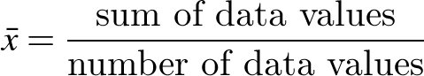
- recognise that the mean is often referred to as the 'average' in everyday language (Communicating)
- use the statistical functions of a calculator to determine the mean for small sets of data (Problem Solving)
- use the statistical functions of a spreadsheet to determine the mean for large sets of data (Problem Solving)
- determine the median, mode and range for sets of data
- recognise which statistical measures are appropriate for the data type, eg the mean, median and range are meaningless for categorical data (Reasoning)
- use the statistical functions of a spreadsheet to determine the median, mode and range for large sets of data (Communicating, Problem Solving)
- identify and describe the mean, median and mode as 'measures of location' or 'measures of centre', and the range as a 'measure of spread'
- describe, in practical terms, the meaning of the mean, median, mode and/or range in the context of the data, eg when referring to the mode of shoe-size data: 'The most popular shoe size is size 7'
Investigate the effect of individual data values, including outliers, on the mean and median (ACMSP207)
- identify any clusters, gaps and outliers in sets of data
- investigate the effect of outliers on the mean, median, mode and range by considering a small set of data and calculating each measure, with and without the inclusion of an outlier
- explain why it is more appropriate to use the median than the mean when the data contains one or more outliers (Communicating, Reasoning)
- determine situations when it is more appropriate to use the median or mode, rather than the mean, when analysing data, eg median for property prices, mode for shoe sizes (Reasoning)
- analyse collected data to identify any obvious errors and justify the inclusion of any individual data values that differ markedly from the rest of the data collected
Describe and interpret data displays using mean, median and range (ACMSP172)
- calculate measures of location (mean, median and mode) and the range for data represented in a variety of statistical displays, including frequency distribution tables, frequency histograms, stem-and-leaf plots and dot plots
- draw conclusions based on the analysis of data displays using the mean, median and/or mode, and range
Explore the variation of means and proportions of random samples drawn from the same population (ACMSP293)
- investigate ways in which different random samples may be drawn from the same population, eg random samples from a census may be chosen by gender, postcode, state, etc
- calculate and compare summary statistics (mean, median, mode and range) of at least three different random samples drawn from the same population
- use a spreadsheet to calculate and compare summary statistics of different random samples drawn from the same population (Communicating, Problem Solving)
- recognise that summary statistics may vary from sample to sample (Communicating)
- recognise that the way in which random samples are chosen may result in significant differences between their respective summary statistics, eg a random sample of girls compared to a random sample of boys from the population, random samples chosen by postcode (Communicating, Reasoning)
- suggest reasons why different random samples drawn from the same population may have different summary statistics (Communicating, Reasoning)
Background Information
Many opportunities occur in this substrand for students to strengthen their skills in:
- collecting, analysing and organising information
- communicating ideas and information
- planning and organising activities
- working with others and in teams
- using mathematical ideas and techniques
- using technology, including spreadsheets.
Purpose/Relevance of Substrand
Single-variable (or 'univariate') data analysis involves the statistical examination of a particular 'variable' (ie a value or characteristic that changes for different individuals, etc) and is of fundamental importance in the statistics used widely in everyday situations and in fields including education, business, economics and government. Most single-variable data analysis methods are used for descriptive purposes. In organising and displaying the data collected, frequencies, tables and a variety of data displays/graphs are used. These data displays/graphs, and numerical summary measures, are used to analyse and describe a data set in relation to a single variable, such as the scores on a test, and to compare a data set to other data sets. Single-variable data analysis is commonly used in the first stages of investigations, research, etc to describe and compare data sets, before being supplemented by more advanced 'bivariate' or 'multivariate' data analysis.
Language
The term 'average', when used in everyday language, generally refers to the mean and describes a 'typical value' within a set of data.
Students need to be provided with opportunities to discuss what information can be drawn from the data presented. They need to think about the meaning of the information and to put it into their own words.
Language to be developed would include superlatives, comparatives, expressions such as 'prefer … over', etc.
Stage 4
Statistics and Probability
Probability 1
Outcomes
A student:
- communicates and connects mathematical ideas using appropriate terminology, diagrams and symbols MA4-1WM
- applies appropriate mathematical techniques to solve problems MA4-2WM
- recognises and explains mathematical relationships using reasoning MA4-3WM
- represents probabilities of simple and compound events MA4-21SP
Related Life Skills outcomes: MALS-38SP, MALS-39SP
Content
Students:
Construct sample spaces for single-step experiments with equally likely outcomes (ACMSP167)
- use the term 'chance experiment' when referring to actions such as tossing a coin, rolling a die, or randomly selecting an object from a bag
- use the term 'outcome' to describe a possible result of a chance experiment and list all of the possible outcomes for a single-step experiment
- use the term 'sample space' to describe a list of all of the possible outcomes for a chance experiment, eg if a standard six-sided die is rolled once, the sample space is {1,2,3,4,5,6}
- distinguish between equally likely outcomes and outcomes that are not equally likely in single-step chance experiments
- describe single-step chance experiments in which the outcomes are equally likely, eg the outcomes for a single toss of a fair coin (Communicating, Reasoning)
- describe single-step chance experiments in which the outcomes are not equally likely, eg the outcomes for a single roll of a die with six faces labelled 1, 2, 3, 4, 4, 4 are not equally likely since the outcome '4' is three times more likely to occur than any other outcome (Communicating, Reasoning)
- design a spinner, given the relationships between the likelihood of each outcome, eg design a spinner with three colours, red, white and blue, so that red is twice as likely to occur as blue, and blue is three times more likely to occur than white (Problem Solving)
Assign probabilities to the outcomes of events and determine probabilities for events (ACMSP168)
- use the term 'event' to describe either one outcome or a collection of outcomes in the sample space of a chance experiment, eg in the experiment of rolling a standard six-sided die once, obtaining the number '1' is an 'event' and obtaining a number divisible by three is also an event
- explain the difference between experiments, events, outcomes and the sample space in chance situations (Communicating)
- assign a probability of 0 to events that are impossible and a probability of 1 to events that are certain to occur
- explain the meaning of the probabilities 0, and 1 in a given chance situation (Communicating)
- assign probabilities to simple events by reasoning about equally likely outcomes, eg the probability of randomly drawing a card of the diamond suit from a standard pack of 52 playing cards is 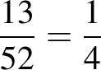
- express the probability of an event, given a finite number of equally likely outcomes in the sample space, as 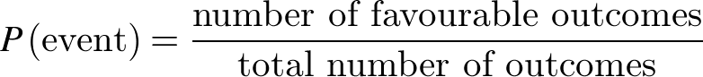
- interpret and use probabilities expressed as fractions, percentages or decimals (Communicating, Reasoning)
- solve probability problems involving single-step experiments using cards, dice, spinners, etc
Identify complementary events and use the sum of probabilities to solve problems (ACMSP204)
- establish that the sum of the probabilities of all of the possible outcomes of a single-step experiment is 1
- identify and describe the complement of an event, eg the complement of the event 'rolling a 6' when rolling a die is 'not rolling a 6'
- establish that the sum of the probability of an event and its complement is 1, ie
- calculate the probability of a complementary event using the fact that the sum of the probabilities of complementary events is 1, eg the probability of 'rolling a 6' when rolling a die is , therefore the probability of the complementary event, 'not rolling a 6', is 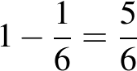
Purpose/Relevance of Substrand
Probability is concerned with the level of certainty that a particular event will occur. The higher the probability of an event, the 'more certain' or 'more likely' it is that the event will occur. Probability is used widely by governments and in many fields, including mathematics, statistics, science, business and economics. In everyday situations, probabilities are key to such areas as risk assessment, finance, and the reliability of products such as cars and electronic goods. It is therefore important across society that probabilities are understood and used appropriately in decision making.
Language
A simple event has outcomes that are equally likely. In a chance experiment, such as rolling a standard six-sided die once, an event might be one of the outcomes or a collection of the outcomes. For example, an event might be that an odd number is rolled, with the favourable outcomes being a '1', a '3' and a '5'.
It is important that students learn the correct terminology associated with probability.
Stage 4
Statistics and Probability
Probability 2
Outcomes
A student:
- communicates and connects mathematical ideas using appropriate terminology, diagrams and symbols MA4-1WM
- applies appropriate mathematical techniques to solve problems MA4-2WM
- recognises and explains mathematical relationships using reasoning MA4-3WM
- represents probabilities of simple and compound events MA4-21SP
Related Life Skills outcomes: MALS-38SP, MALS-39SP
Content
Students:
Describe events using language of 'at least', exclusive 'or' (A or B but not both), inclusive 'or' (A or B or both) and 'and' (ACMSP205)
- recognise the difference between mutually exclusive and non-mutually exclusive events, eg when a die is rolled, 'rolling an odd number' and 'rolling an even number' are mutually exclusive events; however, 'rolling an even number' and 'rolling a 2' are non-mutually exclusive events
- describe compound events using the following terms:
- 'at least', eg rolling a 4, 5 or 6 on a standard six-sided die may be described as rolling 'at least 4'
- 'at most', eg rolling a 1, 2, 3 or 4 on a standard six-sided die may be described as rolling 'at most 4'
- 'not', eg choosing a black card from a standard pack of cards may be described as choosing a card that is 'not red'
- 'and', eg choosing a card that is black and a king means that the card must have both attributes
- pose problems that involve the use of these terms, and solve problems posed by others (Communicating, Problem Solving)
- describe the effect of the use of 'and' and 'or' when using internet search engines (Communicating, Problem Solving)
- classify compound events using inclusive 'or' and exclusive 'or', eg 'choosing a male or a female' is exclusive as one cannot be both, whereas 'choosing a male or someone left-handed' could imply exclusivity or inclusivity
- recognise that the word 'or' on its own often needs a qualifier, such as 'both' or 'not both', to determine inclusivity or exclusivity (Reasoning)
Represent events in two-way tables and Venn diagrams and solve related problems (ACMSP292)
- interpret Venn diagrams involving two or three attributes
- describe regions in Venn diagrams representing mutually exclusive attributes, eg a Venn diagram representing the languages studied by Year 8 students
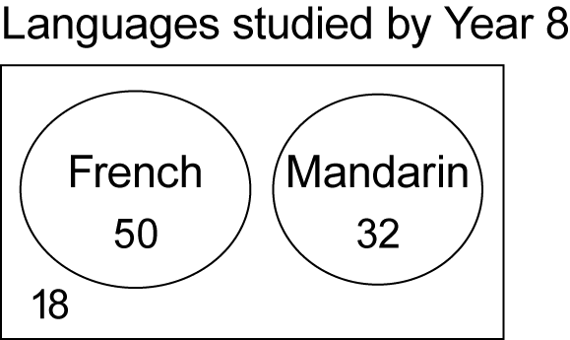
There are 50 students who study French; 32 students who study Mandarin; 18 students who study neither language; and no student who studies both languages (Communicating, Problem Solving, Reasoning)
- describe individual regions or combinations of regions in Venn diagrams representing non-mutually exclusive attributes, using the language 'and', exclusive 'or', inclusive 'or', 'neither' and 'not', eg a Venn diagram representing the sports played by Year 8 students
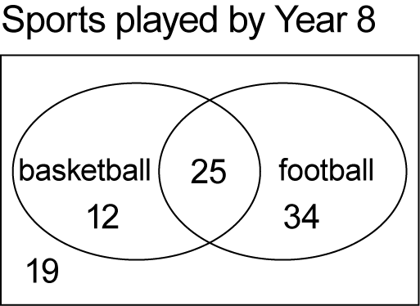
There are 25 students who play both basketball and football; 46 students who play basketball or football, but not both; 19 students who play neither sport; and 71 students who play basketball or football or both (Communicating, Problem Solving, Reasoning)
- construct Venn diagrams to represent all possible combinations of two attributes from given or collected data
- use given data to calculate missing values in a Venn diagram, eg the number of members that have both attributes or the number of members that have neither attribute (Problem Solving, Reasoning)
- interpret given two-way tables representing non-mutually exclusive attributes
- describe relationships displayed in two-way tables using the language 'and', exclusive 'or', inclusive 'or', 'neither' and 'not', eg a table comparing gender and handedness of students in Year 8
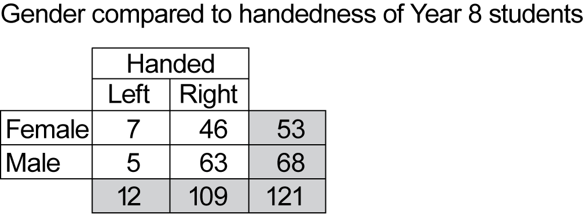
There are 63 male right-handed students, ie 63 students are neither female nor left-handed; there are 114 students who are male or right-handed, or both (Communicating, Problem Solving, Reasoning)
- construct two-way tables to represent the relationships between attributes
- use given data to calculate missing values in a two-way table (Problem Solving)
- convert between representations of the relationships between two attributes in Venn diagrams and two-way tables, eg
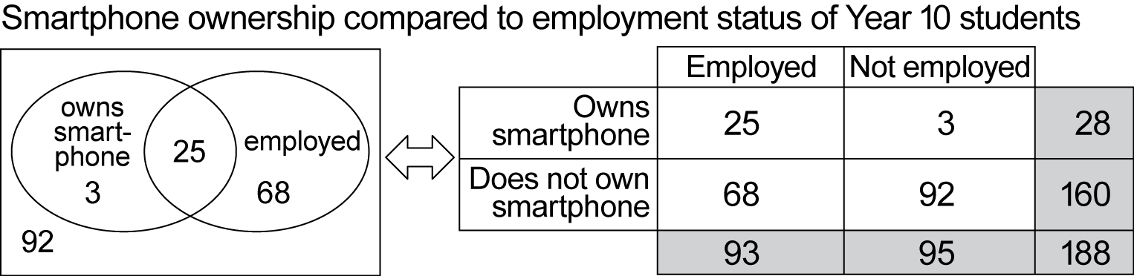
Background Information
John Venn (1834−1923) was a British mathematician best known for his diagrammatic way of representing sets, and their unions and intersections.
Students are expected to be able to interpret Venn diagrams involving three attributes; however, they are not expected to construct Venn diagrams involving three attributes.
Language
A compound event is an event that can be expressed as a combination of simple events, eg drawing a card that is black or a King from a standard set of playing cards, throwing at least 5 on a standard six-sided die.

Stage 5.1
Number and Algebra
Financial Mathematics
Outcomes
A student:
- uses appropriate terminology, diagrams and symbols in mathematical contexts MA5.1-1WM
- selects and uses appropriate strategies to solve problems MA5.1-2WM
- provides reasoning to support conclusions that are appropriate to the context MA5.1-3WM
- solves financial problems involving earning, spending and investing money MA5.1-4NA
Related Life Skills outcomes: MALS-12NA, MALS-13NA, MALS-14NA, MALS-15NA, MALS-16NA, MALS-17NA

Content
Students:
Solve problems involving earning money
- calculate earnings from wages for various time periods, given an hourly rate of pay, including penalty rates for overtime and special rates for Sundays and public holidays
- use classifieds and online advertisements to compare pay rates and conditions for different positions (Problem Solving)
- read and interpret examples of pay slips (Communicating)
- calculate earnings from non-wage sources, including commission and piecework
- calculate weekly, fortnightly, monthly and yearly earnings
- calculate leave loading as 17.5% of normal pay for up to four weeks
- research the reasons for inclusion of leave loading provisions in many awards (Reasoning)
- use published tables or online calculators to determine the weekly, fortnightly or monthly tax to be deducted from a worker's pay under the Australian 'pay-as-you-go' (PAYG) taxation system
- determine annual taxable income by subtracting allowable deductions and use current tax rates to calculate the amount of tax payable for the financial year
- determine a worker's tax refund or liability by comparing the tax payable for a financial year with the tax already paid under the Australian PAYG system (Problem Solving)
- investigate how rebates and levies, including the Medicare levy and Family Tax Benefit, affect different workers' taxable incomes (Problem Solving)
- calculate net earnings after deductions and taxation are taken into account
Solve problems involving simple interest (ACMNA211)
- calculate simple interest using the formula where is the interest, is the principal, is the interest rate per time period (expressed as a fraction or decimal) and is the number of time periods
- apply the simple interest formula to solve problems related to investing money at simple interest rates
- find the total value of a simple interest investment after a given time period (Problem Solving)
- calculate the principal or time needed to earn a particular amount of interest, given the simple interest rate (Problem Solving)
- calculate the cost of buying expensive items by paying an initial deposit and making regular repayments that include simple interest
- investigate fees and charges related to 'buy today, no more to pay until …' promotions (Problem Solving)
- compare the total cost of buying on terms to paying by cash (Problem Solving)
- recognise that repossession does not remove financial debt (Reasoning)
Connect the compound interest formula to repeated applications of simple interest using appropriate digital technologies (ACMNA229)
- calculate compound interest for two or three years using repetition of the formula for simple interest
- connect the calculation of the total value of a compound interest investment to repeated multiplication using a calculator, eg a rate of 5% per annum leads to repeated multiplication by 1.05 (Communicating)
- compare simple interest with compound interest in practical situations, eg to determine the most beneficial investment or loan (Communicating, Reasoning)
- compare simple interest with compound interest on an investment over various time periods using tables, graphs or spreadsheets (Communicating, Reasoning)
Background Information
Pay-as-you-go (PAYG) is the Australian taxation system for withholding taxation from employees in their regular payments from employers. The appropriate level of taxation is withheld from an employee's payment and passed on to the Australian Taxation Office. Deduction amounts will reduce the taxation debt that may be payable following submission of a tax return, or alternatively will be part of the refund given for overpayment.
Simple interest is commonly used for short-term investments or loans. Calculations can involve an annual simple interest rate with a time period given in months or even days.
Internet sites may be used to find commercial interest rates for home loans and to provide 'home loan calculators'.
Language
Students may have difficulty interpreting the language of financial problems. For example, references to 'hourly rate', 'weekly earnings', 'monthly pay', etc need to be interpreted as the amount earned in one hour, one week, one month, etc.
When solving financial problems, students should be encouraged to write a few key words on the left-hand side of the equals sign to identify what is being found in each step of their working, and to conclude with a statement in words.
Stage 5.1
Number and Algebra
Indices
Outcomes
A student:
- uses appropriate terminology, diagrams and symbols in mathematical contexts MA5.1-1WM
- provides reasoning to support conclusions that are appropriate to the context MA5.1-3WM
- operates with algebraic expressions involving positive-integer and zero indices, and establishes the meaning of negative indices for numerical bases MA5.1-5NA
Content
Students:
Extend and apply the index laws to variables, using positive-integer indices and the zero index (ACMNA212)
- use the index laws previously established for numerical bases with positive-integer indices to develop the index laws in algebraic form, eg
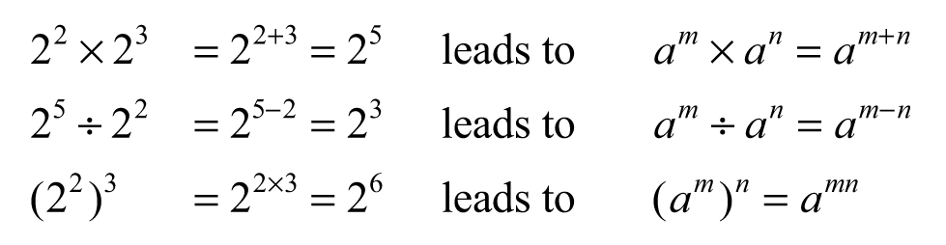
- explain why a particular algebraic sentence is incorrect, eg explain why 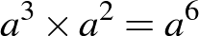 is incorrect (Communicating, Reasoning)
- establish that 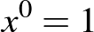 using the index laws, eg
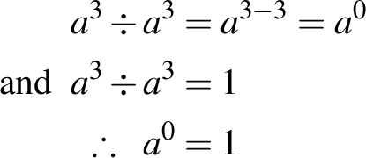
- explain why (Reasoning)
- simplify expressions that involve the zero index, eg 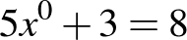
Simplify algebraic products and quotients using index laws (ACMNA231)
- simplify expressions that involve the product and quotient of simple algebraic terms containing positive-integer indices, eg
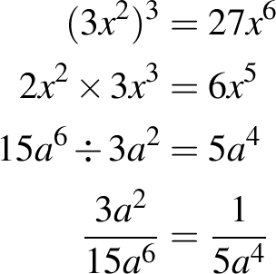
- compare expressions such as 3a² × 5a and 3a² + 5a by substituting values for a (Communicating, Reasoning)
Apply index laws to numerical expressions with integer indices (ACMNA209)
- establish the meaning of negative indices for numerical bases, eg by patterns
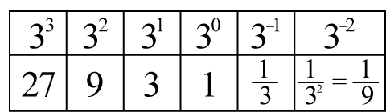
- evaluate numerical expressions involving a negative index by first rewriting with a positive index,
eg 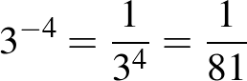
- write given numbers in index form (integer indices only) and vice versa
Stage 5.1
Number and Algebra
Linear Relationships
Outcomes
A student:
- uses appropriate terminology, diagrams and symbols in mathematical contexts MA5.1-1WM
- provides reasoning to support conclusions that are appropriate to the context MA5.1-3WM
- determines the midpoint, gradient and length of an interval, and graphs linear relationships MA5.1-6NA
Related Life Skills outcomes: MALS-32MG, MALS-33MG, MALS-34MG

Content
Students:
Find the midpoint and gradient of a line segment (interval) on the Cartesian plane using a range of strategies, including graphing software (ACMNA294)
- determine the midpoint of an interval using a diagram
- use the process for calculating the 'mean' to find the midpoint, M, of the interval joining two points on the Cartesian plane
- explain how the concept of mean ('average') is used to calculate the midpoint of an interval (Communicating)
- plot and join two points to form an interval on the Cartesian plane and form a right-angled triangle by drawing a vertical side from the higher point and a horizontal side from the lower point
- use the interval between two points on the Cartesian plane as the hypotenuse of a right-angled triangle and use the relationship 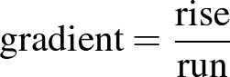 to find the gradient of the interval joining the two points
- describe the meaning of the gradient of an interval joining two points and explain how it can be found (Communicating)
- distinguish between positive and negative gradients from a diagram (Reasoning)
- use graphing software to find the midpoint and gradient of an interval
Find the distance between two points located on the Cartesian plane using a range of strategies, including graphing software (ACMNA214)
- use the interval between two points on the Cartesian plane as the hypotenuse of a right-angled triangle and apply Pythagoras' theorem to determine the length of the interval joining the two points (ie 'the distance between the two points')
- describe how the distance between (or the length of the interval joining) two points can be calculated using Pythagoras' theorem (Communicating)
- use graphing software to find the distance between two points on the Cartesian plane
Sketch linear graphs using the coordinates of two points (ACMNA215)
- construct tables of values and use coordinates to graph vertical and horizontal lines, such as , , 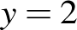, 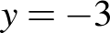
- identify the x- and y-intercepts of lines
- identify the x-axis as the line y = 0 and the y-axis as the line x = 0
- explain why the x- and y-axes have these equations (Communicating, Reasoning)
- graph a variety of linear relationships on the Cartesian plane, with and without the use of digital technologies, eg
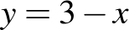, 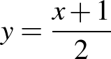, 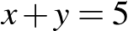, 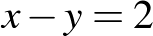, 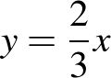
- compare and contrast equations of lines that have a negative gradient and equations of lines that have a positive gradient (Communicating, Reasoning)
- determine whether a point lies on a line by substitution
Solve problems involving parallel lines (ACMNA238)
- determine that parallel lines have equal gradients
- use digital technologies to compare the graphs of a variety of straight lines with their respective gradients and establish the condition for lines to be parallel (Communicating, Reasoning)
- use digital technologies to graph a variety of straight lines, including parallel lines, and identify similarities and differences in their equations (Communicating, Reasoning)
Background Information
The Cartesian plane is named after the French philosopher and mathematician René Descartes (1596–1650), who was one of the first mathematicians to develop analytical geometry on the number plane. He shared this honour with the French lawyer and mathematician Pierre de Fermat (1601–1665). Descartes and Fermat are recognised as the first modern mathematicians.
Stage 5.1
Number and Algebra
Non-Linear Relationships
Outcomes
A student:
- uses appropriate terminology, diagrams and symbols in mathematical contexts MA5.1-1WM
- provides reasoning to support conclusions that are appropriate to the context MA5.1-3WM
- graphs simple non-linear relationships MA5.1-7NA
Content
Students:
Graph simple non-linear relations, with and without the use of digital technologies (ACMNA296)
- complete tables of values to graph simple non-linear relationships and compare these with graphs drawn using digital technologies, eg , 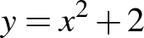, 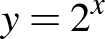
Explore the connection between algebraic and graphical representations of relations such as simple quadratics, circles and exponentials using digital technologies as appropriate (ACMNA239)
- use digital technologies to graph simple quadratics, exponentials and circles, eg
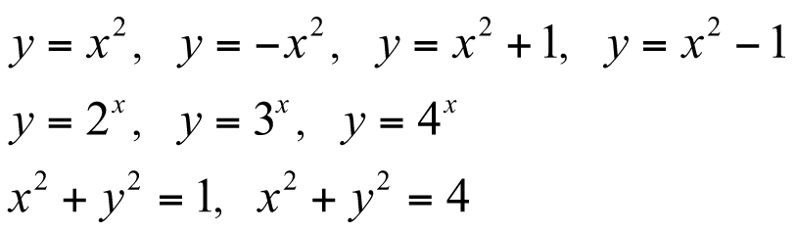
- describe and compare a variety of simple non-linear relationships (Communicating, Reasoning)
- connect the shape of a non-linear graph with the distinguishing features of its equation (Communicating, Reasoning)
Purpose/Relevance of Substrand
Non-linear relationships, like linear relationships, are very common in mathematics and science. A relationship between two quantities that is not a linear relationship (ie is not a relationship that has a graph that is a straight line) is therefore a non-linear relationship, such as where one quantity varies directly or inversely as the square or cube (or other power) of the other quantity, or where one quantity varies exponentially with the other. Examples of non-linear relationships familiar in everyday life include the motion of falling objects and projectiles, the stopping distance of a car travelling at a particular speed, compound interest, depreciation, appreciation and inflation, light intensity, and models of population growth. The graph of a non-linear relationship could be, for example, a parabola, circle, hyperbola, or cubic or exponential graph. 'Coordinate geometry' facilitates exploration and interpretation not only of linear relationships, but also of non-linear relationships.
Stage 5.1
Measurement and Geometry
Area and Surface Area
Outcomes
A student:
- uses appropriate terminology, diagrams and symbols in mathematical contexts MA5.1-1WM
- selects and uses appropriate strategies to solve problems MA5.1-2WM
- calculates the areas of composite shapes, and the surface areas of rectangular and triangular prisms MA5.1-8MG
Related Life Skills outcome: MALS-29MG

Content
Students:
Calculate the areas of composite shapes (ACMMG216)
- calculate the areas of composite figures by dissection into triangles, special quadrilaterals, quadrants, semicircles and sectors
- identify different possible dissections for a given composite figure and select an appropriate dissection to facilitate calculation of the area (Problem Solving)
- solve a variety of practical problems involving the areas of quadrilaterals and composite shapes
- apply properties of geometrical shapes to assist in finding areas, eg symmetry (Problem Solving, Reasoning)
- calculate the area of an annulus (Problem Solving)
Solve problems involving the surface areas of right prisms (ACMMG218)
- identify the edge lengths and the areas making up the 'surface area' of rectangular and triangular prisms
- visualise and name a right prism, given its net
- recognise whether a diagram represents a net of a right prism (Reasoning)
- visualise and sketch the nets of right prisms
- find the surface areas of rectangular and triangular prisms, given their net
- calculate the surface areas of rectangular and triangular prisms
- apply Pythagoras' theorem to assist with finding the surface areas of triangular prisms (Problem Solving)
- solve a variety of practical problems involving the surface areas of rectangular and triangular prisms
Background Information
It is important that students can visualise rectangular and triangular prisms in different orientations before they find their surface areas. Properties of solids are treated in Stage 3. Students should be able to sketch different views of an object.
Language
When calculating the surface areas of solids, many students may benefit from writing words to describe each of the faces as they record their calculations. Using words such as 'top', 'front', 'sides' and 'bottom' should also assist students in ensuring that they include all the faces required.
The abbreviation m² is read as 'square metre(s)' and not 'metre(s) squared' or 'metre(s) square'. The abbreviation cm² is read as 'square centimetre(s)' and not 'centimetre(s) squared' or 'centimetre(s) square'.
When units are not provided in an area question, students should record the area in 'square units'.
Stage 5.1
Measurement and Geometry
Numbers of Any Magnitude
Outcomes
A student:
- uses appropriate terminology, diagrams and symbols in mathematical contexts MA5.1-1WM
- selects and uses appropriate strategies to solve problems MA5.1-2WM
- provides reasoning to support conclusions that are appropriate to the context MA5.1-3WM
- interprets very small and very large units of measurement, uses scientific notation, and rounds to significant figures MA5.1-9MG
Content
Students:
Investigate very small and very large time scales and intervals (ACMMG219)
- use the language of estimation appropriately, including 'rounding', 'approximate' and 'level of accuracy'
- identify significant figures
- round numbers to a specified number of significant figures
- determine the effect that truncating or rounding during calculations has on the accuracy of the results
- interpret the meaning of common prefixes, such as 'milli', 'centi' and 'kilo'
- interpret the meaning of prefixes for very small and very large units of measurement, such as 'nano', 'micro', 'mega', 'giga' and 'tera'
- record measurements of digital information using correct abbreviations, eg kilobytes (kB)
- investigate and recognise that some digital devices may use different notations to record measurements of digital information, eg 40 kB may appear as 40 K or 40 k or 40 KB (Communicating)
- convert between units of measurement of digital information, eg gigabytes to terabytes, megabytes to kilobytes
- use appropriate units of time to measure very small or very large time intervals
- describe the limits of accuracy of measuring instruments (±0.5 unit of measurement)
- explain why measurements are never exact (Communicating, Reasoning)
- recognise the importance of the number of significant figures in a given measurement (Reasoning)
- choose appropriate units of measurement based on the required degree of accuracy (Communicating, Reasoning)
- consider the degree of accuracy needed when making measurements in practical situations or when writing the results of calculations (Problem Solving, Reasoning)
Express numbers in scientific notation (ACMNA210)
- recognise the need for a notation to express very large or very small numbers
- express numbers in scientific notation
- explain the difference between numerical expressions such as 2 × 10⁴ and 2⁴ (Communicating, Reasoning)
- enter and read scientific notation on a calculator
- use index laws to make order of magnitude checks for numbers in scientific notation,
eg
- convert numbers expressed in scientific notation to decimal form
- order numbers expressed in scientific notation
- solve problems involving scientific notation
- communicate and interpret technical information using scientific notation (Communicating)
Background Information
The metric prefixes 'milli', 'centi' and 'deci' for units smaller than the base International System of Units (SI, from the French Système international d'unités) unit derive from the Latin words mille, meaning 'thousand', centum, meaning 'hundred', and decimus, meaning 'tenth'. The metric prefixes 'kilo', 'hecto' and 'deca' for units larger than the base SI unit derive from the Greek words khilioi, meaning 'thousand', hekaton, meaning 'hundred', and deka, meaning 'ten'.
Scientific notation is also known as 'standard notation'.
Purpose/Relevance of Substrand
Measurements always have some degree of uncertainty and are therefore always approximations. Higher-precision instruments can only give better approximations of measurements. In applying knowledge, skills and understanding in measurement, it is necessary to be able to make reasonable estimates for quantities and to have a strong awareness of the levels of accuracy that are appropriate to particular situations. Appropriate approximations are also important for numbers that cannot be expressed exactly in decimal form, eg many fractions, such as and , and all irrational numbers, such as , 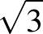, , etc, as well as . The ability to round numbers appropriately is fundamental to the use of approximations in our everyday and working lives. For very large and very small numbers and measurements, it is necessary to be able to write the decimal forms (which generally contain a very high number of zeros as place-holders) in a much more compact form, for practicality and in order to appreciate their relative size, and for much greater facility in associated calculations. 'Scientific notation' is used wherever the writing and use of very large or very small numbers is needed. For example, to write the mass of the Sun in kilograms as a decimal would require a '2' followed by 30 zeros. In scientific notation, this (approximate) measurement is written simply as 2 × 10³⁰ kg. Even writing the equivalent approximation in megatonnes would require a '2' followed by 21 zeros in decimal form, but in scientific notation it is written simply as 2 × 10²¹ Mt. The ability to convert between metric units is very important in order to express very large and very small measurements in appropriate units.
Stage 5.1
Measurement and Geometry
Right-Angled Triangles (Trigonometry)
Outcomes
A student:
- uses appropriate terminology, diagrams and symbols in mathematical contexts MA5.1-1WM
- selects and uses appropriate strategies to solve problems MA5.1-2WM
- provides reasoning to support conclusions that are appropriate to the context MA5.1-3WM
- applies trigonometry, given diagrams, to solve problems, including problems involving angles of elevation and depression MA5.1-10MG
Content
Students:
Use similarity to investigate the constancy of the sine, cosine and tangent ratios for a given angle in right-angled triangles (ACMMG223)
- identify the hypotenuse, adjacent sides and opposite sides with respect to a given angle in a right-angled triangle in any orientation
- label sides of right-angled triangles in different orientations in relation to a given angle (Communicating)
- label the side lengths of a right-angled triangle in relation to a given angle, eg side c is opposite angle C
- define the sine, cosine and tangent ratios for angles in right-angled triangles
- use similar triangles to investigate the constancy of the sine, cosine and tangent ratios for a given angle in right-angled triangles
- use trigonometric notation, eg
- use a calculator to find approximations of the trigonometric ratios for a given angle measured in degrees
- use a calculator to find an angle correct to the nearest degree, given one of the trigonometric ratios for the angle
Apply trigonometry to solve right-angled triangle problems (ACMMG224)
- select and use appropriate trigonometric ratios in right-angled triangles to find unknown sides, including the hypotenuse
- select and use appropriate trigonometric ratios in right-angled triangles to find unknown angles correct to the nearest degree
Solve right-angled triangle problems, including those involving angles of elevation and depression (ACMMG245)
- identify angles of elevation and depression
- interpret diagrams in questions involving angles of elevation and depression (Reasoning)
- connect the alternate angles formed when parallel lines are cut by a transversal with angles of elevation and depression (Reasoning)
- solve a variety of practical problems, including those involving angles of elevation and depression, when given a diagram
Background Information
The definitions of the trigonometric ratios rely on the angle test for similarity, and trigonometry is, in effect, automated calculations with similarity ratios. The content is thus strongly linked with ratio and with scale drawing.
The fact that the other angles and sides of a right-angled triangle are completely determined by giving two other measurements is justified by the four standard congruence tests.
Trigonometry is introduced through similar triangles, with students calculating the ratio of two sides and realising that this remains constant for a given angle.
Purpose/Relevance of Substrand
Trigonometry allows the user to determine unknown sides and angles in both right-angled and non-right-angled triangles, and so solve related two-dimensional and three-dimensional real-world problems. It played a key role in the development of measurement in astronomy and land surveying and, with the trigonometric functions, is very important in parts of pure mathematics and applied mathematics. These are, in turn, very important to many branches of science and technology. Trigonometry or trigonometric functions are used in a broad range of areas, including astronomy, navigation (on ships, on aircraft and in space), the analysis of financial markets, electronics, statistics, biology, medicine, chemistry, meteorology, many physical sciences, architecture, economics, and different branches of engineering.
Language
In Stage 5, students are expected to know and use the sine, cosine and tangent ratios. The reciprocal ratios, cosecant, secant and cotangent, are introduced in selected courses in Stage 6.
Emphasis should be placed on correct pronunciation of 'sin' as 'sine'.
Initially, students should write the ratio of sides for each of the trigonometric ratios in words, eg 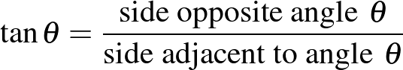. Abbreviations can be used once students are more familiar with the trigonometric ratios.
When expressing fractions in English, the numerator is said first, followed by the denominator. However, in many Asian languages (eg Chinese, Japanese), the opposite is the case: the denominator is said before the numerator. This may lead to students from such language backgrounds mistakenly using the reciprocal of the intended trigonometric ratio.
Students should be explicitly taught the meaning of the phrases 'angle of elevation' and 'angle of depression'. While the meaning of 'angle of elevation' may be obvious to many students, the meaning of 'angle of depression' as the angle through which a person moves (depresses) their eyes from the horizontal line of sight to look downwards at the required point may not be as obvious to some students.
Teachers should explicitly demonstrate how to deconstruct the large descriptive noun groups frequently associated with angles of elevation and depression in word problems, eg 'The angle of depression of a ship 200 metres out to sea from the top of a cliff is 25°'.
Students may find some of the terminology encountered in word problems involving trigonometry difficult to interpret, eg 'base/foot of the mountain', 'directly overhead', 'pitch of a roof', 'inclination of a ladder'. Teachers should provide students with a variety of word problems and they should explain such terms explicitly.
The word 'trigonometry' is derived from two Greek words meaning 'triangle' and 'measurement'.
The word 'cosine' is derived from the Latin words complementi sinus, meaning 'complement of sine', so that .
Stage 5.1
Measurement and Geometry
Properties of Geometrical Figures
Outcomes
A student:
- uses appropriate terminology, diagrams and symbols in mathematical contexts MA5.1-1WM
- selects and uses appropriate strategies to solve problems MA5.1-2WM
- provides reasoning to support conclusions that are appropriate to the context MA5.1-3WM
- describes and applies the properties of similar figures and scale drawings MA5.1-11MG
Related Life Skills outcomes: MALS-32MG, MALS-33MG, MALS-34MG

Content
Students:
Use the enlargement transformation to explain similarity (ACMMG220)
- describe two figures as similar if an enlargement of one is congruent to the other
- recognise that if two figures are similar, they have the same shape but are not necessarily the same size (Reasoning)
- find examples of similar figures embedded in designs from many cultures and historical periods (Reasoning)
- explain why any two equilateral triangles, or any two squares, are similar, and explain when they are congruent (Communicating, Reasoning)
- investigate whether any two rectangles, or any two isosceles triangles, are similar (Problem Solving)
- match the sides and angles of similar figures
- name the vertices in matching order when using the symbol ||| in a similarity statement
- use the enlargement transformation and measurement to determine that the size of matching angles and the ratio of matching sides are preserved in similar figures
- use dynamic geometry software to investigate the properties of similar figures (Problem Solving)
Solve problems using ratio and scale factors in similar figures (ACMMG221)
- choose an appropriate scale in order to enlarge or reduce a diagram
- enlarge diagrams such as cartoons and pictures (Reasoning)
- construct scale drawings
- investigate different methods for producing scale drawings, including the use of digital technologies (Communicating, Problem Solving)
- interpret and use scales in photographs, plans and drawings found in the media and in other key learning areas
- determine the scale factor for pairs of similar polygons and circles
- apply the scale factor to find unknown sides in similar triangles
- calculate unknown sides in a pair of similar triangles using a proportion statement
- apply the scale factor to find unknown lengths in similar figures in a variety of practical situations
- apply the scale factor to find lengths in the environment where it is impractical to measure directly, eg heights of trees, buildings (Problem Solving)
Background Information
The definitions of the trigonometric ratios depend upon the similarity of triangles, eg any two right-angled triangles in which another angle is the same, say 30°, must be similar.
Stage 5.1
Statistics and Probability
Single Variable Data Analysis
Outcomes
A student:
- uses appropriate terminology, diagrams and symbols in mathematical contexts MA5.1-1WM
- selects and uses appropriate strategies to solve problems MA5.1-2WM
- provides reasoning to support conclusions that are appropriate to the context MA5.1-3WM
- uses statistical displays to compare sets of data, and evaluates statistical claims made in the media MA5.1-12SP
Related Life Skills outcomes: MALS-35SP, MALS-36SP, MALS-37SP

Content
Students:
Identify everyday questions and issues involving at least one numerical and at least one categorical variable, and collect data directly from secondary sources (ACMSP228)
- identify and investigate relevant issues involving at least one numerical and at least one categorical variable using information gained from secondary sources, eg the number of hours in a working week for different professions in Australia, the annual rainfall in various parts of Australia compared with that of other countries in the Asia–Pacific region
Construct back-to-back stem-and-leaf plots and histograms and describe data, using terms including 'skewed', 'symmetric' and 'bi-modal' (ACMSP282)
- construct frequency histograms and polygons from a frequency distribution table
- use the terms 'positively skewed', 'negatively skewed', 'symmetric' or 'bi-modal' to describe the shape of distributions of data
- describe the shape of data displayed in stem-and-leaf plots, dot plots and histograms (Communicating)
- suggest possible reasons why the distribution of a set of data may be symmetric, skewed or bi-modal (Reasoning)
- construct back-to-back stem-and-leaf plots to display and compare two like sets of numerical data, eg points scored by two sports teams in each game of the season
- describe differences in the shapes of the distributions of two sets of like data (Communicating)
Compare data displays using mean, median and range to describe and interpret numerical data sets in terms of location (centre) and spread (ACMSP283)
- interpret two sets of numerical data displayed in back-to-back stem-and-leaf plots, parallel dot plots and histograms
- calculate and compare means, medians and ranges of two sets of numerical data displayed in back-to-back stem-and-leaf plots, parallel dot plots and histograms
- make comparisons between two like sets of data by referring to the mean, median and/or range, eg 'The range of the number of goals scored in the various weeks of a competition for Team A is smaller than that for Team B, suggesting that Team A is more consistent from week to week than Team B' (Communicating, Reasoning)
Evaluate statistical reports in the media and other places by linking claims to displays, statistics and representative data (ACMSP253)
- interpret media reports and advertising that quote various statistics, eg media ratings, house prices, sports results, environmental data
- analyse graphical displays to recognise features that may have been manipulated to cause a misleading interpretation and/or support a particular point of view
- explain and evaluate the effect of misleading features on graphical displays (Communicating, Reasoning)
- critically review claims linked to data displays in the media and elsewhere
- suggest reasons why data in a display may be misrepresented in the accompanying text (Communicating, Reasoning)
- consider, informally, the reliability of conclusions from statistical investigations, taking into account issues such as factors that may have masked the results, the accuracy of measurements taken, and whether the results can be generalised to other situations
Background Information
In Stage 5.1, students are only required to recognise the general shape and lack of symmetry in skewed distributions. No specific analysis of the relative positions of mean, median and mode is required.
Stage 5.1
Statistics and Probability
Probability
Outcomes
A student:
- uses appropriate terminology, diagrams and symbols in mathematical contexts MA5.1-1WM
- selects and uses appropriate strategies to solve problems MA5.1-2WM
- provides reasoning to support conclusions that are appropriate to the context MA5.1-3WM
- calculates relative frequencies to estimate probabilities of simple and compound events MA5.1-13SP
Related Life Skills outcomes: MALS-38SP, MALS-39SP

Content
Students:
Calculate relative frequencies from given or collected data to estimate probabilities of events involving 'and' or 'or' (ACMSP226)
- repeat a chance experiment a number of times to determine the relative frequencies of outcomes, eg using random number generators such as dice, coins, spinners or digital simulators
- recognise randomness in chance situations (Reasoning)
- recognise that probability estimates become more stable as the number of trials increases (Reasoning)
- identify theoretical probabilities as being the likelihood of outcomes occurring under ideal circumstances
- explain the relationship between the relative frequency of an event and its theoretical probability (Communicating, Reasoning)
- predict the probability of an event from experimental data using relative frequencies
- apply relative frequency to predict future experimental outcomes (Problem Solving, Reasoning)
- design a device to produce a specified relative frequency, eg a four-coloured circular spinner (Problem Solving)
- calculate probabilities of events, including events involving 'and', 'or' and 'not', from data contained in Venn diagrams representing two or three attributes, eg the Venn diagram below represents the sports played by Year 9 students
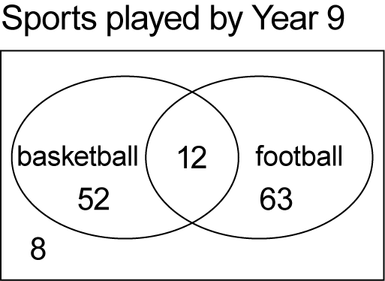
What is the probability that a randomly chosen student plays basketball or football, but not both?
- calculate probabilities of events, including events involving 'and', 'or' and 'not', from data contained in two-way tables, eg the table below represents data collected on Year 10 students comparing gender with handedness
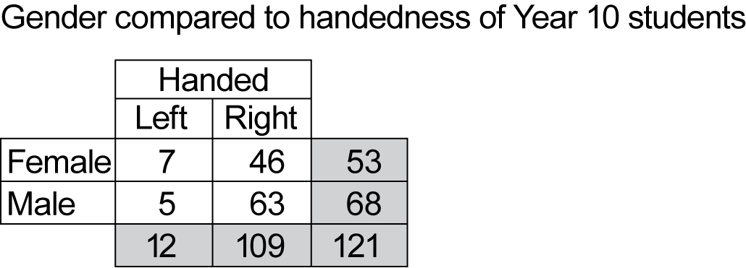
What is the probability that a randomly chosen student is both female and right-handed?
Background Information
Digital technologies could be used for simulation experiments to demonstrate that the relative frequency gets closer and closer to the theoretical probability as the number of trials increases.
Students may not appreciate the significance of a simulation, eg they may not transfer results from a digital simulator for tossing a die to the situation of actually tossing a die a number of times.
Stage 5.2
Number and Algebra
Financial Mathematics ◊
Outcomes
A student:
- selects appropriate notations and conventions to communicate mathematical ideas and solutions MA5.2-1WM
- interprets mathematical or real-life situations, systematically applying appropriate strategies to solve problems MA5.2-2WM
- solves financial problems involving compound interest MA5.2-4NA
Related Life Skills outcomes: MALS-12NA, MALS-13NA, MALS-14NA, MALS-15NA, MALS-16NA, MALS-17NA
Content
Students:
Connect the compound interest formula to repeated applications of simple interest using appropriate digital technologies (ACMNA229)
- establish and use the formula to find compound interest:
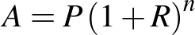 where is the total amount, is the principal, is the interest rate per compounding period as a decimal, and is the number of compounding periods
- calculate and compare investments for different compounding periods, eg calculate and compare the value of an investment of $3000 at an interest rate of 6% per annum after 5 years when the interest is compounded annually, as opposed to the interest being compounded monthly (Problem Solving)
- use a spreadsheet to graph the value of an investment of a particular amount at various compound interest rates over time (Problem Solving)
- solve problems involving compound interest
- calculate the principal or interest rate needed to obtain a particular total amount for a compound interest investment (Problem Solving)
- use a 'guess and refine' strategy to determine the number of time periods required to obtain a particular total amount for a compound interest investment (Problem Solving)
- compare the total amounts obtained for a particular investment when the interest is calculated as compound interest and as simple interest, eg compare the total amount obtained when $10,000 is invested at an interest rate of 6% per annum compounded monthly for 5 years, with the total amount obtained when the interest is calculated as simple interest (Problem Solving)
- use the compound interest formula to calculate depreciation
Background Information
Internet sites may be used to find commercial rates for home loans and to provide 'home-loan calculators'.
Stage 5.2
Number and Algebra
Ratios and Rates
Outcomes
A student:
- selects appropriate notations and conventions to communicate mathematical ideas and solutions MA5.2-1WM
- interprets mathematical or real-life situations, systematically applying appropriate strategies to solve problems MA5.2-2WM
- recognises direct and indirect proportion, and solves problems involving direct proportion MA5.2-5NA
Content
Students:
Solve problems involving direct proportion; explore the relationship between graphs and equations corresponding to simple rate problems (ACMNA208)
- convert between units for rates, eg kilometres per hour to metres per second
- identify and describe everyday examples of direct proportion, eg as the number of hours worked increases, earnings also increase
- identify and describe everyday examples of inverse (indirect) proportion, eg as speed increases, the time taken to travel a particular distance decreases
- recognise direct and inverse proportion from graphs
- distinguish between positive and negative gradients when using a graph (Reasoning)
- interpret and use conversion graphs to convert from one unit to another, eg conversions between different currencies or metric and imperial measures
- use the equation 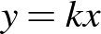 to model direct linear proportion where k is the constant of proportionality
- given the constant of proportionality, establish an equation and use it to find an unknown quantity (Communicating, Problem Solving)
- calculate the constant of proportionality, given appropriate information, and use this to find unknown quantities (Problem Solving)
- use graphing software or a table of values to graph equations representing linear direct proportion
Language
When describing everyday examples involving proportion, teachers should model common words and language structures before independent work is required, eg 'As the speed increases, the time taken to travel a particular distance decreases', 'The greater the speed, the less time is taken to travel a particular distance', 'The time taken to travel a particular distance is reduced when the speed is increased'.
Stage 5.2
Number and Algebra
Algebraic Techniques
Outcomes
A student:
- selects appropriate notations and conventions to communicate mathematical ideas and solutions MA5.2-1WM
- constructs arguments to prove and justify results MA5.2-3WM
- simplifies algebraic fractions, and expands and factorises quadratic expressions MA5.2-6NA
Content
Students:
Apply the four operations to simple algebraic fractions with numerical denominators (ACMNA232)
- simplify expressions that involve algebraic fractions with numerical denominators,
eg 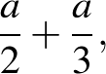 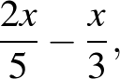 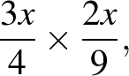 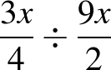
- connect the processes for simplifying expressions involving algebraic fractions with the corresponding processes involving numerical fractions (Communicating, Reasoning)
Apply the four operations to algebraic fractions with pronumerals in the denominator
- simplify algebraic fractions, including those involving indices, eg 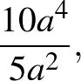 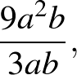 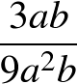
- explain the difference between expressions such as 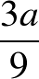 and 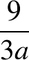 (Communicating)
- simplify expressions that involve algebraic fractions, including algebraic fractions that involve pronumerals in the denominator and/or indices,
eg 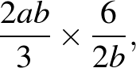 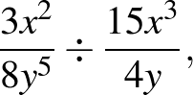 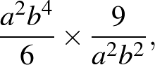 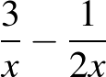
Apply the distributive law to the expansion of algebraic expressions, including binomials, and collect like terms where appropriate (ACMNA213)
- expand algebraic expressions, including those involving terms with indices and/or negative coefficients, eg 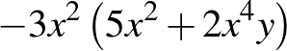
- expand algebraic expressions by removing grouping symbols and collecting like terms where applicable, eg expand and simplify 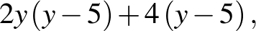 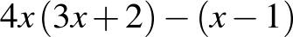
Factorise algebraic expressions by taking out a common algebraic factor (ACMNA230)
- factorise algebraic expressions, including those involving indices, by determining common factors, eg factorise 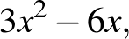 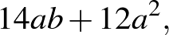 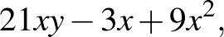 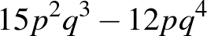
- recognise that expressions such as may represent 'partial factorisation' and that further factorisation is necessary to 'factorise fully' (Reasoning)
Expand binomial products and factorise monic quadratic expressions using a variety of strategies (ACMNA233)
- expand binomial products by finding the areas of rectangles, eg
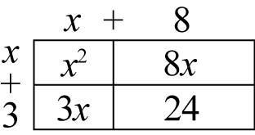
hence,
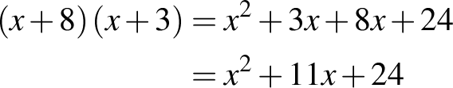
- use algebraic methods to expand binomial products, eg 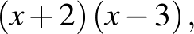 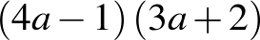
- factorise monic quadratic trinomial expressions, eg 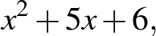 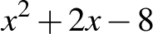
- connect binomial products with the commutative property of arithmetic, such that (Communicating, Reasoning)
- explain why a particular algebraic expansion or factorisation is incorrect, eg 'Why is the factorisation 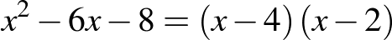 incorrect?' (Communicating, Reasoning)
Stage 5.2
Number and Algebra
Indices
Outcomes
A student:
- selects appropriate notations and conventions to communicate mathematical ideas and solutions MA5.2-1WM
- constructs arguments to prove and justify results MA5.2-3WM
- applies index laws to operate with algebraic expressions involving integer indices MA5.2-7NA
Content
Students:
Apply index laws to algebraic expressions involving integer indices
- use index notation and the index laws to establish that 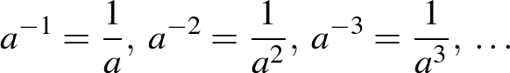
- explain the difference between pairs of algebraic expressions that appear similar,
eg 'Are 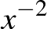 and equivalent expressions? Why or why not?' (Communicating)
- write expressions involving negative indices as expressions involving positive indices, and vice versa
- apply the index laws to simplify algebraic products and quotients involving negative indices,
eg 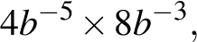 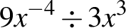
- explain why given statements of equality are true or false and give reasons, eg explain why each of the following is true or false: 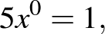 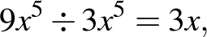 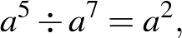 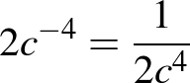 (Communicating, Reasoning)
- verify whether a given expression represents a correct simplification of another algebraic expression by substituting numbers for pronumerals (Communicating, Reasoning)
- write the numerical value of a given numerical fraction raised to the power of –1, leading to 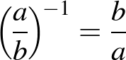 (Communicating, Reasoning)
Stage 5.2
Number and Algebra
Equations
Outcomes
A student:
- selects appropriate notations and conventions to communicate mathematical ideas and solutions MA5.2-1WM
- interprets mathematical or real-life situations, systematically applying appropriate strategies to solve problems MA5.2-2WM
- constructs arguments to prove and justify results MA5.2-3WM
- solves linear and simple quadratic equations, linear inequalities and linear simultaneous equations, using analytical and graphical techniques MA5.2-8NA
Related Life Skills outcome: MALS-19NA
Content
Students:
Solve linear equations (ACMNA215)
- solve linear equations, including equations that involve grouping symbols,
eg 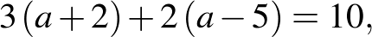 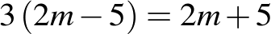
Solve linear equations involving simple algebraic fractions (ACMNA240)
- solve linear equations involving one or more simple algebraic fractions,
eg 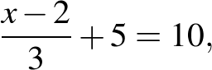 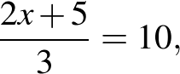 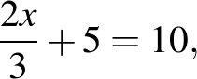 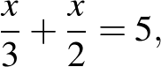 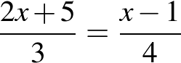
- compare and contrast different algebraic techniques for solving linear equations and justify a choice for a particular case (Communicating, Reasoning)
Solve simple quadratic equations using a range of strategies (ACMNA241)
- solve simple quadratic equations of the form 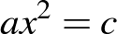, leaving answers in exact form and as decimal approximations
- explain why quadratic equations could be expected to have two solutions (Communicating, Reasoning)
- recognise and explain why does not have a solution if is a negative number (Communicating)
- solve quadratic equations of the form 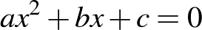, limited to , using factors
- connect algebra with arithmetic to explain that if 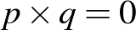, then either 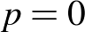 or 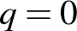 (Communicating, Reasoning)
- check the solution(s) of quadratic equations by substitution (Reasoning)
Substitute values into formulas to determine an unknown (ACMNA234)
- solve equations arising from substitution into formulas, eg given 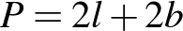 and , , solve for
- substitute into formulas from other strands of the syllabus or from other subjects to solve problems and interpret solutions, eg 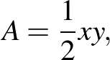 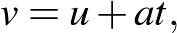 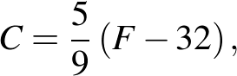 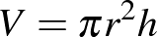 (Problem Solving)
Solve problems involving linear equations, including those derived from formulas (ACMNA235)
- translate word problems into equations, solve the equations and interpret the solutions
- state clearly the meaning of introduced pronumerals when using equations to solve word problems, eg 'n = number of years' (Communicating)
- solve word problems involving familiar formulas, eg 'If the area of a triangle is 30 square centimetres and the base length is 12 centimetres, find the perpendicular height of the triangle' (Problem Solving)
- explain why the solution to a linear equation generated from a word problem may not be a solution to the given problem (Communicating, Reasoning)
Solve linear inequalities and graph their solutions on a number line (ACMNA236)
- represent simple inequalities on the number line, eg represent on a number line
- recognise that an inequality has an infinite number of solutions unless other restrictions are made
- solve linear inequalities, including through reversing the direction of the inequality sign when multiplying or dividing by a negative number, and graph the solutions, eg solve and graph the inequalities on a number line of
- use a numerical example to justify the need to reverse the direction of the inequality sign when multiplying or dividing by a negative number (Reasoning)
- verify the direction of the inequality sign by substituting a value within the solution range (Reasoning)
Solve linear simultaneous equations, using algebraic and graphical techniques, including with the use of digital technologies (ACMNA237)
- solve linear simultaneous equations by finding the point of intersection of their graphs, with and without the use of digital technologies
- solve linear simultaneous equations using appropriate algebraic techniques, including with the use of the 'substitution' and 'elimination' methods, eg solve 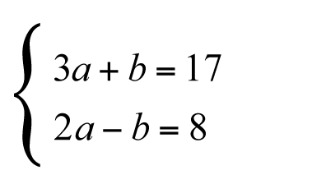
- select an appropriate technique to solve particular linear simultaneous equations by observing the features of the equations (Problem Solving)
- generate and solve linear simultaneous equations from word problems and interpret the results
Background Information
Graphing software and graphics calculators allow students to graph two linear equations and to display the coordinates of the point of intersection of their graphs.
The 'substitution method' for solving linear simultaneous equations involves substituting one equation into the other. This may require the rearranging of one of the equations to make one of its pronumerals the subject, in order to facilitate substitution into the other equation. The 'elimination method' for solving linear simultaneous equations involves adding or subtracting the two equations so that one of the pronumerals is eliminated. This may require the multiplication of one or both of the given equations by a constant so that the pronumeral targeted for elimination has coefficients of equal magnitude. Students should be encouraged to select the most efficient technique when solving linear simultaneous equations.
Stage 5.2
Number and Algebra
Linear Relationships
Outcomes
A student:
- selects appropriate notations and conventions to communicate mathematical ideas and solutions MA5.2-1WM
- constructs arguments to prove and justify results MA5.2-3WM
- uses the gradient-intercept form to interpret and graph linear relationships MA5.2-9NA
Content
Students:
Interpret and graph linear relationships using the gradient-intercept form of the equation of a straight line
- graph straight lines with equations in the form 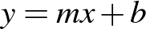 ('gradient-intercept form')
- recognise equations of the form as representing straight lines and interpret the x-coefficient 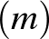 as the gradient, and the constant 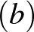 as the y-intercept, of a straight line
- rearrange an equation of a straight line in the form 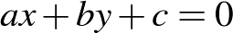 ('general form') to gradient-intercept form to determine the gradient and the y-intercept of the line
- find the equation of a straight line in the form , given the gradient and the y-intercept of the line
- graph equations of the form by using the gradient and the y-intercept, and with the use of digital technologies
- use graphing software to graph a variety of equations of straight lines, and describe the similarities and differences between them, eg
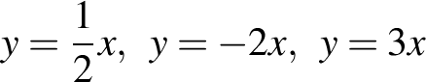
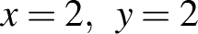
(Communicating)
- explain the effect of changing the gradient or the y-intercept on the graph of a straight line (Communicating, Reasoning)
- find the gradient and the y-intercept of a straight line from its graph and use these to determine the equation of the line
- match equations of straight lines to graphs of straight lines and justify choices (Communicating, Reasoning)
Solve problems involving parallel and perpendicular lines (ACMNA238)
- determine that straight lines are perpendicular if the product of their gradients is –1
- graph a variety of straight lines, including perpendicular lines, using digital technologies and compare their gradients to establish the condition for lines to be perpendicular (Communicating, Reasoning)
- recognise that when two straight lines are perpendicular, the gradient of one line is the negative reciprocal of the gradient of the other line (Reasoning)
- find the equation of a straight line parallel or perpendicular to another given line using
Stage 5.2
Number and Algebra
Non-Linear Relationships ◊
Outcomes
A student:
- selects appropriate notations and conventions to communicate mathematical ideas and solutions MA5.2-1WM
- constructs arguments to prove and justify results MA5.2-3WM
- connects algebraic and graphical representations of simple non-linear relationships MA5.2-10NA
Content
Students:
Graph simple non-linear relationships, with and without the use of digital technologies, and solve simple related equations (ACMNA296)
- graph parabolic relationships of the form 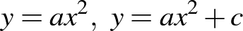, with and without the use of digital technologies
- identify parabolic shapes in the environment (Reasoning)
- describe the effect on the graph of 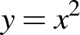 of multiplying 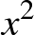 by different numbers (including negative numbers) or of adding different numbers (including negative numbers) to (Communicating, Reasoning)
- determine the equation of a parabola, given a graph of the parabola with the main features clearly indicated (Reasoning)
- determine the x-coordinate of a point on a parabola, given the y-coordinate of the point
- sketch, compare and describe, with and without the use of digital technologies, the key features of simple exponential curves, eg sketch and describe similarities and differences of the graphs of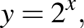 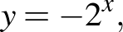 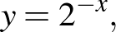 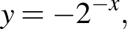 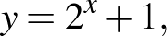 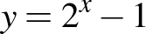
- describe exponentials in terms of what happens to the y-values as the x-values become very large or very small, and the y-value for x = 0 (Communicating, Reasoning)
- use Pythagoras' theorem to establish the equation of a circle with centre the origin and radius of the circle r
- recognise and describe equations that represent circles with centre the origin and radius
- sketch circles of the form 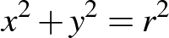 where is the radius of the circle
Explore the connection between algebraic and graphical representations of relationships such as simple quadratics, circles and exponentials using digital technologies as appropriate (ACMNA239)
- identify graphs and equations of straight lines, parabolas, circles and exponentials
- match graphs of straight lines, parabolas, circles and exponentials to the appropriate equations
- sort and classify different types of graphs, match each graph to an equation, and justify each choice (Communicating, Reasoning)
Background Information
Various digital technologies with graphing capabilities facilitate the investigation of the shapes of curves and the effect of multiplying part(s) of the equation by different numbers (including negative numbers), or of adding different numbers (including negative numbers).
This substrand provides opportunities for mathematical modelling. For example, 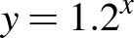 for 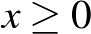 models the growth of a quantity beginning at 1 and increasing 20% for each unit increase in x.
Stage 5.2
Measurement and Geometry
Area and Surface Area
Outcomes
A student:
- selects appropriate notations and conventions to communicate mathematical ideas and solutions MA5.2-1WM
- interprets mathematical or real-life situations, systematically applying appropriate strategies to solve problems MA5.2-2WM
- calculates the surface areas of right prisms, cylinders and related composite solids MA5.2-11MG
Related Life Skills outcome: MALS-29MG

Content
Students:
Calculate the surface areas of cylinders and solve related problems (ACMMG217)
- recognise the curved surface of a cylinder as a rectangle and so calculate the area of the curved surface
- develop and use the formula to find the surface areas of closed right cylinders:
where is the length of the radius and is the perpendicular height
- solve a variety of practical problems involving the surface areas of cylinders, eg find the area of the label on a cylindrical can
- interpret the given conditions of a problem to determine whether a particular cylinder is closed or open (one end only or both ends) (Problem Solving)
Solve problems involving surface area for a range of prisms, cylinders and composite solids (ACMMG242)
- find the surface areas of composite solids involving right prisms and cylinders
- solve a variety of practical problems related to surface areas of prisms, cylinders and related composite solids, eg compare the amount of packaging material needed for different objects
- interpret the given conditions of a problem to determine the number of surfaces required in the calculation (Problem Solving)
Language
Students are expected to be able to determine whether the prisms and cylinders referred to in practical problems are closed or open (one end only or both ends), depending on the context. For example, objects referred to as 'hollow cylinders' or 'pipes' represent cylinders that are open at both ends.
Stage 5.2
Measurement and Geometry
Volume
Outcomes
A student:
- selects appropriate notations and conventions to communicate mathematical ideas and solutions MA5.2-1WM
- interprets mathematical or real-life situations, systematically applying appropriate strategies to solve problems MA5.2-2WM
- applies formulas to calculate the volumes of composite solids composed of right prisms and cylinders MA5.2-12MG
Related Life Skills outcomes: MALS-28MG, MALS-30MG, MALS-31MG

Content
Students:
Solve problems involving the volumes of right prisms (ACMMG218)
- find the volumes of composite right prisms with cross-sections that may be dissected into triangles and special quadrilaterals
- solve a variety of practical problems related to the volumes and capacities of composite right prisms
- compare the surface areas of prisms with the same volume (Problem Solving, Reasoning)
- find the volumes and capacities of various everyday containers, such as water tanks or cartons used by removalists (Problem Solving)
Solve problems involving volume for a range of prisms, cylinders and composite solids (ACMMG242)
- find the volumes of solids that have uniform cross-sections that are sectors, including semicircles and quadrants
- find the volumes of composite solids involving prisms and cylinders, eg a cylinder on top of a rectangular prism
- dissect composite solids into two or more simpler solids to find their volumes (Reasoning)
- solve a variety of practical problems related to the volumes and capacities of prisms, cylinders and related composite solids
Stage 5.2
Measurement and Geometry
Right-Angled Triangles (Trigonometry) ◊
Outcomes
A student:
- selects appropriate notations and conventions to communicate mathematical ideas and solutions MA5.2-1WM
- interprets mathematical or real-life situations, systematically applying appropriate strategies to solve problems MA5.2-2WM
- applies trigonometry to solve problems, including problems involving bearings MA5.2-13MG
Content
Students:
Apply trigonometry to solve right-angled triangle problems (ACMMG224)
- use a calculator to find the values of the trigonometric ratios, given angles measured in degrees and minutes
- use a calculator to find the size in degrees and minutes of an angle, given a trigonometric ratio for the angle
- find the lengths of unknown sides in right-angled triangles where the given angle is measured in degrees and minutes
- find the size in degrees and minutes of unknown angles in right-angled triangles
Solve right-angled triangle problems, including those involving direction and angles of elevation and depression (ACMMG245)
- solve a variety of practical problems involving angles of elevation and depression, including problems for which a diagram is not provided
- draw diagrams to assist in solving practical problems involving angles of elevation and depression (Communicating, Problem Solving)
- interpret three-figure bearings (eg 035°, 225°) and compass bearings (eg SSW)
- interpret directions given as bearings and represent them in diagrammatic form (Communicating, Reasoning)
- solve a variety of practical problems involving bearings, including problems for which a diagram is not provided
- draw diagrams to assist in solving practical problems involving bearings (Communicating, Problem Solving)
- check the reasonableness of solutions to problems involving bearings (Problem Solving)
Background Information
When setting out a solution to a problem that involves finding an unknown side length or angle in a right-angled triangle, students should be advised to give a simplified exact answer, eg 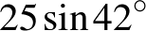 metres or 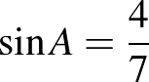, and then to give an approximation correct to a given, or appropriate if not given, level of accuracy.
Students could be given practical experiences in using clinometers for finding angles of elevation and depression and in using magnetic compasses for bearings. They need to recognise the 16 points of a mariner's compass (eg SSW) for comprehension of compass bearings in everyday life, eg weather reports.
Students studying circle geometry will be able to apply their knowledge, skills and understanding in trigonometry to many problems, making use of the right angle between a chord and a radius bisecting the chord, between a tangent and a radius drawn to the point of contact of the tangent, and in a semicircle.
Language
Students need to be able to interpret a variety of phrases involving bearings, such as:
- 'The bearing of Melbourne from Sydney is 230°'
- 'A plane flies to Melbourne on a bearing of 230° from Sydney'
- 'A plane flies from Sydney to Melbourne on a bearing of 230°'
- 'A plane leaves from Sydney and flies on a bearing of 230° to Melbourne'.
Students should be taught explicitly how to identify the location from where a bearing is measured and to draw the centre of the compass rose at this location on a diagram. In each of the examples above, the word 'from' indicates that the bearing has been measured in Sydney and, consequently, in a diagram, the centre of the relevant compass rose is at Sydney.
To help students understand questions that reference a path involving more than one bearing, they may need to be explicitly shown to look for words, such as 'after this', 'then' and 'changes direction', that indicate a change of bearing. A new compass rose needs to be centred on the location of each change in direction.
Stage 5.2
Measurement and Geometry
Properties of Geometrical Figures
Outcomes
A student:
- selects appropriate notations and conventions to communicate mathematical ideas and solutions MA5.2-1WM
- interprets mathematical or real-life situations, systematically applying appropriate strategies to solve problems MA5.2-2WM
- constructs arguments to prove and justify results MA5.2-3WM
- calculates the angle sum of any polygon and uses minimum conditions to prove triangles are congruent or similar MA5.2-14MG
Content
Students:
Formulate proofs involving congruent triangles and angle properties (ACMMG243)
- write formal proofs of the congruence of triangles, preserving matching order of vertices
- apply congruent triangle results to prove properties of isosceles and equilateral triangles:
- if two sides of a triangle are equal in length, then the angles opposite the equal sides are equal
- conversely, if two angles of a triangle are equal, then the sides opposite those angles are equal
- if the three sides of a triangle are equal, then each interior angle is 60°
- use the congruence of triangles to prove properties of the special quadrilaterals, such as:
- the opposite angles of a parallelogram are equal
- the diagonals of a parallelogram bisect each other
- the diagonals of a rectangle are equal
Use the enlargement transformations to explain similarity and to develop the conditions for triangles to be similar (ACMMG220)
- investigate the minimum conditions needed, and establish the four tests, for two triangles to be similar:
- if the three sides of a triangle are proportional to the three sides of another triangle, then the two triangles are similar
- if two sides of a triangle are proportional to two sides of another triangle, and the included angles are equal, then the two triangles are similar
- if two angles of a triangle are equal to two angles of another triangle, then the two triangles are similar
- if the hypotenuse and a second side of a right-angled triangle are proportional to the hypotenuse and a second side of another right-angled triangle, then the two triangles are similar
- explain why the remaining (third) angles must also be equal if two angles of a triangle are equal to two angles of another triangle (Communicating, Reasoning)
- determine whether two triangles are similar using an appropriate test
Apply logical reasoning, including the use of congruence and similarity, to proofs and numerical exercises involving plane shapes (ACMMG244)
- apply geometrical facts, properties and relationships to find the sizes of unknown sides and angles of plane shapes in diagrams, providing appropriate reasons
- recognise that more than one method of solution is possible (Reasoning)
- compare different solutions for the same problem to determine the most efficient method (Communicating, Reasoning)
- apply the properties of congruent and similar triangles, justifying the results (Communicating, Reasoning)
- apply simple deductive reasoning to prove results for plane shapes
- define the exterior angle of a convex polygon
- establish that the sum of the exterior angles of any convex polygon is 360º
- use dynamic geometry software to investigate the constancy of the exterior angle sum of polygons for different polygons (Reasoning)
- apply the result for the interior angle sum of a triangle to find, by dissection, the interior angle sum of polygons with more than three sides
- use dynamic geometry software to investigate the interior angle sum of different polygons (Reasoning)
- express in algebraic terms the interior angle sum of a polygon with n sides, eg (Communicating)
- apply interior and exterior angle sum results for polygons to find the sizes of unknown angles
Background Information
Students are expected to give reasons when proving properties of plane shapes using congruent triangle results.
Dynamic geometry software and prepared applets are useful tools for investigating the interior and exterior angle sums of polygons, allowing students a visual representation of a result.
The concept of the exterior angle sum of a convex polygon may be interpreted as the amount of turning required when completing a circuit of the boundary.
Comparing the perimeters of inscribed and circumscribed polygons leads to an approximation for the circumference of a circle. This is the method that the Greek mathematician and scientist Archimedes (c287–c212 BC) used to develop an approximation for the ratio of the circumference to the diameter of a circle, ie .
Language
The term 'equiangular' is often used to describe a pair of similar figures (which includes congruent figures), as the angles of one figure are equal to the matching angles of the other figure.
The term 'angle sum' is generally accepted to refer to the interior angle sum of a polygon. When calculating the exterior angle sum of a polygon, students need to refer explicitly to the 'exterior angle sum'.
Stage 5.2
Statistics and Probability
Single Variable Data Analysis ◊
Outcomes
A student:
- selects appropriate notations and conventions to communicate mathematical ideas and solutions MA5.2-1WM
- constructs arguments to prove and justify results MA5.2-3WM
- uses quartiles and box plots to compare sets of data, and evaluates sources of data MA5.2-15SP
Related Life Skills outcomes: MALS-35SP, MALS-36SP, MALS-37SP

Content
Students:
Determine quartiles and interquartile range (ACMSP248)
- determine the upper and lower extremes, median, and upper and lower quartiles for sets of numerical data, ie a 'five-number summary'
- describe the proportion of data values contained between various quartiles, eg 75% of data values lie between the lower quartile and the upper extreme (Communicating, Reasoning)
- determine the interquartile range for sets of data
- recognise that the interquartile range is a measure of spread of the middle 50% of the data (Reasoning)
- compare the relative merits of the range and the interquartile range as measures of spread
- explain whether the range or the interquartile range is a better measure of spread for particular sets of data (Communicating, Reasoning)
Construct and interpret box plots and use them to compare data sets (ACMSP249)
- construct a box plot using the median, the upper and lower quartiles, and the upper and lower extremes of a set of data
- compare two or more sets of data using parallel box plots drawn on the same scale
- describe similarities and differences between two sets of data displayed in parallel box plots, eg describe differences in spread using interquartile range, and suggest reasons for such differences (Communicating, Reasoning)
Compare shapes of box plots to corresponding histograms and dot plots (ACMSP250)
- determine quartiles from data displayed in histograms and dot plots, and use these to draw a box plot to represent the same set of data
- compare the relative merits of a box plot with its corresponding histogram or dot plot (Reasoning)
- identify skewed and symmetrical sets of data displayed in histograms and dot plots, and describe the shape/features of the corresponding box plot for such sets of data
Investigate reports of surveys in digital media and elsewhere for information on how data was obtained to estimate population means and medians (ACMSP227)
- investigate survey data reported in the digital media and elsewhere to critically evaluate the reliability/validity of the source of the data and the usefulness of the data
- describe bias that may exist due to the way in which the data was obtained, eg who instigated and/or funded the research, the types of survey questions asked, the sampling method used (Reasoning)
- make predictions from a sample that may apply to the whole population
- consider the size of the sample when making predictions about the population (Reasoning)
Background Information
Graphics calculators and other statistical software will display box plots for entered data, but students should be aware that results may not always be the same. This is because the technologies use varying methods for creating the plots, eg some software packages use the mean and standard deviation by default to create a box plot. This syllabus requires students to create box plots using the upper and lower extremes, the median, and the upper and lower quartiles of sets of data.
Stage 5.2
Statistics and Probability
Bivariate Data Analysis
Outcomes
A student:
- selects appropriate notations and conventions to communicate mathematical ideas and solutions MA5.2-1WM
- constructs arguments to prove and justify results MA5.2-3WM
- investigates relationships between two statistical variables, including their relationship over time MA5.2-16SP
Related Life Skills outcomes: MALS-38SP, MALS-39SP

Content
Students:
Investigate and describe bivariate numerical data where the independent variable is time (ACMSP252)
- recognise the difference between an independent variable and its dependent variable
- distinguish bivariate data from single variable (univariate) data
- describe the difference between bivariate data and single variable data using an appropriate example, eg bivariate data compares two variables, such as arm span and height, while single variable data examines only one variable, such as arm span (Communicating)
- investigate a matter of interest, representing the dependent numerical variable against the independent variable, time, in an appropriate graphical form
- determine and explain why line graphs are the most appropriate method of representing data collected over time (Reasoning)
- describe changes in the dependent variable over time, eg describe changes in carbon pollution over time (Communicating)
- suggest reasons for changes in the dependent variable over time with reference to relevant world or national events, eg describe the change in population of Australia over time with respect to historical events (Reasoning)
- interpret data displays representing two or more dependent numerical variables against time, eg compare the daily food intake of different countries over time
Use scatter plots to investigate and comment on relationships between two numerical variables (ACMSP251)
- investigate a matter of interest involving two numerical variables and construct a scatter plot, with or without the use of digital technologies, to determine and comment on the relationship between them, eg height versus arm span, reaction time versus hours of sleep
- describe, informally, the strength and direction of the relationship between two variables displayed in a scatter plot, eg strong positive relationship, weak negative relationship, no association
- make predictions from a given scatter plot or other graph
Purpose/Relevance of Substrand
Bivariate data analysis involves the analysis of two 'variables' simultaneously. It is important in the statistics used widely in everyday situations and in fields including education, business, economics, government, etc. While most single-variable data analysis methods are used for descriptive purposes, bivariate data analysis explores relationships between variables, including through the use of scatter plots and lines of best fit, and is generally used for explanatory purposes. A researcher investigating the proportion of eligible voters who actually vote in an election might consider a single variable, such as age. If wanting to use a bivariate approach, the researcher might compare age and gender, or age and income, or age and education, etc.
Stage 5.2
Statistics and Probability
Probability
Outcomes
A student:
- selects appropriate notations and conventions to communicate mathematical ideas and solutions MA5.2-1WM
- interprets mathematical or real-life situations, systematically applying appropriate strategies to solve problems MA5.2-2WM
- constructs arguments to prove and justify results MA5.2-3WM
- describes and calculates probabilities in multi-step chance experiments MA5.2-17SP
Related Life Skills outcomes: MALS-38SP, MALS-39SP

Content
Students:
List all outcomes for two-step chance experiments, with and without replacement, using tree diagrams or arrays; assign probabilities to outcomes and determine probabilities for events (ACMSP225)
- sample, with and without replacement, in two-step chance experiments, eg draw two counters from a bag containing three blue, four red and one white counter
- compare results between an experiment undertaken with replacement and then without replacement (Reasoning)
- record outcomes of two-step chance experiments, with and without replacement, using organised lists, tables and tree diagrams
- calculate probabilities of simple and compound events in two-step chance experiments, with and without replacement
- explain the effect of knowing the result of the first step on the probability of events in two-step chance experiments, with and without replacement (Communicating, Reasoning)
Describe the results of two- and three-step chance experiments, with and without replacement, assign probabilities to outcomes, and determine probabilities of events; investigate the concept of independence (ACMSP246)
- distinguish informally between dependent and independent events
- explain the difference between dependent and independent events using appropriate examples (Communicating, Reasoning)
- recognise that for independent events
- sample, with and without replacement, in three-step chance experiments, eg draw three counters from a bag containing three blue, four red and one white counter
- record outcomes of three-step chance experiments, with and without replacement, using organised lists, tables and tree diagrams
- calculate probabilities of simple and compound events in three-step chance experiments, with and without replacement
- use knowledge of complementary events to assist in calculating probabilities of events in multi-step chance experiments (Problem Solving)
- evaluate the likelihood of winning a prize in lotteries and other competitions (Problem Solving, Reasoning)
Use the language of 'if ... then', 'given', 'of', 'knowing that' to investigate conditional statements and to identify common mistakes in interpreting such language (ACMSP247)
- calculate probabilities of events where a condition is given that restricts the sample space, eg given that a number less than 5 has been rolled on a fair six-sided die, calculate the probability that this number was a 3
- describe the effect of a given condition on the sample space, eg in the above example, the sample space is reduced to {1,2,3,4} (Communicating, Problem Solving, Reasoning)
- critically evaluate conditional statements used in descriptions of chance situations
- describe the validity of conditional statements used in descriptions of chance situations with reference to dependent and independent events, eg explain why if you toss a coin and obtain a head, then the probability of obtaining a head on the next toss remains the same (Communicating, Reasoning)
- identify and explain common misconceptions related to chance experiments, eg explain why the statement 'If you obtain a tail on each of four consecutive tosses of a coin, then there is a greater chance of obtaining a head on the next toss' is incorrect (Reasoning)
Background Information
Meteorologists use probability to predict the weather and to communicate their predictions, eg 'There is a 50% chance of rain tomorrow'. Insurance companies use probability to determine premiums, eg the chance of particular age groups having accidents.
The mathematical analysis of probability was prompted by the French writer and gambler Antoine Gombaud, the Chevalier de Méré (1607–1684). Over the years, the Chevalier had consistently won money betting on obtaining at least one 6 in four rolls of a fair six-sided die. He felt that he should also win betting on obtaining at least one double 6 in 24 rolls of two fair six-sided dice, but in fact regularly lost.
In 1654 he asked his friend Blaise Pascal (1623–1662), the French mathematician and philosopher, to explain why he regularly lost in the second situation. This question led to the famous correspondence between Pascal and the renowned French lawyer and mathematician Pierre de Fermat (1601–1665). Chevalier's losses are explained by the fact that the chance of obtaining at least one 6 in four rolls of a die is 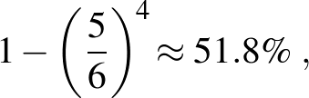 while the chance of obtaining at least one double 6 in 24 rolls of two dice is 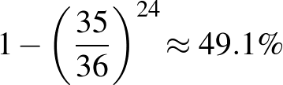.
Language
In a chance experiment, such as rolling a fair six-sided die twice, an event is a collection of outcomes. For instance, an event in this situation might be that the result is 'a sum of 7' or 'a sum of 10 or more'.
Stage 5.3
Number and Algebra
Ratios and Rates
Outcomes
A student:
- uses and interprets formal definitions and generalisations when explaining solutions and/or conjectures MA5.3-1WM
- generalises mathematical ideas and techniques to analyse and solve problems efficiently MA5.3-2WM
- uses deductive reasoning in presenting arguments and formal proofs MA5.3-3WM
- draws, interprets and analyses graphs of physical phenomena MA5.3-4NA
Content
Students:
Solve problems involving direct proportion; explore the relationship between graphs and equations corresponding to simple rate problems (ACMNA208)
- interpret distance/time graphs when the speed is variable
- match distance/time graphs to situations, and explore whether they are accurate, appropriate and possible (Problem Solving, Reasoning)
- match distance/time graphs to appropriate descriptions and give reasons for choices (Communicating, Reasoning)
- record the distance of a moving object from a fixed point at equal time intervals and draw a graph to represent the situation, eg move along a measuring tape for 30 seconds through different activities that include variable speeds, such as running fast, walking slowly, and walking slowly then speeding up (Communicating, Problem Solving)
- analyse the relationship between variables as they change over time, eg draw graphs to represent the relationship between the depth of water in containers of different shapes when they are filled at a constant rate
- interpret graphs, making sensible statements about the rate of increase or decrease, the initial and final points, constant relationships as represented by straight lines, variable relationships as represented by curved lines, etc
- decide whether a particular graph is a suitable representation of a given physical phenomenon (Reasoning)
- describe qualitatively the rate of change of a graph using terms such as 'increasing at a decreasing rate' 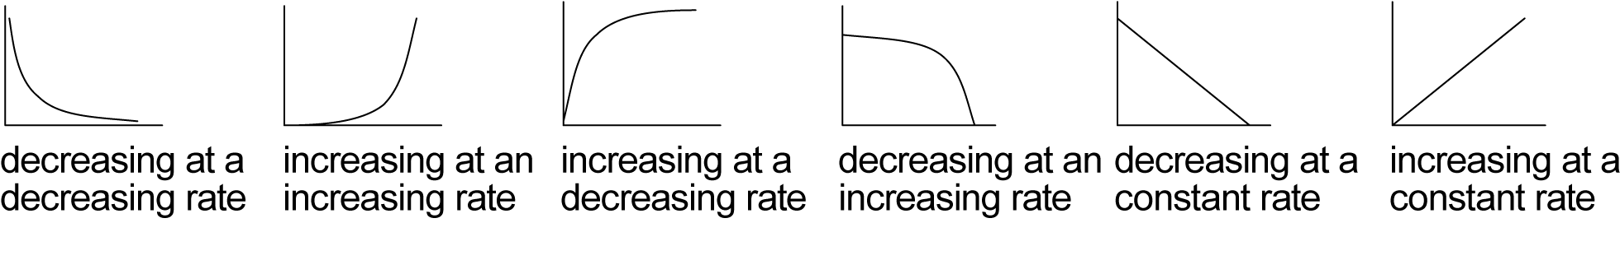
- sketch a graph from a simple description, given a variable rate of change
Background Information
Rate of change is considered as it occurs in practical situations, including population growth and travel. Simple linear models have a constant rate of change. In other situations, the rate of change is variable.
This work is intended to provide students with experiences that will give them an intuitive understanding of rates of change and will assist the development of appropriate vocabulary. No quantitative analysis is needed in Stage 5.3.
Language
When describing graphs of rates of change, teachers should model the various words and language structures before independent work is required, eg 'The population is increasing at a decreasing rate'.
Stage 5.3
Number and Algebra
Algebraic Techniques §
Outcomes
A student:
- uses and interprets formal definitions and generalisations when explaining solutions and/or conjectures MA5.3-1WM
- selects and applies appropriate algebraic techniques to operate with algebraic expressions MA5.3-5NA
Content
Students:
Add and subtract algebraic fractions with numerical denominators, including those with binomial numerators
- add and subtract algebraic fractions, including those with binomial numerators,
eg 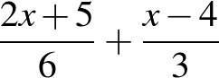, 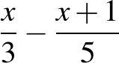
Expand binomial products using a variety of strategies (ACMNA233)
- recognise and apply the special product, 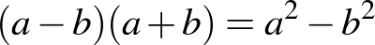
- recognise and name appropriate expressions as the 'difference of two squares' (Communicating)
- recognise and apply the special products, 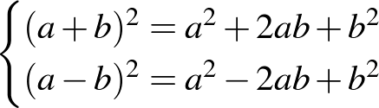
- recognise and name appropriate expressions as 'perfect squares' (Communicating)
- use algebraic methods to expand a variety of binomial products, including the special products, eg 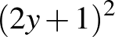, 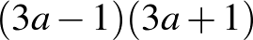
- simplify a variety of expressions involving binomial products, eg 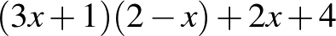, 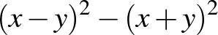
Factorise monic and non-monic quadratic expressions (ACMNA269)
- factorise algebraic expressions, including those involving:
- common factors
- a difference of two squares
- grouping in pairs for four-term expressions
- perfect squares
- quadratic trinomials (monic and non-monic)
- use a variety of strategies to factorise algebraic expressions,
eg 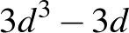, 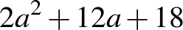, 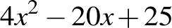, 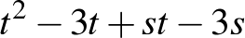, 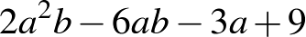
- factorise and simplify complex algebraic expressions involving algebraic fractions,
eg 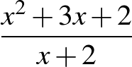, 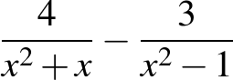, 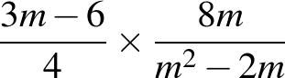, 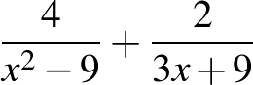
Language
When factorising (or expanding) algebraic expressions, students should be encouraged to describe the given expression (or expansion) using the appropriate terminology (eg 'difference of two squares', 'monic quadratic trinomial') to assist them in learning the concepts and identifying the appropriate process.
Stage 5.3
Number and Algebra
Surds and Indices §
Outcomes
A student:
- uses and interprets formal definitions and generalisations when explaining solutions and/or conjectures MA5.3-1WM
- generalises mathematical ideas and techniques to analyse and solve problems efficiently MA5.3-2WM
- uses deductive reasoning in presenting arguments and formal proofs MA5.3-3WM
- performs operations with surds and indices MA5.3-6NA
Content
Students:
Define rational and irrational numbers and perform operations with surds and fractional indices (ACMNA264)
- define real numbers: a real number is any number that can be represented by a point on the number line
- define rational and irrational numbers: a rational number is any number that can be written as the ratio of two integers a and b where ; an irrational number is a real number that is not rational
- recognise that all rational and irrational numbers are real (Reasoning)
- explain why all integers, terminating decimals and recurring decimals are rational numbers (Communicating, Reasoning)
- explain why rational numbers can be expressed in decimal form (Communicating, Reasoning)
- use a pair of compasses and a straight edge to construct simple rational numbers and surds on the number line (Problem Solving)
- distinguish between rational and irrational numbers
- demonstrate that not all real numbers are rational (Problem Solving)
- use the term 'surd' to refer to irrational expressions of the form 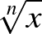 where is a rational number and is an integer such that 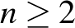
- write recurring decimals in fraction form using calculator and non-calculator methods,
eg 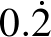, 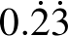, 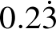
- justify why 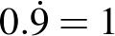 (Communicating, Reasoning)
- demonstrate that 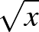 is undefined for x < 0 and that 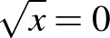 for x = 0
- define as the positive square root of x for x > 0
- use the following results for x > 0 and y > 0:
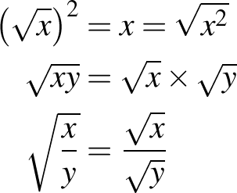
- apply the four operations of addition, subtraction, multiplication and division to simplify expressions involving surds
- explain why a particular sentence is incorrect, eg explain why 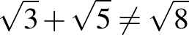 (Communicating, Reasoning)
- expand expressions involving surds, eg expand 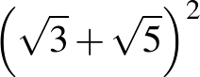, 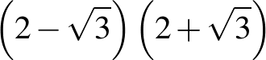
- connect operations with surds to algebraic techniques (Communicating)
- rationalise the denominators of surds of the form 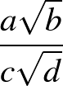
- investigate methods of rationalising surdic expressions with binomial denominators, making appropriate connections to algebraic techniques (Problem Solving)
- recognise that a surd is an exact value that can be approximated by a rounded decimal
- use surds to solve problems where a decimal answer is insufficient, eg find the exact perpendicular height of an equilateral triangle (Problem Solving)
- establish that
- apply index laws to demonstrate the appropriateness of the definition of the fractional index representing the square root, eg
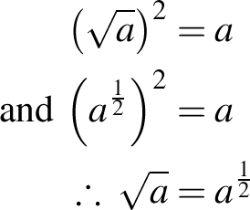
- explain why finding the square root of an expression is the same as raising the expression to the power of a half (Communicating, Reasoning)
- apply index laws to demonstrate the appropriateness of the following definitions for fractional indices: 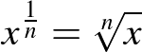, 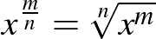
- translate expressions in surd form to expressions in index form and vice versa
- use the 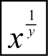 or equivalent key on a scientific calculator
- evaluate numerical expressions involving fractional indices, eg 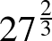
Background Information
Operations with surds are applied when simplifying algebraic expressions.
Having expanded binomial products and rationalised denominators of surds of the form , students could rationalise the denominators of surds with binomial denominators.
Early Greek mathematicians believed that the length of any line could always be given by a rational number. This was proved to be false when the Greek philosopher and mathematician Pythagoras (c580–c500 BC) and his followers found that the length of the hypotenuse of an isosceles right-angled triangle with side length one unit could not be given by a rational number.
Some students may enjoy a demonstration of the proof by contradiction that is irrational.
Language
There is a need to emphasise to students how to read and articulate surds and fractional indices, eg is 'the square root of x' or 'root x'.
Stage 5.3
Number and Algebra
Equations §
Outcomes
A student:
- uses and interprets formal definitions and generalisations when explaining solutions and/or conjectures MA5.3-1WM
- generalises mathematical ideas and techniques to analyse and solve problems efficiently MA5.3-2WM
- uses deductive reasoning in presenting arguments and formal proofs MA5.3-3WM
- solves complex linear, quadratic, simple cubic and simultaneous equations, and rearranges literal equations MA5.3-7NA
Content
Students:
Solve complex linear equations involving algebraic fractions
- solve a range of linear equations, including equations that involve two or more fractions,
eg 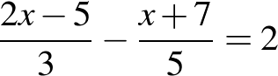, 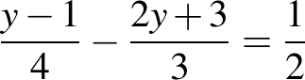
Solve a wide range of quadratic equations derived from a variety of contexts (ACMNA269)
- solve equations of the form by factorisation and by 'completing the square'
- use the quadratic formula 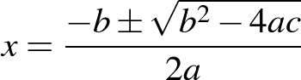 to solve quadratic equations
- solve a variety of quadratic equations, eg 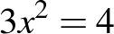, 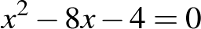, 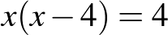, 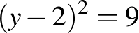
- choose the most appropriate method to solve a particular quadratic equation (Problem Solving)
- check the solutions of quadratic equations by substituting
- identify whether a given quadratic equation has real solutions, and if there are real solutions, whether they are or are not equal
- predict the number of distinct real solutions for a particular quadratic equation (Communicating, Reasoning)
- connect the value of 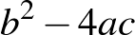 to the number of distinct solutions of and explain the significance of this connection (Communicating, Reasoning)
- solve quadratic equations resulting from substitution into formulas
- create quadratic equations to solve a variety of problems and check solutions
- explain why one of the solutions to a quadratic equation generated from a word problem may not be a possible solution to the problem (Communicating, Reasoning)
- substitute a pronumeral to simplify higher-order equations so that they can be seen to belong to general categories and then solve the equations, eg substitute for to solve 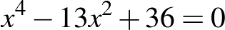 for
Solve simple cubic equations
- determine that for any value of there is a unique value of that solves a simple cubic equation of the form 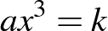 where 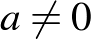
- explain why cubic equations of the form where have a unique solution (Communicating, Reasoning)
- solve simple cubic equations of the form , leaving answers in exact form and as decimal approximations
Rearrange literal equations
- change the subject of formulas, including examples from other strands and other learning areas,
eg make a the subject of 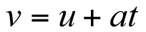, make r the subject of 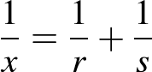, make b the subject of 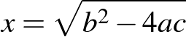
- determine restrictions on the values of variables implicit in the original formula and after rearrangement of the formula, eg consider what restrictions there would be on the variables in the equation 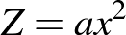 and what additional restrictions are assumed if the equation is rearranged to 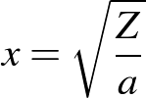 (Communicating, Reasoning)
Solve simultaneous equations, where one equation is non-linear, using algebraic and graphical techniques, including the use of digital technologies
- use analytical methods to solve a variety of simultaneous equations, where one equation is non-linear,
eg 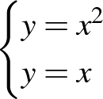, 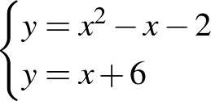, 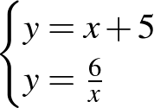
- choose an appropriate method to solve a pair of simultaneous equations (Problem Solving, Reasoning)
- solve pairs of simultaneous equations, where one equation is non-linear, by finding the point of intersection of their graphs using digital technologies
- determine and explain that some pairs of simultaneous equations, where one equation is non-linear, may have no real solutions (Communicating, Reasoning)
Background Information
The derivation of the quadratic formula can be demonstrated for more capable students.
Language
In Stage 6, the term 'discriminant' is introduced for the expression . It is not expected that students in Stage 5 will use this term; however, teachers may choose to introduce the term at this stage if appropriate.
Stage 5.3
Number and Algebra
Linear Relationships §
Outcomes
A student:
- uses and interprets formal definitions and generalisations when explaining solutions and/or conjectures MA5.3-1WM
- generalises mathematical ideas and techniques to analyse and solve problems efficiently MA5.3-2WM
- uses deductive reasoning in presenting arguments and formal proofs MA5.3-3WM
- uses formulas to find midpoint, gradient and distance on the Cartesian plane, and applies standard forms of the equation of a straight line MA5.3-8NA
Content
Students:
Find the midpoint and gradient of a line segment (interval) on the Cartesian plane (ACMNA294)
- use the concept of an average to establish the formula for the midpoint, M, of the interval joining two points 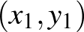 and 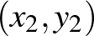 on the Cartesian plane: 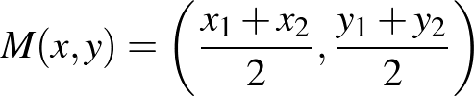
- explain the meaning of each of the pronumerals in the formula for midpoint (Communicating)
- use the formula to find the midpoint of the interval joining two points on the Cartesian plane
- use the relationship to establish the formula for the gradient, m, of the interval joining two points and on the Cartesian plane: 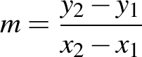
- use the formula to find the gradient of the interval joining two points on the Cartesian plane
- explain why the formula 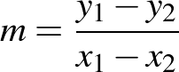 gives the same value for the gradient as (Communicating, Reasoning)
Find the distance between two points located on the Cartesian plane (ACMNA214)
- use Pythagoras' theorem to establish the formula for the distance, d, between two points and on the Cartesian plane: 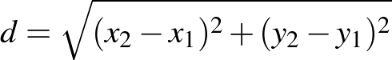
- explain the meaning of each of the pronumerals in the formula for distance (Communicating)
- use the formula to find the distance between two points on the Cartesian plane
- explain why the formula 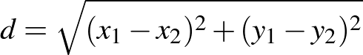 gives the same value for the distance as (Communicating, Reasoning)
Sketch linear graphs using the coordinates of two points (ACMNA215)
- sketch the graph of a line by using its equation to find the x- and y-intercepts
Solve problems using various standard forms of the equation of a straight line
- describe the equation of a line as the relationship between the x- and y-coordinates of any point on the line
- recognise from a list of equations those that can be represented as straight-line graphs (Communicating, Reasoning)
- rearrange linear equations in gradient-intercept form () into general form
- find the equation of a line passing through a point , with a given gradient m, using:
- point-gradient form: 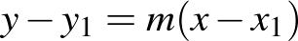
- gradient-intercept form:
- find the equation of a line passing through two points
- recognise and find the equation of a line in general form
Solve problems involving parallel and perpendicular lines (ACMNA238)
- find the equation of a line that is parallel or perpendicular to a given line
- determine whether two given lines are perpendicular
- use gradients to show that two given lines are perpendicular (Communicating, Problem Solving)
- solve a variety of problems by applying coordinate geometry formulas
- derive the formula for the distance between two points (Reasoning)
- show that three given points are collinear (Communicating, Reasoning)
- use coordinate geometry to investigate and describe the properties of triangles and quadrilaterals (Communicating, Problem Solving, Reasoning)
- use coordinate geometry to investigate the intersection of the perpendicular bisectors of the sides of acute-angled triangles (Problem Solving, Reasoning)
- show that four specified points form the vertices of particular quadrilaterals (Communicating, Problem Solving, Reasoning)
- prove that a particular triangle drawn on the Cartesian plane is right-angled (Communicating, Reasoning)
Stage 5.3
Number and Algebra
Non-Linear Relationships §
Outcomes
A student:
- uses and interprets formal definitions and generalisations when explaining solutions and/or conjectures MA5.3-1WM
- uses deductive reasoning in presenting arguments and formal proofs MA5.3-3WM
- sketches and interprets a variety of non-linear relationships MA5.3-9NA
Content
Students:
Describe, interpret and sketch parabolas, hyperbolas, circles and exponential functions and their transformations (ACMNA267)
- find x- and y-intercepts, where appropriate, for the graph of 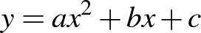, given a, b and c
- graph a variety of parabolas, including where the equation is given in the form , for various values of a, b and c
- use digital technologies to investigate and describe features of the graphs of parabolas given in the following forms for both positive and negative values of a and k, eg
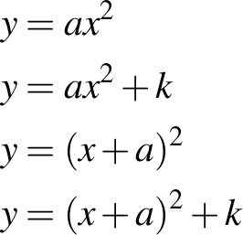
(Communicating, Reasoning)
- describe features of a parabola by examining its equation (Communicating)
- determine the equation of the axis of symmetry of a parabola using:
- the midpoint of the interval joining the points at which the parabola cuts the x-axis
- the formula 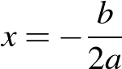
- find the coordinates of the vertex of a parabola by:
- using the midpoint of the interval joining the points at which the parabola cuts the x-axis and substituting to obtain the y-coordinate of the vertex
- using the formula for the axis of symmetry to obtain the x-coordinate and substituting to obtain the y-coordinate of the vertex
- completing the square on x in the equation of the parabola
- identify and use features of parabolas and their equations to assist in sketching quadratic relationships, eg identify and use the x- and y-intercepts, vertex, axis of symmetry and concavity
- determine quadratic expressions to describe particular number patterns, eg generate the equation 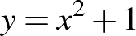 for the table
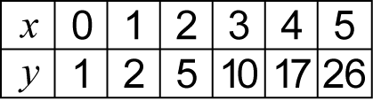
- graph hyperbolic relationships of the form 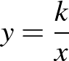 for integer values of k
- describe the effect on the graph of 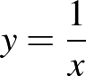 of multiplying by different constants (Communicating)
- explain what happens to the y-values of the points on the hyperbola as the x-values become very large or closer to zero (Communicating)
- explain why it may be useful to choose both small and large numbers when constructing a table of values for a hyperbola (Communicating, Reasoning)
- graph a variety of hyperbolic curves, including where the equation is given in the form 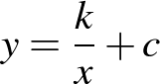 or 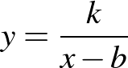 for integer values of k, b and c
- determine the equations of the asymptotes of a hyperbola in the form or (Problem Solving)
- identify features of hyperbolas from their equations to assist in sketching their graphs, eg identify asymptotes, orientation, x- and/or y-intercepts where they exist (Problem Solving, Reasoning)
- describe hyperbolas in terms of what happens to the y-values of the points on the hyperbola as x becomes very large or very small, whether there is a y-value for every x-value, and what occurs near or at x = 0 (Communicating, Reasoning)
- recognise and describe equations that represent circles with centre 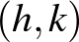 and radius
- establish the equation of the circle with centre and radius , and graph equations of the form 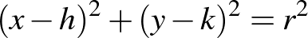 (Communicating, Reasoning)
- determine whether a particular point is inside, on, or outside a given circle (Reasoning)
- find the centre and radius of a circle whose equation is in the form 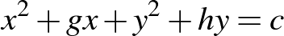 by completing the square (Problem Solving)
- identify and name different types of graphs from their equations, eg 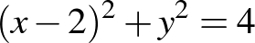, 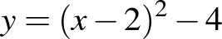, 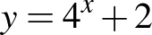, 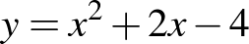, 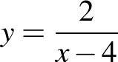
- determine how to sketch a particular curve by determining its features from its equation (Problem Solving)
- identify equations whose graph is symmetrical about the y-axis (Communicating, Reasoning)
- determine a possible equation from a given graph and check using digital technologies
- compare and contrast different types of graphs and determine possible equations from the key features, eg , 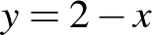, 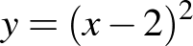, , 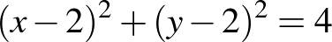, 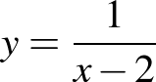, 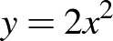 (Communicating, Reasoning)
- determine the points of intersection of a line with a parabola, hyperbola or circle, graphically and algebraically
- compare methods of finding points of intersection of curves and justify choice of method for a particular pair of curves (Communicating, Reasoning)
Describe, interpret and sketch cubics, other curves and their transformations
- graph and compare features of the graphs of cubic equations of the forms
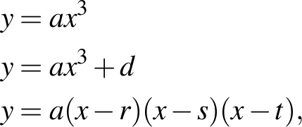
describing the effect on the graph of different values of a, d, r, s and t
- graph a variety of equations of the form 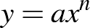 for n an integer, n ≥ 2, describing the effect of n being odd or even on the shape of the curve
- graph curves of the form 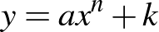 from curves of the form for n an integer, n ≥ 2 by using vertical transformations
- graph curves of the form 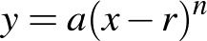 from curves of the form for n an integer, n ≥ 2 by using horizontal transformations
Background Information
This substrand links to other learning areas and real-life examples of graphs, eg exponential graphs used for population growth in demographics, radioactive decay, town planning, etc.
The substrand could provide opportunities for modelling, eg the hyperbola for x > 0 models sharing a prize of $k between x people or the length of a rectangle, given area k and breadth x.
Stage 5.3
Number and Algebra
Polynomials #
Outcomes
A student:
- uses and interprets formal definitions and generalisations when explaining solutions and/or conjectures MA5.3-1WM
- generalises mathematical ideas and techniques to analyse and solve problems efficiently MA5.3-2WM
- uses deductive reasoning in presenting arguments and formal proofs MA5.3-3WM
- recognises, describes and sketches polynomials, and applies the factor and remainder theorems to solve problems MA5.3-10NA
Content
Students:
Investigate the concept of a polynomial and apply the factor and remainder theorems to solve problems (ACMNA266)
- recognise a polynomial expression and use the terms 'degree', 'leading term', 'leading coefficient', 'constant term' and 'monic polynomial' appropriately
- use the notation 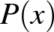 for polynomials and 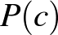 to indicate the value of for
- add and subtract polynomials and multiply polynomials by linear expressions
- divide polynomials by linear expressions to find the quotient and remainder, expressing the polynomial as the product of the linear expression and another polynomial plus a remainder, ie 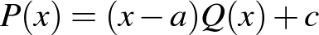
- verify the remainder theorem and use it to find factors of polynomials
- use the factor theorem to factorise particular polynomials completely
- use the factor theorem and long division to find all zeros of a simple polynomial and then solve 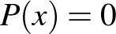 (degree ≤ 4)
- state the number of zeros that a polynomial of degree can have
Apply an understanding of polynomials to sketch a range of curves and describe the features of these curves from their equation (ACMNA268)
- sketch the graphs of quadratic, cubic and quartic polynomials by factorising and finding the zeros
- recognise linear, quadratic and cubic expressions as examples of polynomials and relate the sketching of these curves to factorising polynomials and finding the zeros (Reasoning)
- use digital technologies to graph polynomials of odd and even degree and investigate the relationship between the number of zeros and the degree of the polynomial (Communicating, Problem Solving)
- connect the roots of the equation to the x-intercepts, and the constant term to the y-intercept, of the graph of 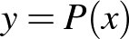 (Communicating, Reasoning)
- determine the importance of the sign of the leading term of a polynomial on the behaviour of the curve as (Reasoning)
- determine the effect of single, double and triple roots of a polynomial equation on the shape of the graph of
- use the leading term, the roots of the equation , and the x- and y-intercepts to sketch the graph of
- describe the key features of a polynomial and draw its graph from the description (Communicating)
- use the graph of to sketch 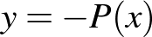, 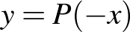, 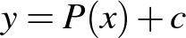, 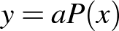
- explain the similarities and differences between the graphs of two polynomials, such as 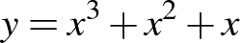 and 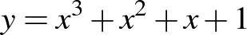 (Communicating, Reasoning)
Purpose/Relevance of Substrand
Polynomials are important in the further study of mathematics and science. They have a range of real-world applications in areas such as physics, engineering, business and economics. Polynomials are used in industries that model different situations, such as in the stock market to predict how prices will vary over time, in marketing to predict how raising the price of a good will affect its sales, and in economics to perform cost analyses. They are used in physics in relation to the motion of projectiles and different types of energy, including electricity. As polynomials are used to describe curves of various types, they are used in the real world to graph and explore the use of curves, eg a road-building company could use polynomials to describe curves in its roads.
Stage 5.3
Number and Algebra
Logarithms #
Outcomes
A student:
- uses and interprets formal definitions and generalisations when explaining solutions and/or conjectures MA5.3-1WM
- uses deductive reasoning in presenting arguments and formal proofs MA5.3-3WM
- uses the definition of a logarithm to establish and apply the laws of logarithms MA5.3-11NA
Content
Students:
Use the definition of a logarithm to establish and apply the laws of logarithms (ACMNA265)
- define 'logarithm': the logarithm of a number to any positive base is the index when the number is expressed as a power of the base, ie 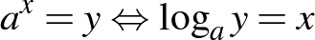 where a > 0, y > 0
- translate statements expressing a number in index form into equivalent statements expressing the logarithm of the number, eg
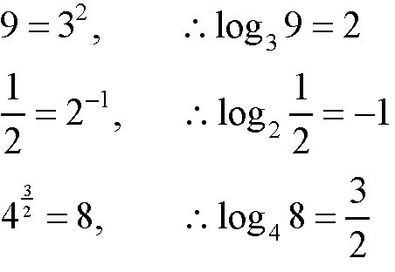
- deduce the following laws of logarithms from the laws of indices:
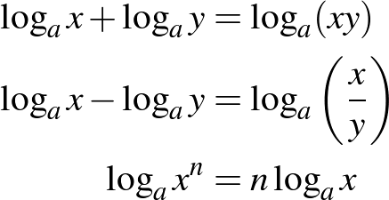
- establish and use the following results:
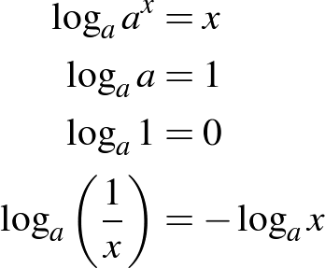
- apply the laws of logarithms to simplify simple expressions, eg 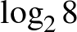, 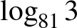, 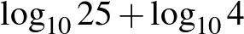, 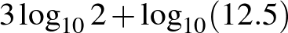, 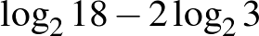
- simplify expressions using the laws of logarithms, eg simplify 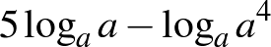
- draw and compare the graphs of the inverse functions 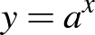 and 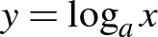
- relate logarithms to practical scales, eg Richter, decibel and pH scales (Problem Solving)
- compare and contrast exponential and logarithmic graphs drawn on the same axes, eg , 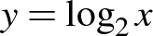, 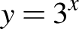, 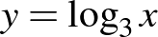 (Communicating, Reasoning)
Solve simple exponential equations (ACMNA270)
- solve simple equations that involve exponents or logarithms,
eg 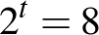, 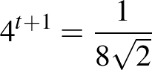, 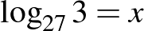, 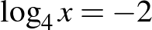
Background Information
Logarithm tables were used to assist with calculations before the use of hand-held calculators. They converted calculations involving multiplication and division to calculations involving addition and subtraction, thus simplifying the calculations.
Purpose/Relevance of Substrand
The laws obeyed by logarithms make them very useful in calculation and problem solving. They are used widely in pure mathematics, including calculus, and have many applications in engineering and science, including computer science. In acoustics, for example, sound intensity is measured in logarithmic units (decibels), and in chemistry 'pH' is a logarithmic measure of the acidity of a solution. Logarithms are common in mathematical and scientific formulas and are fundamental to the solution of exponential equations.
Language
Teachers need to emphasise the correct language used in connection with logarithms,
eg 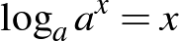 is 'log to the base a, of a to the power of x, equals x'.
Stage 5.3
Number and Algebra
Functions and Other Graphs #
Outcomes
A student:
- uses and interprets formal definitions and generalisations when explaining solutions and/or conjectures MA5.3-1WM
- uses deductive reasoning in presenting arguments and formal proofs MA5.3-3WM
- uses function notation to describe and sketch functions MA5.3-12NA
Content
Students:
Describe, interpret and sketch functions
- define a function as a rule or relationship where for each input value there is only one output value, or that associates every member of one set with exactly one member of a second set
- use the vertical line test on a graph to decide whether it represents a function
- explain whether a given graph represents a function (Communicating, Reasoning)
- decide whether straight-line graphs always, sometimes or never represent a function (Reasoning)
- use the notation 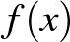
- use 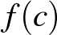 notation to determine the value of when x = c
- find the permissible x- and y-values for a variety of functions (including functions represented by straight lines, parabolas, exponentials and hyperbolas)
- determine the inverse functions for a variety of functions and recognise their graphs as reflections of the graphs of the functions in the line
- describe conditions for a function to have an inverse function (Communicating, Reasoning)
- recognise and describe the restrictions that need to be placed on quadratic functions so that they have an inverse function (Communicating, Reasoning)
- sketch the graphs of 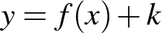 and 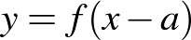, given the graph of 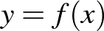
- sketch graphs to model relationships that occur in practical situations and explain the relationship between the variables represented in the graph (Communicating)
- consider a graph that represents a practical situation and explain the relationship between the two variables (Communicating, Reasoning)
Purpose/Relevance of Substrand
Functions are very important concepts in the study of mathematics and its applications to the real world. They are used extensively where situations need to be modelled, such as across science and engineering, and in business and economics. There are many ways to represent a function. A formula may be given for computing the output for a given input. Other functions may be given by a graph that represents the set of all paired inputs and outputs. In science, many functions are given by a table that gives the outputs for selected inputs. Functions, such as inverse functions, can be described through their relationship with other functions.
Stage 5.3
Measurement and Geometry
Area and Surface Area
Outcomes
A student:
- uses and interprets formal definitions and generalisations when explaining solutions and/or conjectures MA5.3-1WM
- generalises mathematical ideas and techniques to analyse and solve problems efficiently MA5.3-2WM
- applies formulas to find the surface areas of right pyramids, right cones, spheres and related composite solids MA5.3-13MG
Content
Students:
Solve problems involving the surface areas of right pyramids, right cones, spheres and related composite solids (ACMMG271)
- identify the 'perpendicular heights' and 'slant heights' of right pyramids and right cones
- apply Pythagoras' theorem to find the slant heights, base lengths and perpendicular heights of right pyramids and right cones
- devise and use methods to find the surface areas of right pyramids
- develop and use the formula to find the surface areas of right cones:
where r is the length of the radius and l is the slant height
- use the formula to find the surface areas of spheres:
where r is the length of the radius
- solve a variety of practical problems involving the surface areas of solids
- find the surface areas of composite solids, eg a cone with a hemisphere on top (Problem Solving)
- find the dimensions of a particular solid, given its surface area, by substitution into a formula to generate an equation (Problem Solving)
Background Information
Pythagoras' theorem is applied here to right-angled triangles in three-dimensional space.
The focus in this substrand is on right pyramids and right cones. Dealing with oblique versions of these objects is difficult and is mentioned only as a possible extension.
The area of the curved surface of a hemisphere is 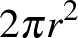, which is twice the area of its base. This may be a way of making the formula for the surface area of a sphere look reasonable to students. Deriving the relationship between the surface area and the volume of a sphere by dissection into very small pyramids may be an extension activity for some students. Similarly, some students may investigate, as an extension, the surface area of a sphere by the projection of very small squares onto a circumscribed cylinder.
Language
The difference between the 'perpendicular heights' and the 'slant heights' of pyramids and cones should be made explicit to students.
Stage 5.3
Measurement and Geometry
Volume
Outcomes
A student:
- uses and interprets formal definitions and generalisations when explaining solutions and/or conjectures MA5.3-1WM
- generalises mathematical ideas and techniques to analyse and solve problems efficiently MA5.3-2WM
- uses deductive reasoning in presenting arguments and formal proofs MA5.3-3WM
- applies formulas to find the volumes of right pyramids, right cones, spheres and related composite solids MA5.3-14MG
Content
Students:
Solve problems involving the volumes of right pyramids, right cones, spheres and related composite solids (ACMMG271)
- develop and use the formula to find the volumes of right pyramids and right cones:
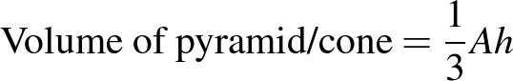 where A is the base area and h is the perpendicular height
- recognise and use the fact that a pyramid/cone has one-third the volume of a prism/cylinder with the same base and the same perpendicular height (Reasoning)
- deduce that the volume of a cone is given by 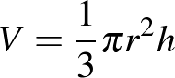 (Reasoning)
- use the formula to find the volumes of spheres:
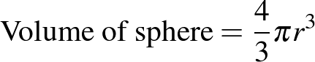 where r is the length of the radius
- find the volumes of composite solids that include right pyramids, right cones and hemispheres,
eg find the volume of a cylinder with a cone on top
- solve a variety of practical problems relating to the volumes and capacities of right pyramids, right cones and spheres
- apply Pythagoras' theorem as needed to calculate the volumes of pyramids and cones (Problem Solving)
- find the dimensions of a particular solid, given its volume, by substitution into a formula to generate an equation, eg find the length of the radius of a sphere, given its volume (Problem Solving)
Background Information
The formulas for the volumes of solids mentioned here depend only on the perpendicular heights and apply equally well to oblique cases. The volumes of oblique solids may be included as an extension for some students.
A more systematic development of the volume formulas for pyramids, cones and spheres can be given after integration is developed in Stage 6 (where the factor emerges essentially because the primitive of is 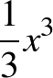).
In Stage 5.3, the relationship could be demonstrated by practical means, eg filling a pyramid with sand and pouring the sand into a prism with the same base and perpendicular height, and repeating until the prism is filled.
Some students may undertake the following exercise: visualise a cube of side length 2a dissected into six congruent pyramids with a common vertex at the centre of the cube, and then prove that each of these pyramids has volume 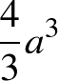, which is of the enclosing rectangular prism.
The problem of finding the edge length of a cube that has twice the volume of another cube is called the 'duplication of the cube' and is one of three famous problems left unsolved by the ancient Greeks. It was proved in the nineteenth century that this cannot be done with a straight edge and a pair of compasses, essentially because the cube root of 2 cannot be constructed on the number line.
Language
The difference between the 'perpendicular heights' and the 'slant heights' of pyramids and cones should be made explicit to students.
Stage 5.3
Measurement and Geometry
Trigonometry and Pythagoras' Theorem §
Outcomes
A student:
- uses and interprets formal definitions and generalisations when explaining solutions and/or conjectures MA5.3-1WM
- generalises mathematical ideas and techniques to analyse and solve problems efficiently MA5.3-2WM
- uses deductive reasoning in presenting arguments and formal proofs MA5.3-3WM
- applies Pythagoras’ theorem, trigonometric relationships, the sine rule, the cosine rule and the area rule to solve problems, including problems involving three dimensions MA5.3-15MG
Content
Students:
Apply Pythagoras' theorem and trigonometry to solve three-dimensional problems in right-angled triangles (ACMMG276)
- solve problems involving the lengths of the edges and diagonals of rectangular prisms and other three-dimensional objects
- use a given diagram to solve problems involving right-angled triangles in three dimensions
- check the reasonableness of answers to trigonometry problems involving right-angled triangles in three dimensions (Problem Solving)
- draw diagrams and use them to solve word problems involving right-angled triangles in three dimensions, including using bearings and angles of elevation or depression, eg 'From a point, A, due south of a flagpole 100 metres tall on level ground, the angle of elevation of the top of the flagpole is 35°. The top of the same flagpole is observed with an angle of elevation 22° from a point, B, due east of the flagpole. What is the distance from A to B?'
- check the reasonableness of answers to trigonometry word problems in three dimensions (Problem Solving)
Use the unit circle to define trigonometric functions, and graph them, with and without the use of digital technologies (ACMMG274)
- prove that the tangent ratio can be expressed as a ratio of the sine and cosine ratios, ie 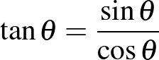
- use the unit circle and digital technologies to investigate the sine, cosine and tangent ratios for (at least) 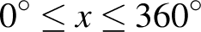 and sketch the results
- compare the features of trigonometric curves, including periodicity and symmetry (Communicating, Reasoning)
- describe how the value of each trigonometric ratio changes as the angle increases from 0° to 360° (Communicating)
- recognise that trigonometric functions can be used to model natural and physical phenomena, eg tides, the motion of a swinging pendulum (Reasoning)
- investigate graphs of the sine, cosine and tangent functions for angles of any magnitude, including negative angles
- use the unit circle or graphs of trigonometric functions to establish and use the following relationships for obtuse angles, where 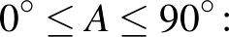
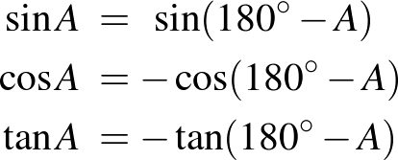
- recognise that if 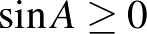, then there are two possible values for , given 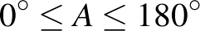 (Reasoning)
- determine the angle of inclination, , of a line on the Cartesian plane by establishing and using the relationship where is the gradient of the line
Solve simple trigonometric equations (ACMMG275)
- determine and use the exact sine, cosine and tangent ratios for angles of 30°, 45° and 60°
- solve problems in right-angled triangles using the exact sine, cosine and tangent ratios for 30°, 45° and 60° (Problem Solving)
- prove and use the relationships between the sine and cosine ratios of complementary angles in right-angled triangles
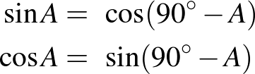
- determine the possible acute and/or obtuse angle(s), given a trigonometric ratio
Establish the sine, cosine and area rules for any triangle and solve related problems (ACMMG273)
- prove the sine rule:
In a given triangle , the ratio of a side to the sine of the opposite angle is a constant 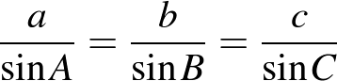
- use the sine rule to find unknown sides and angles of a triangle, including in problems where there are two possible solutions when finding an angle
- recognise that if given two sides and a non-included angle, then two triangles may result, leading to two solutions when the sine rule is applied (Reasoning)
- prove the cosine rule:
For a given triangle ,
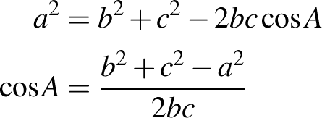
- use the cosine rule to find unknown sides and angles of a triangle
- prove and use the area rule to find the area of a triangle:
For a given triangle , 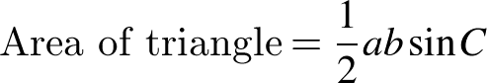
- select and apply the appropriate rule to find unknowns in non-right-angled triangles
- explain what happens if the sine, cosine and area rules are applied in right-angled triangles (Communicating, Reasoning)
- solve a variety of practical problems that involve non-right-angled triangles, including problems where a diagram is not provided
- use appropriate trigonometric ratios and formulas to solve two-dimensional problems that require the use of more than one triangle, where the diagram is provided and where a verbal description is given (Problem Solving)
Background Information
Pythagoras' theorem is applied here to right-angled triangles in three-dimensional space.
In Stage 5, students are expected to know and use the sine, cosine and tangent ratios. The reciprocal ratios, cosecant, secant and cotangent, are introduced in selected courses in Stage 6.
The graphs of the trigonometric functions mark the transition from understanding trigonometry as the study of lengths and angles in triangles (as the word 'trigonometry' implies) to the study of waves, as will be developed in the Stage 6 calculus courses. Waves are fundamental to a vast range of physical and practical phenomena, such as light waves and all other electromagnetic waves, and to periodic phenomena such as daily temperatures and fluctuating sales over the year. The major importance of trigonometry lies in the study of these waves. The sine, cosine and tangent functions are plotted for a full revolution and beyond, so that their wave nature becomes clear.
Students are not expected to reproduce proofs of the sine, cosine and area rules. The cosine rule is a generalisation of Pythagoras' theorem. The sine rule is linked to the circumcircle and to circle geometry.
Students should realise that when the triangle is right-angled, the cosine rule becomes Pythagoras' theorem, the area formula becomes the simple 'half base times perpendicular height' formula, and the sine rule becomes a simple application of the sine function in a right-angled triangle.
The formula is a formula for gradient in the Cartesian plane.
Stage 5.3
Measurement and Geometry
Properties of Geometrical Figures §
Outcomes
A student:
- uses and interprets formal definitions and generalisations when explaining solutions and/or conjectures MA5.3-1WM
- generalises mathematical ideas and techniques to analyse and solve problems efficiently MA5.3-2WM
- uses deductive reasoning in presenting arguments and formal proofs MA5.3-3WM
- proves triangles are similar, and uses formal geometric reasoning to establish properties of triangles and quadrilaterals MA5.3-16MG
Content
Students:
Formulate proofs involving congruent triangles and angle properties (ACMMG243)
- construct and write geometrical arguments to prove a general geometrical result, giving reasons at each step of the argument, eg prove that the angle in a semicircle is a right angle
Apply logical reasoning, including the use of congruence and similarity, to proofs and numerical exercises involving plane shapes (ACMMG244)
- write formal proofs of the similarity of triangles in the standard four- or five-line format, preserving the matching order of vertices, identifying the scale factor when appropriate, and drawing relevant conclusions from this similarity
- prove that the interval joining the midpoints of two sides of a triangle is parallel to the third side and half its length, and the converse (Communicating, Problem Solving)
- establish and apply for two similar figures with similarity ratio the following:
- matching angles have the same size
- matching intervals are in the ratio
- matching areas are in the ratio 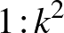
- matching volumes are in the ratio 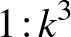
- solve problems involving similarity ratios and areas and volumes (Problem Solving)
- state a definition as the minimum amount of information needed to identify a particular figure
- prove properties of isosceles and equilateral triangles and special quadrilaterals from the formal definitions of the shapes:
- a scalene triangle is a triangle with no two sides equal in length
- an isosceles triangle is a triangle with two sides equal in length
- an equilateral triangle is a triangle with all sides equal in length
- a trapezium is a quadrilateral with at least one pair of opposite sides parallel
- a parallelogram is a quadrilateral with both pairs of opposite sides parallel
- a rhombus is a parallelogram with two adjacent sides equal in length
- a rectangle is a parallelogram with one angle a right angle
- a square is a rectangle with two adjacent sides equal
- use dynamic geometry software to investigate and test conjectures about geometrical figures (Problem Solving, Reasoning)
- prove and apply theorems and properties related to triangles and quadrilaterals:
- the sum of the interior angles of a triangle is 180º
- the exterior angle of a triangle is equal to the sum of the two interior opposite angles
- if two sides of a triangle are equal, then the angles opposite those sides are equal; conversely, if two angles of a triangle are equal, then the sides opposite those angles are equal
- each angle of an equilateral triangle is equal to 60º
- the sum of the interior angles of a quadrilateral is 360º
- the opposite angles of a parallelogram are equal
- the opposite sides of a parallelogram are equal
- the diagonals of a parallelogram bisect each other
- the diagonals of a rhombus bisect each other at right angles
- the diagonals of a rhombus bisect the vertex angles through which they pass
- the diagonals of a rectangle are equal
- recognise that any result proven for a parallelogram would also hold for a rectangle (Reasoning)
- give reasons why a square is a rhombus, but a rhombus is not necessarily a square (Communicating, Reasoning)
- use a flow chart or other diagram to show the relationships between different quadrilaterals
(Communicating)
- prove and apply tests for quadrilaterals:
- if both pairs of opposite angles of a quadrilateral are equal, then the quadrilateral is a parallelogram
- if both pairs of opposite sides of a quadrilateral are equal, then the quadrilateral is a parallelogram
- if all sides of a quadrilateral are equal, then the quadrilateral is a rhombus
- solve numerical and non-numerical problems in Euclidean geometry based on known assumptions and proven theorems
- state possible converses of known results, and examine whether or not they are also true (Communicating, Reasoning)
Background Information
Similarity of triangles is used in Circle Geometry to prove further theorems on intersecting chords, secants and tangents.
Attention should be given to the logical sequence of theorems and to the types of arguments used. The memorisation of proofs is not intended. Every theorem presented could be preceded by a straight-edge-and-compasses construction to confirm the theorem before it is proven in an appropriate manner, by way of an exercise or an investigation.
In Euclidean geometry, congruence is the method used to construct symmetry arguments. It is often helpful to see exactly what transformation, or sequence of transformations, will map one triangle into a congruent triangle. For example, the proof that the opposite sides of a parallelogram are equal involves constructing a diagonal and proving that the resulting triangles are congruent – these two triangles can be transformed into each other by a rotation of 180º about the midpoint of the diagonal.
In the German-born physicist Albert Einstein's (1879–1955) general theory of relativity, three-dimensional space is curved and, as a result, the sum of the angles of a physical triangle of cosmological proportions is not 180º. Abstract geometries of this nature were developed by other mathematicians, including the German Carl Friedrich Gauss (1777–1855), the Hungarian János Bolyai (1802–1860), the Russian Nikolai Lobachevsky (1792–1856), the German Bernhard Riemann (1826–1866) and others, in the nineteenth century, amid suspicions that Euclidean geometry may not be the correct description of physical space.
The Elements, a treatise written by the Greek mathematician Euclid (c325−265 BC), gives an account of geometry written almost entirely as a sequence of axioms, definitions, theorems and proofs. Its methods have had an enormous influence on mathematics. Students could read some of Book 1 of the Elements for a systematic account of the geometry of triangles and quadrilaterals.
Language
If students abbreviate geometrical reasons that they use in deductive geometry, they must take care not to abbreviate the reasons to such an extent that the meaning is lost.
Stage 5.3
Measurement and Geometry
Circle Geometry #
Outcomes
A student:
- uses and interprets formal definitions and generalisations when explaining solutions and/or conjectures MA5.3-1WM
- generalises mathematical ideas and techniques to analyse and solve problems efficiently MA5.3-2WM
- uses deductive reasoning in presenting arguments and formal proofs MA5.3-3WM
- applies deductive reasoning to prove circle theorems and to solve related problems MA5.3-17MG
Content
Students:
Prove and apply angle and chord properties of circles (ACMMG272)
- identify and name parts of a circle (centre, radius, diameter, circumference, sector, arc, chord, secant, tangents, segment, semicircle)
- use terminology associated with angles in circles, eg subtend, standing on the same arc, angle at the centre, angle at the circumference, angle in a segment
- identify the arc on which an angle at the centre or circumference stands
- demonstrate that at any point on a circle there is a unique tangent to the circle, and that this tangent is perpendicular to the radius at the point of contact
- prove the following chord properties of circles:
- chords of equal length in a circle subtend equal angles at the centre and are equidistant from the centre
- the perpendicular from the centre of a circle to a chord bisects the chord; conversely, the line from the centre of a circle to the midpoint of a chord is perpendicular to the chord
- the perpendicular bisector of a chord of a circle passes through the centre
- given any three non-collinear points, the point of intersection of the perpendicular bisectors of any two sides of the triangle formed by the three points is the centre of the circle through all three points
- when two circles intersect, the line joining their centres bisects their common chord at right angles
- use dynamic geometry software to investigate chord properties of circles (Problem Solving, Reasoning)
- prove the following angle properties of circles:
- the angle at the centre of a circle is twice the angle at the circumference standing on the same arc
- the angle in a semicircle is a right angle
- angles at the circumference, standing on the same arc, are equal
- the opposite angles of cyclic quadrilaterals are supplementary
- an exterior angle at a vertex of a cyclic quadrilateral is equal to the interior opposite angle
- use dynamic geometry software to investigate angle properties of circles (Problem Solving, Reasoning)
- apply circle theorems to prove that the angle in a semicircle is a right angle (Problem Solving, Reasoning)
- apply chord and angle properties of circles to find unknown angles and lengths in diagrams
Prove and apply tangent and secant properties of circles
- prove the following tangent and secant properties of circles:
- the two tangents drawn to a circle from an external point are equal in length
- the angle between a tangent and a chord drawn to the point of contact is equal to the angle in the alternate segment
- when two circles touch, their centres and the point of contact are collinear
- the products of the intercepts of two intersecting chords of a circle are equal
- the products of the intercepts of two intersecting secants to a circle from an external point are equal
- the square of a tangent to a circle from an external point equals the product of the intercepts of any secants from the point
- use dynamic geometry software to investigate tangent and secant properties of circles (Problem Solving, Reasoning)
- apply tangent and secant properties of circles to find unknown angles and lengths in diagrams
Background Information
As well as solving arithmetic and algebraic problems in circle geometry, students should be able to reason deductively within more theoretical arguments. To aid reasoning, they should be given diagrams labelled with the important information. Students should also be able to produce a clear diagram from a set of instructions.
Attention should be given to the logical sequence of theorems and to the types of arguments used. The memorisation of proofs is not intended. Ideally, every theorem presented should be preceded by a straight-edge-and-compasses construction to confirm the theorem, before it is proven in an appropriate manner, by way of an exercise or an investigation.
The tangent-and-radius theorem is difficult to justify in Stage 5.3 and is probably better taken as an assumption, as indicated above.
This substrand may be extended to examining the converse of some of the theorems related to cyclic quadrilaterals, leading to a series of conditions for points to be concyclic. However, students may find these results difficult to prove and apply.
The angle in a semicircle theorem is also called Thales' theorem because it was traditionally ascribed to the philosopher Thales of Miletus (c624–c546 BC) by the ancient Greeks, who reported that it was the first theorem ever proven in mathematics.
Purpose/Relevance of Substrand
The study and application of angle relationships and the properties of geometrical figures, undertaken in Stage 4 and Stage 5, is taken further to the context of the circle for those students who study the substrand Circle Geometry. These students add a further dimension to their knowledge, skills and understanding in geometry by learning to analyse circle geometry problems and by developing a broader set of geometric and deductive reasoning skills, as well as additional problem-solving skills. They develop an understanding that the geometry of the circle is very important in the work of architects, engineers, designers, builders, physicists, etc, as well as in everyday situations through its occurrence in nature, sports, buildings, etc.
Language
A considerable amount of specific terminology is introduced in Stage 5.3 Circle Geometry. Teachers will need to model and explain the correct use of terms such as 'subtend', 'point of contact', 'collinear', 'standing on the same arc' and 'angle in the alternate segment'.
Students should write geometrical reasons without the use of abbreviations to assist them in learning new terminology and in understanding and retaining geometrical concepts. If students abbreviate geometrical reasons that they use in circle geometry, they must take care not to abbreviate the reasons to such an extent that the meaning is lost.
Stage 5.3
Statistics and Probability
Single Variable Data Analysis
Outcomes
A student:
- uses and interprets formal definitions and generalisations when explaining solutions and/or conjectures MA5.3-1WM
- generalises mathematical ideas and techniques to analyse and solve problems efficiently MA5.3-2WM
- uses deductive reasoning in presenting arguments and formal proofs MA5.3-3WM
- uses standard deviation to analyse data MA5.3-18SP

Content
Students:
Calculate and interpret the mean and standard deviation of data and use these to compare data sets (ACMSP278)
- investigate the meaning and calculation of standard deviation using a small set of data
- explain why the standard deviation is calculated using the squares of 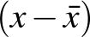 for all data values in a set of data (Communicating, Reasoning)
- find the standard deviation of a set of data using digital technologies
- investigate and describe the effect, if any, on the standard deviation of adding a data value to the set of data, eg adding a data value equivalent to the mean, or adding a data value more or less than one standard deviation from the mean (Problem Solving, Reasoning)
- investigate and describe the effect, if any, on the standard deviation of altering all of the data values in the set of data by operations such as doubling all data values or adding a constant to all data values (Problem Solving, Reasoning)
- use the mean and standard deviation to compare two sets of data
- compare and describe the spread of sets of data with the same mean but different standard deviations (Communicating, Reasoning)
- compare and describe the spread of sets of data with different means by referring to standard deviation (Communicating, Reasoning)
- compare the relative merits of the range, interquartile range and standard deviation as measures of spread
Background Information
It is intended that students develop a feeling for the concept of standard deviation being a measure of the spread of a symmetrical distribution, but without going into detailed analysis. When using a calculator, the 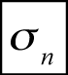 button or equivalent for standard deviation of a population will suffice.
Stage 5.3
Statistics and Probability
Bivariate Data Analysis
Outcomes
A student:
- uses and interprets formal definitions and generalisations when explaining solutions and/or conjectures MA5.3-1WM
- generalises mathematical ideas and techniques to analyse and solve problems efficiently MA5.3-2WM
- investigates the relationship between numerical variables using lines of best fit, and explores how data is used to inform decision-making processes MA5.3-19SP

Content
Students:
Use information technologies to investigate bivariate numerical data sets; where appropriate, students use a straight line to describe the relationship, allowing for variation (ACMSP279)
- use digital technologies, such as a spreadsheet, to construct a line of best fit for bivariate numerical data
- investigate different methods of constructing a line of best fit using digital technologies (Problem Solving)
- use lines of best fit to predict what might happen between known data values (interpolation) and predict what might happen beyond known data values (extrapolation)
- compare predictions obtained from different lines of best fit (Problem Solving, Reasoning)
Investigate reports of studies in digital media and elsewhere for information on their planning and implementation (ACMSP277)
- investigate and evaluate the appropriateness of sampling methods and sample size used in reports where statements about a population are based on a sample
- determine whether a sample used enables inferences or conclusions to be drawn about the relevant population (Reasoning)
- critically review surveys, polls and media reports
- identify, describe and evaluate issues such as the misrepresentation of data, apparent bias in reporting, sampling techniques used, and the wording of questions used to collect data (Communicating, Problem Solving, Reasoning)
- discuss issues to be considered in the implementation of policies that result from studies reported in the media or elsewhere (Communicating, Problem Solving)
- investigate the use of statistics and associated probabilities in shaping decisions made by governments and companies, eg the setting of insurance premiums, the use of demographic data to determine where and when various facilities may be built
- use Australian census data to identify issues for the local area or state and suggest implications for future planning in the local area or state (Problem Solving, Reasoning)

Years 7–10 Life Skills outcomes and content
For a small percentage of students with special education needs, particularly those with an intellectual disability, adjustments to teaching, learning and assessment may not be sufficient
to access some or all of the Stage 4 and Stage 5 outcomes. These students may best fulfil the curriculum requirements for Mathematics Years 7–10 by undertaking Life Skills outcomes
and content.
In order to provide a relevant and meaningful program of study that reflects the needs, interests and abilities of each student, schools may integrate Mathematics Years 7–10 Life Skills outcomes and content across a variety of school and community contexts.
The following points need to be taken into consideration:
- specific Life Skills outcomes will be selected on the basis that they meet the particular needs, goals and priorities of each student
- students are not required to complete all outcomes
- outcomes may be demonstrated independently or with support.
A range of adjustments to teaching, learning and assessment experiences should be explored before a decision is made to access Years 7–10 Life Skills outcomes and content. Decisions about curriculum options for students with special education needs should be made through
the collaborative curriculum planning process.
The Years 7–10 Life Skills outcomes and content are developed from the objectives of the Mathematics K–10 Syllabus. They indicate the knowledge, skills and understanding expected to be gained by most students as a result of effective teaching and learning by the end of a stage.
Further information in relation to planning, implementing and assessing Life Skills outcomes
and content can be found in Life Skills Years 7–10: Advice on Planning, Programming and Assessment.

Years 7–10 Life Skills outcomes

Table of objectives and outcomes

Objective – Working Mathematically
Students:
- develop understanding and fluency in mathematics through inquiry, exploring and connecting mathematical concepts, choosing and applying problem-solving skills and mathematical techniques, communication and reasoning

Life Skills outcomes
A student:
MALS-1WM
responds to and uses mathematical language to demonstrate understanding
MALS-2WM
applies mathematical strategies to solve problems
MALS-3WM
uses reasoning to recognise mathematical relationships

Objective – Number and Algebra
Students:
- develop efficient strategies for numerical calculation, recognise patterns, describe relationships and apply algebraic techniques and generalisation

Life Skills outcomes
A student:
MALS-4NA
recognises language used to represent number
MALS-5NA
counts in familiar contexts
MALS-6NA
reads and represents numbers
MALS-7NA
compares and orders numbers
MALS-8NA
recognises and compares fractions in everyday contexts
MALS-9NA
represents and operates with fractions, decimals or percentages in everyday contexts
MALS-10NA
selects and uses strategies for addition and subtraction
MALS-11NA
selects and uses strategies for multiplication and division
MALS-12NA
recognises and matches coins and notes
MALS-13NA
compares and orders coins and notes
MALS-14NA
reads and writes amounts of money
MALS-15NA
calculates with money
MALS-16NA
makes informed decisions about purchasing goods and services
MALS-17NA
plans and manages personal finances
MALS-18NA
recognises and continues repeating patterns
MALS-19NA
calculates missing values by completing simple number sentences

Objective – Measurement and Geometry
Students:
- identify, visualise and quantify measures and the attributes of shapes and objects, and explore measurement concepts and geometric relationships, applying formulas, strategies and geometric reasoning in the solution of problems

Life Skills outcomes
A student:
MALS-20MG
recognises time in familiar contexts
MALS-21MG
recognises and relates time in a range of contexts
MALS-22MG
reads and interprets time in a variety of situations
MALS-23MG
calculates and measures time and duration in everyday contexts
MALS-24MG
organises personal time and manages scheduled activities
MALS-25MG
estimates and measures in everyday contexts
MALS-26MG
recognises and uses units to estimate and measure length
MALS-27MG
selects and uses units to estimate and measure mass
MALS-28MG
selects and uses units to estimate and measure volume and capacity
MALS-29MG
applies formal units to estimate and calculate area
MALS-30MG
recognises, matches and sorts three-dimensional objects and/or two-dimensional shapes
MALS-31MG
identifies the features of three-dimensional objects and/or two-dimensional shapes and applies these in a range of contexts
MALS-32MG
responds to and uses the language of position in everyday contexts
MALS-33MG
recognises that maps and plans are a representation of positions in space
MALS-34MG
uses maps and plans in a range of contexts

Objective – Statistics and Probability
Students:
- collect, represent, analyse, interpret and evaluate data, assign and use probabilities, and make sound judgements

Life Skills outcomes
A student:
MALS-35SP
recognises data displayed in a variety of formats
MALS-36SP
gathers, organises and displays data
MALS-37SP
interprets information and draws conclusions from data displays
MALS-38SP
recognises and uses the language of chance in a range of contexts
MALS-39SP
recognises the elements of chance and probability in everyday events

Years 7–10 Life Skills and Related Syllabus Outcomes

Objective – Working Mathematically
Students:
- develop understanding and fluency in mathematics through inquiry, exploring and connecting mathematical concepts, choosing and applying problem-solving skills and mathematical techniques, communication and reasoning
Life Skills outcomes  A student: | Related Stage 4/5 outcomes  A student:
MALS-1WM responds to and uses mathematical language to demonstrate understanding | MA4-1WM communicates and connects mathematical ideas using appropriate terminology, diagrams and symbols  MA5.1-1WM uses appropriate terminology, diagrams and symbols in mathematical contexts  MA5.2-1WM selects appropriate notations and conventions to communicate mathematical ideas and solutions
MALS-2WM applies mathematical strategies to solve problems | MA4-2WM applies appropriate mathematical techniques to solve problems  MA5.1-2WM selects and uses appropriate strategies to solve problems  MA5.2-2WM interprets mathematical or  real-life situations, systematically applying appropriate strategies to solve problems
MALS-3WM uses reasoning to recognise mathematical relationships | MA4-3WM recognises and explains mathematical relationships using reasoning  MA5.1-3WM provides reasoning to support conclusions that are appropriate to the context  MA5.2-3WM constructs arguments to prove and justify results

Objective – Number and Algebra
Students:
- develop efficient strategies for numerical calculation, recognise patterns, describe relationships and apply algebraic techniques and generalisation
Life Skills outcomes  A student: | Related Stage 4/5 outcomes  A student:
MALS-4NA recognises language used to represent number  MALS-5NA counts in familiar contexts  MALS-6NA reads and represents numbers  MALS-7NA compares and orders numbers | MA4-4NA compares, orders and calculates with integers, applying a range of strategies  to aid computation
MALS-8NA recognises and compares fractions in everyday contexts  MALS-9NA represents and operates with fractions, decimals or percentages in everyday contexts | MA4-5NA operates with fractions, decimals and percentages
MALS-10NA selects and uses strategies for addition and subtraction  MALS-11NA selects and uses strategies for multiplication and division | MA4-4NA compares, orders and calculates with integers, applying a range of strategies  to aid computation
MALS-12NA recognises and matches coins and notes  MALS-13NA compares and orders coins and notes  MALS-14NA reads and writes amounts of money  MALS-15NA calculates with money  MALS-16NA makes informed decisions about purchasing goods and services  MALS-17NA plans and manages personal finances | MA4-6NA solves financial problems involving purchasing goods  MA5.1-4NA solves financial problems involving earning, spending and investing money  MA5.2-4NA solves financial problems involving compound interest
MALS-18NA recognises and continues repeating patterns | MA4-8NA generalises number properties  to operate with algebraic expressions
MALS-19NA calculates missing values by completing simple number sentences | MA4-7NA operates with ratios and rates, and explores their graphical representation  MA4-10NA uses algebraic techniques to solve simple linear and quadratic equations  MA5.2-8NA solves linear and simple quadratic equations, linear inequalities and linear simultaneous equations, using analytical  and graphical techniques

Objective – Measurement and Geometry
Students:
- identify, visualise and quantify measures and the attributes of shapes and objects, and explore measurement concepts and geometric relationships, applying formulas, strategies and geometric reasoning in the solution of problems
Life Skills outcomes  A student: | Related Stage 4/5 outcomes  A student:
MALS-20MG recognises time in familiar contexts  MALS-21MG recognises and relates time in  a range of contexts  MALS-22MG reads and interprets time in  a variety of situations  MALS-23MG calculates and measures time and duration in everyday contexts  MALS-24MG organises personal time and manages scheduled activities | MA4-15MG performs calculations of time that involve mixed units, and interprets time zones
MALS-25MG estimates and measures in everyday contexts  MALS-26MG recognises and uses units to estimate and measure length | MA4-12MG calculates the perimeters of plane shapes and the circumferences of circles
MALS-27MG selects and uses units to estimate and measure mass
MALS-28MG selects and uses units to estimate and measure volume and capacity | MA4-14MG uses formulas to calculate the volumes of prisms and cylinders, and converts between units of volume  MA5.2-12MG applies formulas to calculate the volumes of composite solids composed of right prisms and cylinders
MALS-29MG applies formal units to estimate and calculate area | MA4-13MG uses formulas to calculate the areas of quadrilaterals and circles, and converts between units of area  MA5.1-8MG calculates the areas of composite shapes, and the surface areas of rectangular and triangular prisms  MA5.2-11MG calculates the surface areas of right prisms, cylinders and related composite solids
MALS-30MG recognises, matches and  sorts three-dimensional objects and/or  two-dimensional shapes  MALS-31MG identifies the features of three-dimensional objects and/or two-dimensional shapes and applies these in a range of contexts | MA4-14MG uses formulas to calculate the volumes of prisms and cylinders, and converts between units of volume  MA4-17MG classifies, describes and uses the properties of triangles and quadrilaterals, and determines congruent triangles to find unknown side lengths and angles  MA5.2-12MG applies formulas to calculate the volumes of composite solids composed of right prisms and cylinders
MALS-32MG responds to and uses the language of position in everyday contexts  MALS-33MG recognises that maps and plans are a representation of positions in space  MALS-34MG uses maps and plans in a range of contexts | MA4-11NA creates and displays number patterns; graphs and analyses linear relationships; and performs transformations  on the Cartesian plane  MA5.1-6NA determines the midpoint, gradient and length of an interval, and graphs linear relationships  MA5.1-11MG describes and applies the properties of similar figures and scale drawings

Objective – Statistics and Probability
Students:
- collect, represent, analyse, interpret and evaluate data, assign and use probabilities, and make sound judgements
Life Skills outcomes  A student: | Related Stage 4/5 outcomes  A student:
MALS-35SP recognises data displayed in  a variety of formats  MALS-36SP gathers, organises and displays data  MALS-37SP interprets information and draws conclusions from data displays | MA4-19SP collects, represents and interprets single sets of data, using appropriate statistical displays  MA5.1-12SP uses statistical displays to compare sets of data, and evaluates statistical claims made in the media  MA5.2-15SP uses quartiles and box plots to compare sets of data, and evaluates sources of data
MALS-38SP recognises and uses the language of chance in a range of contexts  MALS-39SP recognises the elements of chance and probability in everyday events | MA4-21SP represents probabilities of simple and compound events  MA5.1-13SP calculates relative frequencies to estimate probabilities of simple and compound events  MA5.2-16SP investigates relationships between two statistical variables, including their relationship over time  MA5.2-17SP describes and calculates probabilities in multi-step chance experiments

Years 7–10 Life Skills content
The Years 7–10 Life Skills content forms the basis for learning opportunities. Content should be selected based on the abilities, needs and interests of students. Students will not be required to complete all of the content to demonstrate achievement of an outcome.
The Mathematics K–10 Syllabus is organised into three content strands, Number and Algebra, Measurement and Geometry, and Statistics and Probability, with the components of Working Mathematically integrated into the content strands. Further information about the organisation
of content is provided in the Content section of this syllabus.

Life Skills
Number and Algebra
Numeration: Language of Numbers
Outcomes
A student:
- responds to and uses mathematical language to demonstrate understanding MALS-1WM
- uses reasoning to recognise mathematical relationships MALS-3WM
- recognises language used to represent number MALS-4NA
Related Stage 4/5 outcome: MA4-4NA
Content
Students:
- recognise language related to number, eg none, few, many, more, less
- respond to questions that involve descriptions of number, eg 'Are all the books on the shelf?', 'Which box has no pens?', 'Which plate has more cakes?' (Communicating, Understanding)
- respond to requests that involve descriptions of number, eg 'Put all the books on the shelf', 'Take some paper from my desk', 'Place a few chairs near the table' (Communicating, Understanding)
- describe and compare groups of objects using language descriptive of number, eg 'There are none left on the shelf', 'I have more cards than my brother' (Communicating, Reasoning, Understanding)
- recognise that some languages other than English, such as Aboriginal and Torres Strait Islander languages, may have interchangeable terms with the same meaning
- recognise ordinal terms, eg first, second, third
- respond to directions involving ordinal terms, eg 'Give a ball to the first person in each row', 'Put a book on every second chair' (Communicating, Understanding)
- use ordinal terms in familiar contexts, eg 'I go to training on the first and third Wednesday of the month', 'The youth group meets on the first Monday of each month', 'My birthday is on the fifth of November', 'Is the office on the first or second floor?', 'Is the post office in the third or fourth street on the left?' (Communicating, Understanding)
Life Skills
Number and Algebra
Numeration: Counting
Outcomes
A student:
- responds to and uses mathematical language to demonstrate understanding MALS-1WM
- counts in familiar contexts MALS-5NA
Related Stage 4/5 outcome: MA4-4NA
Content
Students:
- count in familiar contexts, eg count out books for a group or class, count uniforms for a sports team, count seedlings when re-planting
- count objects by twos, fives and tens
- match groups of objects that have the same number of items
- identify groups that have the same number of items as a given group, eg match golf balls with tees, match pieces of cake with people at a party (Understanding, Fluency)
- count with single-digit numbers, eg count the number of coins needed to purchase a bus ticket
- count with two-digit numbers
- count with coins and notes of the same denomination (Fluency)
- count with coins and notes of different denominations (Fluency)
- count forwards and backwards from a given number in the range 0 to 100
- solve problems involving counting, eg 'How many people are in class today?', 'How many coins do I have in my wallet?'
- count with three-digit numbers
- count by twos, fives, tens and hundreds
- tell the time on a watch or clock by counting by fives around the watch or clock face (Communicating, Understanding, Fluency)
- count out coins and notes when giving change to a customer (Reasoning, Fluency)
- recognise alternative means of counting, eg the abacus in Asian cultures
Life Skills
Number and Algebra
Numeration: Representing Numbers
Outcomes
A student:
- responds to and uses mathematical language to demonstrate understanding MALS-1WM
- applies mathematical strategies to solve problems MALS-2WM
- uses reasoning to recognise mathematical relationships MALS-3WM
- reads and represents numbers MALS-6NA
Related Stage 4/5 outcome: MA4-4NA
Content
Students:
- read and record the numbers 0 to 9
- identify some of the ways numbers are used in everyday life, eg telephone numbers, bus numbers, personal identification numbers (PINs) (Reasoning, Understanding)
- read and record two-digit numbers
- recognise, read and interpret numerical information in a range of formats, eg recipes, medication dosages
- identify and locate numbers in a range of situations, eg the table of contents in a book, seat numbers in a theatre, odd and even house numbers (Understanding)
- recognise, read and convert Roman numerals used in everyday contexts
- read and record three-digit numbers
- recognise odd and even numbers
- recognise and read numbers with more than three digits
Life Skills
Number and Algebra
Numeration: Comparing and Ordering Numbers
Outcomes
A student:
- applies mathematical strategies to solve problems MALS-2WM
- uses reasoning to recognise mathematical relationships MALS-3WM
- compares and orders numbers MALS-7NA
Related Stage 4/5 outcome: MA4-4NA
Content
Students:
- compare and order groups of objects according to the number in the group
- identify groups that have more or fewer items than a given group, eg available plates/cups for guests at a party (Understanding, Fluency)
- order groups of objects in ascending/descending order according to the number in the group (Fluency)
- compare and order the numbers from 0 to 9
- compare and order two-digit numbers
- order teams in a competition based on points scored (Reasoning)
- locate a given seat in a theatre according to the seat number on the ticket (Reasoning, Understanding)
- identify the value of a given number in relation to other numbers
- recognise whether a given number comes before or after other numbers, eg arrange students in a class in order of age, identify how many people finished a race before or after a given person (Reasoning, Problem Solving)
- use ordinal terms to describe the value of a given number in relation to other numbers, eg identify the position of a sporting team on the competition ladder (Reasoning)
- compare and order three-digit numbers
- order schools according to the size of the student population (Reasoning)
Life Skills
Number and Algebra
Numeration: Fractions
Outcomes
A student:
- responds to and uses mathematical language to demonstrate understanding MALS-1WM
- applies mathematical strategies to solve problems MALS-2WM
- recognises and compares fractions in everyday contexts MALS-8NA
Related Stage 4/5 outcome: MA4-5NA
Content
Students:
- recognise the need for two equal parts when dividing a whole in half
- allocate portions or divide materials, eg cut a length of tape/rope into equal pieces (Problem Solving, Understanding, Fluency)
- recognise halves
- identify items that are a half, eg half an apple, half a pizza (Understanding)
- identify items that are less than a half or more than a half (Understanding)
- determine if parts of a whole object, or collection of objects, are equal, eg 'Has the cake been cut into two equal parts?' (Reasoning, Understanding)
- share an object into two equal parts, eg give half a sandwich (Understanding, Fluency)
- recognise and use the terms 'half' and 'halves'
- describe situations using the terms 'half' and 'halves', eg 'The television program is half an hour long' (Communicating, Understanding)
- follow an instruction involving fraction language in everyday contexts, eg 'Move to the other half of the soccer field' (Understanding)
- recognise the need for four equal parts when dividing a whole into quarters
- allocate portions or divide materials, eg cut a cake into equal pieces (Problem Solving, Understanding, Fluency)
- recognise quarters
- identify items that are a quarter of a whole, eg quarter of an apple, quarter of a sandwich (Understanding)
- identify items that are less than a quarter or more than a quarter (Understanding)
- determine if parts of a whole object, or collection of objects, are equal, eg 'Has the cake been cut into four equal parts?' (Reasoning, Understanding)
- put two quarters together to make a half (Communicating, Understanding)
- share an object into four equal parts, eg give a quarter of an apple (Understanding, Fluency)
- recognise and use the term 'quarter'
- describe situations using the term 'quarter', eg 'Lunch is three-quarters of an hour' (Communicating, Understanding)
- follow an instruction involving fraction language in everyday contexts, eg 'Give a quarter of the orange to your friend' (Understanding, Fluency)
- recognise fractions in everyday contexts, eg three-quarters of Australia is dry desert, more than half of the Earth is covered by water, one-quarter of the class have migrated to Australia
- compare fractions, eg half of the pizza is more than a quarter of the pizza
Life Skills
Number and Algebra
Operations: Fractions, Decimals and Percentages
Outcomes
A student:
- responds to and uses mathematical language to demonstrate understanding MALS-1WM
- applies mathematical strategies to solve problems MALS-2WM
- uses reasoning to recognise mathematical relationships MALS-3WM
- represents and operates with fractions, decimals or percentages in everyday contexts MALS-9NA
Related Stage 4/5 outcome: MA4-5NA
Content
Students:
Fractions
- use fraction notation to represent parts of a whole, eg 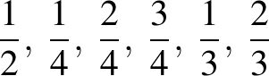
- interpret the denominator as the number of equal parts a whole has been divided into (Understanding)
- interpret the numerator as the number of equal fractional parts, eg means 3 equal parts of 4 (Understanding)
- add a fraction to a whole number using concrete materials and record the result as a mixed numeral, eg 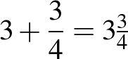
- add a fraction to another fraction, using concrete materials, so that the total is no more than one whole
- add a fraction to another fraction, using concrete materials, so that the total is more than one whole and represent this as a mixed numeral, eg five quarter-slices of pizza are equal to 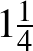 pizzas
- subtract a fraction from one whole using concrete materials, eg subtract three-quarters of a pizza from one whole pizza and find the fraction remaining
- find a unit fraction of a quantity, eg of $30, of 300 g, of 100 cm
- recognise that finding a unit fraction of a quantity is related to division, eg half of $60 is the same as $60 divided by 2 (Understanding, Fluency)
- find any fraction of a quantity, eg of $30, of 100 cm
- recognise the relationship between finding a unit fraction of a quantity and finding any fraction of a quantity, eg to find three-quarters of an hour, first find one-quarter of an hour and then multiply by 3 (Understanding, Fluency)
Decimals
- read numbers as decimals, eg 3.5 is read as 'three point five', 3.12 is read as 'three point one two'
- recognise the use of decimals in the community, eg advertisements for interest rates (Reasoning, Understanding)
- recognise the use of decimals for recording measurements, eg 3.5 metres means three and a half metres, timing swimming races to tenths and hundredths of a second (Communicating, Reasoning, Understanding)
- recognise decimal notation for commonly used fractions, eg = 0.5, = 0.25
- add and subtract numbers correct to two decimal places in the context of money, eg $2.25 + $1.25
- relate fractions to decimals in the context of parts of one dollar, eg 10 cents = 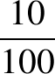 of $1 = $0.10, 50 cents = 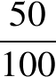 of $1 = $0.50
- interpret decimal notation for tenths and hundredths, eg 0.1 is the same as , 0.01 is the same as 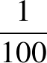
- interpret calculator displays involving decimals (Communicating, Reasoning, Understanding)
- compare decimals with the same number of decimal places, eg 0.3 is less than 0.5
- use a number line to position decimals between 0 and 1 (Communicating, Understanding, Fluency)
- round decimals in the context of money, eg round $4.99 to $5.00
- explain the result of rounding when purchasing goods where the total number of cents involved cannot be made up using 5-cent and/or 10-cent pieces, eg round $5.02 to $5.00, round $2.03 to $2.05 (Communicating, Reasoning, Understanding, Fluency)
Percentages
- read the symbol % as 'percent'
- recognise the use of the % symbol in a variety of contexts, eg advertising, discounts (Communicating, Understanding)
- recognise the fraction equivalent for commonly used percentages, eg 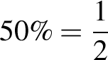, 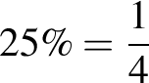, 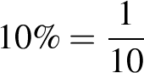
- recognise that percentages are parts of 100, eg 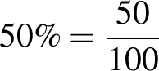
- interpret the use of percentages in everyday contexts
- interpret advertising and media reports involving percentages, eg 90% success rate for goal kicking, 25% more chocolate (Communicating, Reasoning, Understanding)
- decide which is the best interest rate offered for a loan using online calculators (Communicating, Reasoning, Fluency)
- calculate simple percentages of quantities, eg 10% off a $50 item, 10% GST on a bill
- recognise calculations as the same, eg finding 50% of a quantity is the same as dividing a quantity by 2 (Understanding, Fluency)
Life Skills
Number and Algebra
Operations: Addition and Subtraction
Outcomes
A student:
- responds to and uses mathematical language to demonstrate understanding MALS-1WM
- applies mathematical strategies to solve problems MALS-2WM
- uses reasoning to recognise mathematical relationships MALS-3WM
- selects and uses strategies for addition and subtraction MALS-10NA
Related Stage 4/5 outcome: MA4-4NA
Content
Students:
- model addition using concrete materials
- combine two or more groups of objects (Fluency, Understanding)
- compare two groups of objects to determine how many more are in the larger group (Reasoning, Understanding)
- model subtraction using concrete materials
- separate and take away part of a group of objects to model subtraction (Understanding, Fluency)
- respond to and use the language of addition and subtraction in everyday contexts, eg add, plus, take away, minus, the difference between
- recognise terms in a range of situations, eg the difference between scores in a computer game (Understanding)
- use terms in a range of situations, eg 'My allowance plus birthday money equals $50' (Communicating, Understanding)
- add two numbers using concrete materials and/or mental strategies
- count on from the larger number to find the total of two numbers (Communicating, Fluency)
- subtract a number from a given number using concrete materials and/or mental strategies
- count back from a number to find the number remaining (Communicating, Fluency)
- recognise and use the symbols +, – and =
- add two numbers using mental strategies, written processes and/or calculator strategies
- create combinations for numbers to at least 10, eg 'How many more to make 10?' (Understanding, Fluency)
- estimate the sum of two numbers and check by performing the calculation or using a calculator (Problem Solving, Fluency)
- subtract a number from a given number using mental strategies, written processes and/or calculator strategies
- estimate how much will be left over when one number is subtracted from another and check by performing the calculation or using a calculator (Fluency, Problem Solving)
- add more than two numbers, eg 6 + 2 + 5, using mental strategies, written processes and/or calculator strategies
- subtract more than two numbers, eg 6 – 4 – 2, using mental strategies, written processes and/or calculator strategies
- select and apply appropriate mental strategies, written processes and/or calculator strategies for addition and subtraction to solve problems in a range of contexts
- calculate the total cost when purchasing more than one item, eg the total cost of a $2.50 juice and a $4.50 sandwich (Problem Solving, Fluency)
- calculate the change when purchasing items, eg the change from $10 when purchases total $3.50 (Problem Solving, Fluency)
Life Skills
Number and Algebra
Operations: Multiplication and Division
Outcomes
A student:
- applies mathematical strategies to solve problems MALS-2WM
- uses reasoning to recognise mathematical relationships MALS-3WM
- selects and uses strategies for multiplication and division MALS-11NA
Related Stage 4/5 outcome: MA4-4NA
Content
Students:
- model multiplication using concrete materials
- combine equal groups of objects, eg three boxes each containing four pencils (Understanding, Fluency)
- model division using concrete materials
- share a group of objects equally among people, eg 12 balls among 3 students (Understanding, Fluency)
- use repeated subtraction with concrete materials, eg determine how many bags of golf balls can be created by placing 5 golf balls into each bag (Understanding, Fluency)
- respond to and use the language of multiplication and division in everyday contexts, eg lots of, groups of, shares, equal groups
- recognise terms in a range of situations, eg 'Two groups of football supporters were at the game' (Understanding)
- use terms in a range of situations, eg 'My share of the money is $10' (Communicating, Understanding)
- multiply two numbers using concrete materials and/or mental strategies
- collect groups of items from two or more people and determine how many items there are altogether (Understanding, Fluency)
- divide two numbers using concrete materials and/or mental strategies
- share a number of items between two or more people using concrete materials (Understanding, Fluency)
- recognise and use the symbols ×, ÷ and =
- multiply two numbers using mental strategies, written processes and/or calculator strategies
- multiply numbers using an array of equal rows, eg
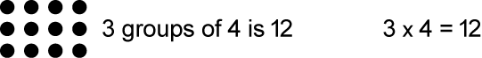 (Fluency)
- determine the quantities needed when preparing a meal for several people using a recipe based on ingredients for one person (Problem Solving)
- estimate the product of two numbers and check by performing the calculation or using a calculator (Problem Solving, Fluency)
- divide two numbers using mental strategies, written processes and/or calculator strategies
- divide numbers using an array of equal rows, eg
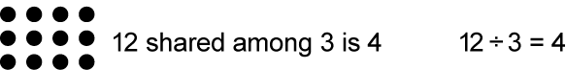(Fluency)
- determine the quantities needed when preparing a meal for one person using a recipe based on ingredients for four people (Problem Solving)
- calculate the cost of a single item when given the price of a pack containing several items (Problem Solving, Fluency)
- estimate the result when dividing two numbers and check by performing the calculation or using a calculator (Problem Solving, Fluency)
- multiply more than two numbers, eg 3 × 5 × 2, using mental strategies, written processes and/or calculator strategies
- divide by one number followed by another, eg 20 ÷ 5 ÷ 2, using mental strategies, written processes and/or calculator strategies
- select and apply appropriate mental strategies, written processes and/or calculator strategies for multiplication and division to solve problems in a range of contexts
- determine the total cost of a number of items, given the price of one, eg calculate the combined cost of train travel over two or more days for two or more people (Problem Solving, Fluency)
- determine the unit cost of an item or service when sold as a group, eg calculate the daily cost of shared accommodation over a set period of time for two or more people (Problem Solving, Fluency)
Life Skills
Number and Algebra
Money: Recognising and Matching Money
Outcomes
A student:
- responds to and uses mathematical language to demonstrate understanding MALS-1WM
- applies mathematical strategies to solve problems MALS-2WM
- recognises and matches coins and notes MALS-12NA
Related Stage 4/5 outcomes: MA4-6NA , MA5.1-4NA , MA5.2-4NA
Content
Students:
- recognise a range of Australian coins and notes
- use the terms 'coin' and 'note' when referring to money, eg 20-cent coin, $10 note (Communicating)
- match coins and notes
- sort coins and notes into groups on the basis of face value
- recognise alternative forms of currency in ancient cultures, eg the bartering system used by Aboriginal and Torres Strait Islander cultures
- recognise and use appropriate coins to purchase items
- recognise and use groups of coins to purchase items
- recognise and use appropriate notes to purchase items
- indicate the most appropriate note to purchase an item in a shop (Communicating, Understanding)
- recognise some coins and notes of foreign currencies, such as Asian currencies
Life Skills
Number and Algebra
Money: Comparing and Ordering Money
Outcomes
A student:
- applies mathematical strategies to solve problems MALS-2WM
- uses reasoning to recognise mathematical relationships MALS-3WM
- compares and orders coins and notes MALS-13NA
Related Stage 4/5 outcomes: MA4-6NA , MA5.1-4NA , MA5.2-4NA
Content
Students:
- recognise that coins and notes have different values
- order coins and notes on the basis of face value (Understanding, Fluency)
- recognise that the value of a coin is not necessarily related to its size, eg a $2 coin is smaller in size but greater in value than a 20-cent coin (Understanding)
- order silver coins
- identify whether a coin is worth more or less than other coins (Reasoning)
- order gold coins
- order notes
- identify whether a given note is worth more or less than other notes (Reasoning)
- order coins and notes
- compare and order a combination of coins and notes when gathering money to purchase an item (Communicating, Reasoning)
Life Skills
Number and Algebra
Money: Reading and Writing Amounts of Money
Outcomes
A student:
- responds to and uses mathematical language to demonstrate understanding MALS-1WM
- applies mathematical strategies to solve problems MALS-2WM
- reads and writes amounts of money MALS-14NA
Related Stage 4/5 outcomes: MA4-6NA , MA5.1-4NA , MA5.2-4NA
Content
Students:
- read the face value of Australian coins and notes
- read amounts in cents
- read amounts in dollars and cents
- write amounts in cents, eg 35 cents is written as 35c
- write amounts in dollars, eg 5 dollars is written as $5
- write amounts of money using decimal notation
- write amounts of money involving cents, dollars, and combinations of dollars and cents, eg $0.25, $5.00, $4.75, $89.95 (Communicating, Fluency)
- write amounts of money in words
- complete a deposit form using words and decimal notation (Communicating, Understanding, Fluency)
- use the language of money, eg dollars, cents, purchase, cost, change, in a range of contexts
Life Skills
Number and Algebra
Money: Calculating with Money
Outcomes
A student:
- applies mathematical strategies to solve problems MALS-2WM
- uses reasoning to recognise mathematical relationships MALS-3WM
- calculates with money MALS-15NA
Related Stage 4/5 outcomes: MA4-6NA , MA5.1-4NA , MA5.2-4NA
Content
Students:
- add coins of the same denomination
- add coins of different denominations
- add notes of the same denomination
- count out notes of the same denomination, indicating the total value of the collection as each note is added, eg counting by $10 notes: $10, $20, $30, ... (Communicating, Fluency)
- add notes of different denominations
- combine a range of coins to demonstrate equivalence of value, eg 2 × 20-cent coins and 1 × 10-cent coin are equivalent to a 50-cent coin, 6 × 5-cent coins are equivalent to 3 × 10-cent coins
- determine the number of coins of each denomination required to form $1 in value, eg 5 × 20-cent coins, 10 × 10-cent coins (Problem Solving)
- combine a range of notes to demonstrate equivalence of value, eg 2 × $5 notes and 1 × $10 note are equivalent to a $20 note
- select and use coins and notes to purchase goods or services
- calculate amounts of money to purchase goods or services using mental strategies, written processes and/or calculator strategies
- recognise the cost of goods or services, eg read price tags attached to clothing, identify the cost of items in a supermarket as indicated on the shelf, read a noticeboard at a theatre to determine the price of entry
- identify the cost of items up to $10 in value by locating prices, eg a drink at the school canteen is $2, a magazine at the supermarket is $4.75 (Problem Solving, Understanding)
- identify the cost of items up to $100 in value by locating prices, eg a meal at a restaurant is $22, a jacket is $80, a pair of sunglasses is $99.95 (Problem Solving, Understanding)
- estimate amounts of money to purchase goods or services
- estimate the cost of a range of items and select the appropriate coin or note to pay for the items, eg select a $2 coin to pay for a drink or snack, select a $20 note to pay for a T-shirt, estimate that a $50 note will be needed to pay for a number of items at a supermarket (Communicating, Understanding, Fluency)
- select additional coins or notes to pay for an item if the original amount tendered was not sufficient (Reasoning, Understanding)
- calculate the amount of change due in relation to a transaction for goods or services, using mental strategies, written processes and/or calculator strategies
- calculate the change to be given when purchasing an item, eg calculate the change to be given when purchasing a $2.50 magazine with a $5 note and count the coins received in change (Problem Solving, Reasoning)
- estimate the amount of change due in relation to a transaction for goods or services
- estimate the amount of change due for a purchase and check using a calculator, eg the change due following a purchase of $3.50 if a $5 note is tendered (Problem Solving, Reasoning)
Life Skills
Number and Algebra
Money: Making Decisions About Purchasing
Outcomes
A student:
- responds to and uses mathematical language to demonstrate understanding MALS-1WM
- applies mathematical strategies to solve problems MALS-2WM
- uses reasoning to recognise mathematical relationships MALS-3WM
- makes informed decisions about purchasing goods and services MALS-16NA
Related Stage 4/5 outcomes: MA4-6NA , MA5.1-4NA , MA5.2-4NA
Content
Students:
- recognise the relationship between value and price for a range of goods and services
- compare costs of goods and services
- calculate discounts and compare them to full prices (Reasoning, Fluency)
- compare the cost of goods using price comparison websites (Reasoning, Fluency)
- compare, using the internet, interest rates and other costs for loans and interest rates for investments (Reasoning, Fluency)
- determine the value of a range of goods and services
- investigate 'unit pricing' used by retailers and determine the best buy (Understanding, Fluency)
- determine the value of 'deals' when purchasing goods or services, eg 'buy-one-get-one-free', 'buy-one-get-another-half-price' (Problem Solving, Fluency)
- determine the costs involved when purchasing by different means, eg cash, lay-by, credit card, loan, online (Problem Solving, Reasoning)
- identify the implications of terms and conditions, eg fees, penalties, interest, warranties
- investigate the processes of refunding and exchanging goods
- recognise the difference between refunding and exchanging goods (Communicating, Understanding)
- recognise how refund and exchange policies vary between businesses, eg time limits, condition of the product, sale items (Reasoning, Understanding)
- understand the process involved when refunding or exchanging an item, such as producing a receipt as proof of purchase (Understanding)
- recognise the relationship between a warranty and value
- recognise the purpose of a warranty, eg for refund, exchange, repair of faulty goods or services (Communicating, Reasoning, Understanding)
- identify types of goods and services that offer warranties (Understanding)
- recognise how warranty policies vary between businesses, eg the length of the warranty, what is covered, the cost, the receipt as proof of purchase, registering online, extended warranties (Communicating, Reasoning, Understanding)
- demonstrate an understanding of why someone would purchase a warranty (Communicating, Reasoning)
Life Skills
Number and Algebra
Money: Personal Finance
Outcomes
A student:
- responds to and uses mathematical language to demonstrate understanding MALS-1WM
- applies mathematical strategies to solve problems MALS-2WM
- plans and manages personal finances MALS-17NA
Related Stage 4/5 outcomes: MA4-6NA , MA5.1-4NA , MA5.2-4NA
Content
Students:
- identify financial matters that influence daily life, eg spending, earning, saving
- allocate amounts of money from an allowance for specific purposes, eg 'From my $10 allowance I need to keep $4 for pool entry, so I have $6 to spend or save' (Communicating, Problem Solving, Fluency)
- calculate earnings from a range of sources, eg allowance, casual or part-time work
- use a pay slip to determine an amount of pay (Understanding)
- calculate a week's wage, given the hourly rate of pay and number of hours worked (Fluency)
- read and interpret a timesheet to calculate weekly earnings (Fluency)
- interpret information from a variety of bills
- recognise common terms used on bills, eg 'amount due', 'interest charged', 'discount', 'due date' (Understanding)
- interpret the variety of payment options, eg BPAY, direct debit, phone payments using credit card (Communicating, Understanding)
- interpret information presented graphically, eg electricity usage (Communicating, Understanding)
- manage income and expenditure
- check bank statements online (Understanding, Fluency)
- investigate different methods for making payments, eg direct debit (Understanding)
- use digital technologies to manage accounts, eg alerts and reminders via SMS and email (Understanding, Fluency)
- balance expenses with available funds
- identify personal funds available for specific purposes, eg 'From my weekly wage I have saved $30 this month, which I can spend at the movies on Saturday' (Communicating, Problem Solving, Fluency)
- calculate the amount of time it will take to save for items at a specific amount per week or month (Problem Solving, Fluency)
- develop a budget, with or without the use of digital technologies, to meet personal financial needs (Communicating, Problem Solving, Understanding, Fluency)
- identify and describe financial terms, eg income, expenditure, saving, borrowing, interest
- use a variety of banking services, eg over the counter, ATM, EFTPOS, cheque book, telephone banking, internet banking, credit card (Understanding, Fluency)
- keep and check records of financial transactions, eg keep card number and PIN confidential and in a safe place, retain card and receipt after using ATM, retain and check receipts after purchasing goods and services, record receipt number when using telephone or internet services to make payments (Problem Solving, Understanding)
- retain and review bank statements (Problem Solving, Understanding)
Life Skills
Number and Algebra
Patterns and Algebra: Repeating Patterns
Outcomes
A student:
- responds to and uses mathematical language to demonstrate understanding MALS-1WM
- uses reasoning to recognise mathematical relationships MALS-3WM
- recognises and continues repeating patterns MALS-18NA
Related Stage 4/5 outcome: MA4-8NA
Content
Students:
- recognise what comes next in a repeating pattern of familiar objects,
eg blue button, red button, blue button, red button, _____
- copy a pattern involving familiar objects (Understanding, Fluency)
- complete a pattern involving familiar objects, eg a place setting at a dinner table, put a program on every second chair (Communicating, Understanding, Fluency)
- recognise what comes next in a simple pattern of shapes
- recognise repeating patterns of shapes in a range of contexts, eg paving patterns, wallpaper, Aboriginal artwork (Understanding)
- recognise what comes next in a simple sound or action pattern,
eg two claps, one clap, two claps, _____
- recognise repeating patterns of sounds or actions in a range of contexts, eg dance, music (Understanding)
- identify patterns used in familiar activities such as games, eg dominoes, Mahjong
- recognise when an error occurs in a pattern and describe what is wrong, eg when making a bracelet, recognise that a red bead has been used instead of a blue bead and correct the error
- create number patterns using concrete materials
- continue simple number patterns that increase, eg 2, 4, 6, 8, __
- continue simple number patterns that decrease, eg 9, 7, 5, 3, __
- describe number patterns when counting forwards or backwards, eg for 3, 6, 9, 12, … where 'three is added each time'
Life Skills
Number and Algebra
Patterns and Algebra: Number Sentences
Outcomes
A student:
- responds to and uses mathematical language to demonstrate understanding MALS-1WM
- applies mathematical strategies to solve problems MALS-2WM
- calculates missing values by completing simple number sentences MALS-19NA
Related Stage 4/5 outcomes: MA4-7NA , MA4-10NA , MA5.2-8NA
Content
Students:
- complete number sentences involving one operation by calculating missing values,
eg find if 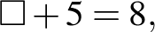 find if
- describe strategies for calculating missing values (Communicating, Understanding)
- use a number sentence to solve a given problem, eg 'I have $25 and the CD costs $31. How much more money do I need to purchase the CD?'; this can be solved by 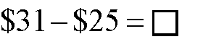
Life Skills
Measurement and Geometry
Time: Recognising Time
Outcomes
A student:
- responds to and uses mathematical language to demonstrate understanding MALS-1WM
- recognises time in familiar contexts MALS-20MG
Related Stage 4/5 outcome: MA4-15MG
Content
Students:
- sequence regular daily activities
- use a pictorial, written or electronic diary or timetable to sequence activities (Communicating, Understanding, Fluency)
- demonstrate an awareness of the passage of time, eg the time to cook an egg using an egg timer is less than the lunch period in a school day
- recognise the language of time in relation to personal activities and events, eg 'It is now 12 o'clock and it's time for lunch', 'It is time to pack up because the bus will be here in 10 minutes'
- associate familiar activities with times of the day
- recognise an association between a time of the day and a range of familiar activities, eg morning and evening activities (Communicating, Understanding)
- associate familiar activities with days and weeks
- identify activities that occur on weekdays, eg school and class timetables, after-school activities (Understanding)
- identify activities that occur on the weekend, eg sport, outings (Understanding)
- identify activities that occur on specific days and at specific times, eg gym group is on Wednesday evenings during school terms, the dance is held every second Saturday in the afternoon (Understanding)
- associate activities at particular times of the day/year with temperatures and seasons, eg 'I go to swimming lessons in the summer' (Communicating, Understanding, Fluency)
Life Skills
Measurement and Geometry
Time: Relating Time
Outcomes
A student:
- responds to and uses mathematical language to demonstrate understanding MALS-1WM
- recognises and relates time in a range of contexts MALS-21MG
Related Stage 4/5 outcome: MA4-15MG
Content
Students:
- relate time to a personal context
- respond to questions related to time, eg 'What time does your bus leave?' (Communicating, Understanding)
- identify time related to personal activities, eg 'I need to catch the bus at 13 minutes past 5' (Communicating, Understanding)
- recognise the language of time in a range of everyday contexts
- respond to questions involving the language of time, eg 'Did you have your shower in the morning or evening?', 'Will you be going to training this afternoon?' (Communicating, Understanding)
- describe activities using the language of time in a range of everyday situations
- describe personal activities and events, eg 'I did my homework after dinner last night', 'I will be going to the football tomorrow afternoon', 'There was a delay of half an hour this morning on the school bus', 'I will be going to a barbecue next weekend', 'The holidays are only three weeks away' (Communicating, Understanding)
- recognise language related to representations of time on a calendar, eg a week is seven days, a weekend is two days, a fortnight is two weeks or 14 days, a month is about four weeks or a certain number of days
- recognise methods used by some cultures for representing calendar time, eg the use of animal migration patterns by Aboriginal and Torres Strait Islander peoples to indicate seasons
Life Skills
Measurement and Geometry
Time: Interpreting Time
Outcomes
A student:
- responds to and uses mathematical language to demonstrate understanding MALS-1WM
- applies mathematical strategies to solve problems MALS-2WM
- reads and interprets time in a variety of situations MALS-22MG
Related Stage 4/5 outcome: MA4-15MG
Content
Students:
Clocks and Watches
- read and relate 'hour', 'half-hour', 'quarter-hour' and 'minutes' in analog and digital formats in a range of contexts
- interpret digital formats of time to determine which numbers represent hours and which numbers represent minutes (Understanding)
- identify minutes and hours on a clock face (Understanding)
- count around a clock face by fives to determine minutes past the hour (Communicating, Fluency)
- understand the relationship between analog and digital time, eg '12:30 is the same as half past 12'
- identify and relate am and pm on digital clocks or watches, eg set an alarm clock for 7 am
- apply an understanding of the passage of time to plan or participate in a range of activities or events
Timetables
- read and interpret a written timetable in a range of formats and a variety of contexts, eg in coordinating travel arrangements
- read and follow an individual sequence chart, or timetable, for a range of activities (Understanding)
- read and follow a school timetable for group or class activities (Understanding)
- investigate and determine travel arrangements by using online transport timetables (Problem Solving, Fluency)
Calendars and Planners
- identify the names or symbols for the days of the week on a calendar
- identify the months of the year on a calendar
- locate special days and events on a calendar, eg 'ANZAC Day is the 25th of April'
- locate, on a calendar, the birthdays of significant people, eg family, friends (Understanding)
- identify representations of time on a calendar, eg week, weekend, fortnight, month
- identify the number of days, weeks or months between one event and another, eg 'It's three days until the weekend', 'There are four more weeks until the end of term' (Communicating, Understanding, Fluency)
- recognise different notations for the date, eg 5 September 2012 is represented as 2012.9.5 in Asian cultures
- recognise that calendars are used to plan events and activities, eg the school term plan in the newsletter, coming events in the newspaper
Life Skills
Measurement and Geometry
Time: Calculating and Measuring Time
Outcomes
A student:
- responds to and uses mathematical language to demonstrate understanding MALS-1WM
- applies mathematical strategies to solve problems MALS-2WM
- uses reasoning to recognise mathematical relationships MALS-3WM
- calculates and measures time and duration in everyday contexts MALS-23MG
Related Stage 4/5 outcome: MA4-15MG
Content
Students:
- identify the duration of a range of activities and events for a variety of purposes
- select a track of music to fit a time frame, eg for a dance piece, a multimedia presentation (Problem Solving)
- identify the length of time needed to watch a movie to determine if the activity fits into a personal schedule (Problem Solving)
- measure and calculate the time taken for a variety of activities or events, eg use a stopwatch to time a race
- record starting and finishing times to calculate the duration of an activity or event (Communicating, Understanding, Fluency)
- use addition/subtraction strategies to calculate the duration of an activity or event (Fluency)
- recognise that there are different time zones around the world
- identify countries in the Asia–Pacific region that are in the same time zone as Australia (Understanding)
- compare and calculate the local times in a range of places nationally and internationally
- identify time differences between various locations, eg London is 10 hours behind Sydney (Understanding)
- use appropriate addition/subtraction strategies to calculate the local time in a particular location, eg given that London is 10 hours behind Sydney, find the time in London when it is 6 pm in Sydney (Fluency)
- solve problems about international time in everyday contexts, eg determine whether a soccer game in another country can be watched live on television in the daytime (Problem Solving)
- recognise the effect of daylight saving on local time (Reasoning, Understanding)
Life Skills
Measurement and Geometry
Time: Managing Time
Outcomes
A student:
- responds to and uses mathematical language to demonstrate understanding MALS-1WM
- applies mathematical strategies to solve problems MALS-2WM
- uses reasoning to recognise mathematical relationships MALS-3WM
- organises personal time and manages scheduled activities MALS-24MG
Related Stage 4/5 outcome: MA4-15MG
Content
Students:
- identify the amount of time needed for a range of activities
- recognise that specific activities require a particular amount of time, eg 'I need half an hour to have a shower and get dressed', 'It takes me 10 minutes to walk from home to the railway station' (Understanding)
- make choices and decisions about activities on the basis of time available, eg 'I can't make that movie because I have training at that time'
- schedule events over a day or week, taking into account a range of activities and personal responsibilities
- identify priorities in relation to personal time, and discriminate between essential and non-essential activities (Communicating, Reasoning, Understanding)
- plan personal time over a day or a week so that activities do not clash (Problem Solving)
- prepare and follow a personal timetable/schedule
- use electronic formats of calendars and planners (Fluency)
- use a calendar/diary to plan for regular activities, eg swimming every second Friday, PE each Tuesday (Understanding, Fluency)
- use a calendar to plan events and activities, eg camp, birthday party (Understanding, Fluency)
- use a calendar or planner to calculate the time needed for particular activities, eg block out three weeks for completion of a school project (Understanding, Fluency)
Life Skills
Measurement and Geometry
Measurement: Estimating and Measuring
Outcomes
A student:
- responds to and uses mathematical language to demonstrate understanding MALS-1WM
- estimates and measures in everyday contexts MALS-25MG
Related Stage 4/5 outcome: MA4-12MG
Content
Students:
- recognise attributes that can be measured, eg length, temperature, mass, volume, capacity, area
- recognise the language associated with attributes of length, temperature, mass, volume, capacity and area:
- length, short, tall, higher than, lower than
- temperature, eg hot, cold, warm, lukewarm, freezing, boiling, hotter, colder
- mass of objects, eg light, heavy, harder to push/pull, heavier, lightest
- volume and capacity, eg full, empty, half-full, has more/less, will hold more/less
- area, eg bigger/smaller than, surface
- make comparisons based on attributes that can be estimated and measured, eg 'I am taller than my brother', 'John is the tallest in the class':
- length, eg longer than, shorter than
- height, eg taller than, shortest
- temperature, eg hotter than, colder than
- mass, eg heavier, lighter
- capacity, eg fullest, emptier
- area, eg bigger, smaller, smallest
- recognise the appropriate device for measuring attributes of length, temperature, mass, volume and capacity:
- length (or distance), eg ruler, measuring tape, trundle wheel, odometer
- temperature, eg thermometer
- mass, eg scales, weigh station
- capacity, eg measuring cup, measuring spoon
- investigate how the odometer of a car can measure distance (Understanding)
- recognise that some countries use different units of measurement
Life Skills
Measurement and Geometry
Measurement: Length
Outcomes
A student:
- responds to and uses mathematical language to demonstrate understanding MALS-1WM
- uses reasoning to recognise mathematical relationships MALS-3WM
- recognises and uses units to estimate and measure length MALS-26MG
Related Stage 4/5 outcome: MA4-12MG
Content
Students:
- recognise features of an object associated with length that can be estimated and measured, eg length, breadth, height
- use informal units to estimate and measure length, eg measure the length of a table in equal hand spans, without gaps or overlaps
- compare and order two or more lengths or distances using informal units (Communicating, Problem Solving, Understanding)
- recognise the appropriate unit, and its abbreviation, for measuring length, eg centimetre (cm), metre (m), kilometre (km)
- select and use the appropriate unit and device for measuring length, eg measure the heights of students in the class using a metre ruler and record the results in a table
- recognise the relationship between commonly used units for measuring length, eg 1 m = 100 cm
- estimate the lengths of everyday objects and check using a measuring device, eg estimate the length of a room and check using a measuring tape
- identify the concept of length in a problem (Understanding)
- select and use appropriate strategies, and make calculations, to solve a problem (Communicating, Problem Solving, Fluency)
- convert measurements of length in larger units to measurements in smaller units, eg 3 m = 300 cm
Life Skills
Measurement and Geometry
Measurement: Mass
Outcomes
A student:
- responds to and uses mathematical language to demonstrate understanding MALS-1WM
- applies mathematical strategies to solve problems MALS-2WM
- selects and uses units to estimate and measure mass MALS-27MG
Content
Students:
- recognise features of an object associated with mass that can be estimated and measured, eg weight
- use informal units to estimate and compare masses, eg 'This book is heavier than the other one'
- compare and order the masses of two or more objects by lifting them and then check using an equal-arm balance (Communicating, Problem Solving, Understanding)
- recognise the appropriate unit, and its abbreviation, for measuring mass, eg gram (g), kilogram (kg)
- select and use the appropriate unit and device for measuring mass, eg weigh a piece of steak using kitchen scales and record the weight for a recipe
- recognise the relationship between commonly used units for measuring mass, eg 1 kg = 1000 g
- estimate the mass of everyday objects and check using a measuring device, eg estimate the weight of a soccer ball and check using scales
- identify the concept of mass in a problem (Understanding)
- select and use appropriate strategies, and make calculations, to solve a problem (Communicating, Problem Solving, Fluency)
- convert measurements of mass in larger units to measurements in smaller units, eg 3 kg = 3000 g
Life Skills
Measurement and Geometry
Measurement: Volume and Capacity
Outcomes
A student:
- responds to and uses mathematical language to demonstrate understanding MALS-1WM
- uses reasoning to recognise mathematical relationships MALS-3WM
- selects and uses units to estimate and measure volume and capacity MALS-28MG
Related Stage 4/5 outcomes: MA4-14MG, MA5.2-12MG
Content
Students:
- use informal units to estimate and measure capacity, eg count the number of times a glass can be filled and emptied into a jug
- use informal units to estimate and measure volume, eg count the number of same-sized marbles required to fill a box, ensuring there are no large spaces
- compare and order the volumes of two or more models by counting the number of blocks used in each model (Communicating, Problem Solving, Understanding)
- recognise the appropriate unit, and its abbreviation, for measuring capacity, eg millilitre (mL), litre (L)
- select and use the appropriate unit and device for measuring volume and capacity, eg a medicine glass for medicine, measuring cups for recipes
- recognise the relationship between commonly used units for measuring volume and capacity, eg 1 L = 1000 mL
- estimate the capacities of everyday objects and check using a measuring device, eg estimate the capacity of a bucket and check using a measuring jug
- identify the concept of volume/capacity in a problem (Understanding)
- select and use appropriate strategies, and make calculations, to solve a problem (Communicating, Problem Solving, Fluency)
- convert measurements of volume/capacity in larger units to measurements in smaller units, eg 3 L = 3000 mL
Life Skills
Measurement and Geometry
Measurement: Area
Outcomes
A student:
- responds to and uses mathematical language to demonstrate understanding MALS-1WM
- uses reasoning to recognise mathematical relationships MALS-3WM
- applies formal units to estimate and calculate area MALS-29MG
Related Stage 4/5 outcomes: MA4-13MG, MA5.1-8MG, MA5.2-11MG
Content
Students:
- use informal units to estimate and calculate area, eg count the number of equal-sized pieces of paper required to cover a table, without gaps or overlaps
- compare the areas of two similar shapes by cutting out the shapes and placing one over the other (Communicating, Problem Solving, Understanding)
- recognise the appropriate unit, and its abbreviation, for measuring area, eg square centimetre (cm²), square metre (m²)
- select and use the appropriate unit and device for measuring area, eg measure area using a grid overlay
- estimate the areas of everyday objects and check using a measuring device, eg estimate the area of the classroom and check with a tape measure and calculations
- identify the concept of area in a problem (Understanding)
- select and use appropriate strategies, and make calculations, to solve a problem (Communicating, Problem Solving, Fluency)
Life Skills
Measurement and Geometry
Two-Dimensional and Three-Dimensional Space: Recognising Objects and Shapes
Outcomes
A student:
- responds to and uses mathematical language to demonstrate understanding MALS-1WM
- applies mathematical strategies to solve problems MALS-2WM
- uses reasoning to recognise mathematical relationships MALS-3WM
- recognises, matches and sorts three-dimensional objects and/or two-dimensional shapes MALS-30MG
Related Stage 4/5 outcomes: MA4-14MG, MA4-17MG, MA5.2-12MG
Content
Students:
- recognise three-dimensional objects in the environment
- identify and name three-dimensional objects that are used in everyday situations, eg cones, cubes, cylinders (Communicating, Understanding)
- identify three-dimensional objects in pictures, in computer displays and in the environment (Understanding)
- match three-dimensional objects based on an attribute, eg shape, colour, size, function
- sort three-dimensional objects based on an attribute, eg shape, colour, size, function
- sort objects on the basis of their shape, colour, size and function, eg crockery, cutlery, sports equipment, clothes for washing (Understanding)
- indicate the reasons for sorting objects in a particular way (Communicating, Reasoning)
- predict and describe the ways in which particular objects can be stacked and test predictions by stacking the objects (Communicating, Problem Solving, Reasoning)
- recognise three-dimensional objects when presented in different orientations using dynamic geometry software
- identify two-dimensional shapes found in the environment
- match two-dimensional shapes based on an attribute, eg size, shape
- match circles, squares, triangles and rectangles (Understanding)
- sort two-dimensional shapes based on an attribute, eg the number of corners or sides
- circle all the three-sided shapes in a group of mixed shapes (Understanding)
- construct a table classifying shapes according to their number of angles (Communicating, Reasoning, Understanding)
- match and sort two-dimensional shapes when presented in different orientations using dynamic geometry software
Life Skills
Measurement and Geometry
Two-Dimensional and Three-Dimensional Space: Features of Objects and Shapes
Outcomes
A student:
- responds to and uses mathematical language to demonstrate understanding MALS-1WM
- applies mathematical strategies to solve problems MALS-2WM
- identifies the features of three-dimensional objects and/or two-dimensional shapes and applies these in a range of contexts MALS-31MG
Related Stage 4/5 outcomes: MA4-14MG, MA4-17MG, MA5.2-12MG
Content
Students:
- describe the features of common three-dimensional objects using everyday language, eg flat, round, curved
- describe the features of common two-dimensional shapes using everyday language, eg sides, corners
- recognise similarities and differences between a variety of three-dimensional objects in a range of contexts
- recognise and describe the attributes of two-dimensional shapes
- identify circles, squares, triangles and rectangles in the built environment (Understanding)
- draw two-dimensional shapes using computer software (Communicating, Understanding, Fluency)
- identify the result of putting together (or separating) two-dimensional shapes, eg 'This house shape is made up of a triangle and a square'
- apply knowledge of the features of three-dimensional objects in a range of contexts
- pack a lunch box, organise a pantry, stack shelves (Problem Solving)
- complete a technology project involving materials of different shapes and sizes, eg a quilt for textiles, wood inlay (Problem Solving)
- construct and describe models involving a variety of three-dimensional objects (Communicating, Problem Solving, Understanding)
- apply knowledge of the features of two-dimensional shapes in a range of contexts
- make representations of two-dimensional shapes using a variety of materials (Communicating, Understanding)
- put a ticket/card into the correct slot in a machine (Reasoning, Understanding)
Life Skills
Measurement and Geometry
Position: Language
Outcomes
A student:
- responds to and uses mathematical language to demonstrate understanding MALS-1WM
- responds to and uses the language of position in everyday contexts MALS-32MG
Related Stage 4/5 outcomes: MA4-11NA , MA5.1-6NA , MA5.1-11MG
Content
Students:
- recognise and respond to the language of position in a range of contexts
- identify preference for a position in response to a question, eg 'Would you rather lie on your side or sit in the chair?', 'Would you rather sit next to John or Sam?' (Communicating, Understanding)
- follow spoken instructions relating to the language of position, eg 'Put your bag on the top hook', 'Take the books from the cupboard behind the desks', 'Please move inside the carriage' (Understanding)
- follow symbols and written instructions relating to the language of position, eg follow arrows to locate an office on an upper floor, follow symbols to carry a container right side up, follow written instructions to stack items in a storeroom (Understanding, Fluency)
- use the language of position
- indicate the positions of objects or buildings in response to a question, eg 'The books are on the shelf in the classroom', 'The seats are under the trees in the playground', 'The supermarket is next to the garage in the main street', 'The yellow tulips are in the middle of the row in the garden' (Communicating, Understanding)
- describe the positions of objects or buildings in a range of contexts, eg 'I went to the ticket office inside the railway station', 'The bus stop is opposite the main gate', 'Appliances are located on the ground floor', 'This lift goes to the upper level', 'Tickets are purchased at the office beside the turnstiles' (Communicating, Understanding)
- give instructions relating to the language of position in a range of contexts, eg 'Stand behind the line to throw the ball', 'Walk towards the doorway', 'Turn left at the top of the stairs' (Communicating, Understanding)
Life Skills
Measurement and Geometry
Position: Recognising Maps and Plans
Outcomes
A student:
- responds to and uses mathematical language to demonstrate understanding MALS-1WM
- applies mathematical strategies to solve problems MALS-2WM
- recognises that maps and plans are a representation of positions in space MALS-33MG
Related Stage 4/5 outcomes: MA4-11NA , MA5.1-6NA , MA5.1-11MG
Content
Students:
- recognise the purpose and functions of maps and plans, eg to provide directions, to show the location of objects/features, to represent landforms
- recognise that plans can represent buildings, eg the classroom
- identify how key features, such as doors, windows, tables, chairs and cupboards, are represented on a plan
- construct or draw a plan showing key features of specific environments, eg the classroom, school, community (Communicating, Problem Solving)
- locate floor plans of properties for sale on the internet and interpret them (Understanding, Fluency)
- recognise different cultural representations of maps, including in Aboriginal and Torres Strait Islander cultures
- identify inventions that have assisted map reading, eg the compass invented in China
Life Skills
Measurement and Geometry
Position: Using Maps and Plans
Outcomes
A student:
- responds to and uses mathematical language to demonstrate understanding MALS-1WM
- applies mathematical strategies to solve problems MALS-2WM
- uses maps and plans in a range of contexts MALS-34MG
Related Stage 4/5 outcomes: MA4-11NA , MA5.1-6NA , MA5.1-11MG
Content
Students:
- use maps and plans to locate position and follow routes
- locate a seat on a plan of a movie theatre (Understanding)
- locate the classroom on a plan of the school (Understanding)
- locate a house or street using a printed or online map, eg Google Earth (Understanding)
- use a map to show direction from the classroom to the library (Communicating, Problem Solving, Understanding)
- identify direction on a map, eg north/south, left/right (Communicating, Understanding)
- use maps for a variety of purposes, eg a street directory, web-based maps, GPS technology
- use a map to find a location (Problem Solving, Understanding)
- locate specific sites using grid references in street directories and on road maps (Communicating, Problem Solving, Understanding)
- identify and describe features of an environment using map keys/legends (Communicating, Understanding)
Life Skills
Statistics and Probability
Data: Recognising Data
Outcomes
A student:
- responds to and uses mathematical language to demonstrate understanding MALS-1WM
- recognises data displayed in a variety of formats MALS-35SP
Related Stage 4/5 outcomes: MA4-19SP, MA5.1-12SP, MA5.2-15SP
Content
Students:
- recognise that information can be presented in tables and graphs, eg a picture graph to show favourite foods, column graph to show classroom gender, sector graph to represent sports students play, table to record daily rainfall
- identify information in graphs using features such as the heading/title of the graph, labels on axes, scale and key
- recognise data displayed in different ways, eg a table and graph to show daily temperatures over a week
- recognise ways in which data about the environment can be displayed, eg data about climate and population growth
Life Skills
Statistics and Probability
Data: Organising Data
Outcomes
A student:
- responds to and uses mathematical language to demonstrate understanding MALS-1WM
- applies mathematical strategies to solve problems MALS-2WM
- uses reasoning to recognise mathematical relationships MALS-3WM
- gathers, organises and displays data MALS-36SP
Related Stage 4/5 outcomes: MA4-19SP, MA5.1-12SP, MA5.2-15SP
Content
Students:
- collect data about themselves and their environment
- pose a question to be answered using a survey, eg 'What is the cultural background of students in the class?' (Communicating, Understanding)
- record collected data using a variety of means, eg concrete materials, symbols, words, tally marks (Communicating, Understanding)
- sort collected data into groups
- display data using tables, column graphs, line graphs and/or sector graphs (pie charts)
- use appropriate strategies, including the use of digital technologies, to display data (Communicating, Fluency, Understanding)
- follow conventions for displaying data, including equal spacing, same-sized symbols, key for symbols, headings, labels for axes (Communicating, Understanding, Fluency)
- gather and display data for a specific purpose, eg to determine the range of eye colour represented in a class of students
- select an appropriate method and use this to collect data, eg survey, questionnaire (Communicating, Problem Solving, Fluency)
- sort collected data appropriately (Communicating, Understanding, Fluency)
- decide on the most appropriate way to display collected data, eg line graph, sector graph, table (Understanding, Fluency)
- display data using concrete materials, eg use different-coloured counters/blocks to create a column graph to represent the favourite colours of students in the class (Communicating)
- construct data displays (Communicating, Understanding, Fluency)
- use spreadsheet software to construct data displays (Communicating)
- communicate and interpret findings from collected data (Communicating, Reasoning)
Life Skills
Statistics and Probability
Data: Interpreting Data
Outcomes
A student:
- responds to and uses mathematical language to demonstrate understanding MALS-1WM
- applies mathematical strategies to solve problems MALS-2WM
- uses reasoning to recognise mathematical relationships MALS-3WM
- interprets information and draws conclusions from data displays MALS-37SP
Related Stage 4/5 outcomes: MA4-19SP, MA5.1-12SP, MA5.2-15SP
Content
Students:
- interpret information presented in tables and graphs to answer questions, eg 'The columns show that there are more boys than girls', 'Swimming is the most popular sport among students in our class'
- interpret tables and graphs from a variety of sources, eg newspapers, television, internet
- compare tables and graphs constructed from the same data to determine which is the most appropriate method of display
- use spreadsheet software to construct different graphical representations of the same data set and determine the most appropriate display (Communicating, Reasoning)
- draw conclusions on the basis of the information displayed in tables and graphs
Life Skills
Statistics and Probability
Chance: Language of Chance
Outcomes
A student:
- responds to and uses mathematical language to demonstrate understanding MALS-1WM
- uses reasoning to recognise mathematical relationships MALS-3WM
- recognises and uses the language of chance in a range of contexts MALS-38SP
Related Stage 4/5 outcomes: MA4-21SP, MA5.1-13SP, MA5.2-16SP, MA5.2-17SP
Content
Students:
- distinguish between events that are certain and events that are uncertain, eg having a birthday, winning a lottery
- describe the likelihood of familiar events using informal terms, eg might, certain, probable, likely, unlikely, possible, impossible
- predict possible outcomes in everyday situations, eg decide what might occur in a movie before the ending of the story (Communicating, Reasoning)
- ask questions related to the likelihood of events, eg 'Do I need to take my umbrella if the sky is grey?' (Communicating, Reasoning)
- use the language of chance in everyday situations (Communicating, Understanding)
- order events from least likely to most likely
Life Skills
Statistics and Probability
Chance: Chance and Probability
Outcomes
A student:
- responds to and uses mathematical language to demonstrate understanding MALS-1WM
- applies mathematical strategies to solve problems MALS-2WM
- uses reasoning to recognise mathematical relationships MALS-3WM
- recognises the elements of chance and probability in everyday events MALS-39SP
Related Stage 4/5 outcomes: MA4-21SP, MA5.1-13SP, MA5.2-16SP, MA5.2-17SP
Content
Students:
- recognise the element of chance in familiar events, eg tossing a coin, rolling dice
- interpret numerical values assigned to the probability of events occurring in real-life contexts, eg 50:50, 1 in 2, 1 in 100, 1 in a million
- evaluate the probability of winning prizes in lotteries and other competitions, using online applications as appropriate (Communicating, Reasoning)
- conduct simple experiments to determine the probability of an outcome, eg spin a spinner 20 times and predict, record and communicate the results

Assessment

Standards
The Board of Studies K–10 Curriculum Framework is a standards-referenced framework
that describes, through syllabuses and other documents, the expected learning outcomes
for students.
Standards in the framework consist of three interrelated elements:
- outcomes and content in syllabuses showing what is to be learned
- stage statements that summarise student achievement
- samples of work on the Board’s Assessment Resource Centre (ARC) website, which provide examples of levels of achievement within a stage.
Syllabus outcomes in Mathematics contribute to a developmental sequence in which students are challenged to acquire new knowledge, skills and understanding.

Assessment
Assessment is an integral part of teaching and learning. Well-designed assessment is central
to engaging students and should be closely aligned to the outcomes within a stage. Effective assessment increases student engagement in their learning and leads to enhanced student outcomes.
Assessment for Learning, Assessment as Learning and Assessment of Learning are three approaches to assessment that play an important role in teaching and learning. The Board of Studies Years K–10 syllabuses particularly promote Assessment for Learning as an essential component of good teaching.
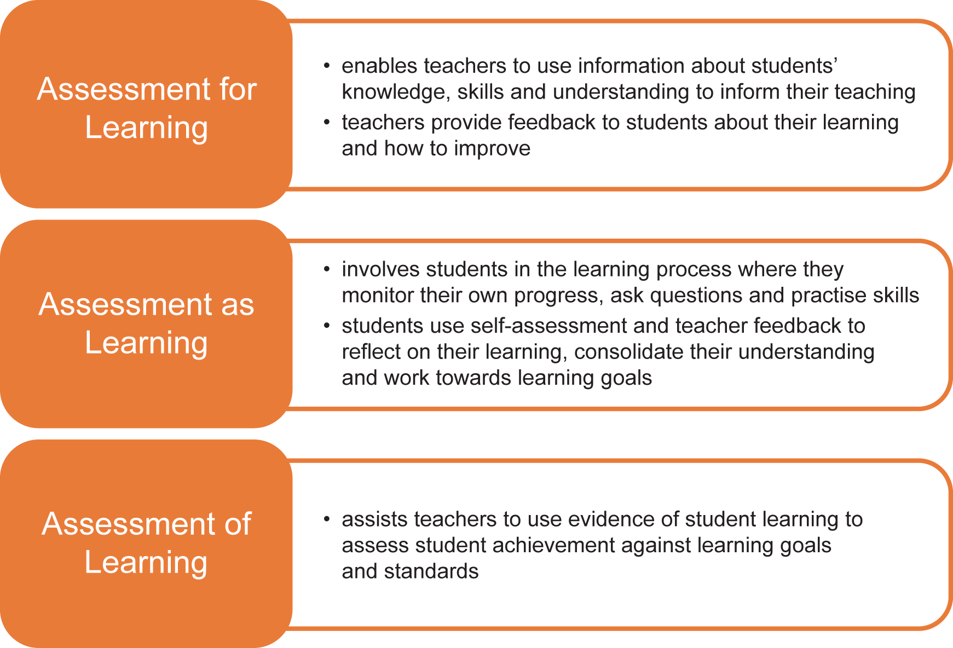
Further advice on programming and appropriate assessment practice in relation to the Mathematics syllabus is contained in Mathematics Years K–10: Advice on Programming
and Assessment. This support document provides general advice on assessment as well
as strategies to assist teachers in planning education programs.

Assessment for students with special education needs
Some students with special education needs will require adjustments to assessment practices in order to demonstrate what they know and can do in relation to syllabus outcomes and content. These may be:
- adjustments to the assessment process, for example additional time, rest breaks, quieter conditions, or the use of a reader and/or scribe or specific technology
- adjustments to assessment activities, for example rephrasing questions, using simplified language, fewer questions or alternative formats for questions
- alternative formats for responses, for example written point form instead of essays, scaffolded structured responses, short objective questions or multimedia presentations.
Further examples of adjustments to assessment for students with special education needs can be found in the Mathematics support material.

Life Skills assessment
Each student undertaking Mathematics Years 7–10 Life Skills will study selected outcomes
and content. The syllabus outcomes and content form the basis of learning opportunities
for students.
Assessment should provide opportunities for students to demonstrate achievement in relation to the outcomes and to apply their knowledge, skills and understanding to a range of situations or environments, including the school and the wider community.
Students may demonstrate achievement in relation to Mathematics Years 7–10 Life Skills outcomes independently, with adjustments, or with support. The type of adjustments and support will vary according to the particular needs of the student and the requirements of
the activity.
Further information about the assessment of students undertaking Life Skills outcomes
and content can be found in Life Skills Years 7–10: Advice on Planning, Programming
and Assessment.

Reporting
Reporting is the process of providing feedback to students, parents and other teachers about student progress.
Teachers use assessment evidence to extend the process of assessment for learning into their assessment of learning. In a standards-referenced framework, teachers make professional judgements about student achievement at key points in the learning cycle. These points may
be at the end of a year or stage, when schools may wish to report differentially on the levels
of knowledge, skills and understanding demonstrated by students.
Descriptions of student achievement in Mathematics provide schools with a useful tool to report consistent information about student achievement to students and parents, and to the next teacher to help plan the next steps in the learning process.
The A–E grade scale or equivalent provides a common language for reporting by describing observable and measurable features of student achievement at the end of a stage, within
the indicative hours of study. Teachers use the descriptions of the standards to make a professional, on-balance judgement, based on available assessment information, to match
each student’s achievement to a description. The Common Grade Scale (A–E) or equivalent
is used by teachers to report student levels of achievement from Stage 1 to Stage 5.
For students with special education needs, teachers may need to consider, in consultation with their school and sector, the most appropriate method of reporting student achievement. It may be deemed more appropriate for students with special education needs to be reported against outcomes or goals identified through the collaborative curriculum planning process. There is
no requirement for schools to use the Common Grade Scale (A–E) or equivalent to report achievement of students undertaking Life Skills outcomes and content.

Glossary
The following glossary was developed by the Australian Curriculum, Assessment and Reporting Authority (ACARA) (as accessed from the ACARA website at www.acara.edu.au on 9 July 2012) and is included here to assist teachers in the implementation of the Mathematics K–10 Syllabus.
For any additional information regarding the glossary, please see the ACARA website. Enquiries regarding the content of the glossary should be directed to ACARA.
adjacent angles | Two angles at a point are called adjacent if they share a common ray and a common vertex.  Hence, in the diagram,  - and are adjacent, and  - and are adjacent.  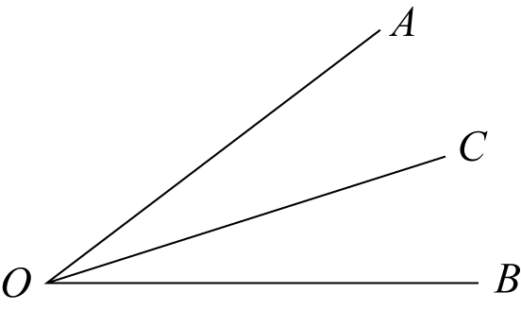
algebraic expression | An algebraic expression is formed by combining numbers and algebraic symbols using arithmetic operations. The expression must be constructed unambiguously according to the rules of algebra. For example, 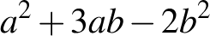 and 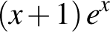 are algebraic expressions, but 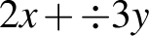 is not because it is incomplete.
algebraic fraction | An algebraic fraction is a fraction in which both the numerator and denominator are algebraic expressions.
algebraic term | An algebraic term is an algebraic expression that forms a 'separable' part of some other algebraic expression. For example, 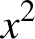 and 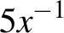 are terms in the inequality 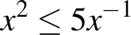, and 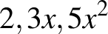 are terms of the polynomial 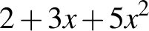.
alternate angles | In each diagram below, the two marked angles are called alternate angles (since they are on alternate sides of the transversal).  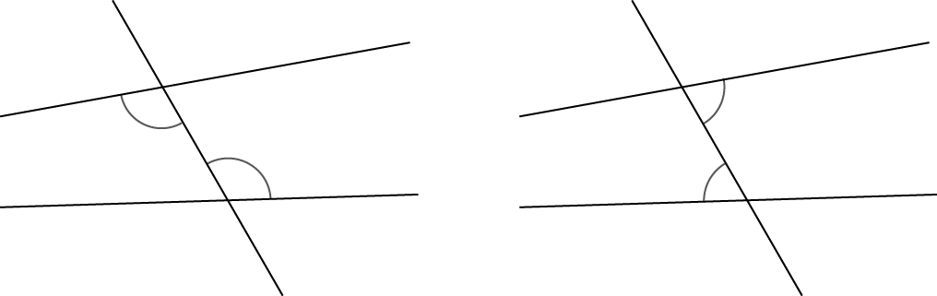  If the lines AB and CD are parallel, then each pair of alternate angles is equal.  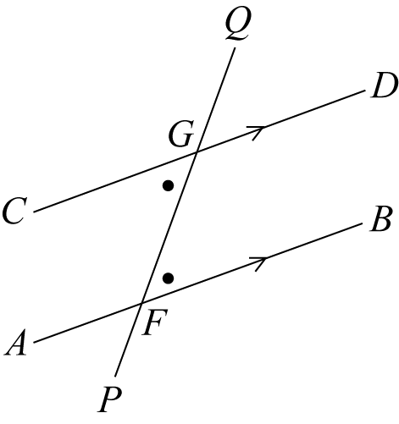
angle | An angle is the figure formed by two rays sharing a common endpoint, called the vertex of the angle.  Imagine that the ray OB is rotated about the point O until it lies along OA. The amount of turning is called the size of the angle AOB.  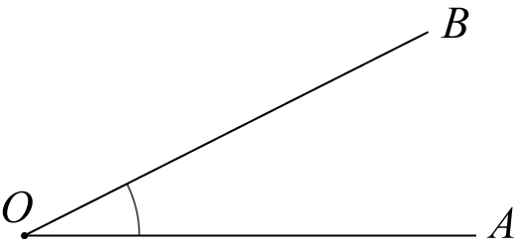
angle classification | Angles are classified according to their size.  We say that  - an angle with size is acute if ,  - an angle with size is obtuse if 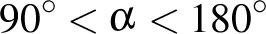,  - an angle with size is reflex if 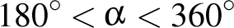.
angles of elevation and depression | When an observer looks at an object that is lower than 'the eye of the observer', the angle between the line of sight and the horizontal is called the angle of depression.  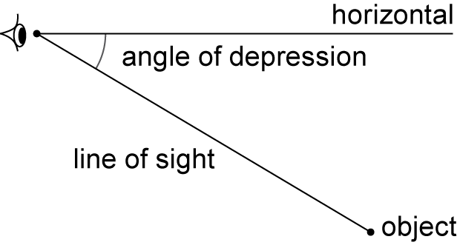  When an observer looks at an object that is higher than 'the eye of the observer', the angle between the line of sight and the horizontal is called the angle of elevation.  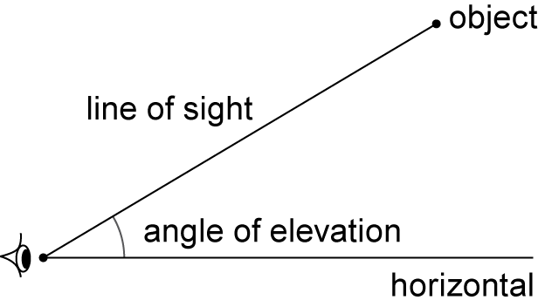
array | An array is an ordered collection of objects or numbers. Rectangular arrays are commonly used in primary mathematics.
associative | A method of combining two numbers or algebraic expressions is associative if the result of the combination of three objects does not depend on the way in which the objects are grouped.  For example, addition of numbers is associative and the corresponding associative law is:  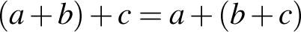 for all numbers , and .  Multiplication is also associative: 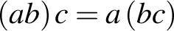 for all numbers , and , but subtraction and division are not, because, for example, 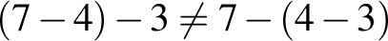 and .
back-to-back stem-and-leaf plot | A back-to-back stem-and-leaf plot is a method for comparing two data distributions by attaching two sets of 'leaves' to the same 'stem' in a stem-and-leaf plot.  For example, the stem-and-leaf plot below displays the distribution of pulse rates of 19 students before and after gentle exercise.  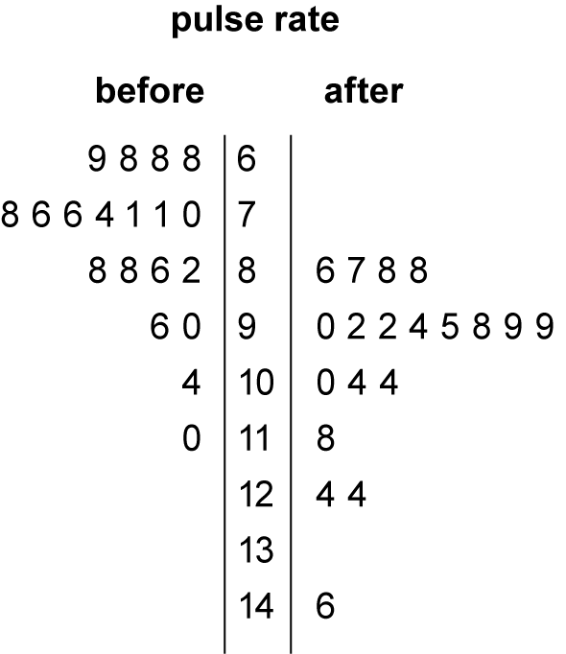
bi-modal data | Bi-modal data is data whose distribution has two modes.
bivariate data | Bivariate data is data relating to two variables, for example, the arm spans and heights of 16-year-olds, the sex of primary school students and their attitude to playing sport.
bivariate numerical data | Bivariate numerical data is data relating to two numerical variables, for example height and weight.
box plot | The term box plot is a synonym for a box-and-whisker plot.  A box-and-whisker plot is a graphical display of a five-number summary.  In a box-and-whisker plot, the 'box' covers the interquartile range (IQR), with 'whiskers' reaching out from each end of the box to indicate maximum and minimum values in the data set. A vertical line in the box is used to indicate the location of the median.  The box-and-whisker plot below has been constructed from the five-number summary of the resting pulse rates of 17 students.  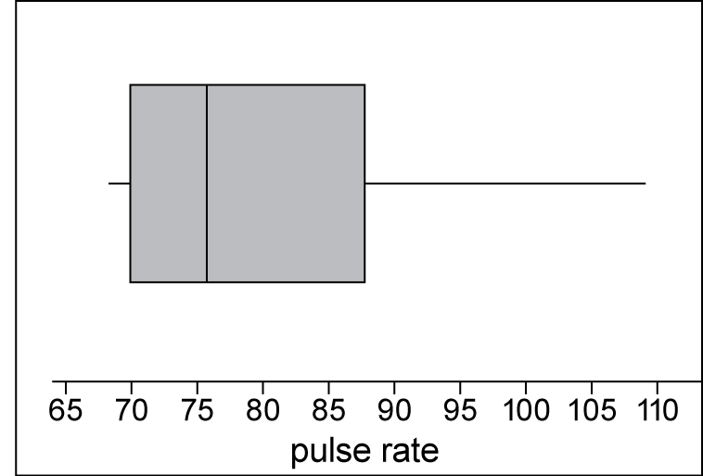  The term 'box-and-whisker plot' is commonly abbreviated to 'box plot'.
capacity | Capacity is a term used to describe how much a container will hold. It is often used in relation to the volume of fluids. Units of capacity (volume of fluids or gases) include litres and millilitres.
Cartesian coordinate system | Two intersecting number lines are intersecting at right angles at their origins to form the axes of the coordinate system.  The plane is divided into four quadrants by these perpendicular axes called the x-axis (horizontal line) and the y-axis (vertical line).  The position of any point in the plane can be represented by an ordered pair of numbers 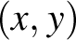. These are called the coordinates of the point. This is called the Cartesian coordinate system. The plane is called the Cartesian plane.  The point with coordinates (4, 2) has been plotted on the Cartesian plane shown. The coordinates of the origin are (0, 0).  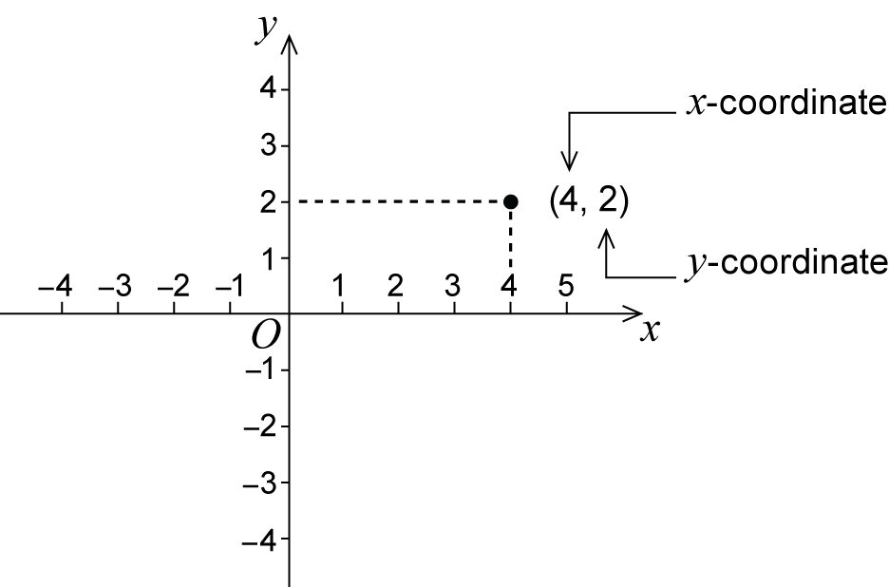
categorical variable | A categorical variable is a variable whose values are categories.  Examples: blood group is a categorical variable; its values are: A, B, AB or O. So too is construction type of a house; its values might be brick, concrete, timber, or steel.  Categories may have numerical labels, for example, for the variable postcode the category labels would be numbers like 3787, 5623, 2016, etc, but these labels have no numerical significance. For example, it makes no sense to use these numerical labels to calculate the average postcode in Australia.
census | A census is an attempt to collect information about the whole population.
chord | A chord is a line segment (interval) joining two points on a circle.  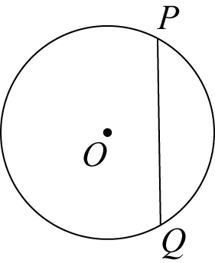
circle | The circle with centre Oand radius r is the set of all points in the plane whose distance from Ois r.  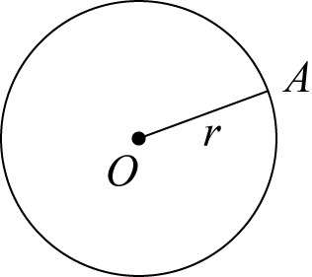  The line segment OA(interval OA) is also called a radius of the circle.  Putting the point of a pair of compasses at the centre and opening the arms to the radius can draw a circle.
co-interior angles | In each diagram the two marked angles are called co-interior angles and lie on the same side of the transversal.  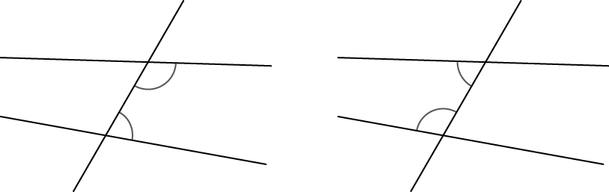  If the lines AB and CD are parallel then 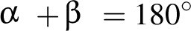.  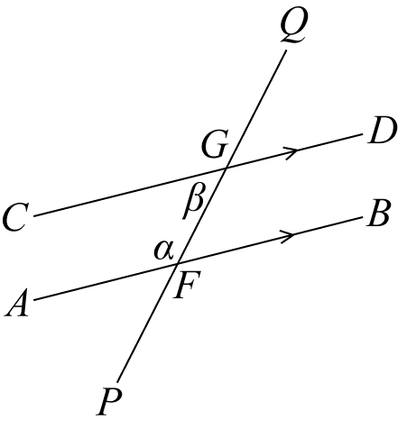  Co-interior angles formed by parallel lines are supplementary.  Conversely, if a pair of co-interior angles is supplementary then the lines are parallel.
column graph | A column graph is a graph used in statistics for organising and displaying categorical data.  To construct a column graph, equal width rectangular bars are constructed for each category with height equal to the observed frequency of the category as shown in the example below, which displays the hair colours of 27 students.  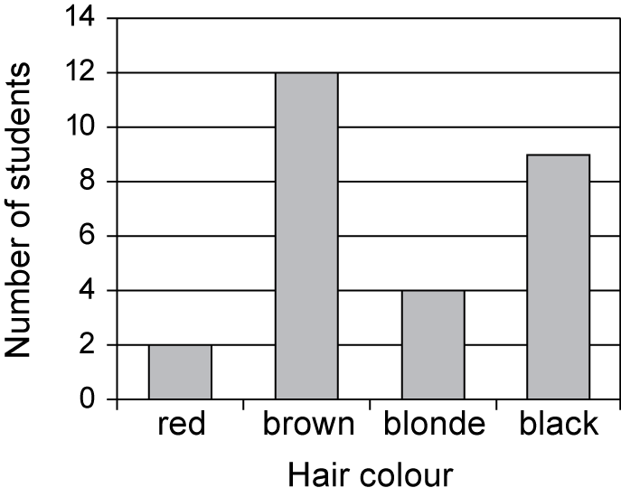  Column graphs are frequently called bar graphs or bar charts. In a bar graph or chart, the bars can be either vertical or horizontal.
common factor | A common factor (or common divisor) of a set of numbers or an algebraic expression is a factor of each element of that set.  For example, 6 is a common factor of 24, 54 and 66, and 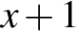 is a common factor of 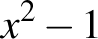 and 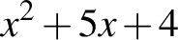.
commutative | A method of combining two numbers or algebraic expressions is commutative if the result of the combination does not depend on the order in which the objects are given.  For example, addition of numbers is commutative, and the corresponding commutative law is:  for all numbers and .  Multiplication is also commutative: for all numbers and , but subtraction and division are not, because, for example, 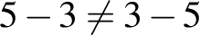 and 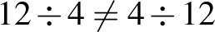.
complementary angles | Two angles that add to 90° are called complementary. For example, 23° and 67° are complementary angles.
complementary events | Events and are complementary events, if and are mutually exclusive and 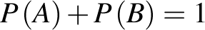.
composite number | A natural number that has a factor other than 1 and itself is a composite number.
compound interest | The interest earned by investing a sum of money (the principal) is compound interest if each successive interest payment is added to the principal for the purpose of calculating the next interest payment.  For example, if the principal  earns compound interest at the rate of r per period, then after n periods the principal plus interest is 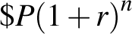.
cone | A cone is a solid that is formed by taking a circle called the base and a point not in the plane of the circle, called the vertex, which lies above or below the circle and joining the vertex to each point on the circle.  If the vertex is directly above or below the centre of the circular base, we call the cone a right cone.  The height of the cone is the distance from the vertex to the centre of the circular base.  The slant height of a cone is the distance from any point on the circle to the vertex.  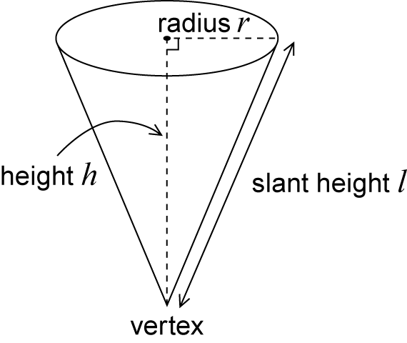
congruence | Two plane figures are called congruent if one can be moved by a sequence of translations, rotations and reflections so that it fits exactly on top of the other figure.  Two figures are congruent when we can match every part of one figure with the corresponding part of the other figure. For example, the two figures below are congruent.  Matching intervals have the same length, and matching angles have the same size.  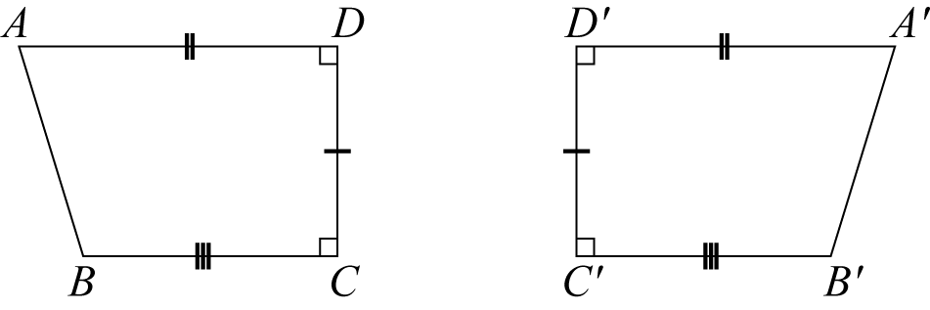
congruent triangles | The four standard congruence tests for triangles  Two triangles are congruent if:  SSS: the three sides of one triangle are respectively equal to the three sides of the other triangle, or  SAS: two sides and the included angle of one triangle are respectively equal to two sides and the included angle of the other triangle, or  AAS: two angles and one side of one triangle are respectively equal to two angles and the matching side of the other triangle, or  RHS: the hypotenuse and one side of one right-angled triangle are respectively equal to the hypotenuse and one side of the other right-angled triangle.
continuous variable | A continuous variable is a numerical variable that can take any value that lies within an interval. In practice, the values taken are subject to the accuracy of the measurement instrument used to obtain these values.  Examples include height, reaction time to a stimulus and systolic blood pressure.
corresponding angles | In each diagram the two marked angles are called corresponding angles.  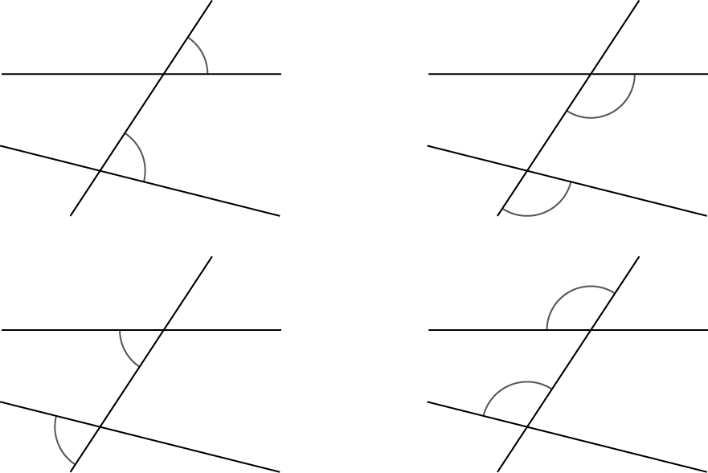  If the lines are parallel, then each pair of corresponding angles is equal.  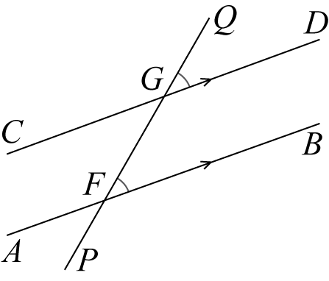  Conversely, if a pair of corresponding angles is equal, then the lines are parallel.
cosine | In any right-angled triangle,  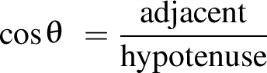 where .  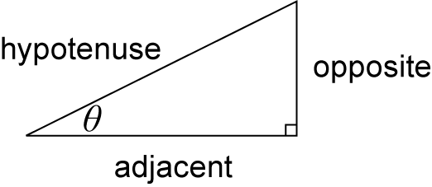
cosine rule | In any triangle ,  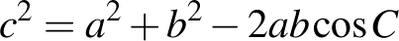.  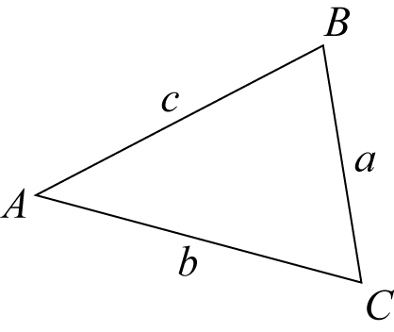
counting number | The counting numbers are the non-negative integers, that is, one of the numbers 0, 1, 2, 3, …  Sometimes it is taken to mean only a positive integer.  A natural number is a positive integer or counting number. The natural numbers are 1, 2, 3, … The set of natural numbers is usually denoted by .
counting on | Counting a collection, or reciting a sequence of number words, from a point beyond the beginning of the sequence.  For example, when a child has counted that there are 6 objects in a collection and is then asked 'How many?' after several more are added, the child might count on from 6 saying '7, 8, 9, ...' to reach the total. This is considered a more sophisticated strategy than counting the whole collection from 1.
cylinder | A cylinder is a solid that has parallel circular discs of equal radius at the ends. Each cross-section parallel to the ends is a circle with the same radius, and the centres of these circular cross-sections lie on a straight line, called the axis of the cylinder.  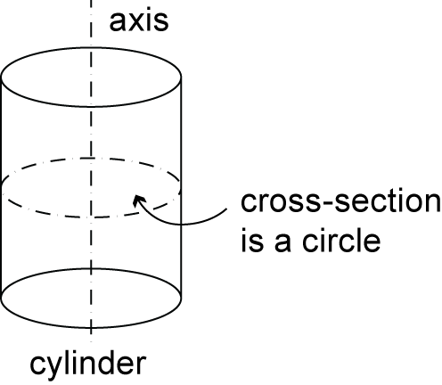
data | Data is a general term for a set of observations and measurements collected during any type of systematic investigation.  Primary data is data collected by the user. Secondary data is data collected by others. Sources of secondary data include web-based data sets, the media, books, scientific papers, etc.
data display | A data display is a visual format for organising and summarising data.  Examples include box plots, column graphs, frequency tables and stemplots.
decimal | A decimal is a numeral in the decimal number system.  For example, the decimal expansion of 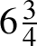 is 6.75. The integer part is 6 and the fractional part is 0.75.  A decimal is terminating if the fractional part has only finitely many decimal digits. It is non-terminating if it has infinitely many digits.  For example, 6.75 is a terminating decimal, whereas 0.3161616…, where the pattern 16 repeats indefinitely, is non-terminating.  Non-terminating decimals may be recurring, that is, contain a pattern of digits that repeats indefinitely after a certain number of places.  For example, 0.3161616… is a recurring decimal, whereas 0.101001000100001…, where the number of 0s between the 1s increases indefinitely, is not recurring.  It is common practice to indicate the repeating part of a recurring decimal by using dots or lines as superscripts.  For example, 0.3161616… could be written as 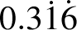 or 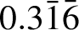.  The decimal number system is the base 10, place-value system most commonly used for representing real numbers. In this system positive numbers are expressed as sequences of Arabic numerals 0 to 9, in which each successive digit to the left or right of the decimal point indicates a multiple of successive powers (respectively positive or negative) of 10.  For example, the number represented by the decimal 12.345 is the sum .
denominator | In the fraction , b is the denominator. It is the number of equal parts into which the whole is divided in order to obtain fractional parts. For example, if a line segment is divided into 5 equal parts, each of those parts is one-fifth of the whole and corresponds to the unit fraction .
diameter | A diameter is a chord passing through the centre of a circle.  The word diameter is also used for the length of the diameter.
difference | A difference is the result of subtracting one number or algebraic quantity from another.
distributive | Multiplication of numbers is distributive over addition because the product of one number with the sum of two others equals the sum of the products of the first number with each of the others. This means that we can multiply two numbers by expressing one (or both) as a sum and then multiplying each part of the sum by the other number (or each part of its sum).  For example, .  This distributive law is expressed algebraically as follows:  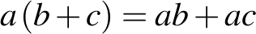, for all numbers a, b and c.
divisible | In general, a number or algebraic expression x is divisible by another y if there exists a number or algebraic expression q of a specified type for which .  A natural number m is divisible by a natural number n if there is a natural number q such that .  For example, 12 is divisible by 4 because 12 = 3 x 4.
dot plot | A dot plot is a graph used in statistics for organising and displaying numerical data.  Using a number line, a dot plot displays a dot for each observation. Where there is more than one observation, or observations are close in value, the dots are stacked vertically. If there is a large number of observations, dots can represent more than one observation. Dot plots are ideally suited for organising and displaying discrete numerical data.  The dot plot below displays the number of passengers observed in 32 cars stopped at a traffic light.  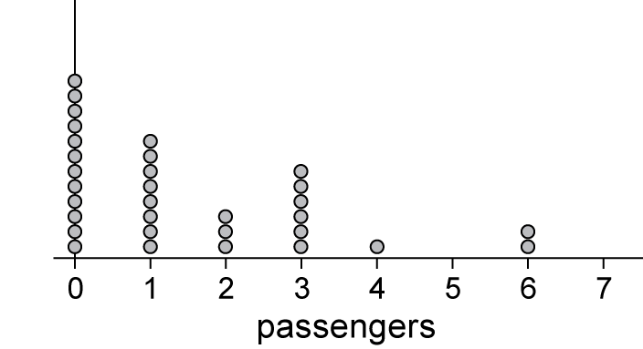  Dot plots can also be used to display categorical data, with the numbers on the number line replaced by category labels.
element | An element of a set is a member of that set. For example, the elements of the set 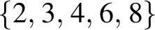 are the numbers 2, 3, 4, 6 and 8 . We write to indicate that is a member of the set .
enlargement (dilation) | An enlargement (or dilation) is a scaled up (or down) version of a figure in which the transformed figure is in proportion to the original figure. The relative positions of points are unchanged and the two figures are similar.  In the diagram below, triangle 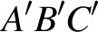 is the image of triangle ABC under the enlargement with enlargement factor 2 and centre of enlargement O.  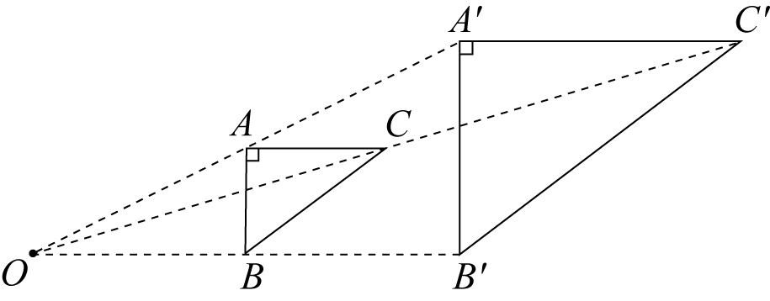
equally likely outcomes | Equally likely outcomes occur with the same probability.  For example, in tossing a fair coin, the outcome 'head' and the outcome 'tail' are equally likely.  In this situation, 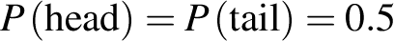.
equation | An equation is a statement that asserts that two numbers or algebraic expressions are equal in value. An equation must include an equals sign. For example, 3 + 14 = 11 + 6.  An identity is an equation involving algebraic expressions that is true for all values of the variables involved.  For example, 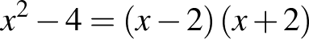.  An identity is an equation that is true for all values of the variables involved.  For example, 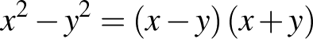.
equivalent fractions | Two fractions and are equivalent if they are equal, that is, .  Equivalent fractions are alternative ways of writing the same fraction.  For example, 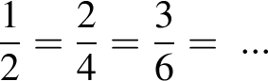
estimate | In statistical terms, an estimate is information about a population extrapolated from a sample of the population.  For example, the mean number of decayed teeth in a randomly selected group of eight-year-old children is an estimate of the mean number of decayed teeth in eight-year-old children in Australia.
even number | A whole number is even if it is divisible by 2.
event | An event is a subset of the sample space for a random experiment.  For example, the set of outcomes from tossing two coins is , where represents a 'head' and a 'tail'.  For example, if A is the event 'at least one head is obtained', then 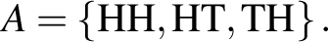
expected frequency | An expected frequency is the number of times that a particular event is expected to occur when a chance experiment is repeated a number of times. For example, if the experiment is repeated n times, and on each of those times the probability that the event occurs is p, then the expected frequency of the event is np.  For example, suppose that a fair coin is tossed 5 times and the number of heads showing recorded. Then the expected frequency of 'heads' is .  This example shows that the expected frequency is not necessarily an observed frequency, which in this case is one of the numbers 0, 1, 2, 3, 4 or 5.
expression | Two or more numbers or variables connected by operations. For example, are all expressions.  Expressions do not include an equals sign.
factor | In general, a number or algebraic expression x is a factor (or divisor) of another y if there exists a number or algebraic expression q of a specified type for which .  A natural number m is a factor of a natural number n if there is a natural number q such that .  For example, 4 is a factor of 12 because .  A polynomial 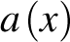 is divisible by a polynomial 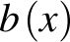 if there is a polynomial 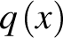 for which 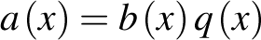.  For example, is a factor of 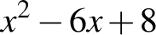 because 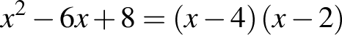.
factor and remainder theorem | According to the factor theorem, if 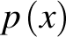 is a polynomial and 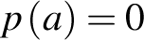 for some number a, then is divisible by .  This follows easily from the remainder theorem, because for 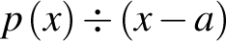 the remainder is 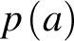. So if , the remainder is and is divisible by .  The factor theorem can be used to obtain factors of a polynomial.  For example, if 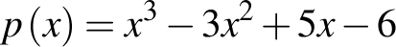, then it is easy to check that . So by the factor theorem is a factor of .  According to the remainder theorem, if a polynomial is divided by , where is any real number, the remainder is . That is, , for some polynomial .
factorise | To factorise a number or algebraic expression is to express it as a product.  For example, 15 is factorised when expressed as a product: , and 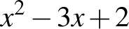 is factorised when written as a product: 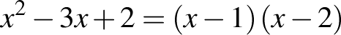.
five-number summary | A five-number summary is a method for summarising a data set using five statistics: the minimum value, the lower quartile, the median, the upper quartile and the maximum value.
fraction | The fraction (written alternatively as / ), where is a non-negative integer and is a positive integer, was historically obtained by dividing a unit length into equal parts and taking of these parts.  For example, refers to 3 of 5 equal parts of the whole, taken together.  In the fraction the number is the numerator and the number is the denominator.  It is a proper fraction if and an improper fraction otherwise.
frequencies | Frequency, or observed frequency, is the number of times that a particular value occurs in a data set.  For grouped data, it is the number of observations that lie in that group or class interval.
frequency distribution | A frequency distribution is the division of a set of observations into a number of classes, together with a listing of the number of observations (the frequency) in that class.  Frequency distributions can be displayed in tabular or graphical form.
frequency table | A frequency table lists the frequency (number of occurrences) of observations in different ranges, called class intervals.  The frequency distribution of the heights (in cm) of a sample of 42 people is displayed in the frequency table below.  Height (cm)
  Class interval | Frequency
  155–<160 | 3
  160–<165 | 2
  165–<170 | 9
  170–<175 | 7
  175–<180 | 10
  180–<185 | 5
  185–<190 | 5
  190–<195 | 1
function | A function f assigns to each element of one set S precisely one element of a second set T.  The functions most commonly encountered in elementary mathematics are real functions of real variables. For such functions, the domain and codomain are sets of real numbers.  Functions are usually defined by a formula for 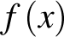 in terms of x.  For example, the formula 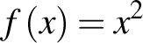 defines the 'squaring function' that maps each real number x to its square ² x.
gradient | If 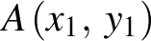 and 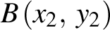 are points in the plane, 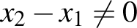, the gradient of the line segment (interval) 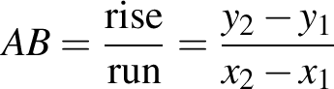.  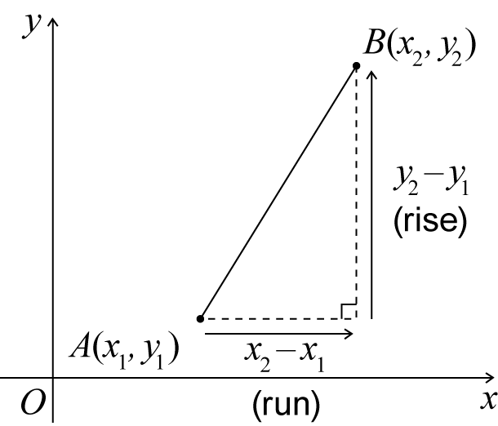  The gradient of a line is the gradient of any line segment (interval) within the line.
highest common factor | The highest common factor (HCF), greatest common factor (GCF) or greatest common divisor (GCD) of a given set of natural numbers is the common divisor of the set that is greater than each of the other common divisors.  For example, 1, 2, 3 and 6 are the common factors of 24, 54 and 66 and 6 is the greatest common divisor.
histogram | A histogram is a statistical graph for displaying the frequency distribution of continuous data.  A histogram is a graphical representation of the information contained in a frequency table. In a histogram, class frequencies are represented by the areas of rectangles centred on each class interval. The class frequency is proportional to the rectangle's height when the class intervals are all of equal width.  The histogram below displays the frequency distribution of the heights (in cm) of a sample of 42 people with class intervals of width 5 cm.  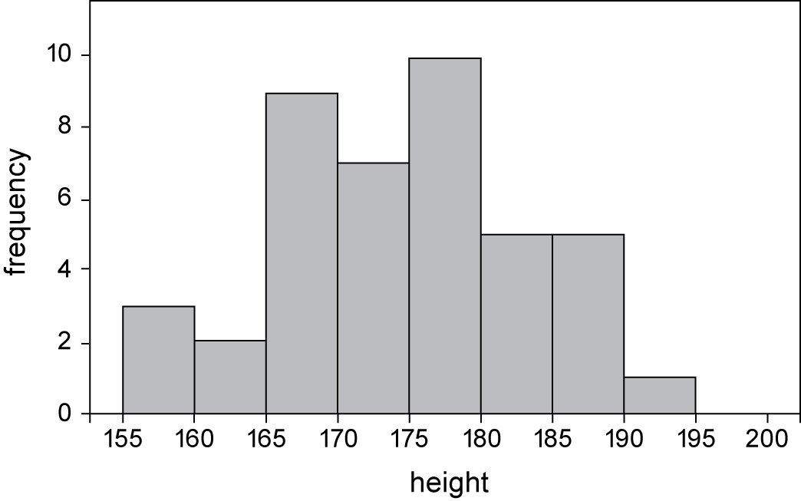
hyperbola (rectangular) | The graph of is called a rectangular hyperbola. The x- and y-axes are asymptotes as the curve gets as close as we like to them.  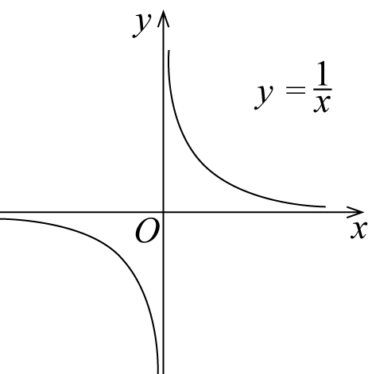
independent event | Two events are independent if knowing the outcome of one event tells us nothing about the outcome of the other event.
independent variable | When investigating relationships in bivariate data, the explanatory variable is the variable that may explain or cause a difference in the response variable.  For example, when investigating the relationship between the temperature of a loaf of bread and the time it has spent in a hot oven, temperature is the response variable and time is the explanatory variable.  With numerical bivariate data it is common to attempt to model such relationships with a mathematical equation and to call the response variable the dependent variable and the explanatory variable the independent variable.  When graphing numerical data, the convention is to display the response (dependent) variable on the vertical axis and the explanatory (independent) variable on the horizontal axis.  When there is no clear causal link between the events, the classification of the variables as either the dependent or independent variable is quite arbitrary.
index | Index is synonymous with exponent.  The exponent or index of a number or algebraic expression is the power to which the latter is to be raised. The exponent is written as a superscript. Positive integral exponents indicate the number of times a term is to be multiplied by itself. For example, 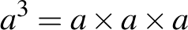.
index law | Index laws are rules for manipulating indices (exponents). They include  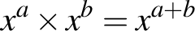; 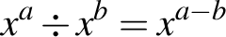; 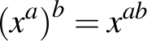; 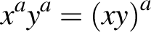; 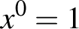; 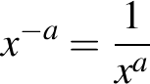; and 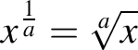.
inequality | An inequality is a statement that one number or algebraic expression is less than (or greater than) another. There are four types of inequalities:  - a is less than b is written ,  - a is greater than b is written ,  - a is less than or equal to b is written 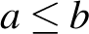, and  - a is greater than or equal to b is written 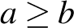.
informal unit | Informal units are not part of a standardised system of units for measurement. For example, an informal unit for length could be paperclips of uniform length. An informal unit for area could be uniform paper squares of any size. Informal units are sometimes referred to as nonstandard units.
integer | The integers are the 'whole numbers'  The set of integers is usually denoted by . Integers are basic building blocks in mathematics.
interquartile range | The interquartile range ( IQR) is a measure of the spread within a numerical data set. It is equal to the upper quartile 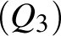 minus the lower quartile 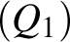; that is, .  The IQR is the width of an interval that contains the middle 50% (approximately) of the data values. To be exactly 50%, the sample size must be a multiple of four.
interval | An interval is a certain type of subset of the number line.  A finite interval is the set of all real numbers between two given real numbers called the endpoints of the interval. The endpoints may or may not be included in the interval.
irrational number | An irrational number is a real number that is not rational. Some commonly used irrational numbers are , and .  The Euler number is an irrational real number whose decimal expansion begins
irregular shape | An irregular shape can be a polygon. A polygon that is not regular is irregular.
kite | A kite is a quadrilateral with two pairs of adjacent sides of equal length.  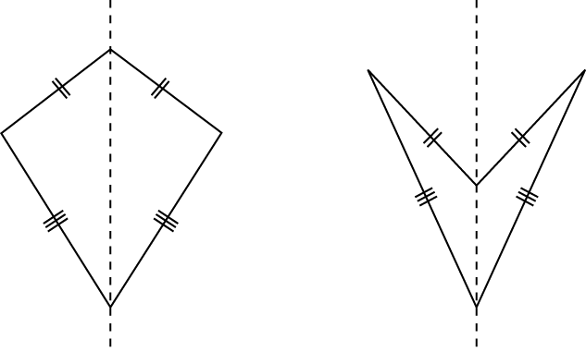  A kite may be convex, as shown in the diagram above to the left, or non-convex, as shown above to the right. The axis of the kite is shown.
line segment (interval) | If A and B are two points on a line, the part of the line between and including A and Bis called a line segment or interval.  The distance ABis a measure of the size or length of AB.  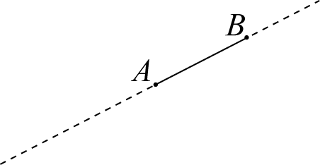  Any point A on a line divides the line into two pieces called rays. The ray AP is that ray which contains the point P (and the point A). The point A is called the vertex of the ray and it lies on the ray.  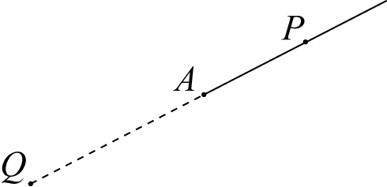
line symmetry | A plane figure F has line symmetry in a line m if the image of F under the reflection in m is F itself. The line m is called the axis of symmetry.  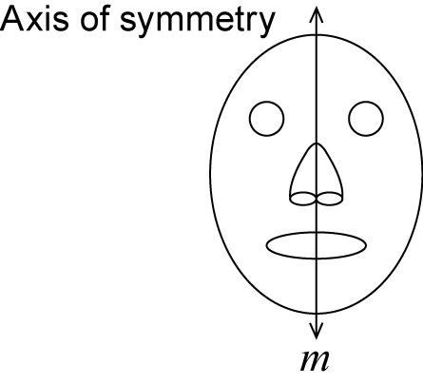
linear equation | A linear equation is an equation involving just linear terms, that is, polynomials of degree 1. The general form of a linear equation in one variable is 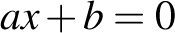.
location (statistics) | A measure of location is a single number that can be used to indicate a central or 'typical value' within a set of data.  The most commonly used measures of location are the mean and the median, although the mode is also sometimes used for this purpose.
logarithm | The logarithm of a positive number x is the power to which a given number b, called the base, must be raised in order to produce the number x. The logarithm of x, to the base b is denoted by 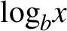.  Algebraically: 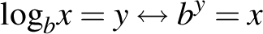.  For example, 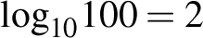 because , and 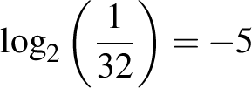 because 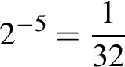.
many-to-one correspondence | A many-to-one correspondence is a function or mapping that takes the same value for at least two different elements of its domain. For example, the squaring function 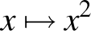 is many-to-one because 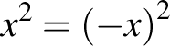 for all real numbers .
mean | The arithmetic mean of a list of numbers is the sum of the data values divided by the number of numbers in the list.  In everyday language, the arithmetic mean is commonly called the average.  For example, for the following list of five numbers 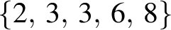 the mean equals 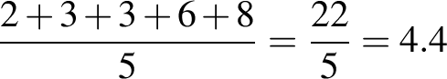.
median | The median is the value in a set of ordered data that divides the data into two parts. It is frequently called the 'middle value'.  Where the number of observations is odd, the median is the middle value.  For example, for the following ordered data set with an odd number of observations, the median value is 5.  1, 3, 3, 4, 5, 6, 8, 9, 9  Where the number of observations is even, the median is calculated as the mean of the two central values.  For example, in the following ordered data set, the two central values are 5 and 6, and median value is the mean of these two values, 5.5.  1, 3, 3, 4, 5, 6, 8, 9, 9, 10  The median provides a measure of location of a data set that is suitable for both symmetric and skewed distributions and is also relatively insensitive to outliers.
midpoint | The midpoint of a line segment (interval) is the point that divides the segment into two equal parts.  Let 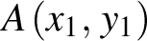 and 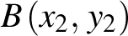 be points in the Cartesian plane. Then the midpoint of line segment has coordinates 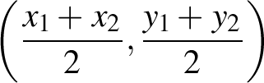.  This can be seen from the congruent triangles below.  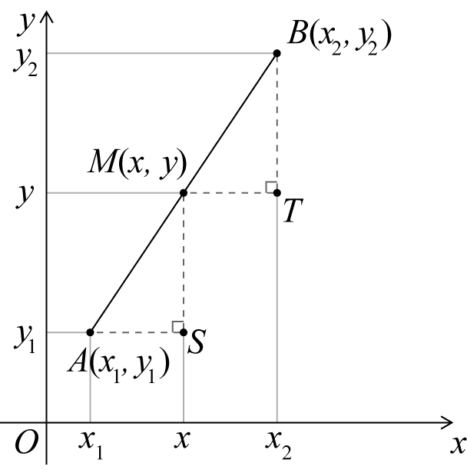
mode | The mode is the most frequently occurring value in a set of data. There can be more than one mode. When there are two modes, the data set is said to be bi-modal.  The mode is sometimes used as a measure of location.
monic | A monic polynomial is one in which the coefficient of the leading term is 1.  For example, 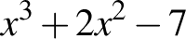 is monic, but 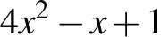 is not.
multiple | A multiple of a number is the product of that number and an integer.  A multiple of a real number x is any number that is a product of x and an integer. For example, 4.5 and –13.5 are multiples of 1.5 because and .
multiplication | Multiplicative situations are problems or contexts that involve multiplication (or division). Calculating the number of seats in a theatre that has 30 rows of 24 seats, finding equivalent fractions, and working with ratios and percentages are all multiplicative situations.
mutually exclusive events | Two events and are mutually exclusive if one is incompatible with the other; that is, if they cannot be simultaneous outcomes in the same chance experiment.  For example, when a fair coin is tossed twice, the events '' and '' cannot occur at the same time and are, therefore, mutually exclusive.  In a Venn diagram, as shown below, mutually exclusive events do not overlap.  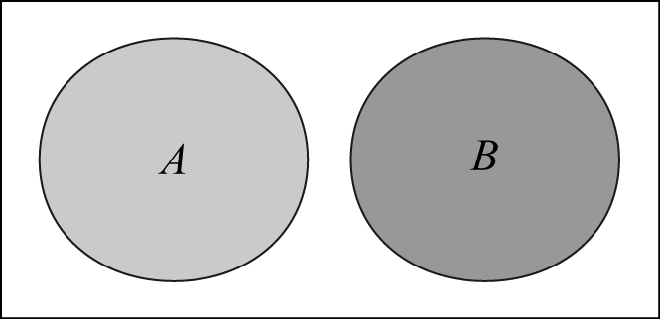
net | A net is a plane figure that can be folded to form a polyhedron.  One possible net for a cube is shown below.  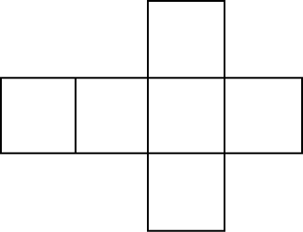
number line | A number line gives a pictorial representation of real numbers.
numeral | A figure or symbol used to represent a number. For example, –3, 0, 45, IX.
numerator | In the fraction , a is the numerator. If an object is divided into b equal parts, then the fraction represents a of these parts taken together.  For example, if a line segment is divided into 5 equal parts, each of these parts is one-fifth of the whole and 3 of these parts taken together corresponds to the fraction .
numerical data | Numerical data is data associated with a numerical variable.
numerical variables | Numerical variables are variables whose values are numbers, and for which arithmetic processes such as adding and subtracting, or calculating an average, make sense.  A discrete numerical variable is a numerical variable, each of whose possible values is separated from the next by a definite 'gap'. The most common numerical variables have the counting numbers 0, 1, 2, 3, … as possible values. Others are prices, measured in dollars and cents.  Examples include the number of children in a family or the number of days in a month.
odd number | An odd number is an integer that is not divisible by 2.
one-to-one correspondence | In early counting development one-to-one correspondence refers to the matching of one and only one number word to each element of a collection.  More generally it refers to a relationship between two sets such that every element of the first set corresponds to one and only one element of the second set.
operation | The process of combining numbers or expressions. In the primary years operations include addition, subtraction, multiplication and division. In later years operations include substitution and differentiation.
order of operations | A convention for simplifying expressions that stipulates that multiplication and division are performed before addition and subtraction and in order from left to right. For example, in 5 – 6 ÷ 2 + 7, the division is performed first and the expression becomes 5 – 3 + 7 = 9. If the convention is ignored and the operations are performed in order, the incorrect result, 6.5, is obtained.
outlier | An outlier is a data value that appears to stand out from the other members of the data set by being unusually high or low. The most effective way of identifying outliers in a data set is to graph the data.  For example, in the following list of ages of a group of 10 people, , the 24 would be considered to be a possible outlier.  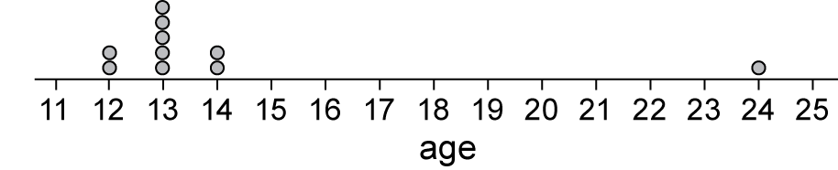
parabola | Definition 1  The graph of is called a parabola. The point 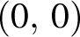 is called the vertex of the parabola and the y-axis is the axis of symmetry of the parabola, called simply the axis.  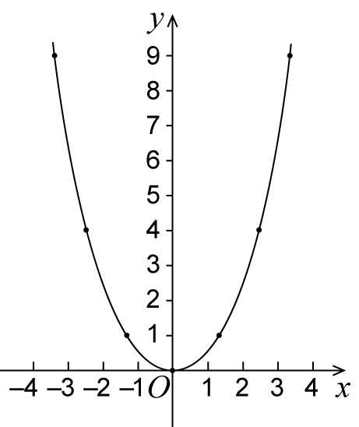  Some other parabolas are the graphs of 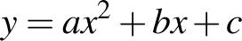 where .  More generally, every parabola is similar to the graph of .  Definition 2  A parabola is the locus of all points P such that the distance from P to a fixed point F is equal to the distance from P to a fixed line l.
parallel box plots | Parallel box-and-whisker plots are used to visually compare the five-number summaries of two or more data sets.  For example, the box-and-whisker plots below can be used to compare the five-number summaries for the pulse rates of 19 students before and after gentle exercise.  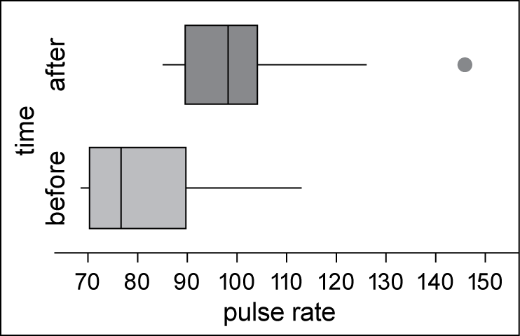  Note that the box plot for pulse rates after exercise shows the pulse rate of 146 as a possible outlier (•). This is because the distance of this data point above the upper quartile 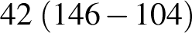 is more than .  The term 'parallel box-and-whisker plots' is commonly abbreviated to 'parallel box plots'.
parallelogram | A parallelogram is a quadrilateral whose opposite sides are parallel.  Thus the quadrilateral ABCD shown below is a parallelogram because AB || DC and DA || CB.  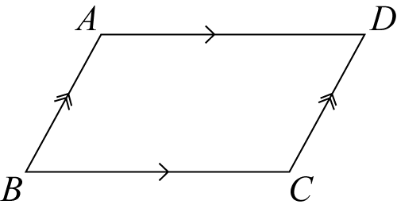  Properties of a parallelogram  - The opposite angles of a parallelogram are equal.  - The opposite sides of a parallelogram are equal.  - The diagonals of a parallelogram bisect each other.
partitioning | Dividing a quantity into parts. In the early years it commonly refers to the ability to think about numbers as made up of two parts, for example, 10 is 8 and 2. In later years it refers to dividing both continuous and discrete quantities into equal parts.
percentage | A percentage is a fraction whose denominator is 100.  For example, 6 percent (written as 6%) is the percentage whose value is 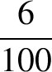.  Similarly, 40 as a percentage of 250 is 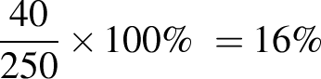.
percentiles | Percentiles are the values that divide an ordered data set into 100 (approximately) equal parts. It is only possible to divide a data set into exactly 100 equal parts when the number of data values is a multiple of one hundred.  There are 99 percentiles. Within the above limitations, the first percentile divides off the lower 1% of data values. The second, the lower 2% and so on. In particular, the lower quartile is the 25th percentile, the median is the 50th percentile and the upper quartile is the 75th percentile.
perimeter | The perimeter of a plane figure is the length of its boundary.
pi | Pi is the name of the Greek letter that is used to denote the ratio of the circumference of any circle to its diameter. The number is irrational, but 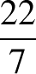 is a rational approximation accurate to 2 decimal places. The decimal expansion of begins  There is a very long history of attempts to estimate accurately. One of the early successes was due to Archimedes (287–212 BC), who showed that 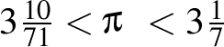.  The decimal expansion of has now been calculated to at least the first 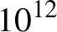 places.
picture graphs | A picture graph is a statistical graph for organising and displaying categorical data.  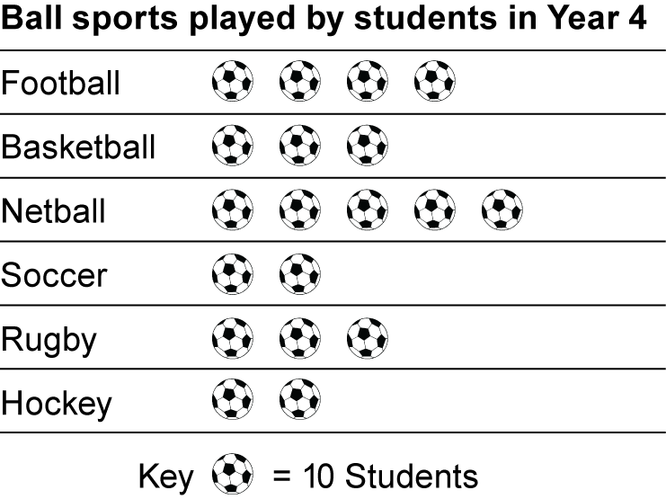
place value | The value of a digit as determined by its position in a number relative to the ones (or units) place. For integers the ones place is occupied by the rightmost digit in the number.  For example, in the number 2594.6 the 4 denotes 4 ones, the 9 denotes 90 ones or 9 tens, the 5 denotes 500 ones or 5 hundreds, the 2 denotes 2000 ones or 2 thousands, and the 6 denotes 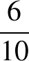 of a one or 6 tenths.
point | A point marks a position, but has no size.
polygon | A polygon is a plane figure bounded by line segments.  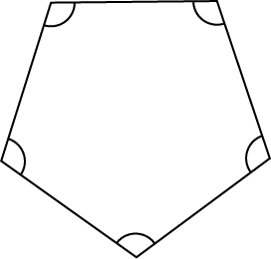  The figure shown above is a regular pentagon. It is a convex five-sided polygon. It is called a pentagon because it has five sides. It is called regular because all sides have equal length and all interior angles are equal.
polyhedron | A polyhedron is a solid figure bounded by plane polygonal faces.  Two adjacent faces intersect at an edge and each edge joins two vertices.  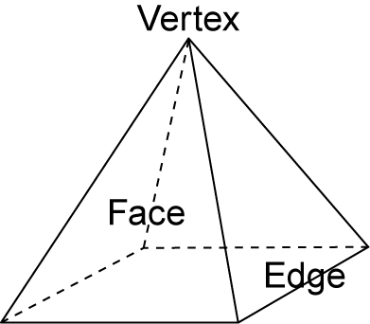  The polyhedron shown above is a pyramid with a square base. It has 5 vertices, 8 edges and 5 faces. It is a convex polyhedron.  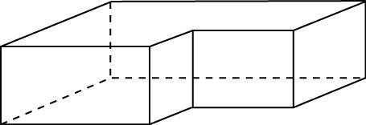  The figure above is a non-convex polyhedron.  A convex polyhedron is a finite region bounded by planes, in the sense that the region lies entirely on one side of the plane.
polynomial | A polynomial in one variable x (simply called a polynomial) is a finite sum of terms of the form 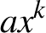 where a is a number and k is a non-negative integer.  A non-zero polynomial can be written in the form ,  where n is a non-negative integer and 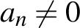.
population | A population is the complete set of individuals, objects, places, etc, that we want information about. A census is an attempt to collect information about the whole population.
prime factor | A prime factor of a natural number n is a factor of n that is a prime number.  For example, the prime factors of 330 are 2, 3, 5 and 11.
prime number | A prime number is a natural number greater than 1 that has no factor other than 1 and itself.
prism | A prism is a convex polyhedron that has two congruent and parallel faces and all its remaining faces are parallelograms.  A right prism is a convex polyhedron that has two congruent and parallel faces and all its remaining faces are rectangles. A prism that is not a right prism is often called an oblique prism.  Some examples of prisms are shown below.  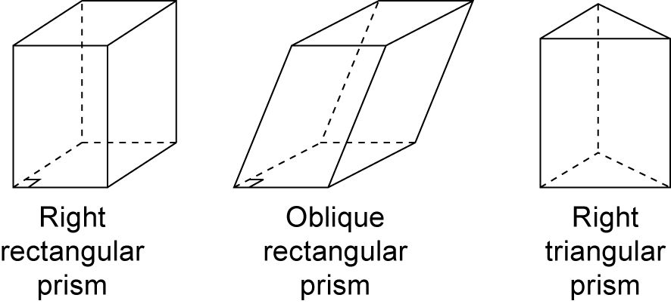
probability | The probability of an event is a number between 0 and 1 that indicates the chance of something happening.  For example, the probability that the sun will come up tomorrow is 1, the probability that a fair coin will come up 'heads' when tossed is 0.5, while the probability of someone being physically present in Adelaide and Brisbane at exactly the same time is 0.
product | A product is the result of multiplying together two or more numbers or algebraic expressions. For example, 36 is the product of 9 and 4, and 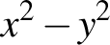 is the product of and 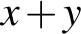.
proportion | Corresponding elements of two sets are in proportion if there is a constant ratio. For example, the circumference and diameter of a circle are in proportion because for any circle the ratio of their lengths is the constant .
pyramid | A pyramid is a convex polyhedron with a polygonal base and triangular sides that meet at a point called the vertex. The pyramid is named according to the shape of its base.  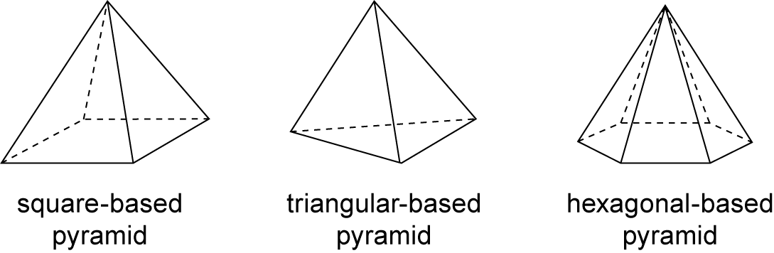
Pythagoras' theorem | For a right-angled triangle  The square of the hypotenuse of a right-angled triangle equals the sum of the squares of the lengths of the other two sides.  In symbols, 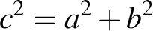.  The converse  If in a triangle ABC, then C is a right angle.
quadratic equation | The general quadratic equation in one variable is 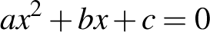, where .  The roots are given by the quadratic formula 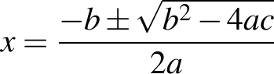.
quadratic expression | A quadratic expression or function contains one or more of the terms in which the variable is raised to the second power, but no variable is raised to a higher power. Examples of quadratic expressions include 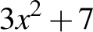 and 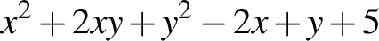.
quartile | Quartiles are the values that divide an ordered data set into four (approximately) equal parts. It is only possible to divide a data set into exactly four equal parts when the number of data of values is a multiple of four.  There are three quartiles. The first, the lower quartile (), divides off (approximately) the lower 25% of data values. The second quartile (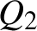) is the median. The third quartile, the upper quartile (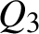), divides off (approximately) the upper 25% of data values.
quotient | A quotient is the result of dividing one number or algebraic expression by another. See also remainder.
random number | A random number is one whose value is governed by chance; for example, the number of dots showing when a fair die is tossed. The value of a random number cannot be predicted in advance.
range (statistics) | The range is the difference between the largest and smallest observations in a data set.  The range can be used as a measure of spread in a data set, but it is extremely sensitive to the presence of outliers and should only be used with care.
rate | A rate is a particular kind of ratio in which the two quantities are measured in different units. For example, the ratio of distance to time, known as speed, is a rate because distance and time are measured in different units (such as kilometres and hours). The value of the rate depends on the units in which the quantities are expressed.
ratio | A ratio is a quotient or proportion of two numbers, magnitudes or algebraic expressions. It is often used as a measure of the relative size of two objects. For example, the ratio of the length of a side of a square to the length of a diagonal is 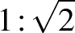; that is, 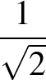.
rational number | A real number is rational if it can be expressed as a quotient of integers. It is irrational otherwise.
real numbers | The numbers generally used in mathematics, in scientific work and in everyday life are the real numbers. They can be pictured as points on a number line, with the integers evenly spaced along the line, and a real number b to the right of a real number a if .  A real number is either rational or irrational.  Every real number has a decimal expansion. Rational numbers are the ones whose decimal expansions are either terminating or recurring.
rectangle | A rectangle is a quadrilateral in which all angles are right angles.  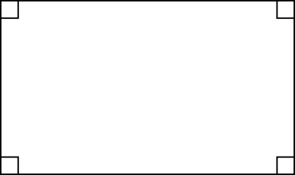
recurring decimal | A recurring decimal is a decimal that contains a pattern of digits that repeats indefinitely after a certain number of places.  For example, 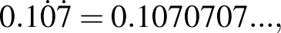  and this is the decimal expansion of the rational number  .  Every recurring decimal is the decimal expansion of a rational number.
reflection | To reflect the point in an axis of reflection, a line has been drawn at right angles to the axis of reflection and the point  is marked at the same distance from the axis of reflection as , but on the other side.  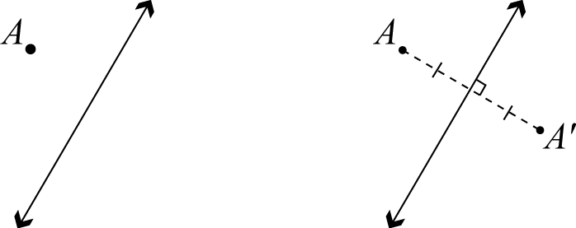  The point is called the reflection image of A.  A reflection is a transformation that moves each point to its reflection image.
regular shape | A regular shape can be a polygon. A polygon is regular if all of its sides are the same length and all of its angles have the same measure.
related denominators | Denominators are related when one is a multiple of the other. For example, the fractions and have related denominators because 9 is a multiple of 3.  Fractions with related denominators are more easily added and subtracted than fractions with unrelated denominators because only one needs to be renamed.  For example, to add and we can rename as and then compute 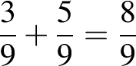.
relative frequency | Relative frequency is given by the ratio , where f is the frequency of occurrence of a particular data value or group of data values in a data set and n is the number of data values in the data set.
remainder | A remainder is the amount left over when one number or algebraic quantity a is divided by another b. If a is divisible by b then the remainder is 0.  For example, when 68 is divided by 11, the remainder is 2, because 68 can be expressed as 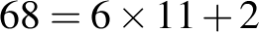.
revolution | A revolution is the amount of turning required to rotate a ray about its endpoint until it falls back onto itself. The size of 1 revolution is 360°.  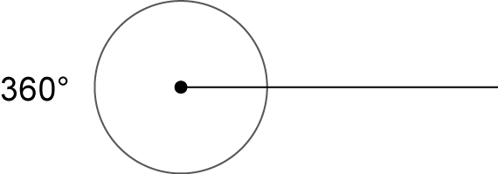
rhombus | A rhombus is a quadrilateral with all sides equal.  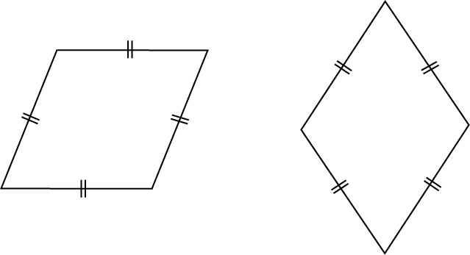
right angle | Let AOB be a line, and let OX be a ray making equal angles with the ray OA and the ray OB. Then the equal angles AOX and BOX are called right angles.  A right angle is half of a straight angle, and so is equal to 90°.  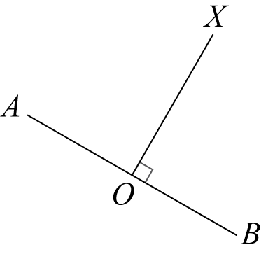
rotation | A rotation turns a figure about a fixed point, called the centre of rotation.  A rotation is specified by:  - the centre of rotation O  - the angle of rotation  - the direction of rotation (clockwise or anticlockwise).  In the first diagram below, the point A is rotated through 120° clockwise about O. In the second diagram, it is rotated through 60° anticlockwise about O.  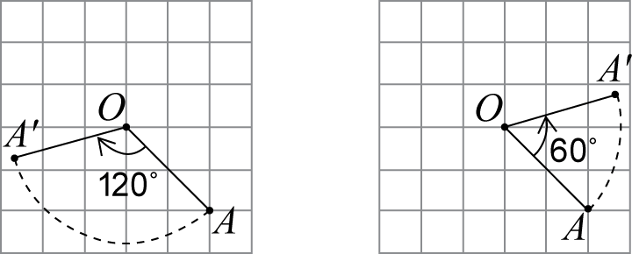  A rotation is a transformation that moves each point to its rotation image.
rotational symmetry | A plane figure F has rotational symmetry about a point O if there is a non-trivial rotation such that the image of F under the rotation is F itself.  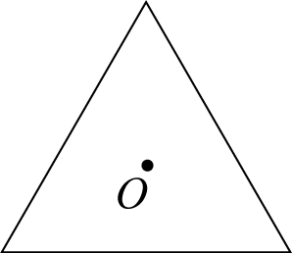  A rotation of 120° around O moves the equilateral triangle onto itself.
rounding | The decimal expansion of a real number is rounded when it is approximated by a terminating decimal that has a given number of decimal digits to the right of the decimal point.  Rounding to n decimal places is achieved by removing all decimal digits beyond (to the right of) the 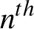 digit to the right of the decimal place, and adjusting the remaining digits where necessary.  If the first digit removed (the 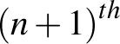 digit) is less than 5 the preceding digit is not changed.  For example, 4.02749 becomes 4.027 when rounded to 3 decimal places.  If the first digit removed is greater than 5, or 5 and some succeeding digit is non-zero, the preceding digit is increased by 1.  For example, 6.1234586 becomes 6.12346 when rounded to 5 decimal places.
sample | A sample is part of a population. It is a subset of the population, often randomly selected for the purpose of estimating the value of a characteristic of the population as a whole.  For instance, a randomly selected group of eight-year-old children (the sample) might be selected to estimate the incidence of tooth decay in eight-year-old children in Australia (the population).
sample space | A sample space is the set of all possible outcomes of a chance experiment. For example, the set of outcomes (also called sample points) from tossing two coins is , where  represents a 'head' and  a 'tail'.
scientific notation | A positive real number is expressed in scientific notation when it is written as the product of a power of 10 and a decimal that has just one digit to the left of the decimal point.  For example, the scientific notation for is 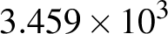, and the scientific notation for is 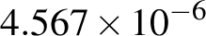.  Many electronic calculators will show these as and .
secondary data set | Primary data is data collected by the user. Secondary data is data collected by others. Sources of secondary data include web-based data sets, the media, books, scientific papers, etc.
shape (statistics) | The shape of a numerical data distribution is most simply described as symmetric if it is roughly evenly spread around some central point, or skewed if it is not. If a distribution is skewed, it can be further described as positively skewed ('tailing-off' to the upper end of the distribution) or negatively skewed ('tailing-off' to the lower end of the distribution).  These three distribution shapes are illustrated in the parallel dot plot display below.  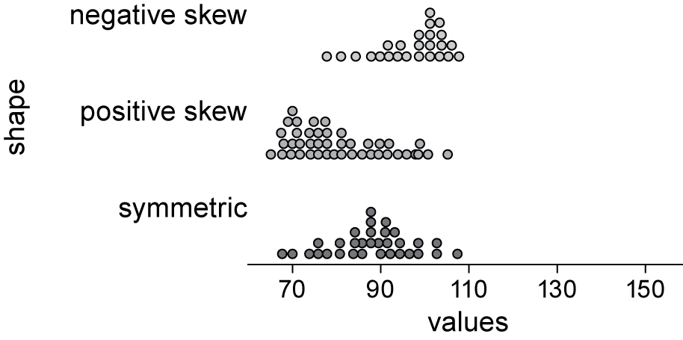  Dot plots, histograms and stem plots can all be used to investigate the shape of a data distribution.
side-by-side column graph | A side-by-side column graph can be used to organise and display the data that arises when a group of individuals or things is categorised according to two or more criteria.  For example, the side-by-side column graph below displays the data obtained when 27 children are categorised according to hair type (straight or curly) and hair colour (red, brown, blonde, black). The legend indicates that dark grey columns represent children with straight hair and light grey columns children with curly hair.  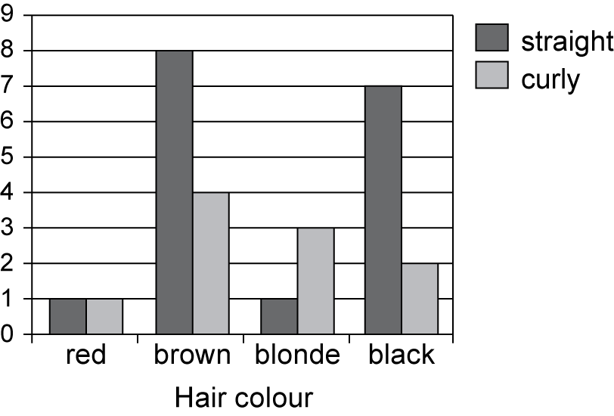  Side-by-side column graphs are frequently called side-by-side bar graphs or bar charts. In a bar graph or chart, the bars can be either vertical or horizontal.
similar | The four standard tests for two triangles to be similar  AAA: If two angles of one triangle are respectively equal to two angles of another triangle, then the two triangles are similar.  SAS: If the ratio of the lengths of two sides of one triangle is equal to the ratio of the lengths of two sides of another triangle, and the included angles are equal, then the two triangles are similar.  SSS: If we can match up the sides of one triangle with the sides of another so that the ratios of matching sides are equal, then the two triangles are similar.  RHS: If the ratio of the hypotenuse and one side of a right-angled triangle is equal to the ratio of the hypotenuse and one side of another right-angled triangle, then the two triangles are similar.
similarity | Two plane figures are called similar if an enlargement of one figure is congruent to the other.  That is, if one can be mapped to the other by a sequence of translations, rotations, reflections and enlargements.  Similar figures thus have the same shape, but not necessarily the same size.
simple interest | Simple interest is the interest accumulated when the interest payment in each period is a fixed fraction of the principal.
sine | In any right-angled triangle,  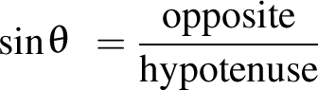, where .
sine rule | In any triangle ABC,  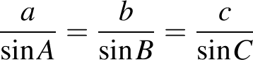.  In words it says:  Any side of a triangle over the sine of the opposite angle equals any other side of the triangle over the sine of its opposite angle.
square | A square is a quadrilateral that is both a rectangle and a rhombus.  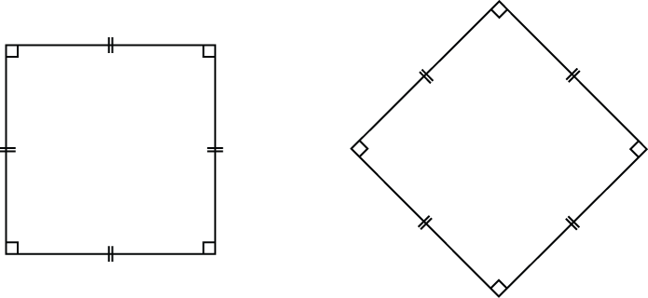  A square thus has all the properties of a rectangle, and all the properties of a rhombus.
standard deviation | Standard deviation is a measure of the variability or spread of a data set. It gives an indication of the degree to which the individual data values are spread around their mean.
stem-and-leaf plot | A stem-and-leaf plot is a method of organising and displaying numerical data in which each data value is split into two parts, a 'stem' and a 'leaf'.  For example, the stem-and-leaf plot below displays the resting pulse rates of 19 students.  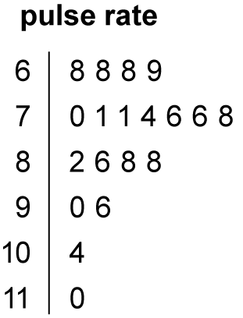  In this plot, the stem unit is '10' and the leaf unit is '1'. Thus the top row in the plot 6 | 8 8 8 9 displays pulse rates of 68, 68, 68 and 69.  Stemplot is a synonym for stem-and-leaf plot.
straight angle | A straight angle is the angle formed by taking a ray and its opposite ray. A straight angle is half of a revolution, and so has size equal to 180°.  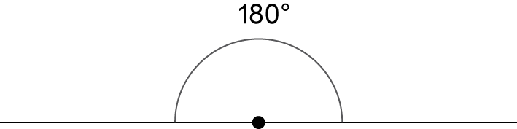
subitising | Recognising the number of objects in a collection without consciously counting.
sum | A sum is the result of adding together two or more numbers or algebraic expressions.
supplementary angles | Two angles that add to 180° are called supplementary angles. For example, 45° and 135° are supplementary angles.
surd | A surd is a numerical expression involving one or more irrational roots of numbers. Examples of surds include , 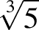 and 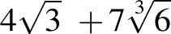.
tangent (plane geometry) | A tangent to a circle is a line that intersects a circle at just one point. It touches the circle at that point of contact, but does not pass inside it.  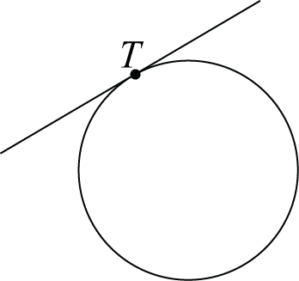
tangent (trigonometry) | In any right-angled triangle,  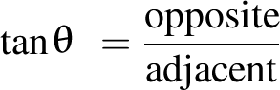, where .  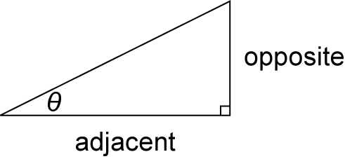
terminating decimal | A terminating decimal is a decimal that contains only finitely many decimal digits.  Every terminating decimal represents a rational number where the denominator is a power of 10. For example, 54.321 is the decimal expansion of the sum .
transformation | The transformations included in this glossary are enlargements, reflections, rotations and translations.
translation | Shifting a figure in the plane without turning it is called translation. To describe a translation, it is enough to say how far left or right and how far up or down the figure is moved.  A translation is a transformation that moves each point to its translation image.
transversal | A transversal is a line that meets two or more other lines in a plane.  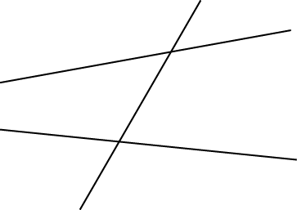
trapezium | A trapezium is a quadrilateral with one pair of opposite sides parallel.  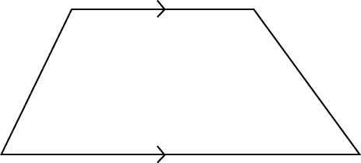
tree diagram | A tree diagram is a diagram that can be used to enumerate the outcomes of a multistep random experiment.  The diagram below shows a tree diagram that has been used to enumerate all of the possible outcomes when a coin is tossed twice. This is an example of a two-step random experiment.  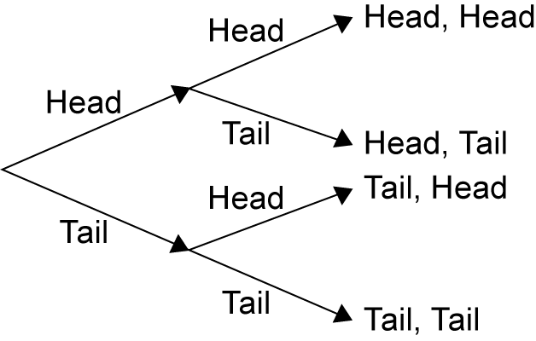
triangular number | A triangular number is the number of dots required to make a triangular array of dots in which the top row consists of just one dot, and each of the other rows contains one more dot than the row above it. So the first triangular number is 1, the second is 3 (= 1 + 2), the third is 6 (= 1 + 2 + 3) and so on.
trigonometric ratios | Sine, cosine, tangent.
two-way table | A two-way table is commonly used for displaying the two-way frequency distribution that arises when a group of individuals or things is categorised according to two criteria.  For example, the two-way table below displays the two-way frequency distribution that arises when 27 children are categorised according to hair type (straight or curly) and hair colour (red, brown, blonde, black).  The information in a two-way table can also be displayed graphically using a side-by-side column graph.
  Hair colour | Hair type |  | Total
  Straight | Curly
  red | 1 | 1 | 2
  brown | 8 | 4 | 12
  blonde | 1 | 3 | 4
  black | 7 | 2 | 9
  Total | 17 | 10 | 27
unit fraction | A unit fraction is a simple fraction whose numerator is 1, that is, a fraction of the form where is a natural number.
univariate data | Univariate data is data relating to a single variable, for example, hair colour or the number of errors in a test.
variable (algebra) | A variable is a symbol, such as x, y or z, used to represent an unspecified member of some set. For example, the variable x could represent an unspecified real number.
variable (statistics) | A variable is something measurable or observable that is expected to change either over time or between individual observations.  Examples of variables in statistics include the age of students, their hair colour or a playing field's length or its shape.
Venn diagram | A Venn diagram is a graphical representation of the extent to which two or more events, for example and , are mutually inclusive (overlap) or mutually exclusive (do not overlap).  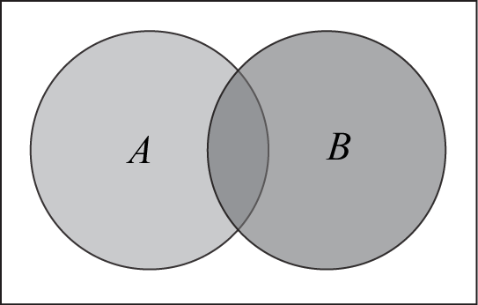
vertically opposite angle | When two lines intersect, four angles are formed at the point of intersection. In the diagram, the angles marked AOX and BOY are called vertically opposite.  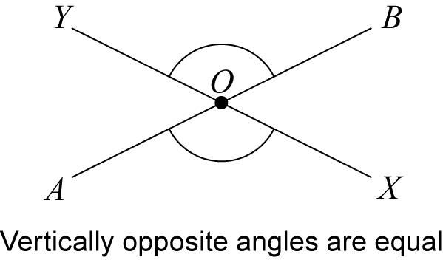
volume | The volume of a solid region is a measure of the size of a region.  For a rectangular prism, .
whole number | A whole number is a non-negative integer, that is, one of the numbers 0, 1, 2, 3, …  Sometimes it is taken to mean only a positive integer, or any integer.

